Section 8: Ideas and more ideas
https://www.edenprojectcommunities.com/stuff-you-can-do?g4id=18

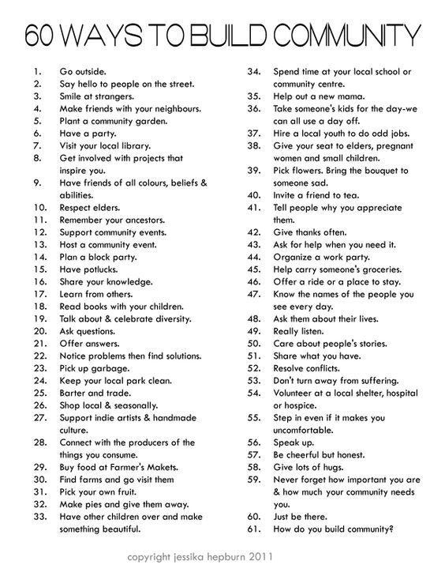
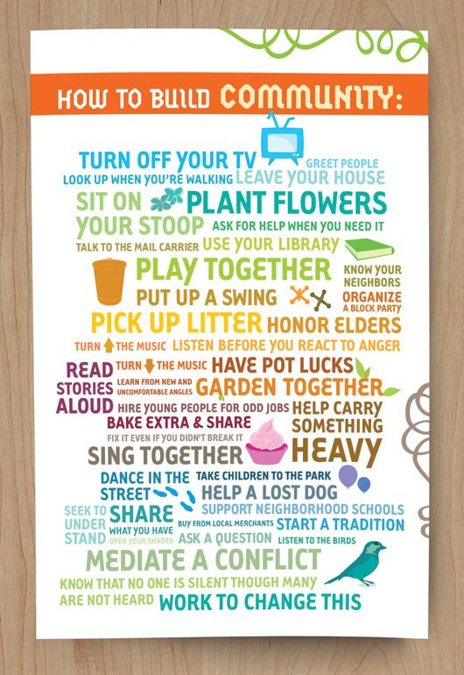

See things from a different perspective. It might change the way you do things and in turn attract new people

