How to Attract the ‘Unusual Suspects’

TOOLKIT

This toolkit is a result of three ‘Attracting Unusual Suspects’ workshops organised by CFO in November 2017 and February 2018.

We held these events after listening to community hall committees, parish councils and other community action groups who have concerns about the lack of new people getting involved in their community.

The objectives of the workshops were to:

- identify issues facing community action groups in getting people involved in positions of responsibility
- discuss strategies for encouraging people to get involved

Over 120 people came to the sessions. From the workshops, a small group was formed to oversee production of this Toolkit.

It won't be the answer to all your queries and concerns but hopefully will give you some ideas how to keep your community vibrant and active.

- We’re very keen to hear from you with your great ideas, success stories and concerns.

- Please let us know what is missing from this toolkit and what other information you would find helpful.

- We will be adding to the Toolkit regularly – so send in your ideas and good practice examples. We will use social media to tell you when there have been updates.

Contents

- Section 1: Ways to do things differently

- Section 2: Ideas for help in the short term – where to go for help

- Section 3: Good ideas that have worked elsewhere

- Section 4: Useful links

- Section 5: New ideas from the toolkit workshop

- Section 6: Understanding why people do and do not get involved

- Section 7: What we did that made a difference

- Section 8: Ideas and more ideas

- Section 9: I want to help out but I’m not sure….

- Section 10: Checklist

Section 1: Ways to do things differently

Since the workshops, we have added to the initial ideas, offering further information and responses. These are meant to be used as conversation starters within your organisations to see if you can do things differently in order to get new people involved.
Ideas from the workshops | How can we respond? | Why should we do things differently?
Discrete task and finish approach | Try to divide up roles, responsibilities and work into less onerous tasks.  Adopt a project type approach with a start and end-point rather than ongoing. | More people may be inclined to help out on a short-term basis to complete a particular project.  People can get involved working to their strengths and interests.
Direct and personal approach to people for specific tasks | Advertise for these specific tasks.  Talk to people.  Door knock.  Hold a ‘Get Involved‘ event in your community. | People know how much time they are committing to and what their support will achieve.  They can use their existing skills or be given the opportunity to try new things in a safe environment.
Create easy to access taster sessions of roles so people can see what they can get out of it | ‘Piggy back’ onto a community events or in local community newspapers advertising what you need.  Develop job roles.  Hold a volunteer summit inviting all local groups to advertise their roles.  Advertise in a way that shows people what they will get out of it, not just what you need. | People are more likely to get involved if they think they can develop skills, learn new things, make friends, etc.
Use social media and organise tutorials | Look for online training courses.  OCVA may put on training that would be appropriate. See if anyone in the community would be willing to put on a session.  Use all methods of social media as part of your communications. They all have a different purpose and audience. | A good way to engage people who use social media.  Those people who may work long hours or only available for a limited time.  May engage younger people.
Embrace technology and use it | There are many technological innovations that can make life easier and meetings etc. less onerous.  Ask people in the community for their ideas as to what computer programmes etc. they know about and how they could be used. | Time saving.  People can get involved if unable to attend meetings.  Decisions can be made quickly and efficiently.  Money saving  Can be updated quickly and frequently.
Be specific and clear about what you are asking for with roles | Write role descriptions with indications of time commitment. CFO and OCVA can assist with these. | People may be more inclined to get involved if they know exactly what is expected of them
Offer opportunities to enhance CV and skills and develop leadership skills | Develop role descriptions outlining the skills that could be developed.  Work with local schools /uniformed organisations to encourage young people to get involved as part of their personal challenge experiences. | This may encourage younger people to get involved and people looking to get back into employment
Mentor volunteers | Assign a mentor role within the organisation. | People who are new to community activity may need to be supported in the early stages to understand how things work, to build confidence and to learn about aims, aspirations or the organisation.  Having one person to ask is less threatening than having to ask in a public situation.
Welcome pack for new communities and new developments | Research and collate information about local groups.  Publish on line.  Use social media to advertise.  Develop a ‘New Neighbours Scheme’.  Work with local estate agents, schools, local shops and services etc. | To develop a sense of cohesion and community between old and new communities.
Thank volunteers: write letters - let them know they are appreciated | Use local talent to develop a thank you card.  Hold a competition to develop a local ‘brand’. | People like to feel valued but not patronised.
Use different communication channels for different audiences | Use a variety of methods of communication: social media, posters, go where people are, group emails, community newspapers, be inventive and innovative.  Talk with people at every opportunity. | People have different preferences for getting information from a poster on a lamppost to a tweet.  To ensure you are getting the right message to the right audience it is important to understand all the methods at your disposal and who is likely to use which channel.
Start to engage with young people at an early age and make ourselves approachable | Encourage families to get involved with events.  Ask young people to get involved with contributing to and leading community events, questionnaires etc.  Ask them how and when they would like to get involved.  Meet on their terms.  Engage with schools, clubs and organisations. | Evidence shows that people’s involvement is often a family affair and children of people who are involved in their community in turn tend to get involved.  It is important to manage expectations.  This is a constant issue as young people grow up and move away and the next generation need to be nurtured and encouraged.
Have events with food | Always provide refreshments.  Organise picnics, Big Lunch.  People get involved for social as well as business reasons.  Support national initiatives - National beer week etc.  Do something for fun. | Food can be a communal event and people like to eat together. Good way to engage people from different cultures.  Can be simple or sophisticated.  Can show case local produce and talent.
See things from others’ perspectives – what’s in it for them? | Talk to people and ask what or why they would get involved.  What are the barriers to their involvement.  Respond to your findings by seeing if you could do things differently. | Consider why people get involved and what would make it more attractive to them to give up their time?  Not everyone gets involved for the same reason – do not make assumptions about why or why not people give up their time.
Review current processes to see if they are fit for purpose | Spend a meeting reviewing your policies, procedures, structures, times, frequency and venues of meetings, expectations – ensure they are all still relevant and fit for purpose.  Do things need changing, stopping?  Be critical of the processes and ask, ‘Why are we doing this?’ Are we doing it like this because we always have?  Be open to new ideas and ways of doing things. | Onerous paperwork and polices can be very off putting when trying to attract new people.
Limit the time people can be on committees or more specifically in roles of responsibility | Look at the group’s constitution and change if necessary.  Support new people to take on responsibility in a timely fashion.  Consider succession planning.  Ensure group memory and experience isn’t lost. | If the same people do the same things, you will get the same outcomes.  Groups and community activity need to keep relevant, adapt to new circumstances and change accordingly if necessary.
Get people doing what they want to do | Ask people what their interests and passions are and support them in developing these.  Bring people together with similar interests and let them organise themselves in an organic spontaneous way.  Great for intergenerational work – craft skills etc. | To fully engage someone they need to feel passionate and convinced that they are making a difference on a personal level.  They will stop being involved if asked to something that that ‘doesn’t rock their boat’
Appreciate that there is not a hierarchy of involvement – all roles are needed | Look at new ways of structuring meetings – does there always need to be a chair person?  Could a flatter structure be introduced?  Do the ‘officers’ understand their role properly?  Do they prevent, encourage new people?  Are they open to new ideas? | People have different skills, interests and experiences and all are needed in a community.  People need to feel valued and welcomed.
Section 2: Ideas for help in the short term – where to go for help.
At the workshops, people were asked to identify what would help in the short term. These possible solutions are a result of CFO research after the workshop. These are not exhaustive answers and will be added to over time. If you have any thoughts or useful contacts please do let us know and we can add to this section.

One thing we need | Possible solutions, ideas and places to go for further information
More Trustees | OCVA offer support with this:  https://ocva.org.uk/
More volunteers | OCVA  NCVO volunteering toolkits:  https://www.ncvo.org.uk/ncvo-volunteering  OCVA and Abingdon and Witney College training for volunteers:  http://www.abingdon-witney.ac.uk/coursesearch/?area=Volunteering&type=PT  Don’t assume people aren’t doing anything already- maybe community of interest /identity rather than geography.
Breaking down jargon | Avoid using jargon and acronyms – challenge ‘professionals’ who use jargon
Advice pointers for other people

How to bring in young people | District Youth engagement officers  Duke of Edinburgh award:  oxfordshiredofe.org.uk  NCIS:  Oxfordshire.gov.uk/cms/content/national-citizen-service-oxfordshire  Oxfordshire Youth:  https://www.oxfordshireyouth.org/  Local organisations e.g. scouts
Counter some reasons for people not getting involved. E.g. DBS. Legal obligations | OALC – parish council advice and support:  http://www.oalc.org.uk  OCVA – DBS info  CFO - village halls and shops advice:  http://www.communityfirstoxon.org/
Improved communications | Develop social media and marketing courses
Resources to support residents,set up Residents Associations | Housing Associations
How do we help people commit in a commitment light age | ‘The Elephant in the box’- new research  lankellychase.org.uk/elephants-in-the-box/ - principles for engagement  Break down roles and tasks into smaller chunks.  Its ok for people to dip in and dip out – Personal circumstances change.
What do other people do? | CFO to undertake research from elsewhere and share via website
Other agencies we could engage to get people involved | Know your local community -who is already working in the area?  Local authority – team building volunteering days.  West Oxfordshire: http://www.vlu.org.uk  Cherwell DC: http://volunteerconnectbanbury.com  County-wide: http://oxonvolunteers.org
Ideas of how we can empower others | Be welcoming, avoid cliques.  Open to new ideas.  Mentoring.  Training.  Building confidence -OCVA and Abingdon Witney College training.  Ensure there are no barriers perceived or real preventing people from getting involved.  Offer to pay expenses – caring costs.
Share own passions | Share at community events. What are my gifts to share? Gifts of the head – Things I know about and would enjoy talking to others about’. Gifts of the Hands – things or skills I know how to do and would like to share with others. Gifts of the Heart – things I care deeply about.  http://www.nurturedevelopment.org
Succession planning | Sharing roles within your organisation – mentoring new people
New community hall – need ideas to bring others onto the committee | CFO Community Halls advice.
How to reach out and involve and get views from unusual suspects | Marketing.  Youth engaging.  District Council communication teams.  Go where people are - don’t expect them to come to you.
How to involved newly retired and those new to the area | Personal contact.  Businesses via HR department.  Retirement planning and support.  SODC volunteer officer.
How to keep people’s interest | New ideas – open to change – do things differently.
How to get the message through that people are needed. | Marketing.  Personal contacts.  Talk to your neighbours.
Tools and ideas for attracting different people | This Toolkit!
How to get people to understand importance of fundraising | http://www.gnof.org/wp-content/uploads/2014/06/10-most-important-things-FD.pdf  www.institute-of-fundraising.org.uk
Attracting people who can run projects | Skills audits.  Advertise specifically.  Free project management training courses:  futurelearn.com

Section 3: Good ideas that have worked elsewhere

There are always good practice ideas from successful organisations and it’s great to try things that have worked elsewhere. Please do send us your ideas and success stories so we can share them here.

- Any committee needs to work as a team with complimentary skills working for the common good - make sure you have a range of people with the skills you need, not all the usual suspects. Regularly review what you do and what skills you need in order to do them.

- Leave your ego at the door: the position you hold is what’s important, not you.

- Instigate reviews and appraisals for volunteers and the organisations.

- Discuss – what have we achieved this year? Are we too focussed on process and not product?

- Adopt a plan, do, review model.

- Be creative and fluid – things change, you may need to.

- Keep paperwork proportionate and to a minimum.

- Explain things to new people.

- Understand legal requirements and how they affect you. Charitable status, safe guarding, Health and safety etc. Get advice from OCVA etc. Don’t be put off or scare other people off. Keep things proportionate.

- Keep people involved but ensure they step down from being an officer.

- Start with a nice task for people playing to their strengths.

- Match volunteers with the task in hand.

Section 4: Useful links
You told us that we wanted us to research useful information on the internet. Here are some links we think you might find interesting

http://www.diycommitteeguide.org/about-diy-committee-guide
http://www.diycommitteeguide.org/download/dealing-conflict-what-to-do-when
https://www.mindtools.com/pages/article/newTMM_65.htm
https://ctb.ku.edu/en
https://ctb.ku.edu/en/get-started
https://ctb.ku.edu/en/table-of-contents/leadership/leadership-functions/become-community-leader/main
https://www.corganisers.org.uk/
http://www.nurturedevelopment.org/asset-based-community-development/

Section 5: New ideas from the toolkit workshop

- How to get the right person in the right position -be specific in your needs – try to fill gaps in skills by undertaking a skills audit. Understand why your group/ committee can never make a decision or people get involved and then leave.
https://www.mindtools.com/pages/article/improving-group-dynamics.htm

https://www.tools4management.com/article/forming-storming-norming-and-performing-group-dynamics-of-tuckman/

- Give people a sense of the outcome their contribution has made- we are all part of a bigger picture – jigsaw etc.

- Feedback – explain feedback loop:
https://knowhownonprofit.org/your-team/volunteers/keeping/supporting-volunteers

- Be specific in what you need, time frames, expectations.

- Value to you as a volunteer.

- Ownership and collective action.

- Change the way meetings are organised -even a new set up within the room can yield different results.

- Family activities.

- Community activities calendar:
https://www.awarenessdays.com/awareness-days-calendar/

- Bring a mate -encourage people to come along with a friend- there is safety and confidence in numbers.

- Talk to people – nothing can substitute for just building relationships with people.

- Convince people there’s a need for their input and support

- Mind your language: don’t use the word ‘volunteer’ as this can be off putting; try to use other words to get people interested in working with you (ownership, delegation, support, doing your bit, playing your part, contributing, enabling).

- Be brave - leaders/ community activist must challenge the status quo and promote cultural change.

- Design flexibility into roles- ask ‘why not?’ rather than ‘why?’

Section 6. Understanding why people do and do not get involved

In development
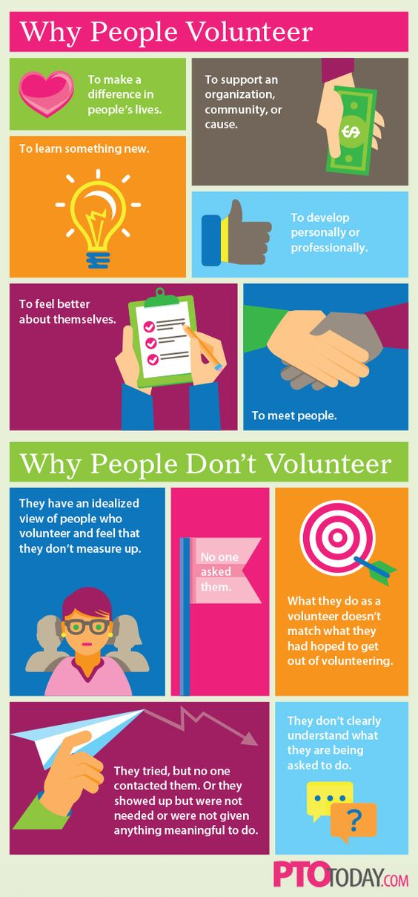

Section 7: What we did that made a difference

Have a look at the CFO tube channel where people tell us what they are doing and how it has helped their community.
Send us in your films to share your great ideas.
https://www.youtube.com/channel/UCPZa42091m19uNj4RxERbjg

Section 8: Ideas and more ideas
https://www.edenprojectcommunities.com/stuff-you-can-do?g4id=18

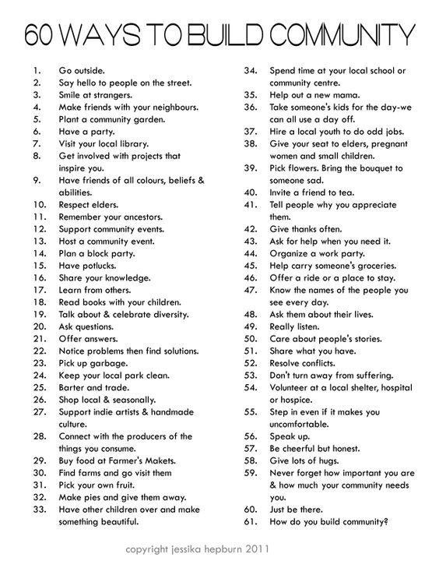
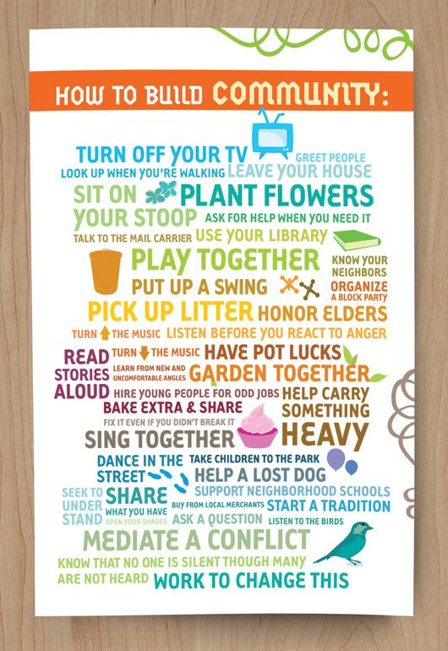

See things from a different perspective. It might change the way you do things and in turn attract new people

Section 9: I want to help out but I’m not sure….
- Do I really have the skills you need?
- What if I don’t have much time?
- What will I get out of volunteering?

Michelle Obama once said, "Success isn't about how much money you make; it's about the difference you make in people's lives." Most of us know that charity is its own reward. The true wealth of charity is measured by good deeds, not ego and material gain. Countless studies validate the benefits of giving, not only for the ones on the receiving end but for the ones who support those in need. Benefits of giving back include feelings of happiness and wellbeing, as well as inspiring a greater sense of purpose in life. Volunteering is also a great way to boost self-esteem and may help you discover talents you never knew existed within you.

Everyone has something to offer their community, it’s just a matter of finding where you can get involved that suits you and your needs. Ask your neighbour, at the village hall, at your place of worship, at the school, at your community shop, at your parish council.

If you want to start something new but are not sure how to go about it, get in touch with us:
hilary.lombard@communityfirstoxon.org.

These websites might be of interest:
http://www.cancerresearchuk.org/support-us/volunteer/help-at-an-event
https://www.signupgenius.com/nonprofit/community-service-project-ideas.cfm
https://issuesiface.com/magazine/10-ways-to-help-your-community

Ways to help out

Little Things Count:

- Still not sure where to start? Helping your community doesn’t have to entail a grand gesture. There are plenty of small steps you can take to make a difference in the lives of those around you.

- Commit to keeping your local streets clean – keep that used sweet wrapper in your pocket if you can’t find a rubbish bin.

- Be that person who lets a frazzled parent holding a child or an older person ahead of you at the supermarket.

- Remember, if you’re committed to helping the community you live in, the most important thing to do is to take action. Decide that you’re tired of sitting around wondering how to help your community and instead choose an action item, even if just one, and move on it immediately. Whether you invest money, energy, or time in the place you call home, the sooner you get involved, the better you’ll feel about your community and the brighter its prospects will look.

What other ideas do you have? Share them with us so we can let other people learn from your great ideas.

- https://thegirlwhoknows.com/soul-to-soul-100-ways-to-make-a-difference/
- https://www.theguardian.com/theguardian/2000/jan/08/weekend7.weekend5
- https://www.curbed.com/2016/9/22/13019420/urban-design-community-building-placemaking

And its official – helping out in your community is good for you!

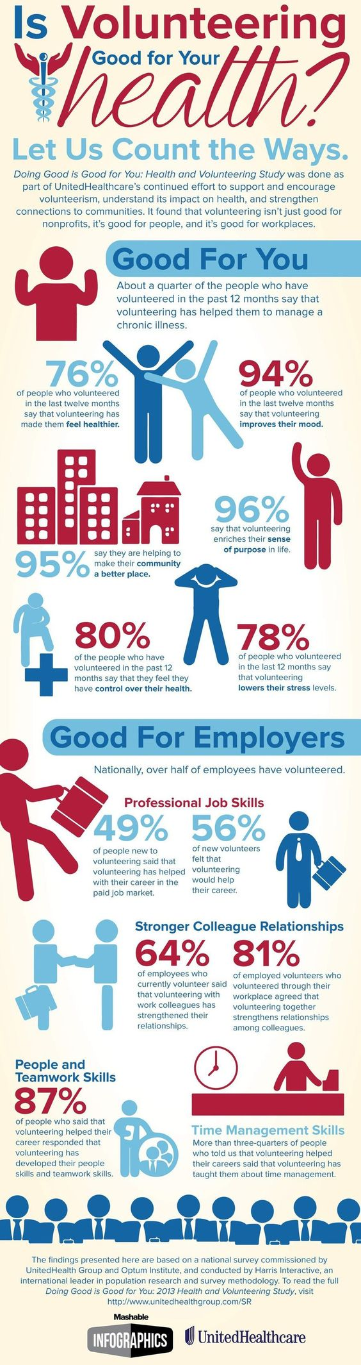

Section 10: Guidance checklist
In development
We are always looking for great news to share – send us through your good ideas, achievements and stories of how doing things differently encouraged more people to be involved.

