Rural community profile for Long Wittenham (Parish)

Action with Communities in Rural England (ACRE) Rural evidence project
November 2013



A national review carried out by John Egan highlighted a set of characteristics that a community should have in order to create thriving, vibrant, sustainable communities to improve the quality of life of its residents. These characteristics were broken down into a set of themes, around which this report for Long Wittenham is structured

Finding your way around this profile report
 | Social and cultural | See pages 5-12 for information on who lives in the local community, how the local community is changing and community cohesion…
 | Equity & prosperity | See pages13-21 for information on deprivation, low incomes, poor health and disability in the local community…
 | Economy | See pages 22-27 for information on the labour market, skills and resident employment…
 | Housing & the built environment | See pages 28-33 for information on housing in the local area, household ownership, affordability and housing conditions…
 | Transport and connectivity | See pages 34-37 for information on access to transport and services within the local area…
 | Services | See pages 38-39 for information on distance to local services…
 | Environmental | See pages 40-41 for information on the quality of the local environment…
 | Governance | See pages 42-43 for information on the level of engagement within the local community…

This report was commissioned by Action with Communities in Rural England (ACRE) and the Rural Community Councils from Oxford Consultants for Social Inclusion (OCSI), www.ocsi.co.uk / 01273 810 270.
ACRE would like to thank DEFRA for their support and provision of Ordnance Survey data and licensing, OS license number 100022861. ©ACRE/ OCSI 2013.
This report, or any part, may be reproduced in any format or medium, provided that is reproduced accurately and not used in a misleading context. The source must be identified and the title of the publication specified with the copyright status acknowledged.

Introduction
Profiling the sustainability of communities in rural England  If you live or work in your community, you will no doubt already have some good ideas about its strengths and weaknesses and how things can be improved. However, in order to effect real change it is essential that you back this up with evidence and discuss it with members of your community.  There is a great deal of ‘hard’ data published that is useful for rural communities. However, this information is rarely brought together; profiles of areas tend to be produced for Local Authorities and other administrative areas, rather than ‘real’ communities. ACRE therefore commissioned Oxford Consultants for Social Inclusion (OCSI) to develop a set of profiles for each of the rural communities in England.  How this profile is intended to help you  This profile brings together up to date quantitative data for your area, to help you when deciding which actions and activities to prioritise locally. Each of the sections shows data for Long Wittenham, comparing with other areas (local authority and national averages), and with trends over time where data is available. The data is intended to help you discuss questions like:  - Where are we now?  - What change has taken place in the past?  - What are the strengths (and weaknesses) in our community?  - What changes would we like to see in future, and what needs to be done?  Of course, we cannot show all the data for all the issues that you might be interested in, so under each section we have highlighted further data that could be collected by you, and links to more detailed data that could be available, e.g., held by local organisations.  The profile report has been designed so that you can work through each of the sections, or jump straight to the most useful parts using the index on page 2 or using the links to other relevant pages in the report at the bottom of each page. | How we have created this profile for Long Wittenham  The Parish of Long Wittenham is in the Local Authority of South Oxfordshire, in the area served by Oxfordshire Rural Community Council.  To create this profile, OCSI have developed datasets for all rural communities in England, including parishes, towns and villages. To do this, we have used the Office for National Statistics (ONS) definitions of parishes and urban areas; the data for Long Wittenham is based on this ONS definition which is shown in the map on the following page (due to the differences in definition, there may be small differences between the data provided in this profile and data published in the Census Parish Profiles). You can access this and the other community profiles at the Rural Evidence website, www.rural-evidence.org.uk (you will need a login from ACRE to access the reports).  The main datasets used in this report are shown in the introduction to each section. Full details of each indicator and data sources are available at www.rural-evidence.org.uk.  About the Community Led Planning Toolkit and other available support  You can use this profile of your community to inform the development of a Community Led Plan. A Community Led Plan is an opportunity for your community to take action and improve your area based on a detailed understanding of local needs and aspirations.  Guidance in ACRE’s national toolkit for Community Led Planning shows you how you can use the information presented in this profile to identify key features and characteristics of your community which you may want to investigate further and discuss with other people locally. This information will help you to plan actions for the improvement of your area that are better informed and more likely to benefit everyone locally.  To obtain a copy of ACRE’s national toolkit for Community Led Planning, including specific guidance on the use of this community profile, please contact Oxfordshire Rural Community Council or visit www.acre.org.uk.

Map of Long Wittenham (Parish)
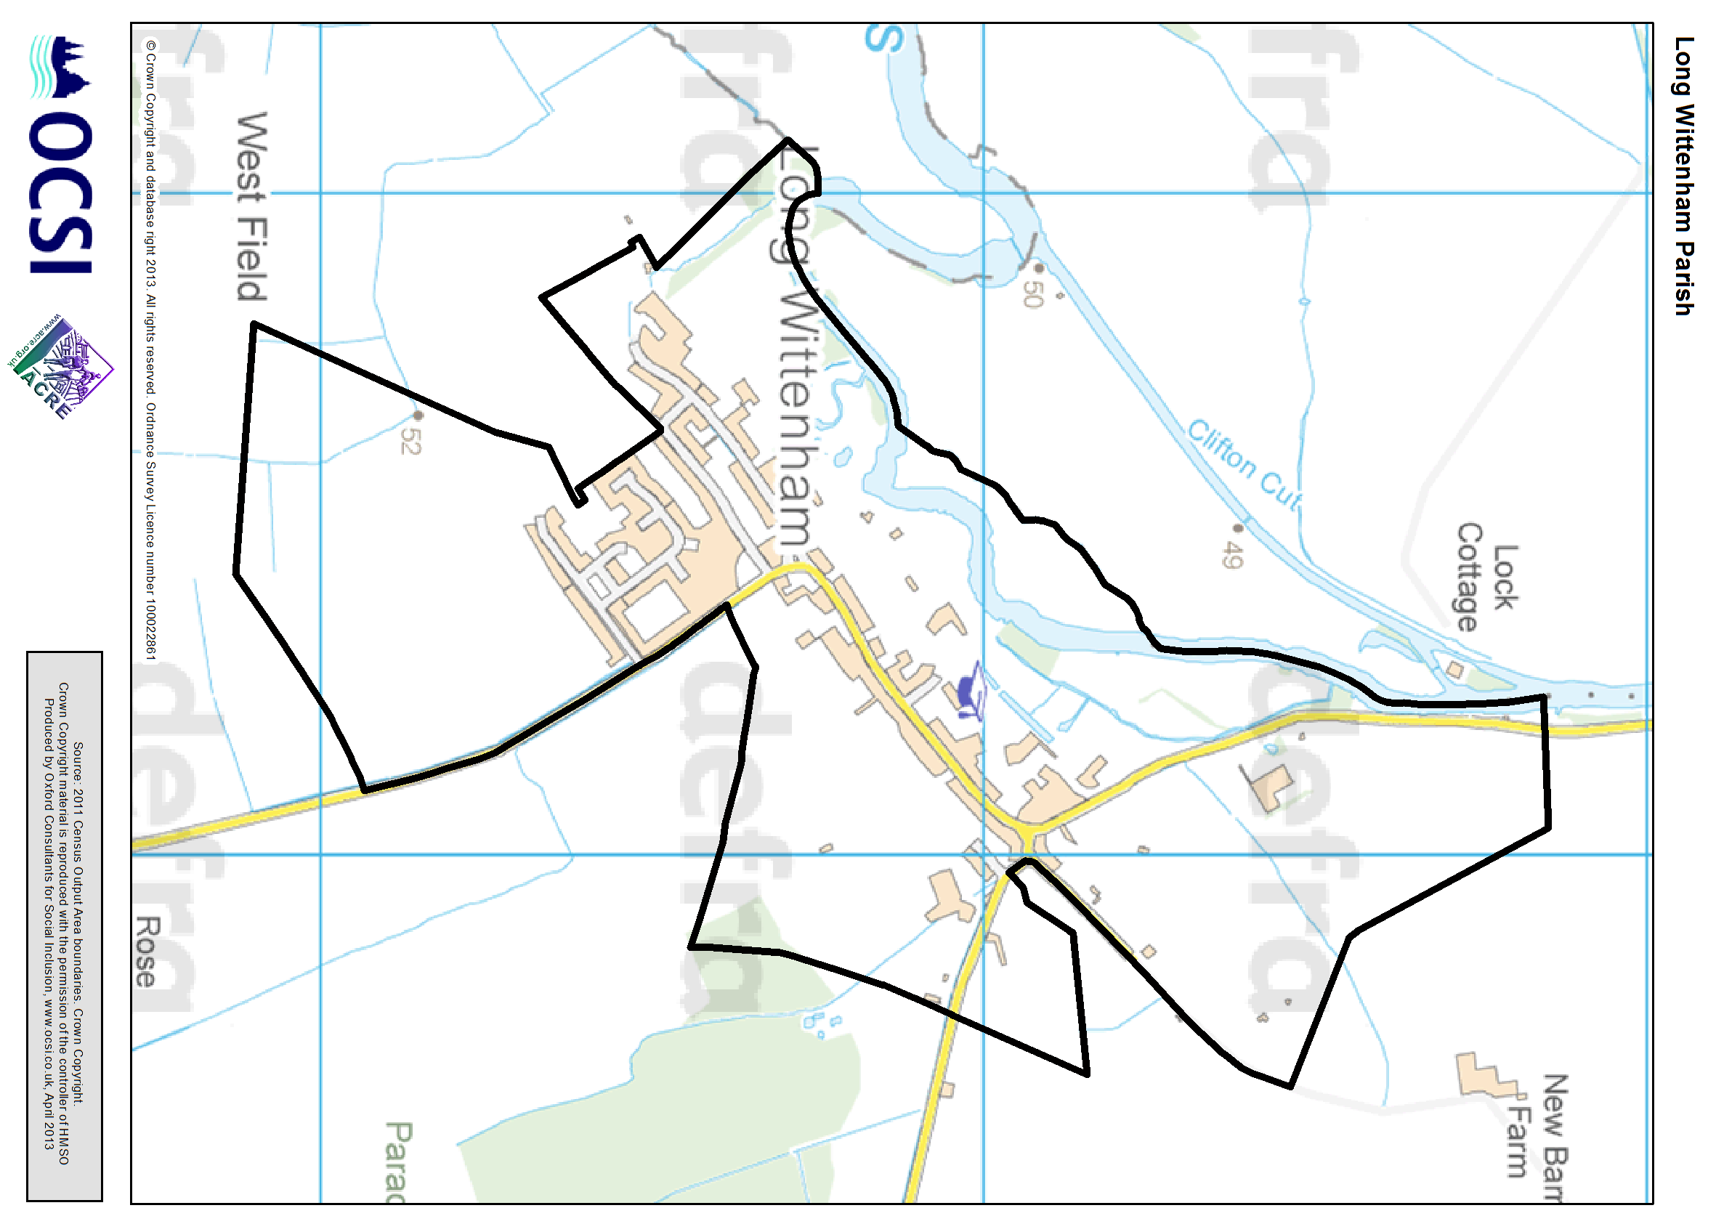

What does a sustainable community look like?  Social and cultural: Introduction  Active, inclusive and safe. Fair, tolerant and cohesive with a strong local culture and other community activities  What do sustainable communities offer?  - A sense of community identity and belonging;  - Tolerance, respect and engagement with people from different cultures, background and beliefs;  - Friendly, co-operative and helpful behaviour in neighbourhoods;  - Opportunities for cultural, leisure, community, sport and other activities, including for children and young people;  - Low levels of crime, drugs and antisocial behaviour with visible, effective and community-friendly policing;  - Social inclusion and good life chances for all.  Using this report to explore Social and Cultural data for Long Wittenham | What other information might be available?  As with all analysis in this report, we have used data published for all small areas across the country, aggregated to local rural areas. Additional detailed local datasets may be available from organisations such as the local authority, while some useful data is published nationally only for larger geographies (so cannot be broken-down for local rural areas). Other relevant data includes:  - More detailed breakdowns of population sizes by age and gender are available from census 2011 (http://www.data4nr.net/resources/1605/).  - Annual migration estimates, including internal and international migration, are published by the Office for National Statistics at Local Authority level, see www.data4nr.net/resources/960.  - Data on births, including births by gender / ethnicity of baby and age / country of birth of mother, are also published at Local Authority level, www.data4nr.net/resources/436.  - Population projections data by age and gender to 2033 are available at Local Authority level, see www.data4nr.net/resources/797.  - The police now publish maps of recorded crime offences and anti-social behaviour – enter your postcode into the website at www.police.uk to see this for your local area, as well as details of your local community policing team and events.  - Many communities have carried out local surveys asking similar questions, to understand the strength of the community, what opportunities there are locally and to identify particular areas of concern for residents and businesses.
  Sub heading | Indicators
  Who lives in the local community? | Population by age and gender, Country of birth, Household composition
  How is the local population changing? | Population , National Insurance Number registrations for Overseas Nationals, Migration
  How strong is the local community? | Community Strength indicators, Participation in sport
  How safe is the local community? | Indices of Deprivation 2010 Crime domain , Notifiable offences recorded by the Police , Perceptions of crime

Social and cultural: Who lives in the local community? (1)

Although you probably have a good idea of who lives in your area, knowing the actual numbers – and how these are changing over time – can help you decide which actions and activities to prioritise locally.  For example, if the population size is increasing more quickly than in other areas, it may be useful to think about pressure on housing and services. Similarly, the numbers of lone parents or older people has been used by communities when thinking about what additional services, such as care support for older people, may be needed.  What information is shown here?  The information boxes on the right show the numbers of people and households in Long Wittenham, with counts of groups by age, ethnic minority and those born outside the UK. They also show groups who may be particularly vulnerable – lone parents and older people living alone, as well as the dependency ratio (the ratio of non-working age to working age population).  The chart on the right shows the population breakdown by age group for Long Wittenham, with local and National comparators. The charts on the following page show the population by 5 year age bands and by gender in Long Wittenham, as well as population breakdowns by ethnic group, household composition and those born outside of England, each with national comparisons.  Where next?  On page 8 we show how the population is changing over time, to see if groups such as younger people are more likely to be moving out of the area. Data on community cohesion and belonging can be found on page10. Information on levels of local engagement is in the section on Governance (page 42). Information on numbers of houses and housing type is in the section on housing (page 27).
  How many people live locally? |  | How many households? |  | Children under 16 |  | Working age adults |  | Older people over 65
  875 |  | 325 |  | 190 |  | 550 |  | 135
  49.1% male; 50.9% female |  |  |  | 21.9% (England average = 18.9%) |  | 62.6% (England average = 64.7%) |  | 15.5% (England average = 16.3%)
  Lone parent families  with children |  | Single pensioner households |  | People from Black or Minority ethnic groups |  | People born outside the UK |  | Dependency Ratio
  10 |  | 30 |  | 55 |  | 70 |  | 0.59
  7.7% of all families with dependent children (England average = 24.5%) |  | 9.3% of households (England average = 12.4%) |  | 6.4% (England average = 20.2%) |  | 7.6% (England average = 13.8%) |  | England average = 0.55
 | 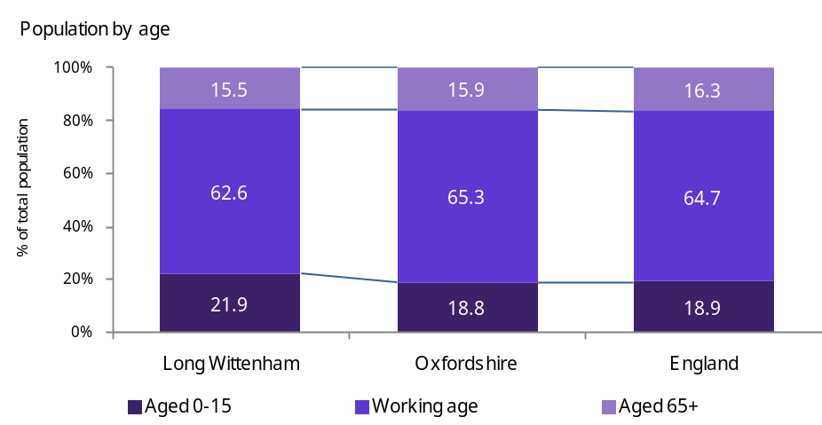
 | Source: Census 2011 (table KS102EW)

Social and cultural: Who lives in the local community? (2)

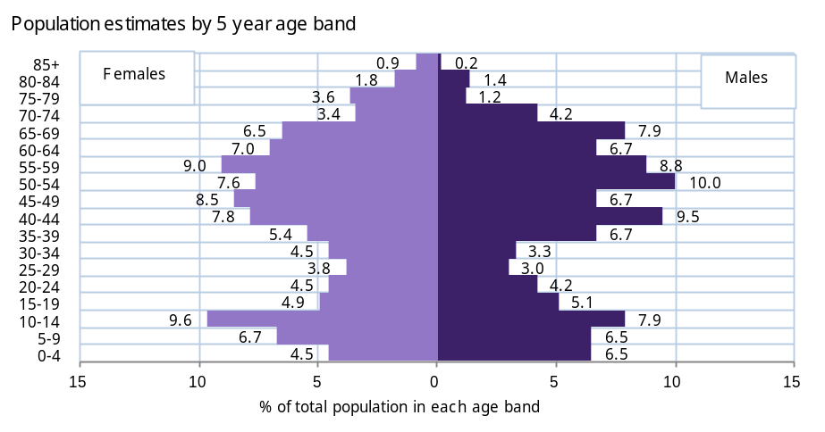 | 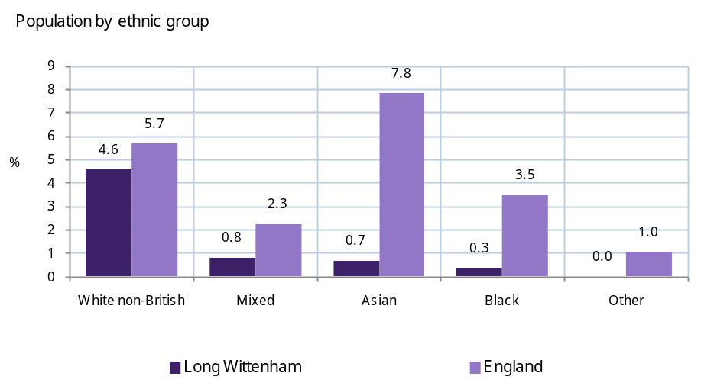
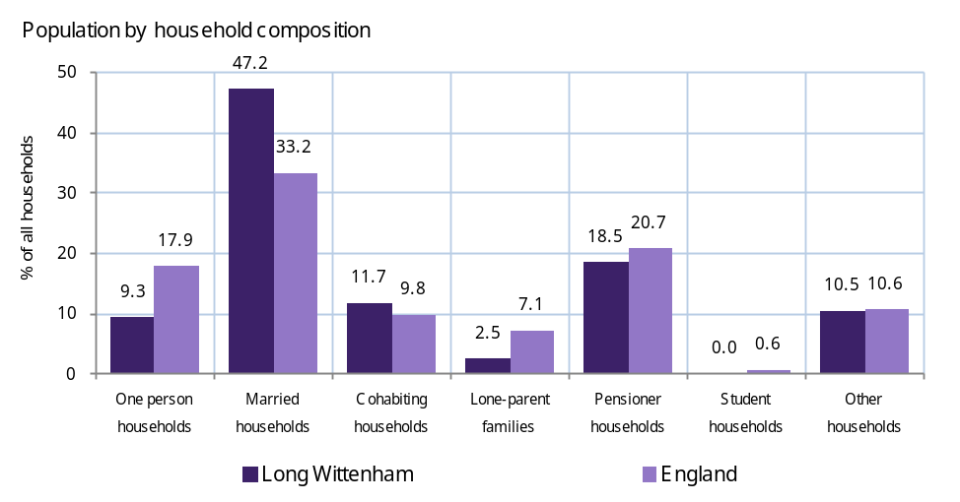 | 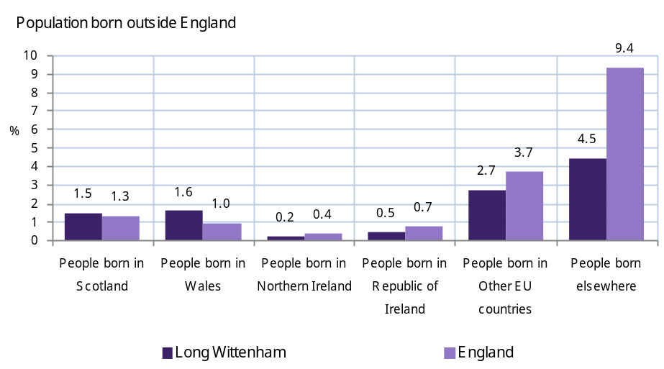
Source: Census 2011 (tables KS201EW, KS204EW and KS105EW)

Social and cultural: How is the local population changing? (1)

Many local rural communities highlight that younger groups – particularly families – are moving out. This is often due to lack of affordable housing, or not having suitable employment and training opportunities. These groups are often replaced by more affluent older families, for example moving in from urban areas.  Information on this issue has been used to help identify the need for particular types of housing or services in local communities, to ensure that people have the opportunity to stay in the local area.  What information is shown here?  The information boxes on the top right show the number of national insurance number registrations by overseas nationals in Long Wittenham and the number of people who have moved address in the last 12 months. This information is replicated in the charts on the following page. The chart on the left shows the level of inward and outward migration in the local area (this does not include births or deaths). This is expressed as a rate per 1,000 for each age group. The right-hand bars (dark purple) show people moving into the area. The left-hand bars (light purple) show people moving out of the area. Higher values for a particular group indicate that this age-group is more likely to move into or out of the area.  The chart to the right shows the change in the total population between 2001 and 2011 for Long Wittenham, the local authority, and the change across England.  Where next?  In the section on Equity & prosperity (page 13) we look at changes over time in the proportion of vulnerable groups living in the local area, including children in poverty and those on DWP benefits. For data on housing and affordability of the local area see the section on housing (page 28). For information on skills and employment levels in the local area see the section on the Economy (page 22).
  People who have moved address within the last 12 months (2001) |  | National Insurance Number registrations of overseas nationals
  85 |  | 5
  9.7% (England average = 12.2%) |  | 0.5% (England average = 1.6%)
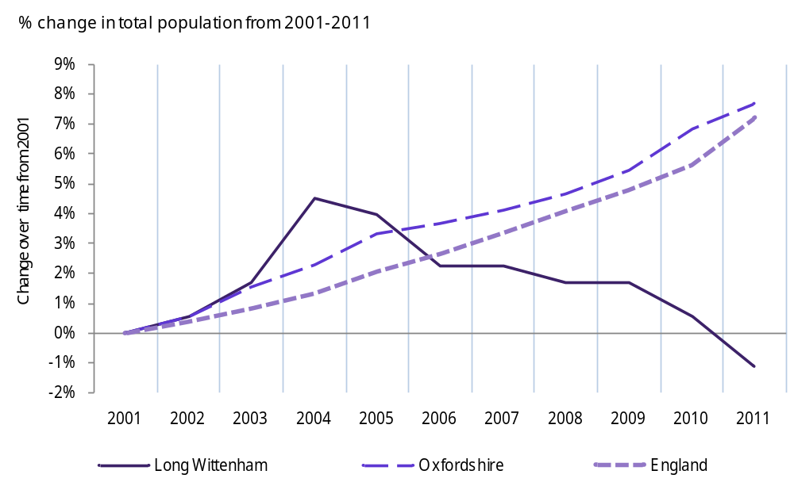
Source: People who have moved address (Census 2001: table KS 24), Population Change 2001-2011 (ONS Mid Year Estimates/Census 2011, National Insurance No. registrations (DWP 2011/12)

Social and cultural: How is the local population changing? (2)

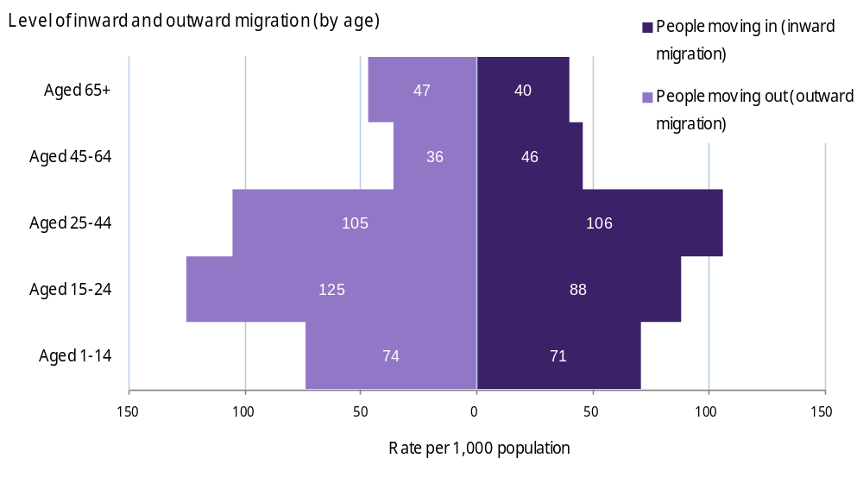
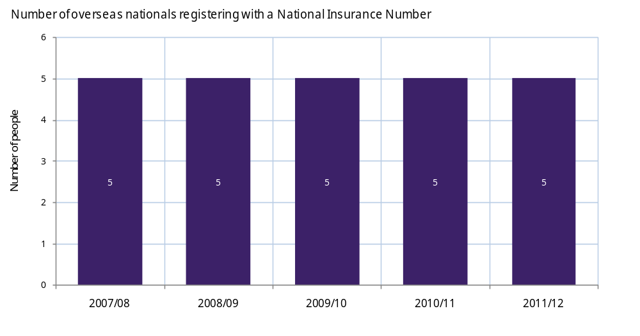
Source: Population Turnover rates (ONS 2009/10), National Insurance No. registrations (DWP 2011/12)

Social and cultural: How strong is the local community?

Many different things can contribute to the strength and sustainability of your community but a good starting point can be to find out how people feel about the area in general.  What information is shown here?  The data shown is from the national ‘Place Survey’, collected by all local authorities in 2008. Data is only published for the local authority area. However you may be able to get more detailed information from surveys carried out in your local area.  The indicators shown are measures of community strength, indicating how satisfied people are with their local area, and whether they felt that they belonged to the area. The data also shows the proportion of adults regularly taking part in sport. As well as an indicator of healthy lifestyles, this can be a useful indicator of the opportunities available in the local area.  The bar chart on the right shows how your local authority compares with the national picture. Across England, nearly 80% of people asked were satisfied with their local area as a place to live, and more than three-quarters felt that people from different backgrounds got on well locally. However, only 58% of people nationally felt they actually belonged to their neighbourhood.  Where next?  See the following sections in this profile for information on deprivation, poverty and health in the local area (page 13), employment opportunities (page 22) and quality of local housing (page 33). For information on levels of local engagement and the voluntary sector see the section on Governance (page 42).
  “Satisfied with the local area as a place to live” |  | “I belong to the neighbourhood” |  | “People from different backgrounds get on well together in the local area” |  | Aged 65+ "satisfied with both home and neighbourhood" |  | Adults (aged 16+) participating in sport 3+ times each week
  91% |  | 64% |  | 83% |  | 90% |  | 26%
  Data shown is for South Oxfordshire (England = 79%) |  | Data shown is for South Oxfordshire (England = 58%) |  | Data shown is for South Oxfordshire (England = 76%) |  | Data shown is for South Oxfordshire (England = 83%) |  | Data shown is for South Oxfordshire (England = 22%)
 | 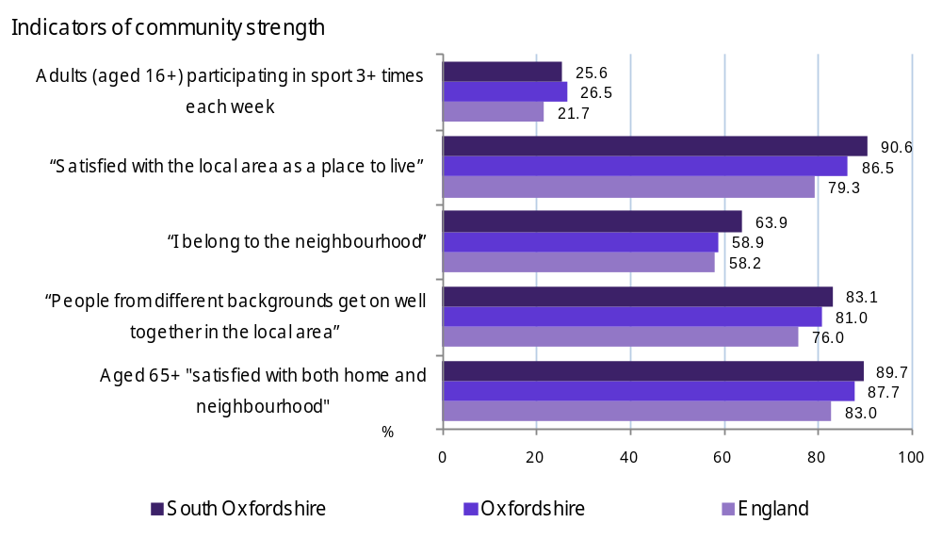
 | Source: Place Survey 2008, Sport England Survey 2009

Social and cultural: How safe is the local community? (1)

Crime, fear of crime and anti-social behaviour regularly feature in priorities for local areas. Visible, effective and community-friendly policing can help bring down crime levels, as well as reducing people’s fear of crime. Information on actual and perceived crime levels therefore, may help you demonstrate evidence to support local priorities in these areas.  What information is shown here?  The information box (in the top right) shows the number of people in the local area living in crime hotspots. Crime “hotspots” are defined as areas ranked among the most deprived 20% of areas on the Indices of Deprivation 2010 crime domain. The chart on the right shows the number of people in Long Wittenham living in each crime decile.  The bar chart to the left on the following page shows the level of recorded crime in the local authority compared with national information for different types of crime (data is not published for the local area). The data is shown as a rate per 1,000 residents (or 1,000 households for burglaries) so you can compare between different areas. The chart to the right on the following page shows whether residents perceive there to be a problem in the local area with anti-social behaviour, drug use and so on. This data is taken from the Place Survey, and is published at local authority level (and compared to the national picture).  Where next?  Information on community strength can be found on the above page. See the Equity & prosperity section for information on deprivation, poverty and health in the local area (page 13). For information on participation in the local community see the section on Governance (page 42).
  Number of people living in crime 'hotspots'
  0
  -
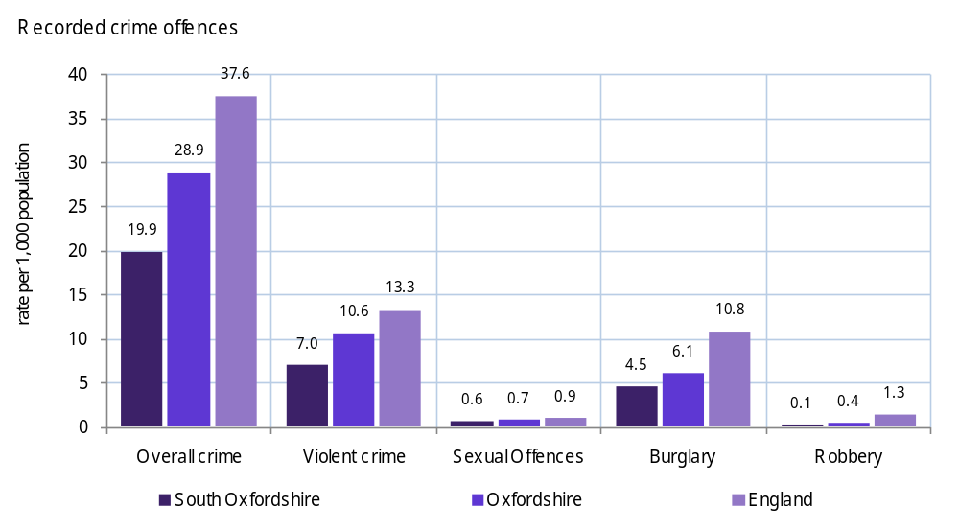
Source: Indices of Deprivation 2010, CLG

Social and cultural: How safe is the local community? (2)

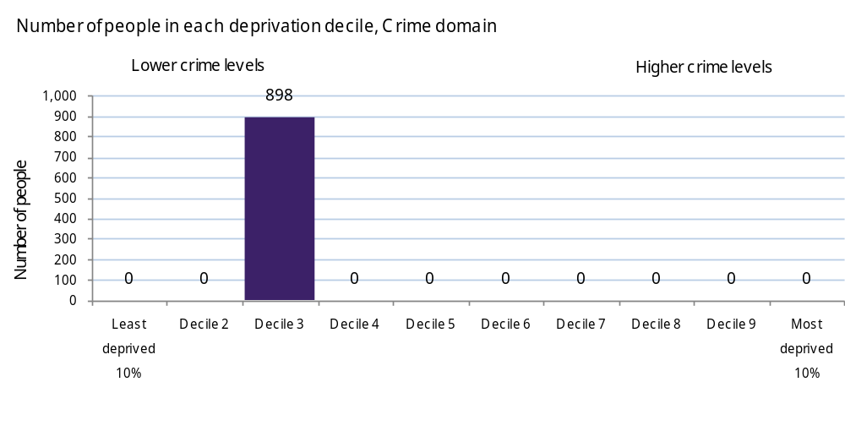
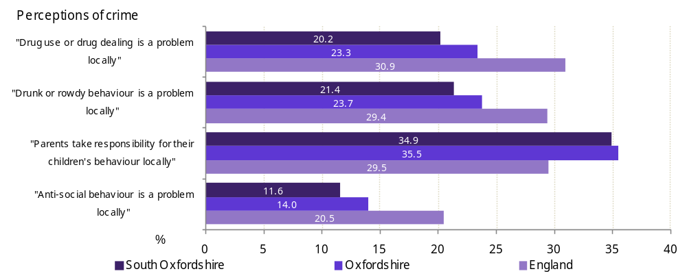
Source: Recorded crime (Home Office 2011/12), Perceptions of crime (Place Survey 2008)

Equity and prosperity: Introduction

What does a sustainable community look like?  Fair for everyone, including those in other communities, now and in the future  What do sustainable communities offer?  - They recognise individuals' rights and responsibilities;  - Respect the rights and aspirations of others (both neighbouring communities, and across the wider world) also to be sustainable  - Have due regard for the needs of future generations in current decisions and actions.  Using this report to explore data on Equity & prosperity for Long Wittenham | What other information might be available?  As with all analysis in this report, we have used data published for all small areas across the country, aggregated to local rural areas. Additional detailed local datasets may be available from organisations such as the local authority, while some useful data is published nationally only for larger geographies (so cannot be broken-down for local rural areas). Other relevant data includes:  - Data on wage levels is published at local authority district level, but your local authority may have access to commercial data on local area wages such as CACI Paycheck data.  - Housing Benefit data (published at Local Authority level) provides information on households living in low income see www.data4nr.net/resources/373  - Morbidity data: prevalence of non-fatal (possibly recurrent) health conditions may be available from PCTs for local areas  - Data on maternity related health outcomes, including infant mortality, still births and low birth weight are collected by the ONS at Local Authority level http://www.statistics.gov.uk/hub/population/births-and-fertility/live-births-and-stillbirths/  - Prevalence of mental health issues, including dementia, and numbers of people with learning disabilities are collected by the Projecting Adult Needs and Services information system (PANSI) for upper tier Local Authorities http://www.pansi.org.uk/  - A range of sexual health indicators are collected and published by the Health Protection Agency at Local Authority level http://www.data4nr.net/resources/health--disability/1469/  - Office for National Statistics: Measuring National Well-being – Health publication http://www.ons.gov.uk/ons/rel/wellbeing/measuring-national-well-being/health/index.html
  Sub heading | Indicators
  How deprived is the local area? | Index of Multiple Deprivation 2010, Working Age Client Group, Households experiencing multiple deprivation
  People living on a low income | Income Support, Pension Credit, Economic Deprivation Index 2009, Fuel Poverty, Housing/Council Tax Benefit, Households below median income
  Children | Children in out of work households, Children in Poverty, Children in lone parent households, Child Wellbeing Index 2010, Pupil attainment - Average Point Score at Key Stage 2 and 4
  Poor health and disability | Indices of Deprivation 2010 Health domain, Limiting long-term illness, Attendance Allowance, Disability Living Allowance

Equity and prosperity: How deprived is the local area? (1)

The idea of ‘deprivation’ is based on more than just poverty, with the standard national measure of deprivation – the ‘Index of Multiple Deprivation’ (or IMD) – based on income, unemployment, health, education and skills, housing, crime, environment and access to services. The IMD can be used to identify whether local areas are deprived compared to other areas across England.  However, many deprived people do not live in deprived areas. Although there is no single indicator that encapsulates all different dimensions of deprivation and exclusion for people in rural areas, indicators of those on benefits (including national DWP benefits, and local authority Council Tax and Housing Benefits) can provide a general measure covering low income, employment and health issues.  What information is shown here?  The data on the following page shows whether any local areas are highly deprived, and if so identifies how many people are living in such areas based on the national Index of Multiple Deprivation 2010. Data also shows the number and proportion of people locally receiving benefits and the number of households experiencing multiple deprivation.  The line chart shows the proportion of working-age people receiving benefits, showing the trend over time and comparisons against the local authority and national averages.  Where next?  Data on people living on a low income is shown on the next page, and those with poor health on the following page. The next section on the Economy shows data for people who are out-of-work or with low skills (page 22). | Source: IMD 2010 (CLG), Working age Benefits (DWP Aug-12), Multiple deprivation (Census 2011)
  Number of people living in the most deprived 20% of areas in England |  | Working-age DWP benefit claimants |  | Households experiencing multiple deprivation (1)
  0 |  | 32 |  | 00
  - |  | 5.8% of working age adults (England average = 13.9%) |  | 0.0% of households (England average = 0.5%)

Equity and prosperity: How deprived is the local area? (2)

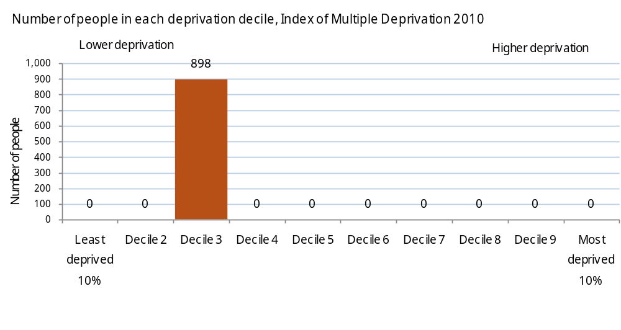
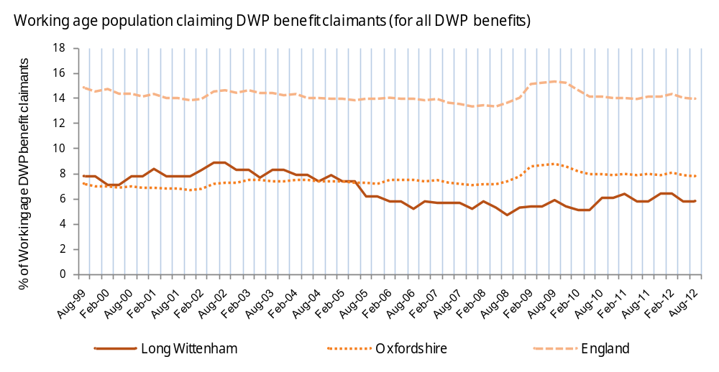
Source: IMD 2010 (CLG), Working age Benefits (DWP Aug-12), Multiple deprivation (Census 2011)

Equity and prosperity: People living on a low income (1)

People living on a low income are among the most deprived groups in society. This can mean that they have severe difficulty in paying for even basic household expenses such as food and heating, or taking up employment or training opportunities due to costs such as travel and childcare. Although many of those living on very low incomes are out-of-work, an increasing number of people below the poverty line (60% of the national average wage) are in low-paid work.  What information is shown here?  Housing Benefit (HB) can be claimed by a person if they are liable to pay rent and if they are on a low income. Council Tax Benefit (CTB) is designed to help people on low-income to pay their Council Tax. These indicators provide a measure of the number of households living in low income. Income Support is a measure of people of working age with low incomes and is a means tested benefit payable to people aged over 16 working less than 16 hours a week and having less money coming in than the law says they need to live on. Pension credit is a measure of people over 65 living in low income households.  Data on people living in ‘income deprivation’ comes from the Index of Multiple Deprivation 2010, and is based on people receiving low income benefits as well as those with household living in poverty. Households are defined as in ‘poverty’ if their equivalised income (after size of household is taken into account) is below 60% of the median income (after housing costs). In 2007/08 a household’s net equivalised income would need to be below £199 for it to be classified as in poverty. Fuel poverty is said to occur when in order to heat its home to an adequate standard of warmth a household needs to spend more than 10% of its income on total fuel use.  The chart on the right shows the average weekly household income estimate (equivalised to take into account variations in household size) across Long Wittenham and comparator areas (before and after housing costs). The two line charts on the following page show change over time of income support and pension credit claimants.
  Housing and Council Tax Benefit claimants |  | Income Support claimants |  | Pension Credit claimants
  32 |  | 03 |  | 26
  9.9% of households (England average = 20.6%) |  | 0.5% of working age adults (England average = 3.2%) |  | 19.1% of people aged 65+ (England average = 24.4%)
  People living in ‘income deprivation’ (Economic Deprivation Index) |  | Households below 60% of the median income, after housing costs (as a % of all households) |  | Households estimated to be in 'Fuel Poverty'
  13 |  | 17.9% |  | 35
  1.9% of all people (England average = 13.5%) |  | England Average = 21.5% |  | 10.9% of households (England = 10.9%)
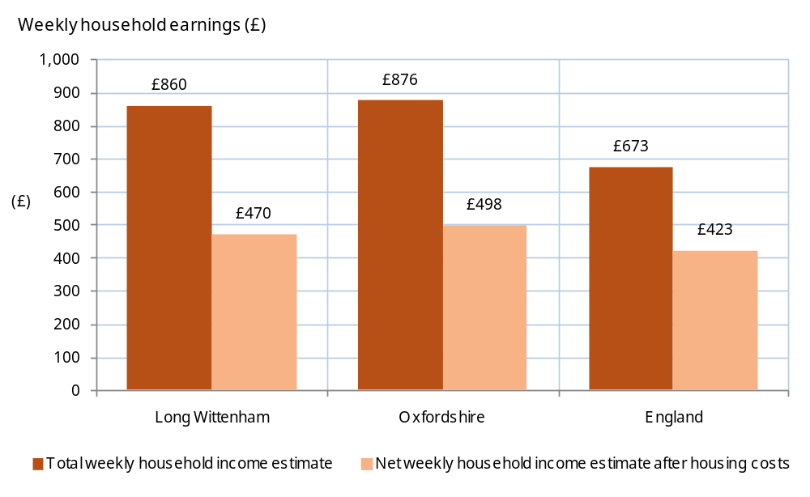
Source: Income Support/Pension Credit (DWP Aug-12), Economic Deprivation Index 2009, Fuel Poverty (Department for Energy and Climate Change 2009), Housing/Council Tax Benefit (DWP 2005), Households below median income (ONS 2008)

Equity and prosperity: People living on a low income (2)

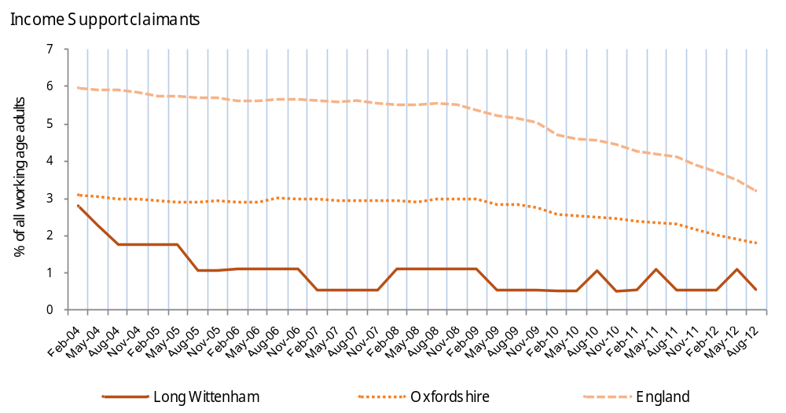
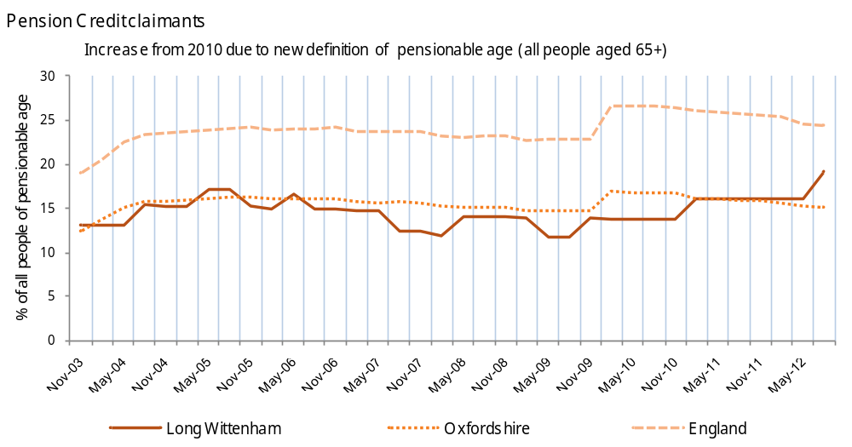
Source: DWP Aug-12

Equity and prosperity: Children (1)

Nationally, children and older people are more likely to be living in low income and these groups generally are indicators of vulnerability within an area. Reducing child poverty is therefore a major element of building sustainable communities.  What information is shown here?  This page looks at the Child Wellbeing index (CWI), children in out of work households, children in poverty and children in lone parent households. The CWI is a small area index measuring child wellbeing – how children are doing in a number of different aspects of their life.  Children in ‘out of work’ households, are defined as dependent children living in families where all adults are in receipt of Income Support or income-based Jobseeker/s Allowance (IS/JSA). The children in poverty measure shows the proportion of children (aged 0-15) in families in receipt of out of work benefits, or in receipt of tax credits where their reported income is less than 60% median income. Out of work means-tested benefits include: Income-Based Jobseekers Allowance, incapacity benefits and Income Support.  The information boxes on the right show the count of people in each of these categories in Long Wittenham. The chart on the right shows the number of people living in neighbourhoods grouped according to level of child wellbeing deprivation. The charts on the following page show the year on year change in the proportion of children in out of work and lone parent households, as well as information on pupil attainment in the local area.
  Number of people living in the most deprived 20% of areas in England on the Child Wellbeing Index |  | Children in 'out of work' households (2011) |  | Children in lone parent households (2010) |  | Children in poverty (2010)
  0 |  | 06 |  | 19 |  | 06
   |  | 3.2% of children aged 0-15 (England average = 19.2%) |  | 10.3% of children aged 0-15 (England average = 27.9%) |  | 4.3% of children aged 0-15 (England average = 21.0%)
 | 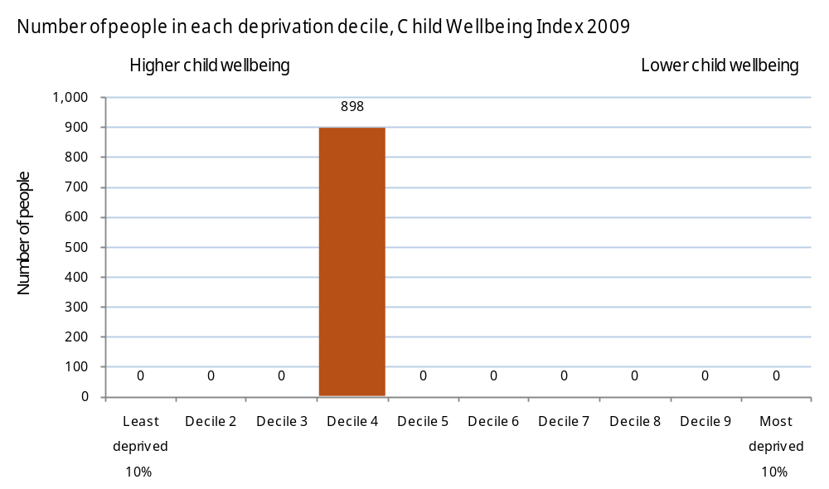
 | Source: Children in out of work households (HMRC 2011), Children in Poverty/Lone parent households (HMRC 2010), Child Wellbeing Index 2010

Equity and prosperity: Children (2)

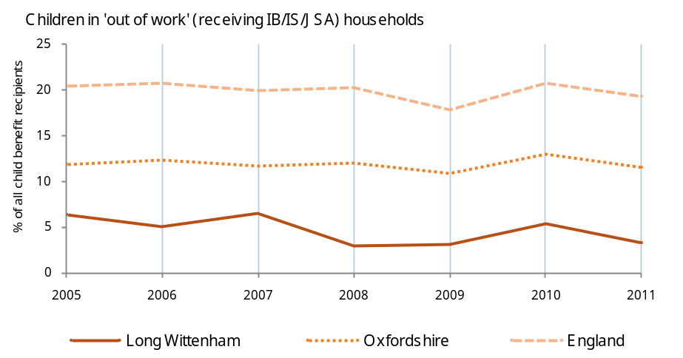 | 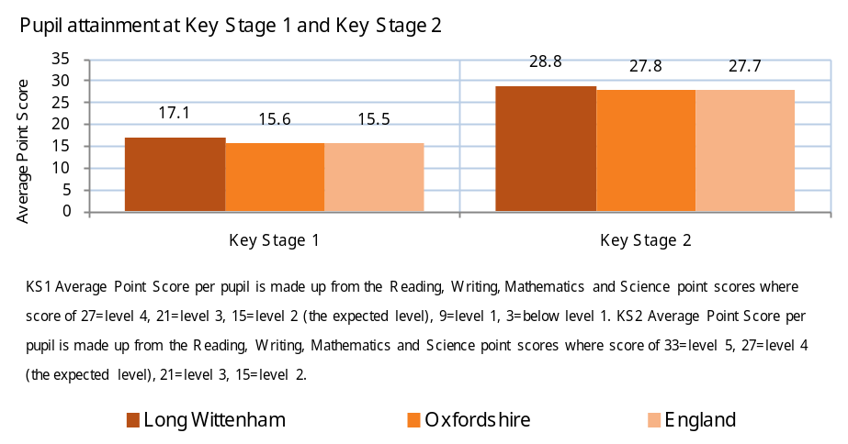
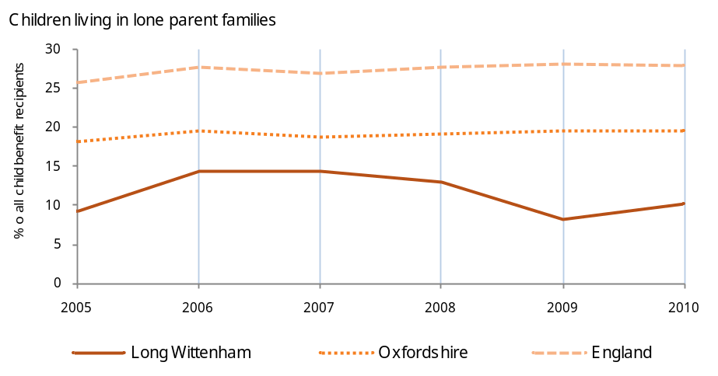 | 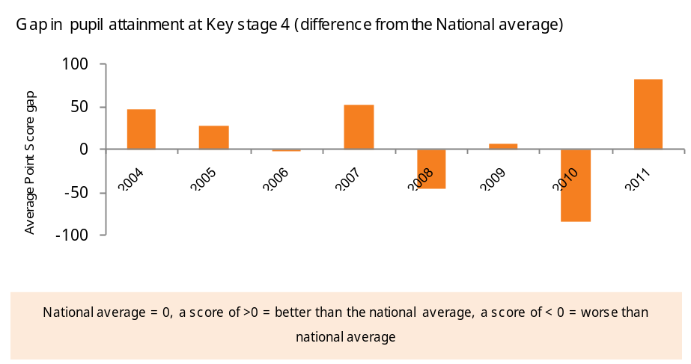
Source: Children in out of work households (HMRC 2011), Children lone parent households (HMRC 2010), Pupil attainment at Key Stage 2 and 4 (Department for Education 2010/11)

Equity and prosperity: Poor health and disability

Health is a fundamental factor in wellbeing and quality of life, having a direct impact on an individual’s ability to live a fulfilling and enjoyable life and also indirectly impacting on their ability to sustain standards of living through income.  Poor health may also have a severe effect on other people, either directly through changing relationships (for example forcing family members into informal unpaid care), or through indirect effects such as change in household income.  What information is shown here?  The data in the first information box shows whether any local areas are highly deprived based on the Index of Multiple Deprivation (IMD) health domain 2010, and if so identifies how many people are living in such areas.  The other information boxes show the number (and proportion) of people who identified themselves as having a limiting long-term health issue, as well as those receiving government benefits for reasons of poor health (Attendance Allowance or Disability Living Allowance).  The chart on the right shows the number of people in Long Wittenham living in each health deprivation decile on the IMD health domain. The charts on the following page show the time trends for Attendance Allowance and Disability Living Allowance claimants, as well as the proportion of people with limited long term illness in the local area with local and national comparators.  Where next?  For information on access to transport, travel times and distances to health services (hospitals and GPs) see the sections on Transport (page 34) and Services (page 38).
  Number of people living in health deprivation 'hotspots' |  | People with a limiting long-term illness (aged 16-64) |  | Attendance Allowance claimants (aged 65+) |  | Disability Living Allowance claimants
  0 |  | 55 |  | 30 |  | 30
  - |  | 10.2% of people aged 16-64 (England= 12.8%) |  | 23.5% of people aged 65+ (England average = 16.7%) |  | 3.3% of the population (England average = 5.1%)
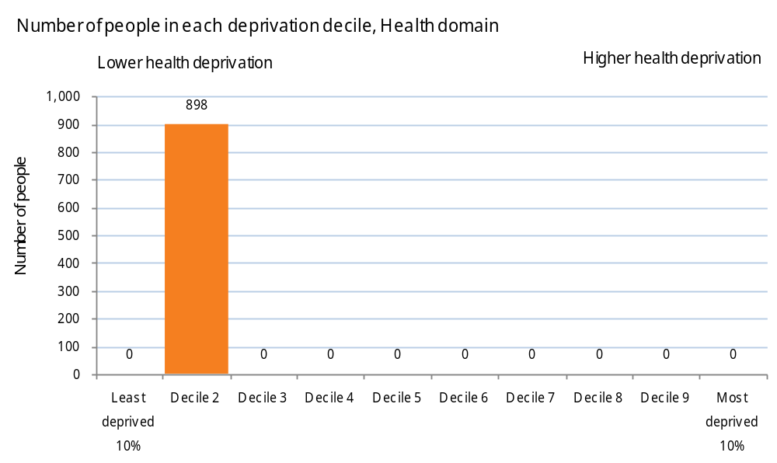
Source: Indices of Deprivation 2010 Health domain, Limiting long-term illness (Census 2011), Attendance Allowance/Disability Living Allowance (DWP Aug-12)

Equity and prosperity: Poor health and disability

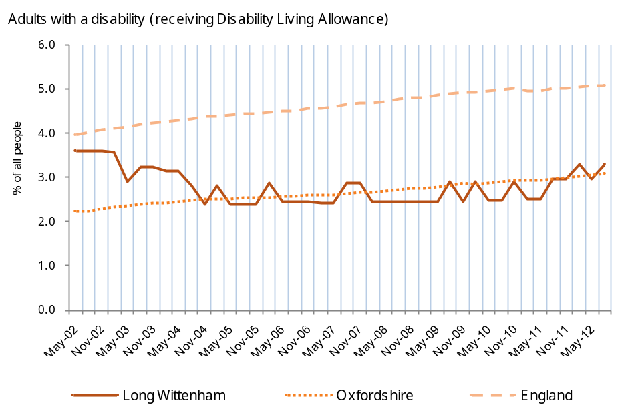 | 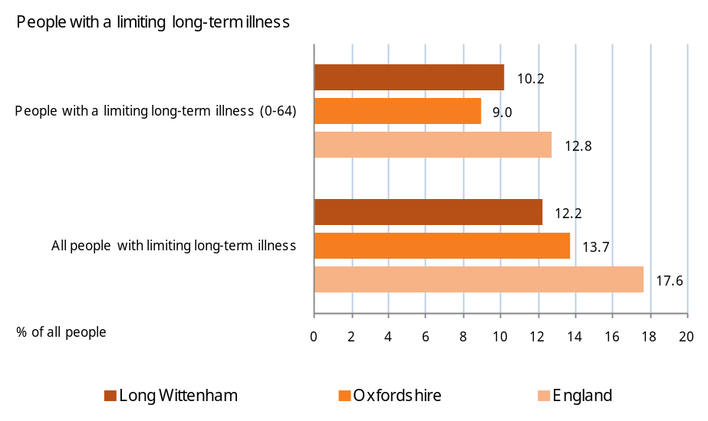
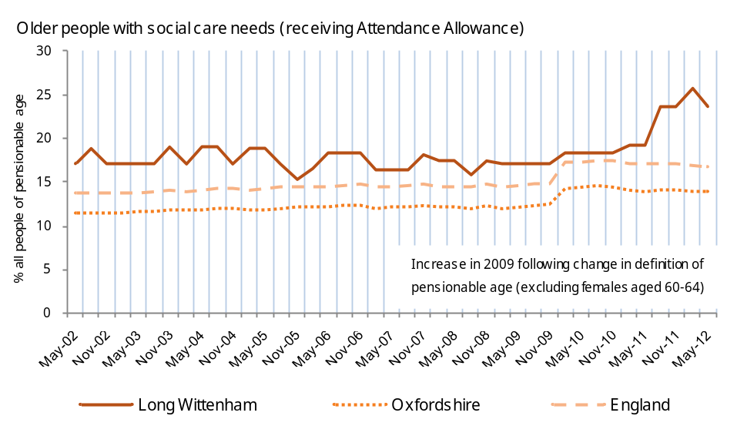 | Source: Limiting long-term illness (Census 2011), Attendance Allowance/Disability Living Allowance (DWP Aug-12)

Economy: Introduction

What does a sustainable community look like?  Thriving, with a flourishing and diverse local economy  What do sustainable communities offer?  - A wide range of jobs and training opportunities;  - Sufficient suitable land and buildings to support economic prosperity and change;  - Dynamic job and business creation, with benefits for the local community;  - A strong business community with links into the wider economy;  - Economically viable and attractive town centres.  Using this report to explore data on the Economy for Long Wittenham | What other information might be available?  - Up-to-date information on employment and jobs for local rural areas is scarce. The Annual Population Survey (APS) provides data for local authorities, but not for smaller areas.  - The Annual Population Survey also contains estimated data on the levels of job-related training and work based learning in the area. Because of the sample size of the survey, figures are only available at Local Authority level, see www.data4nr.net/resources/226.  - Some communities have carried out local surveys identifying which skills and courses are most wanted by local residents, and whether there were enough appropriate spaces to carry out training.  - The national BRES survey provides more detailed local area data on employee jobs by industry of employment and by public/ private sector. To get this data at local area level, you need to request access from the Office of National Statistics (there is a charge, currently £125). Data is available at Local Authority Level and modelled down to Super Output Area, www.nomisweb.co.uk/query/select/getdatasetbytheme.asp?theme=27.  - There is also published information on local businesses by sector (www.data4nr.net/resources/527), and some areas have also carried out surveys to find out more about what local businesses see as priority issues.  - The Employers Skills Survey provides information relating to skills gaps reported by employers http://www.ukces.org.uk/ourwork/local-data
  Sub heading | Indicators
  People in employment | Economic activity, Hours worked, Industry of Employment
  People out of work | Jobseekers Allowance claimants, Employment Support Allowance/Incapacity Benefits/Out of work benefits, Available jobs
  What are skills levels like? | Qualifications
  What jobs do residents have? | Industry of Employment , Occupation Group

Economy: People in employment

Employment levels are usually higher in rural than urban areas, with a gradual shift in many areas towards commuting (see the later section on Transport for information on how far people travel to work from the local area). However, there are also large numbers of economically inactive, part-time employees and people working from home, many of whom may be in the local area during the day and so needing services and facilities.  What information is shown here?  The data shown opposite shows the number of the ‘economically active’ (i.e. those either working or unemployed, see the following page), and ‘economically inactive’ (including students, home-makers, and retired) groups resident in the local area. Also shown are numbers and proportions of those working, including full or part-time status, self-employed, working from home, and those working in the public sector.  The chart on the left shows people in employment by employment status in the local area with national comparator. The chart on the right shows whether residents are working primarily in public or private sector jobs, for your area compared to England.  Where next?  Data on unemployment, skill levels and jobs are on the following pages, and data on how far people travel to work is shown in the section on Transport (page 34).
  Economically active residents |  | Economically inactive residents |  | Full-time employees |  | Part-time employees
  490 |  | 155 |  | 285 |  | 95
  76.0% of people aged 16-74 (England average = 69.9%) |  | 24.0% of people aged 16-74 (England average = 30.1%) |  | 44.2% of people aged 16-74 (England average = 38.6%) |  | 14.7% of people aged 16-74 (England average = 13.7%)
  Self-employed |  | Working 49+ hours per week |  | Working from home |  | Employed in the public sector
  83 |  | 76 |  | 50 |  | 130
  12.9% of people aged 16-74 (England average = 9.8%) |  | 16.0% of people in employment (England average = 13.3%) |  | 7.9% of people aged 16-74 (England = 3.5%) |  | 27.8% of 470 people in employment (England = 28.2%)
 | 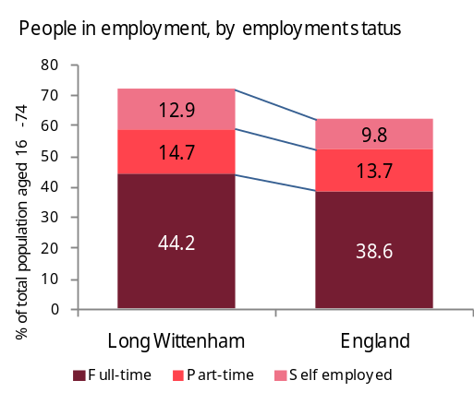 | 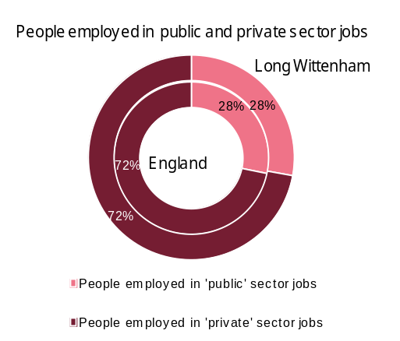
This data is based on standard definitions: ‘Public sector jobs’ are defined as jobs in Health, Education or Public Administration industry sectors. ‘Private sector jobs’ are those in other sectors. Voluntary sector jobs are not identified separately but are included within the public and private sector figures.
Source: Census 2011 (tables KS601EW, KS604EW and KS605EW)

Economy: People out of work (1)

Many rural communities have been affected by the recent economic downturns, with unemployment levels rising even in areas that have had few people out of work in the past. Being out of work can have a severe impact on an individual’s quality of life, and not just economically. People out of work may also feel excluded from the local community, and the impacts can also affect partners and children, not just the person out of work.  Knowing the number of people out of work – and how this is changing – may help you identify relevant actions for your community plan. For example, areas have used this to think about whether suitable training is available, or support for people to start their own businesses, or whether broadband access is good enough for job-hunting, and so on.  What information is shown here?  The best available local data on people out of work is generally claimant data from Jobseekers Allowance (those who are unemployed) and Employment Support Allowance (those who are unable to work due to sickness).  The information boxes show the number and proportion of people receiving out-of-work benefits locally, as well as the unemployment to available jobs ratio. The line chart on the right shows the trend in unemployment claimant rates (Jobseekers Allowance) over time compared with the national average. As seen nationally, most areas saw significant increases following the start of the downturn in September 2008.  The line charts on the following page show the proportion of the working age population claiming incapacity benefits and the ratio of unemployment to available jobs over time. The bar chart shows the total number of vacancies notified to job centre plus in the local area from January 2011 to November 2012.  Where next?  For data on deprivation and vulnerable groups in the local area see the section on Equity & prosperity (page 13)
  Jobseekers Allowance claimants (Feb-13) |  | Jobseekers Allowance claimants claiming for more than 12 months (Feb-13) |  | Employment Support Allowance / Incapacity Benefit claimants (Aug-12)
  06 |  | 00 |  | 16
  1.1% of working age adults (England average = 3.8%) |  | 0.0% of working age adults (England average = 1.0%) |  | 2.9% of working age adults (England average = 6.1%)
  Unemployment to 'Available Jobs' Ratio (Nov-12) |  | All people receiving 'out of work' benefits (Aug-12)
  0.00 claimants per job |  | 26
  England average = 343.44 |  | 4.7% of working age adults (England average = 9.8%)
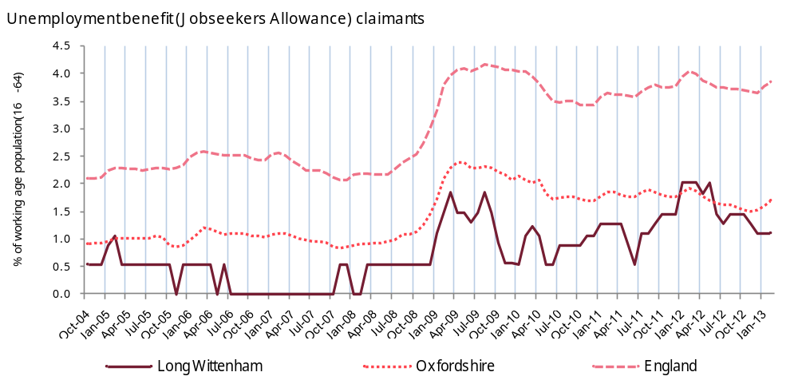
Source: Jobseekers Allowance claimants (DWP Feb 2013), Employment Support Allowance/Incapacity Benefits/Out of work benefits (DWP Aug 2012), Available jobs (Job Centre Plus Nov 2012)

Economy: People out of work (2)

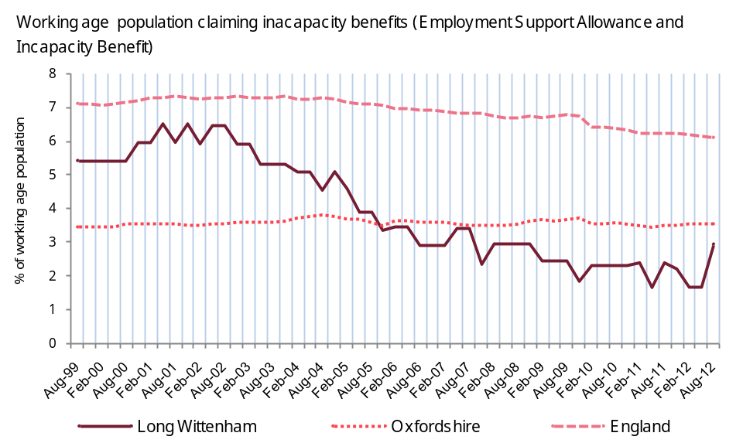 | 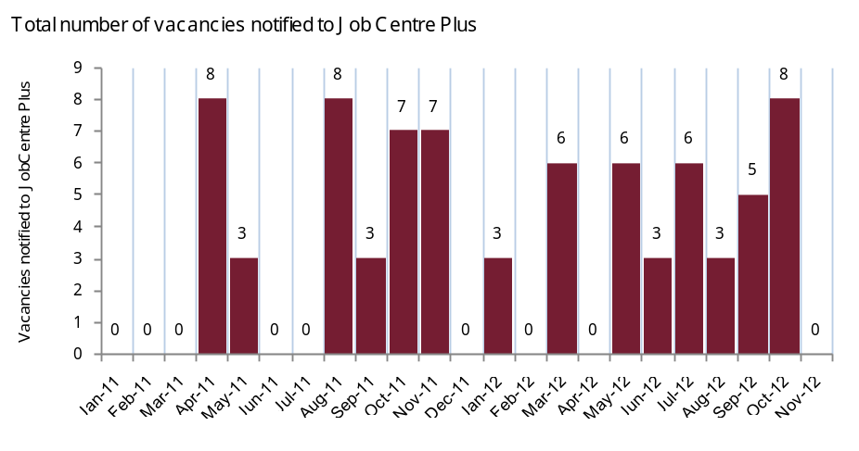
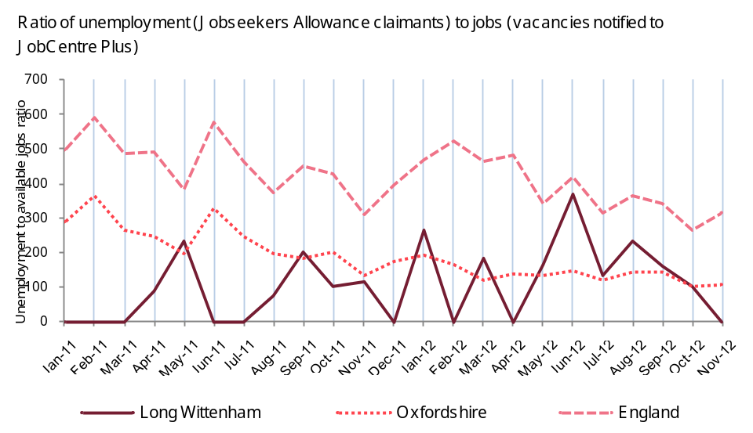 | Source: Employment Support Allowance/Incapacity Benefits (DWP Aug 2012), Unemployment and Available jobs (DWP/Job Centre Plus Nov 2012)

Economy: What are skills levels like?

Skill levels in the local population can be an important driver of community sustainability. In general, those with low or no skills are more likely to experience exclusion, and be vulnerable to changes in the economy, such as increased demand for higher-skilled workers. By contrast, those with high-level skills are more likely to be in secure better-paid jobs, and are more likely to run or start their own businesses. Employers are also more likely to locate in areas with a good supply of skilled workers.  Knowing whether there are ‘skills gaps’ has helped communities think about whether there are enough learning and training opportunities locally; for example, many communities run IT and other courses.  What information is shown here?  There is little published data on local ‘skills’, but one commonly-used proxy is ‘qualifications’ (although of course many people with low or no qualifications may be highly-skilled).  The information boxes on the right show the number and proportion of people locally by their level of qualification, and compared to local authority and national averages.  The bar chart on the right shows how your local area compares to the local authority and England averages for the number of people with no qualifications, as well as degree level (and higher) qualifications.
  People with no qualifications |  | People with highest qualification: Level 1 |  | People with highest qualification: Level 2 |  | People with highest qualification: Level 3
  105 |  | 85 |  | 95 |  | 80
  15.3% of people aged 16+ (England= 22.5%) |  | 12.1% of people aged 16+ (England= 13.3%) |  | 13.6% of people aged 16+ (England= 15.2%) |  | 12.0% of people aged 16+ (England= 12.4%)
  People with highest qualification: Level 4 (degree level qualifications) |  |  |  | ‘Level 1’ qualifications are equivalent to a single O-level, GCSE or NVQ. ‘Level 2’ qualifications are equivalent to five O-levels or GCSEs. ‘Level 3’ qualifications are equivalent to two A levels. ‘Level 4’ qualifications are equivalent to degree level or higher.  Source: Census 2011 (table KS501EW)
  270
  39.4% of people aged 16+ (England= 27.4%)
 | 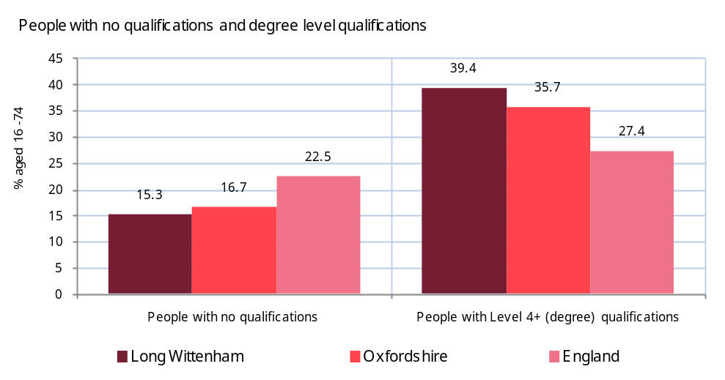

Economy: What jobs do residents have?

The jobs that residents have reflect the opportunities in the local area, and within commuting distance. Although some areas have a proportion of jobs in agriculture, overall the sector makes up only 3% of employment in rural areas, the property and wholesale and retail trade is the largest employer in rural (and urban) areas nationally.  Some communities have identified that developing economic diversity is a local priority, for example helping identify possible business sites, or supporting appropriate planning applications for commercial premises.  What information is shown here?  The information boxes show the three largest employment sectors for residents in the local area, also the number and percentage of employed people working in each of these sectors. Numbers are also shown by type of occupation (e.g., managers, professional, administrative).  The bar chart on the right compares your local area with the local authority and national averages, for people working in senior and elementary occupations.  Where next?  The number of people in work is in the “People in work” section above, including numbers by part-time / full-time, whether they are self-employed, and whether they work in the public sector.
  Largest employment sector |  | Second largest employment sector |  | Third largest employment sector
  Education |  | Retail |  | Professional
  60 employees (13% of 470 of people in employment) |  | 55 employees (12% of 470 of people in employment) |  | 50 employees (11% of 470 of people in employment)
  Managerial occupations |  | Professional (or associate) occupations |  | Administrative or secretarial occupations |  | Skilled trades occupations |  | Elementary occupations
  75 |  | 175 |  | 50 |  | 50 |  | 35
  15.6% of 470 people in employment (England = 12.0%) |  | 36.5% of 470 people in employment (England = 30.3%) |  | 10.1% of 470 people in employment (England = 11.5%) |  | 11.0% of 470 people in employment (England = 11.4%) |  | 7.4% of 470 people in employment (England = 11.1%)
 | 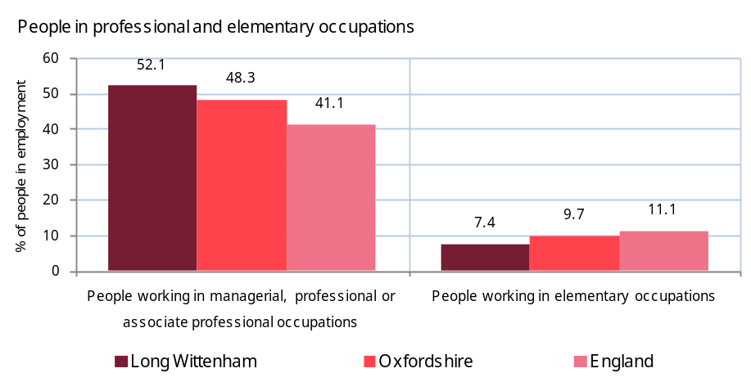
 | Source: Census 2011 tables (KS605EW and KS608EW)

Housing & the built environment: Introduction

What does a sustainable community look like?  Well designed and built, featuring a quality built and natural environment  What do sustainable communities offer?  - A sense of place - a place with a positive 'feeling' for people and local distinctiveness;  - User-friendly public and green spaces with facilities for everyone including children and older people;  - Sufficient range, diversity, affordability and accessibility of housing within a balanced housing market ;  - Appropriate size, scale, density, design and layout, including mixed-use development, that complement the distinctive local character of the community;  - High quality, mixed-use, durable, flexible and adaptable buildings, using materials which minimise negative environmental impacts;  - Buildings and public spaces which promote health and are designed to reduce crime and make people feel safe;  - Accessibility of jobs, and key services by public transport, walking and cycling.  Using this report to explore data on Housing for Long Wittenham | What other information might be available?  - The main source of housing data across the country is the Census. The 2001 census provides breakdowns of type of dwelling by access to central heating (www.data4nr.net/resources/housing--households/750/), tenure (www.data4nr.net/resources/housing--households/745/) and type of household space, i.e. shared dwellings etc. (www.data4nr.net/resources/housing--households/743/). Census 2011 data with these breakdowns is due to be published at the end of 2013. In addition, many local communities have carried out their own surveys to provide up-to-date information on the number and type of houses in the local area, as well as need for affordable housing.  - DCLG publish annual data on social housing stock levels, including Local Authority, Housing Association and Registered Social Landlord housing (https://www.gov.uk/government/statistical-data-sets/live-tables-on-dwelling-stock-including-vacants).  - DCLG also compile a code for sustainable homes measuring the energy efficiency of homes, www.data4nr.net/resources/housing--households/1412/.  - The Land Registry tracks all housing transactions, with this data published by DCLG at local authority level (more detailed data may be available from commercial or estate agent sites), including median (www.data4nr.net/resources/housing--households/986/) and lower quartile (www.data4nr.net/resources/housing--households/987/) house-prices. The CLG produce estimates of rental costs for social rented dwellings www.data4nr.net/resources/housing--households/991/)
  Sub heading | Indicators
  What type of housing is in the local area? | Dwelling type
  Do people rent or own their homes? | Tenure
  How affordable is local housing? | Council Tax Band , House prices, Affordability Ratio
  Housing in poor condition | Source: Overcrowding, Central heating, Vacant household spaces, Fuel Poverty

Housing & the built environment: What type of housing is in the local area?

Housing is an important issue in rural communities. Increases in house-prices, which recently have far outstripped average increases in earnings, mean that local people may be priced out of the housing market in the area in which they grew up. For a community to sustain a fair and balanced housing market, it must provide affordable housing accessible to the local community. However, local housing development can also strain local services, as well as affect the character of the area (although a larger population may be able to sustain more shops, businesses and local amenities).  With levels of overcrowding increasing, record population growth and the limited supply of affordable homes, evidencing the type and availability of housing in the local area will be essential to community planning.  What information is shown here?  The data shows the housing types in the local area. Data is taken from Census 2011 and offers the most up to date account of the types of housing in the local area.  The bar chart on the right shows how your area compares against the local authority and national averages on the type of housing.  Where next?  The following pages show data on housing tenure (owner occupied, social housing, private rented), affordable housing, overcrowded housing and housing in poor condition.
  Detached houses |  | Semi-detached houses |  | Terraced houses
  146 |  | 117 |  | 28
  43.7% of dwellings (England average = 22.3%) |  | 35.0% of dwellings (England average = 30.7%) |  | 8.4% of dwellings (England average = 24.5%)
  Flats (purpose built) |  | Flats (other) |  | Caravan or other temporary accommodation
  11 |  | 06 |  | 26
  3.3% of dwellings (England average = 16.7%) |  | 1.8% of dwellings (England average = 5.4%) |  | 7.8% of dwellings (England average = 0.4%)
 | 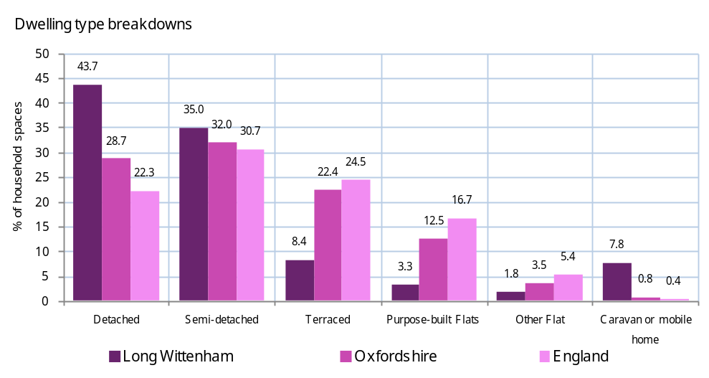
 | Source: Census 2011 (table KS401EW)

Housing & the built environment: Do people rent or own their homes?

The mixture of owner-occupied, social rented and private rented accommodation in the area is an important component in the sustainability of the local community. With high house-prices, it may be difficult for less affluent people (for example younger people or families who have grown up in the area) to stay in, or move to, areas which have low levels of social or private rented housing.  Knowing this information may be useful in demonstrating evidence that there is a need for certain housing in the area, and has been used by communities to prioritise actions, such as supporting sympathetic development proposals that increase the stock of needed housing.  What information is shown here?  The data shows housing tenure in the local area and is taken from the Census 2011, the most up to date source of information on housing tenure in the local area. Although trends in housing tenure have varied across the country since 2001, nationally owner occupied housing has declined (-5%) and private renting has gone up (6%) to 2011. This trend is particularly acute when considering age breakdowns, with “Generation Rent” becoming a common term as young people are increasingly out priced of the housing market.  The bar chart shows how your area compares against the local authority and national averages on levels of owner occupation and renting.  Where next?  See the Social and Cultural section at the beginning of this profile for information on household types, who lives in your local area and migration into and out of the area (page 5). For data on deprivation and vulnerable households, see the section on Equity & prosperity (page 13). Information on the local economy and employment status is on page 22.
  Housing that is owner occupied |  | Housing that is social rented |  | Housing that is private rented |  | Other rented accommodation
  264 |  | 36 |  | 17 |  | 07
  81.5% of households (England average = 64.1%) |  | 11.1% of households (England average = 17.7%) |  | 5.2% of households (England average = 15.4%) |  | 2.2% of households (England average = 2.8%)
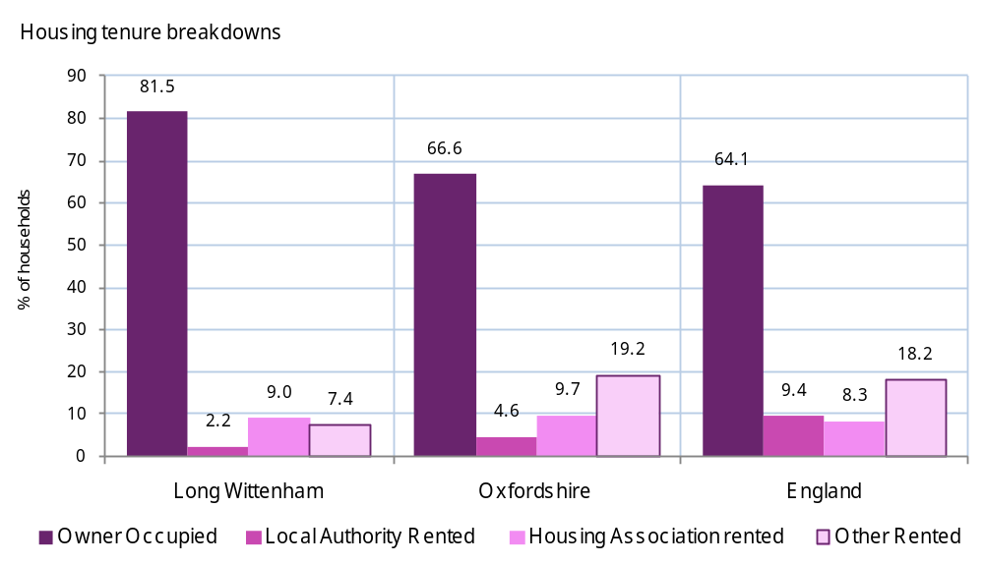
Source: Census 2011 (KS402EW)

Housing & the built environment: How affordable is local housing? (1)

The need for affordable housing is a critical issue in rural areas, with house-prices increasingly beyond the reach of many groups wanting to stay in, or move to, the local area. Whilst many communities recognise the need for additional housing, development needs to be balanced with the impact on the character of the local area, as well as pressure on local services.  The information shown here can help local groups identify, and provide evidence for, the need for affordable housing. Some communities have supported specific housing developments, e.g. where such development might meet current (and future) needs for mixed housing, and offer affordable opportunities for people to stay living locally.  What information is shown here?  The housing affordability ratio is based on comparing house prices to earnings. Rather than compare average house prices and incomes, we have compared the “lowest quartile” (the lowest 25%) of prices to the lowest quartile of household incomes – which is more representative of groups trying to get onto the housing ladder. An affordability index of 10 would mean that lowest quartile house prices are 10 times as high as lowest quartile incomes. This data is only available for the local authority, not the local area.  The data on Council Tax bands shows the number (and proportion) of houses in bands A, B or C (the lowest price bands) locally. These price bands are set nationally, so can be used to show how the cost of all local property (not just those properties that have recently been sold) compares with other areas; the chart on the right compares your area against the local authority and national averages for these Council Tax bands.  The information boxes on the bottom row show the median house price by household type in the local area. The line charts on the following page show the same information as trends over time, with local and national comparators.  Where next?  The Social and Cultural section has data on household composition and migration in and out of the area (page 5). For data on deprivation and vulnerable households, see the section on Equity & prosperity (page 13). Information on employment status is on page 22.
  Affordability ratio (median house prices as ratio of median incomes) |  | Dwellings in Council Tax Band A |  | Dwellings in Council Tax Band B |  | Dwellings in Council Tax Band C
  14.4 |  | 68 |  | 05 |  | 51
  England average = 15.4 |  | 21.1% of dwellings (England average = 24.8%) |  | 1.5% of dwellings (England average = 19.6%) |  | 15.8% of dwellings (England average = 21.8%)
  Median house price: Detached houses |  | Median house price: Semi-detached houses |  | Median house price: Terraced houses |  | Median house price: Flats
  £495,000 |  | £205,000 |  | £153,000 |  | £167,500
  England average = £320,268 |  | England average = £211,043 |  | England average = £174,653 |  | England average = £131,110
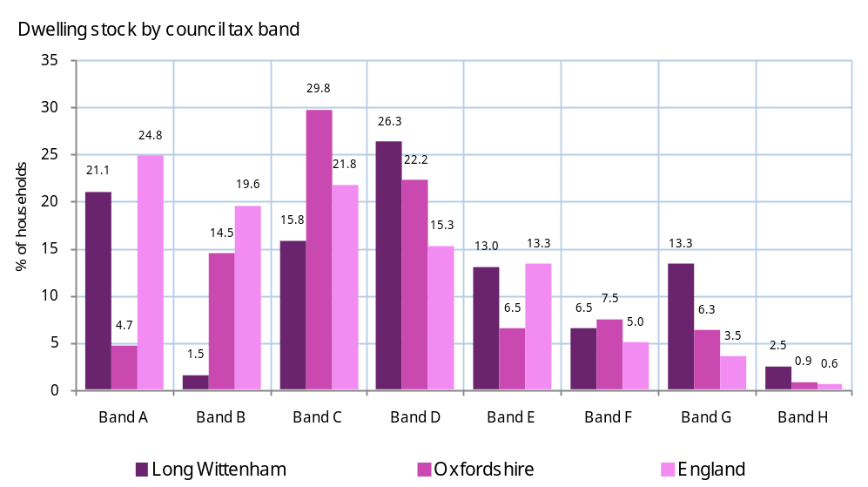
Source: Council Tax Band (Valuation Office Agency 2011), House prices (Land Registry 2009), Affordability Ratio (Land Registry/ONS 2007/08)

Housing & the built environment: How affordable is local housing? (2)

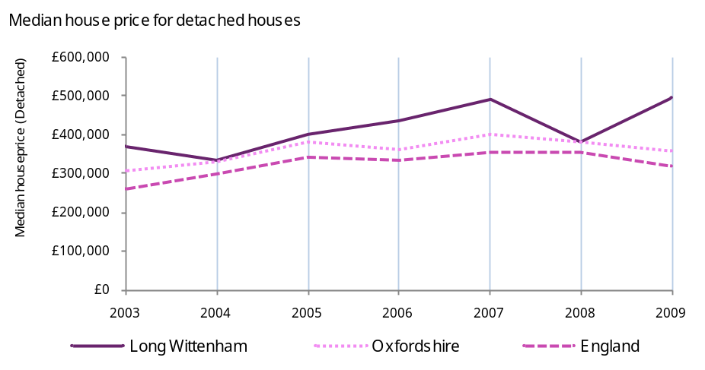 | 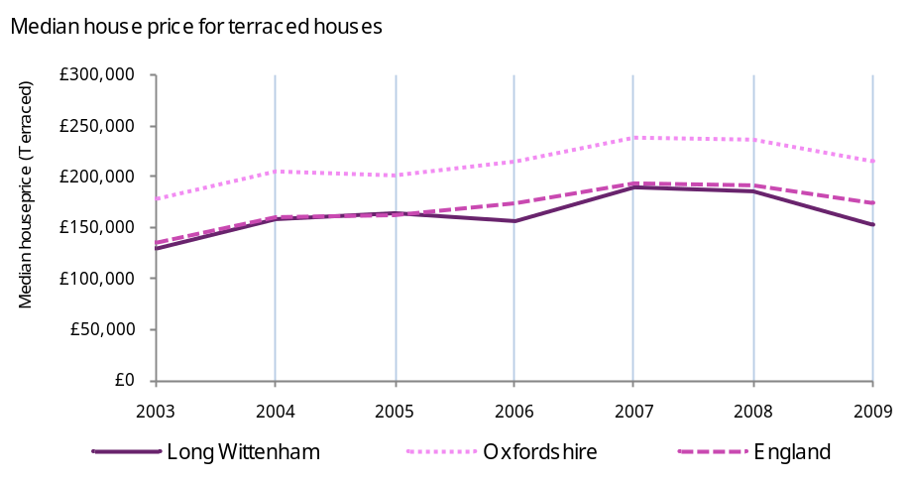
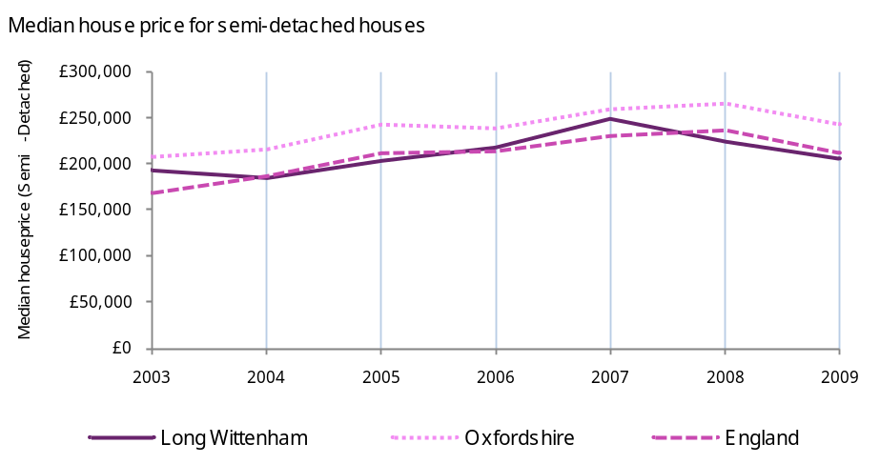 | 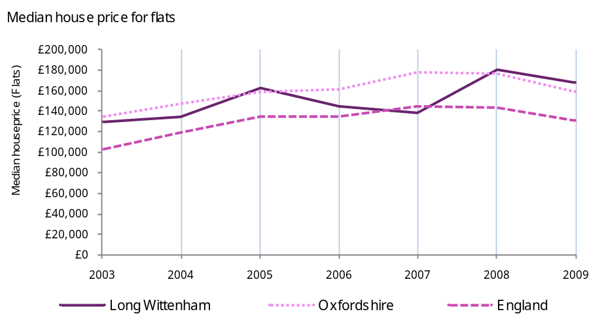
Source: Land Registry (2009)

Housing & the built environment: Housing in poor condition

The highest levels of non-decent homes (that do not pass the Housing Health & Safety rating system) are found in smaller rural communities, particularly those more isolated areas. This is often due to the age of properties, with older housing (more common in rural areas) most likely to be in this condition.  Housing conditions can indicate other issues, for example overcrowded housing can highlight areas with pressing needs for more affordable housing. Where central heating is not present, fuel poverty is significantly more likely.  What information is shown here?  Whether a household is overcrowded is based on a standard definition using the number of inhabitants, and number of rooms. Housing without central heating is self-reported. These indicators and the vacant household spaces data are shown in the information boxes and in the bar char on the right, with local and national comparators.  The definition of fuel poverty is based on the Low Income High Costs (LIHC) framework. Under this definition, a household is said to be in fuel poverty if they have required fuel costs that are above average (the national median level); were they to spend that amount they would be left with a residual income below the official poverty line. It is calculated using the income of households, the cost of fuel required, and the ability of their home to retain heat. In January 2013 the government launched the Energy Company Obligation (ECO) with a focus on reducing levels of fuel poverty and poor housing conditions in rural areas. The rural element of this energy efficiency measure is due to the fact that fuel poverty and poor quality housing tends to be higher in rural areas and therefore a priority for improving the quality of life of residents in rural communities.  Where next?  See the Social and Cultural for information on household composition and who lives in the local area (page 5). For data on deprivation and vulnerable households, see the section on Equity & prosperity (page 13). Data on unemployment is on page 22.
  Households living in overcrowded conditions |  | Households without central heating |  | Vacant household spaces |  | Households estimated to be in 'Fuel Poverty'
  08 |  | 10 |  | 10 |  | 35
  2.5% of households (England average = 8.7%) |  | 3.1% of households (England average = 2.7%) |  | 3.0% of households (England average = 4.3%) |  | 10.9% of households (England = 10.9%)
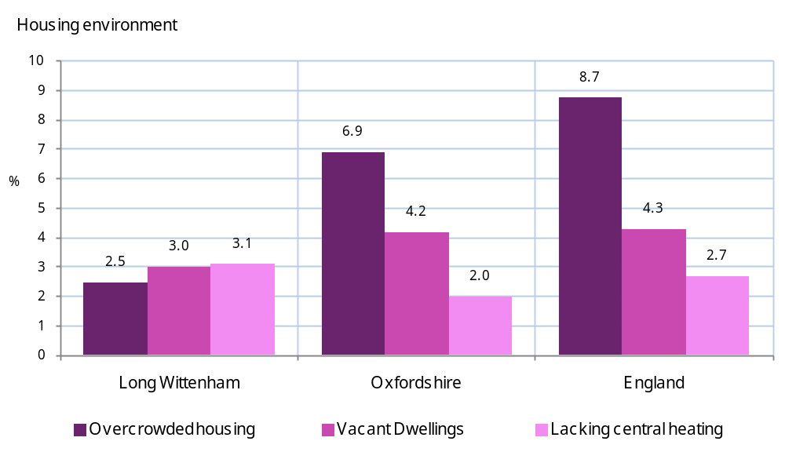
Source: Overcrowding/Central heating/Vacant household spaces (Census 2011 KS403EW), Fuel Poverty (Department for Energy and Climate Change 2011)

Transport and connectivity: Introduction

What does a sustainable community look like?  Well connected, with good transport services and communication linking people to jobs, schools, health and other services  What do sustainable communities offer?  - Transport facilities, including public transport, that help people travel within and between communities and reduce dependence on cars;  - Facilities to encourage safe local walking and cycling;  - An appropriate level of local parking facilities in line with local plans to manage road traffic demand;  - Widely available and effective telecommunications and Internet access;  - Good access to regional, national and international communications networks.  Using this report to explore data on Transport and Connectivity for Long Wittenham | What other information might be available?  - DVLA data on local car registrations has been obtained by some local groups as part of their community planning, which provides data over time for the level of car ownership in the area.  - Census 2011 data provides breakdowns for vulnerable groups with no access to car, including pensioners living alone, unemployed, and those with a limiting long-term illness (www.data4nr.net/resources/24).  - Your local authority may hold more detailed information on local commuting patterns, for example if they have carried out local transport and commuting surveys. In addition, many communities have carried out their own local surveys on how far residents travel to work, and whether they might be interested in employment opportunities nearer to home.  - Many communities have also carried out local surveys to highlight where travel times affect people’s ability to use facilities or amenities.  - If there is a local train station, data may also be available on the numbers using the service, which can be useful to highlight where there is pressure on local amenities such as parking.  - More detail on estimated travel times by foot or public transport to key services is published by DfT in the ‘Core Accessibility’ dataset, at www.data4nr.net/resources/841.
  Sub heading | Indicators
  Access to private transport | Car or van availability
  How far do people travel to work | Working from home, Distance travelled to work, Travel to employment centres
  Travel times by public transport | Core Accessibility indicators

Transport and connectivity: Access to private transport

People in rural areas rely more on private transport and, in general, spend more on transport than their urban counterparts (nationally, higher transport expenditure accounts for almost half the higher expenditure by rural households than urban ones). Overall, the residents of rural hamlets and villages travel nearly twice as far by car each year compared to urban residents.  Combined with information on public transport and distance to services, this information may help you evidence the need for improvements in public and community transport.  What information is shown here?  The data shows the number of households who do not have access to a car, as well as those households with one or more cars. Data is taken from Census 2011.  The bar chart on the right shows how your local area compares with the local authority and England averages.  Where next?  For information on distance to services see the next section (page 38).
  No cars |  | One car |  | Two cars |  | Three cars |  | Four+ cars
  15 |  | 100 |  | 155 |  | 35 |  | 15
  5.2% of 320 households (England = 25.8%) |  | 30.9% of 320 households (England = 42.2%) |  | 47.5% of 320 households (England = 24.7%) |  | 11.4% of 320 households (England = 5.5%) |  | 4.9% of 320 households (England = 1.9%)
 | 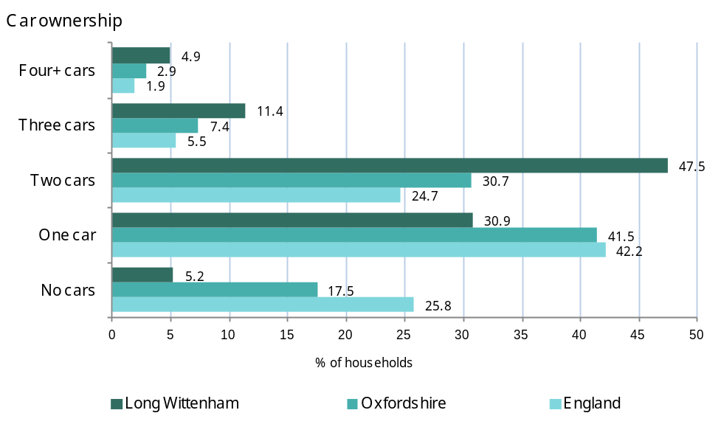
 | Source: Census 2011 (table KS404EW)

Transport and connectivity: How far do people travel to work?

There are typically fewer jobs in rural areas than urban, and those local jobs are often lower-paid than their urban counterparts. Many rural communities act as “commuter villages”, providing a higher quality of life for residents who commute to urban areas for work (although there can also be large numbers of people working from home).  Understanding how far people travel to work may help identify actions based on potential demand for local employment. For example, some communities may identify priorities to support local businesses and develop more opportunities for local employment, which could include actions such as supporting local planning applications for appropriate business premises or small business parks.  What information is shown here?  The data shown on how far people travel to work is taken from Census 2011, based on actual commuter data. The travel time data is from the Department for Transport, based on travel times (by car, cycle and public transport/ foot) to employment centres (which are defined as Super Output Areas with more than 500 jobs).  The bar chart on the right shows how your area compares to the local authority and England averages, in terms of how far people travel to work.  Where next?  For information on distance to services see the next section (page 38).
  People working from home |  | People travelling less than 2km to work (2001) |  | People travelling 40km+ to work (2001)
  50 |  | 60 |  | 45
  7.9% of people aged 16-74 (England = 3.5%) |  | 13.2% of people aged 16-74 (England = 20.0%) |  | 10.0% of people aged 16-74 (England = 10.0%)
  Average travel time to nearest employment centre by car |  | Average travel time to nearest employment centre by cycle |  | Travel time to nearest employment centre by public transport/walking
  5 |  | 9 |  | 13
  County average: 5 mins |  | County average: 7 mins |  | County average: 11 mins
 | 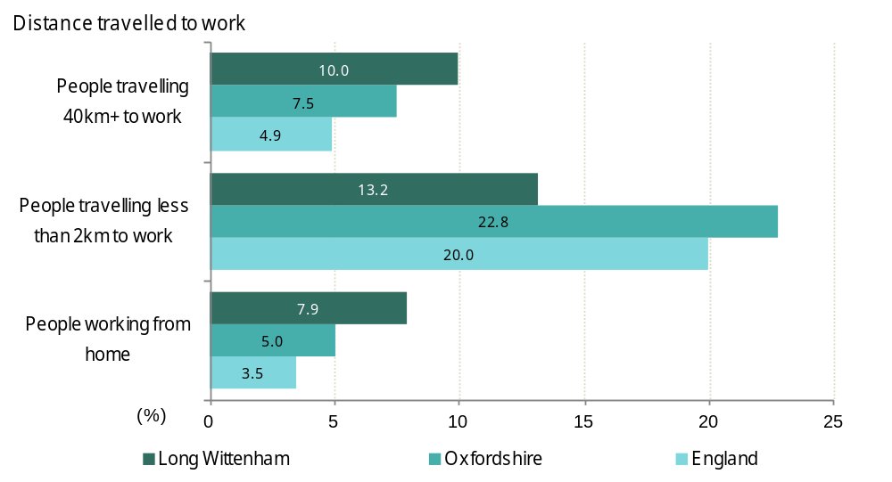
 | Source: Working from home (Census 2011 QS701EW) Distance travelled to work (Census 2001 UV 35), Travel to employment centres (DfT 2011)

Transport and connectivity: Travel times by public transport

Many rural communities highlight a lack of good public transport as a real barrier in accessing public services such as post-16 education, health, sport and leisure services, employment, financial services and training.  Knowing the average travel times by public transport – and the frequency of public transport – can help make the case for improving local public transport provision. For example, helping show that there is a need for additional community transport services or alterations to existing routes, or additional evening / weekend services.  What information is shown here?  The travel time data is from the Department for Transport, based on travel times (by car, cycle and public transport/ foot) to key amenities, and the people travelling to work is taken from Census 2011 commuter data.  The bar chart on the right shows how travel times from the local area to particular services compare to the national average.  Where next?  Data on distance commuted by local residents to work is on the previous page, and distance to key services is in the next section on Services.
  Average travel time to nearest hospital by public transport/walking |  | Average travel time to nearest supermarket by public transport/walking |  | Average travel time to nearest town centre by public transport/walking |  | People travelling to work by public transport
  113 |  | 12 |  | 26 |  | 32
  County average: 58 mins |  | County average: 10 mins |  | County average: 18 mins |  | 5.0% (England = 11.0%)
 | 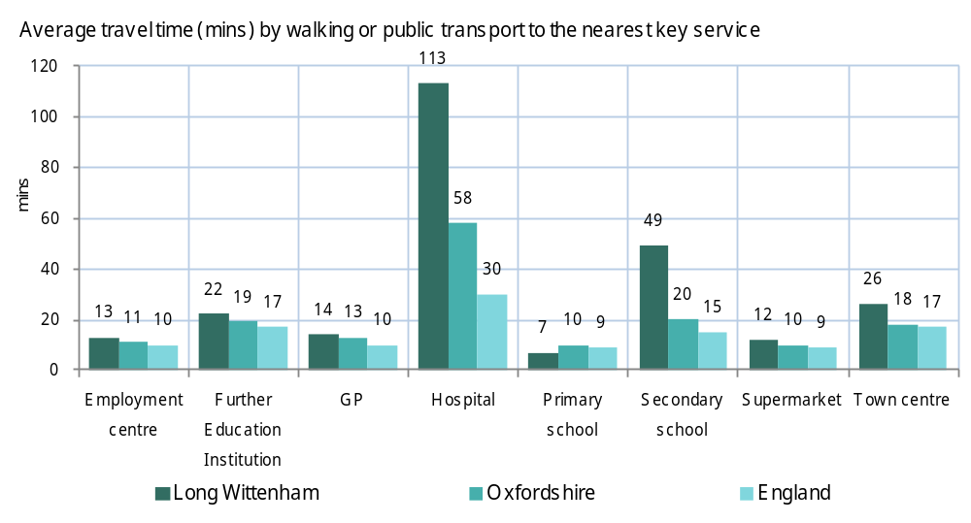
 | Source: DfT 2011

Services: Introduction

What does a sustainable community look like?  Well served, with public, private, community & voluntary services that are appropriate to people’s needs & accessible to all  What do sustainable communities offer?  - Well-performing local schools, further and higher education institutions, and other opportunities for lifelong learning;  - High quality local health care and social services, integrated where possible with other services;  - High quality services for families and children (including early years child care);  - Good range of affordable public, community, voluntary and private services (e.g. retail, fresh food, commercial, utilities, information and advice) which are accessible to the whole community;  - Service providers who think and act long-term and beyond their own immediate geographical and interest boundaries, and who involve users and local residents in shaping their policy and practice.  Using this report to explore data on local services in Long Wittenham | What other information might be available?  - Many communities have carried out local surveys to highlight where people have difficulty using key services.  - More detailed information on rural Services data: Service locations are used to calculate numbers of households within distance of key service indicators, www.data4nr.net/resources/820.  - The Indices of Deprivation contains indicators measuring road distances to key services: primary school http://www.data4nr.net/resources/1487/; food shop http://www.data4nr.net/resources/1485/; GP http://www.data4nr.net/resources/1486/; Post Office http://www.data4nr.net/resources/1484/.
  Sub heading | Indicators
  How far away are key services? | Road distance to key services

Services: How far away are key services?

Access to services is a major factor in quality of life for people in rural communities, where services and amenities may be some distance away. This is especially likely to cause difficulties for people without cars or who are unable to drive, whose mobility is limited, and in areas where public transportation is poor.  Many rural communities have identified a lack of facilities and amenities as a priority locally. These facilities might include shops, post offices, pubs, leisure facilities, and meeting places for young people.  What information is shown here?  The data shown is taken from Commission for Rural Communities data on rural services, and shows average road distances from houses in the local area to a set of key services.  The bar chart on the right shows how the local area compares to the local authority and England averages in terms of road distances to these services.  Where next?  Data on distance commuted by local residents to work, and travel times to key services, are in the previous section on Transport & connectivity (page 34).
  Road distance from a Job Centre (2010) |  | Road distance from a Secondary School (2010) |  | Road distance from a GP (2010)
  5.9km |  | 6.2km |  | 2.6km
  England average = 4.6km |  | England average = 2.1km |  | England average = 1.2km
  Road distance from a Public House (2010) |  | Road distance from a Post Office (2010)
  0.2km |  | 2.3km
  England average = 0.7km |  | England average = 1.0km
 | 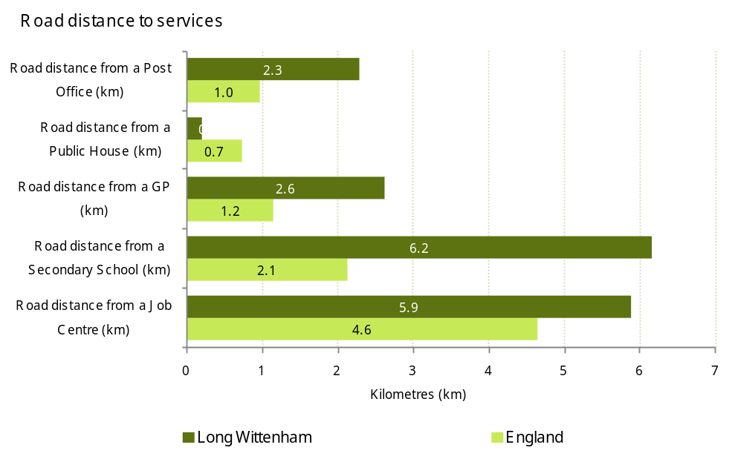
 | Source: Commission for Rural Communities 2010

Environmental: Introduction

What does a sustainable community look like?  Environmentally sensitive, providing places for people to live that are considerate of the environment  What do sustainable communities offer?  - Actively seek to minimise climate change, including through energy efficiency and the use of renewables;  - Protect the environment, by minimising pollution on land, in water and in the air;  - Minimise waste and dispose of it in accordance with current good practice;  - Make efficient use of natural resources, encouraging sustainable production and consumption;  - Protect and improve bio-diversity (e.g. wildlife habitats);  - Enable a lifestyle that minimises negative environmental impact and enhances positive impacts (e.g. by creating opportunities for walking and cycling, and reducing noise pollution and dependence on cars);  - Create cleaner, safer and greener neighbourhoods (e.g. by reducing litter and graffiti, and maintaining pleasant public spaces).  Using this report to explore Environmental data for Long Wittenham | What other information might be available?  - At local authority level there is data on the quality of green-space, parks, beaches and so on. More detailed small area data is available from DEFRA on indicators relating to air emissions and background concentrations of pollutants, e.g. nitrogen oxide at www.data4nr.net/resources/environment/503/.  - There is a lack of ‘hard’ data on climate change and other issues that might be identified as local priorities (although Local Authorities have been graded on their actions to mitigate climate change – www.data4nr.net/resources/environment/1246/).  - Many local areas have also carried out their own surveys to identify priorities for improving the local environment.
  Sub heading | Indicators
  Quality of the local environment | Waste statistics, Population, Living Environment domain, C02 emissions

Environmental: Quality of the local environment

The local environment can play a major role in quality of life in rural communities, and conserving and improving the quality of the environment is a priority in many community plans. Concerns often relate to local issues such as physical environment, including fly tipping, graffiti etc, environmental sustainability, including recycling, renewable energy use, and the built environment, including the character of housing developments. Wider issues can also be raised, such as actions to tackle climate change.  What information is shown here?  There is a lack of good environmental data available for local communities; data collected at local authority level includes data shown for CO₂ emissions and recycling.  Population density is based on the local population size and geographical area. Figure 22 shows how the population density compares to the local authority and England.  Data is also shown for the level of “outdoors environment deprivation” as measured in the Index of Multiple Deprivation (IMD) 2010. This is based on levels of air pollution, and road traffic accidents involving injury to pedestrians and/or cyclists. The data shows whether local areas are identified as having poor outdoors environment, based on the environment domain of the IMD 2010.  Where next?  See the Social and Cultural section at the beginning of this profile for information on population growth, migration and types of people living in the local community (page 5). Information on private and public transport is on page 34 and data on fuel poverty and quality of local housing can be found from page 28.
  CO₂ emissions (ktonnes - kt) per head |  | Household waste that is recycled or composted |  | Residual household waste per head
  8.0Kt |  | 43% |  | 509Kg
  Data shown is for South Oxfordshire (England = 6.7Kt) |  | Data shown is for South Oxfordshire (England = 35%) |  | Data shown is for South Oxfordshire (England = 618Kg)
  Population density (people per hectare) |  | Number of people living in Living Environment deprivation ‘hotspots’
  7.42 |  | 00
  England average = 4.1 persons per hectare. |  | No local areas are in the most deprived 20% in England on the ID 2010 Outdoors Living Environment domain
 | 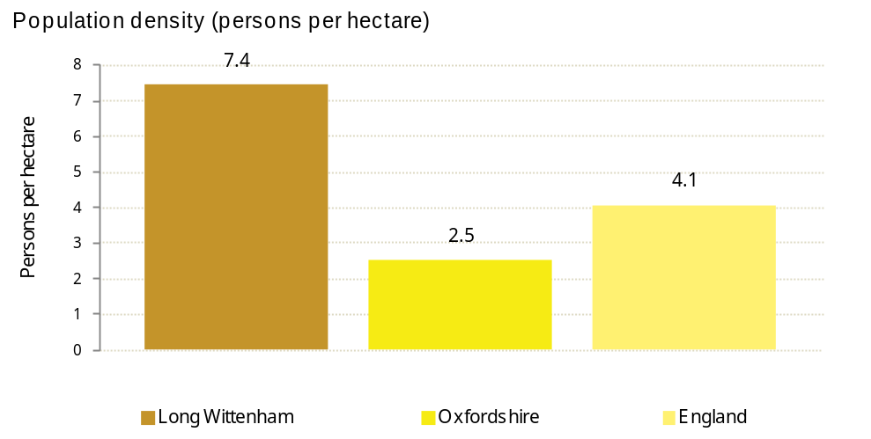
 | Source: Waste statistics (DEFRA WasteDataFlow system, 2009), Population Density (Census 2011), Living Environment domain (Indices of Deprivation 2010, CLG) C02 emissions DEFRA 2008)

Governance: Introduction

What does a sustainable community look like?  Well run, with effective and inclusive participation, representation and leadership  What do sustainable communities offer?  - Representative, accountable governance systems which both facilitate strategic, visionary leadership and enable inclusive, active and effective participation by individuals and organisations;  - Effective engagement with the community at neighbourhood level, including capacity building to develop the community's skills, knowledge and confidence;  - Strong, informed and effective partnerships that lead by example (e.g. government, business, community);  - A strong, inclusive, community and voluntary sector;  - A sense of civic values, responsibility and pride.  Using this report to explore data on Governance for Long Wittenham | What other information might be available?  - Place Survey data may be available from your local authority, and provide more detailed measures of civic participation. Data from the electoral commission can also provide more information relating to voter participation in local, national and European elections (www.electoralcommission.org.uk/home).
  Sub heading | Indicators
  How engaged are people locally? | Place Survey governance questions, Active Charities

Governance: How engaged are people locally?

A recent report by the Office for National Statistics found that over 50s are more likely to feel they belong to their communities than younger people and subsequently feel happier. Community engagement across all groups within an area is therefore an important aspect of resident wellbeing, often even more so in rural areas due to the remote nature of many communities.  Some areas have found that the process of developing a community plan can help increase the engagement with people living and working locally; and other actions to improve engagement with particular local groups might also be seen as priorities for local community plans.  What information is shown here?  The data shown is from the national ‘Place Survey’, collected by all local authorities in 2008. Data is only published for the local authority area; however more detailed information may be available from local surveys.  The chart on the right shows how your local authority compares with the national picture. Across England, nearly 30% of people asked felt they could influence local decisions, but less than half that number had actually participated in a group making such decisions in the past year.  Where next?  Information on the strength of the local neighbourhood and community safety can be found in the Social and Cultural section (page 5).
  Adults who have participated in a group which makes decisions that affect their local area in the past year |  | People who feel they can influence decisions in their locality |  | Active charities
  15% |  | 33% |  | 5.1 per 1,000 population
  Data shown is for South Oxfordshire (England = 14%) |  | Data shown is for South Oxfordshire (England = 29%) |  | Data shown is for South Oxfordshire (England = 2.6 per 1,000)
 | 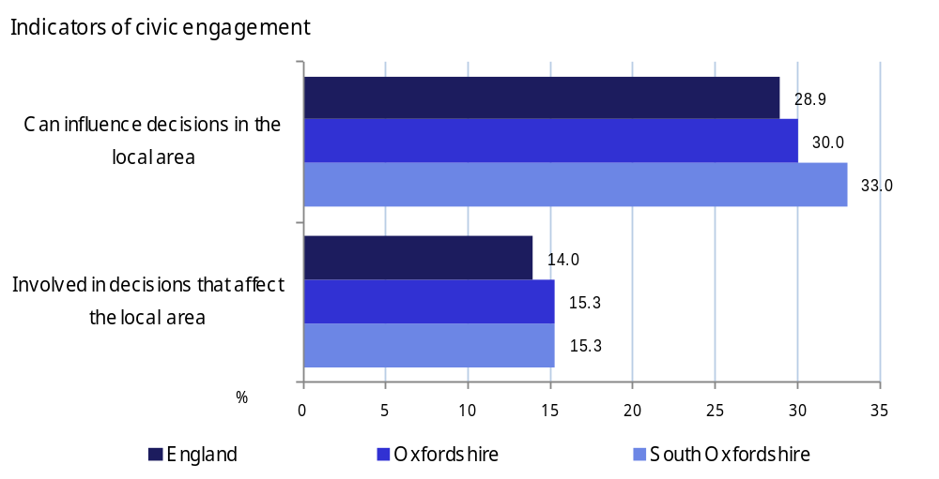
 | Source: Place Survey 2008, Active Charities (NCVO 2009)

Data tables for Long Wittenham

Indicator | Long Wittenham |  | South Oxfordshire |  | England
 | N | Rate |  | Rate | Rate
All People (2011) | 875
Males (2011) | 430 | 49.1 |  | 49.2 | 49.2
Females (2011) | 445 | 50.9 |  | 50.8 | 50.8
Aged 0-15 (2011) | 190 | 21.9 |  | 19.2 | 18.9
Working age (2011) | 550 | 62.6 |  | 62.6 | 64.7
Aged 65+ (2011) | 135 | 15.5 |  | 18.2 | 16.3
Dependency Ratio (2011) |  | 0.6 |  | 0.6 | 0.6
Female, aged 0-4 (2011) | 20 | 4.5 |  | 6.0 | 6.0
Female, aged 5-9 (2011) | 30 | 6.7 |  | 5.9 | 5.4
Female, aged 10-14 (2011) | 45 | 9.6 |  | 5.8 | 5.6
Female, aged 15-19 (2011) | 20 | 4.9 |  | 5.4 | 6.1
Female, aged 20-24 (2011) | 20 | 4.5 |  | 4.1 | 6.6
Female, aged 25-29 (2011) | 15 | 3.8 |  | 5.0 | 6.8
Female, aged 30-34 (2011) | 20 | 4.5 |  | 5.6 | 6.5
Female, aged 35-39 (2011) | 25 | 5.4 |  | 7.1 | 6.6
Female, aged 40-44 (2011) | 35 | 7.8 |  | 8.1 | 7.3
Female, aged 45-49 (2011) | 40 | 8.5 |  | 8.0 | 7.3
Female, aged 50-54 (2011) | 35 | 7.6 |  | 6.9 | 6.4
Female, aged 55-59 (2011) | 40 | 9.0 |  | 6.0 | 5.6
Female, aged 60-64 (2011) | 30 | 7.0 |  | 6.5 | 6.0
Female, aged 65-69 (2011) | 30 | 6.5 |  | 5.6 | 4.8
Female, aged 70-74 (2011) | 15 | 3.4 |  | 4.4 | 4.0
Female, aged 75-79 (2011) | 15 | 3.6 |  | 3.5 | 3.4
Female, aged 80-84 (2011) | 10 | 1.8 |  | 2.8 | 2.7
Female, aged 85-89 (2011) | 05 | 0.9 |  | 2.0 | 1.9
Female, aged 90+ (2011) | 00 | 0.0 |  | 1.3 | 1.1
Male, aged 0-4 (2011) | 30 | 6.5 |  | 6.2 | 6.5
Male, aged 5-9 (2011) | 30 | 6.5 |  | 5.8 | 5.8
Male, aged 10-14 (2011) | 35 | 7.9 |  | 6.5 | 6.1
Male, aged 15-19 (2011) | 20 | 5.1 |  | 6.2 | 6.6
Male, aged 20-24 (2011) | 20 | 4.2 |  | 5.1 | 6.9
Male, aged 25-29 (2011) | 15 | 3.0 |  | 5.6 | 7.0
Male, aged 30-34 (2011) | 15 | 3.3 |  | 5.6 | 6.7
Male, aged 35-39 (2011) | 30 | 6.7 |  | 6.6 | 6.8
Male, aged 40-44 (2011) | 40 | 9.5 |  | 8.0 | 7.4
Male, aged 45-49 (2011) | 30 | 6.7 |  | 8.0 | 7.4
Male, aged 50-54 (2011) | 45 | 10.0 |  | 7.0 | 6.5
Male, aged 55-59 (2011) | 40 | 8.8 |  | 6.1 | 5.7
Male, aged 60-64 (2011) | 30 | 6.7 |  | 6.5 | 6.0
Male, aged 65-69 (2011) | 35 | 7.9 |  | 5.2 | 4.7
Male, aged 70-74 (2011) | 20 | 4.2 |  | 4.2 | 3.7
Male, aged 75-79 (2011) | 05 | 1.2 |  | 3.3 | 2.9
Male, aged 80-84 (2011) | 05 | 1.4 |  | 2.2 | 2.0
Male, aged 85-89 (2011) | 00 | 0.2 |  | 1.21.2 | 1.1
Male, aged 90+ (2011) | 00 | 0.0 |  | 0.5 | 0.4

Indicator | Long Wittenham |  | South Oxfordshire | England
 | N | Rate | Rate |  | Rate
All households (2011) | 325
Pensioner households (2011) | 60 | 18.5 | 22.9 |  | 20.7
Lone pensioner households (2011) | 30 | 12.1 | 12.1 |  | 0.0
Student households (2011) | 00 | 0.0 | 0.0 |  | 0.0
One person households (2011) | 30 | 9.3 | 13.2 |  | 0.0
Married households (2011) | 155 | 47.2 | 41.3 |  | 0.0
Cohabiting households (2011) | 40 | 11.7 | 9.5 |  | 0.0
Other households (2011) | 35 | 10.5 | 8.4 |  | 0.0
Households of one pensioner (as % of all pension households) (2011) | 30 | 9.3 | 12.1 |  | 12.4
Lone-parent households (as % of households with dependent children) (2011) | 10 | 2.5 | 4.6 |  | 7.1
Households of one pensioner (as % of all households) (2011) |  | 49.2 | 53.0 |  | 59.6
Households of one lone-parent family (as % of all households) (2011) |  | 7.7 | 15.4 |  | 24.5
White British (2011) | 820 | 93.6 | 90.9 |  | 79.8
White (Non British) (2011) | 40 | 4.6 | 5.1 |  | 5.7
Non-white (2011) | 15 | 1.8 | 3.9 |  | 14.6
Mixed (2011) | 05 | 0.8 | 1.3 |  | 2.3
Asian (2011) | 05 | 0.7 | 1.8 |  | 7.8
Black (2011) | 05 | 0.3 | 0.6 |  | 3.5
Arab (2011) | 00 | 0.0 | 0.1 |  | 0.4
Other ethnic group (2011) | 00 | 0.0 | 0.1 |  | 0.6
People born in England (2011) | 780 | 89.0 | 86.6 |  | 83.5
People born in Scotland (2011) | 15 | 1.5 | 2.0 |  | 1.3
People born in Wales (2011) | 15 | 1.6 | 1.8 |  | 1.0
People born in Northern Ireland (2011) | 00 | 0.2 | 0.5 |  | 0.4
People born in Republic of Ireland (2011) | 05 | 0.5 | 0.6 |  | 0.8
People born in other EU countries (2011) | 15 | 1.7 | 1.9 |  | 1.7
People born in other EU Accession countries (2011) | 10 | 1.0 | 1.5 |  | 2.1
People born elsewhere (2011) | 40 | 4.5 | 5.2 |  | 9.4
People who have moved address in the last year (2001) | 85 | 9.7 | 12.3 |  | 12.2
Population turnover rate, total inflow (per 1,000 pop) (2009/10) |  | 68 | 68 |  | 79
Inflow of people aged 1-14 (per 1,000 pop aged 1-14) (2009/10) |  | 71 | 65 |  | 88
Inflow of people aged 15-24 (per 1,000 pop aged 15-24) (2009/10) |  | 88 | 109 |  | 119
Inflow of people aged 25-44 (per 1,000 pop aged 25-44) (2009/10) |  | 106 | 112 |  | 112
Inflow of people aged 45-64 (per 1,000 pop aged 45-64) (2009/10) |  | 46 | 41 |  | 44
Inflow of people aged 65+ (per 1,000 pop aged 65+) (2009/10) |  | 40 | 29 |  | 29
Population turnover rate, total outflow (per 1,000 pop) (2009/10) |  | 71 | 69 |  | 79
Outflow of people aged 1-14 (per 1,000 pop aged 1-14) (2009/10) |  | 74 | 64 |  | 88
Outflow of people aged 15-24 (per 1,000 pop aged 15-24) (2009/10) |  | 125 | 127 |  | 125
Outflow of people aged 25-44 (per 1,000 pop aged 25-44) (2009/10) |  | 105 | 106 |  | 111
Outflow of people aged 45-64 (per 1,000 pop aged 45-64) (2009/10) |  | 36 | 42 |  | 45
Outflow of people aged 65+ (per 1,000 pop aged 65+) (2009/10) |  | 47 | 30 |  | 31
National Insurance Number registrations of overseas nationals (2011/12) |  | 0.5 | 0.8 |  | 1.6

Data tables for Long Wittenham

Indicator | Long Wittenham |  | South Oxfordshire | England
 | N | Rate | Rate | Rate
Index of Multiple Deprivation 2010, Population in Decile 1 (least deprived) | 00 | 0.0 | 38.7 | 10.1
Index of Multiple Deprivation 2010, Population in Decile 2 | 00 | 0.0 | 21.6 | 10.1
Index of Multiple Deprivation 2010, Population in Decile 3 | 900 | 100.0 | 17.0 | 10.1
Index of Multiple Deprivation 2010, Population in Decile 4 | 00 | 0.0 | 9.0 | 10.0
Index of Multiple Deprivation 2010, Population in Decile 5 | 00 | 0.0 | 6.1 | 10.1
Index of Multiple Deprivation 2010, Population in Decile 6 | 00 | 0.0 | 4.2 | 10.0
Index of Multiple Deprivation 2010, Population in Decile 7 | 00 | 0.0 | 3.4 | 9.9
Index of Multiple Deprivation 2010, Population in Decile 8 | 00 | 0.0 | 0.0 | 9.9
Index of Multiple Deprivation 2010, Population in Decile 9 | 00 | 0.0 | 0.0 | 9.9
Index of Multiple Deprivation 2010, Population in Decile 10 (most deprived) | 00 | 0.0 | 0.0 | 9.8
Working age DWP benefit claimants (Aug-2012) | 30 | 5.8 | 6.5 | 14.0
Households deprived on four deprivation characteristics (2001) | 00 | 0.0 | 0.2 | 0.5
Income Support (Aug-2012) | 05 | 0.5 | 1.4 | 3.2
Housing Benefit and Council Tax Benefit Claimants (2005) | 30 | 9.9 | 10.7 | 20.6
Children experiencing income deprivation (Economic Deprivation Index 2009) | 00 | 0.0 | 7.3 | 20.3
All people experiencing income deprivation (Economic Deprivation Index 2009) | 15 | 1.9 | 5.3 | 13.5
Pension Credit claimant (Aug-2012) | 25 | 19.1 | 12.3 | 24.4
Households below 60% of the median income, after housing costs (2007/08) |  | 17.9 | 13.1 | 21.5
Net weekly household income estimate after housing costs (£) (2007/08) |  | 470 | 545 | 423
Total weekly household income estimate (£) (2007/08) |  | 860 | 974 | 673
Children in lone parent families (2010) | 20 | 10.3 | 15.6 | 27.9
Children in poverty (2010) | 05 | 4.3 | 8.7 | 21.0
Children in out of work families (2011) | 05 | 3.2 | 8.0 | 19.2
Average Point Score: Key Stage 1 pupils (score) (2011) |  | 17.1 | 15.9 | 15.5
Average Point Score: Key Stage 2 pupils (score) (2011) |  | 28.8 | 28.3 | 27.7
Average Point Score: GCSE pupils (score) (2011) |  | 556.4 | 440.2 | 475.8

Data tables for Long Wittenham

Data tables for Long Wittenham

Indicator | Long Wittenham |  | South Oxfordshire | England
Attendance Allowance claimants (Aug-2012) | 30 | 23.5 | 12.5 | 16.7
Disability Living Allowance claimants (Aug-2012) | 30 | 3.3 | 2.7 | 5.1
Limiting-long-term illness aged (all ages) (2011) | 110 | 12.2 | 13.8 | 17.6
Limiting-long-term illness aged 0-64 (2011) | 55 | 10.2 | 8.5 | 12.8
Economically active (2011) | 490 | 76.0 | 75.2 | 69.9
Economically inactive (2011) | 155 | 24.0 | 24.8 | 30.1
Full-time employees (2011) | 285 | 44.2 | 43.3 | 38.6
Part-time employees (2011) | 95 | 14.7 | 14.0 | 13.7
Self-employed people (2011) | 85 | 12.9 | 13.0 | 9.8
People working more than 49 hours (2011) | 75 | 16.0 | 15.9 | 13.3
People employed in the public sector (2011) | 130 | 27.8 | 27.3 | 28.2
People employed in the private sector (2011) | 340 | 72.2 | 72.7 | 71.8
Jobseekers Allowance claimants (Feb-2013) | 05 | 1.1 | 1.3 | 3.9
All people receiving ‘out of work’ benefits (Aug 2012) | 25 | 4.7 | 4.1 | 9.8
Incapacity benefits claimants (Aug-2012) | 15 | 2.9 | 2.9 | 6.1
People with no qualifications (2011) | 105 | 15.3 | 16.5 | 22.5
People with Level 1 qualifications (2011) | 85 | 12.1 | 12.1 | 13.3
People with Level 2 qualifications (2011) | 95 | 13.6 | 14.9 | 15.2
People with Level 3 qualifications (2011) | 80 | 12.0 | 12.0 | 12.4
People with Level 4+ (degree) qualifications (2011) | 270 | 39.4 | 36.7 | 27.4
Employees by industrial sector: Agriculture, forestry & fishing (2011) | 05 | 0.6 | 1.0 | 0.8
Employees by industrial sector: Mining & quarrying (2011) | 00 | 0.4 | 0.2 | 0.2
Employees by industrial sector: Manufacturing (2011) | 30 | 6.8 | 7.2 | 8.9
Employees by industrial sector: Electricity, gas, (2011) | 05 | 1.1 | 0.7 | 0.6
Employees by industrial sector: Water supply; waste management (2011) | 10 | 1.9 | 1.0 | 0.7
Employees by industrial sector: Construction (2011) | 40 | 8.6 | 7.5 | 7.7
Employees by industrial sector: Reatil (2011) | 55 | 11.8 | 14.5 | 15.9
Employees by industrial sector: Transport & storage (2011) | 20 | 3.8 | 3.6 | 5.0
Employees by industrial sector: Accommodation & food service (2011) | 25 | 5.5 | 4.4 | 5.6
Employees by industrial sector: Information & communication (2011) | 30 | 6.8 | 7.2 | 4.1
Employees by industrial sector: Financial & insurance activities (2011) | 00 | 0.4 | 2.8 | 4.4
Employees by industrial sector: Real estate activities (2011) | 10 | 2.3 | 1.4 | 1.5
Employees by industrial sector: Professional, scientific & technical (2011) | 50 | 11.0 | 11.3 | 6.7
Employees by industrial sector: Administrative & support service (2011) | 20 | 4.2 | 4.7 | 4.9
Employees by industrial sector: Public administration & defence; (2011) | 25 | 5.5 | 6.4 | 5.9
Employees by industrial sector: Education (2011) | 60 | 12.7 | 10.8 | 9.9
Employees by industrial sector: Human health & social work activities (2011) | 45 | 9.7 | 10.1 | 12.4
Employees by industrial sector: Other sectors (2011) | 35 | 7.0 | 5.2 | 5.0

Data tables for Long Wittenham

Indicator | Long Wittenham |  | South Oxfordshire | England
 | N | Rate | Rate | Rate
Managers and senior officials (2011) | 75 | 15.6 | 14.4 | 10.9
Professional occupations (2011) | 110 | 23.2 | 21.4 | 17.5
Associate professional and technical occupations (2011) | 65 | 13.3 | 14.6 | 12.8
Administrative and secretarial occupations (2011) | 50 | 10.1 | 10.6 | 11.5
Skilled trades occupations (2011) | 50 | 11.0 | 11.4 | 11.4
Personal service occupations (2011) | 35 | 7.8 | 8.1 | 9.3
Sales and customer service occupations (2011) | 30 | 5.9 | 6.0 | 8.4
Process; plant and machine operatives (2011) | 25 | 5.7 | 4.8 | 7.2
Elementary occupations (2011) | 35 | 7.4 | 8.7 | 11.1
Unemployment to 'Available Jobs' Ratio (Nov-12) |  | 0.0 | 144.6 | 3.4
Detached housing (2011) | 145 | 43.7 | 35.8 | 22.3
Semi-detached housing (2011) | 115 | 35.0 | 32.3 | 30.7
Terraced housing (2011) | 30 | 8.4 | 19.0 | 24.5
Purpose-built Flats (2011) | 10 | 3.3 | 8.7 | 16.7
Flat in Converted or Shared House (2011) | 05 | 0.9 | 1.5 | 4.3
Flat in Commercial Building (2011) | 05 | 0.9 | 1.0 | 1.1
Caravan or other mobile or temporary home (2011) | 25 | 7.8 | 1.6 | 0.4
Second homes (2011) | 05 | 2.1 | 0.7 | 0.6
Owner occupied households (2011) | 265 | 81.5 | 73.8 | 64.1
Households that are owner-occupied and owned outright (2011) | 135 | 41.0 | 37.2 | 30.6
Households that are owner-occupied and owned with mortgage or loan (2011) | 130 | 39.5 | 35.8 | 32.8
Households that are owner-occupied in shared ownership (2011) | 05 | 0.9 | 0.8 | 0.8
Social rented households (2011) | 35 | 11.1 | 11.4 | 17.7
Housing rented from Council (2011) | 05 | 2.2 | 1.6 | 9.4
Housing rented from Housing Association or Social Landlord (2011) | 30 | 9.0 | 9.8 | 8.3
Housing rented from private landlord or letting agency (2011) | 15 | 5.2 | 11.1 | 15.4
Housing rented from other (2011) | 00 | 0.6 | 2.2 | 1.4
Households living rent free (2011) | 05 | 1.5 | 1.5 | 1.3
Dwellings in Council Tax Band A (2011) | 70 | 21.1 | 3.9 | 24.8
Dwellings in Council Tax Band B (2011) | 05 | 1.5 | 8.8 | 19.6
Dwellings in Council Tax Band C (2011) | 50 | 15.8 | 26.6 | 21.8
Dwellings in Council Tax Band D (2011) | 85 | 26.3 | 22.9 | 15.3
Dwellings in Council Tax Band E (2011) | 40 | 13.0 | 16.4 | 9.4
Dwellings in Council Tax Band F (2011) | 20 | 6.5 | 10.3 | 5.0
Dwellings in Council Tax Band G (2011) | 45 | 13.3 | 9.7 | 3.5
Dwellings in Council Tax Band H (2011) | 10 | 2.5 | 1.4 | 0.6
Median houseprice: Detached Houses (£) (2009) |  | 495,000 | 413,273 | 320,268
Median houseprice: Flats (£) (2009) |  | 167,500 | 168,193 | 131,110
Median houseprice: Semi-detached houses (£) (2009) |  | 205,000 | 254,847 | 211,043
Median houseprice: Terraced (£) (2009) |  | 153,000 | 225,007 | 174,653
Median houseprice to household earnings ratio (2008) |  | 14.4 | 16.7 | 15.4
Houses lacking central heating (2011) | 10 | 3.1 | 2.0 | 2.7
Overcrowded housing (2011) | 10 | 2.5 | 4.3 | 8.7
Vacant household spaces (2011) | 10 | 3.0 | 4.5 | 4.3
Households living in 'Fuel Poverty' (2011) | 35 | 10.9 | 7.6 | 10.9

Data tables for Long Wittenham

Indicator | Long Wittenham |  | South Oxfordshire | England
 | N | Rate | Rate | Rate
Households with no cars or vans (2011) | 15 | 5.2 | 11.6 | 25.8
Households with one car or van (2011) | 100 | 30.9 | 38.9 | 42.2
Households with two cars or vans (2011) | 155 | 47.5 | 36.0 | 24.7
Households with three cars or vans (2011) | 35 | 11.4 | 9.3 | 5.5
Households with four or more cars or vans (2011) | 15 | 4.9 | 4.1 | 1.9
People working from home (2011) | 50 | 7.9 | 6.4 | 3.5
People travelling less than 2km to work (2001) | 60 | 13.2 | 18.5 | 20.0
People travelling 2km to less than 5km to work (2001) | 45 | 9.8 | 10.0 | 20.1
People travelling 5km to less than 10km to work (2001) | 95 | 95 | 15.5 | 18.3
People travelling 10km to less than 20km to work (2001) | 70 | 15.6 | 17.8 | 15.2
People travelling 20km to less than 30km to work (2001) | 30 | 6.6 | 8.5 | 5.3
People travelling 30km to less than 40km to work (2001) | 05 | 1.1 | 3.8 | 2.4
People travelling 40km to less than 60km to work (2001) | 20 | 4.3 | 4.4 | 2.2
People travelling 60km and over to work (2001) | 25 | 5.7 | 4.3 | 2.7
People working at an offshore installation (2001) | 00 | 0.0 | 0.0 | 0.1
Travel time to nearest employment centre by car (mins) (2011) |  | 5 | 5 | 5
Travel time to nearest employment centre by cycle (mins) (2011) |  | 9 | 8 | 7
Travel time to employment centre by Public Transport/walk (mins) (2011) |  | 13 | 12 | 10
Travel time to Further Education Institution by Public Transport/walk (2011) |  | 22 | 24 | 17
Travel time to nearest GP by Public Transport/walk (mins) (2011) |  | 14 | 14 | 10
Travel time to nearest Hospital by Public Transport/walk (mins) (2011) |  | 113 | 66 | 30
Travel time to nearest primary school by Public Transport/walk (mins) (2011) |  | 7 | 10 | 9
Travel time to secondary school by Public Transport/walk (mins) (2011) |  | 49 | 21 | 15
Travel time to nearest supermarket by Public Transport/walk (mins) (2011) |  | 12 | 10 | 9
Travel time to nearest town centre by Public Transport/walk (mins) (2011) |  | 26 | 20 | 17
People travelling to work by public transport (2011) | 30 | 5.0 | 6.0 | 11.0
Road distance from the nearest Job Centre (meters) (2010) |  | 5,877 | 9,049 | 4,637
Road distance from the nearest Secondary School (meters) (2010) |  | 6,161 | 3,201 | 2,124
Road distance from the nearest GP (meters) (2010) |  | 2,624 | 1,848 | 1,154
Road distance from the nearest Pub (meters) (2010) |  | 203 | 632 | 728
Road distance from the nearest Post Office (meters) (2010) |  | 2,284 | 1,386 | 978
Population density (persons per hectare) (2011) |  | 7.4 | 2.0 | 4.1
ID 2010 Outdoors Living Environment, Population in Decile 1 (least deprived) | 00 | 0.0 | 18.6 | 10.6
ID 2010 Outdoors Living Environment, Population in Decile 2 | 00 | 0.0 | 21.9 | 10.1
ID 2010 Outdoors Living Environment, Population in Decile 3 | 00 | 0.0 | 15.2 | 9.9
ID 2010 Outdoors Living Environment, Population in Decile 4 | 900 | 16.5 | 16.5 | 9.8
ID 2010 Outdoors Living Environment, Population in Decile 5 | 00 | 0.0 | 8.1 | 9.8
ID 2010 Outdoors Living Environment, Population in Decile 6 | 00 | 0.0 | 10.9 | 9.8
ID 2010 Outdoors Living Environment, Population in Decile 7 | 00 | 0.0 | 7.6 | 9.8
ID 2010 Outdoors Living Environment, Population in Decile 8 | 00 | 0.0 | 1.3 | 9.9
ID 2010 Outdoors Living Environment, Population in Decile 9 | 00 | 0.0 | 0.0 | 10.0
ID 2010 Outdoors Living Environment, Population in Decile 10 (most deprived) | 00 | 0.0 | 0.0 | 10.3
Overall polution concentrations (score) (ID 2010) |  | 0.7 | 0.8 | 1.0
Benzene concentrations (score) (ID 2010) |  | 0.0 | 0.0 | 0.0
Nitrogen Dioxide concentrations (score) (ID 2010) |  | 0.3 | 0.3 | 0.5
Particulates (PM10) concentrations (score) (ID 2010) |  | 0.4 | 0.4 | 0.4
Sulphur Dioxide concentrations (score) (ID 2010) |  | 0.0 | 0.0 | 0.1

Parish/Urban area definitions  The Parish and urban area boundaries used in this report are defined using the ONS Census 2011 Geography lookup tables http://www.ons.gov.uk/ons/guide-method/geography/products/census/lookup/index.html. The ONS Geography lookup tables give information on the relationship between 2011 Output Areas and parish and urban area boundaries.  All parish and urban area boundaries are ‘best–fitted’ from Output Areas (see the paragraph below for definition of Output Areas) in line with the Geography Policy for National Statistics. In other words, a parish or settlement is defined as being made up of one or more Output Areas – a best fit definition means that a whole Output Area is either in or out of a Parish/Urban area.  To create this profile report, OCSI have collected key socio-economic datasets for Output Areas in Britain. These estimates have then been aggregated to Parish and urban areas.  Census Output Areas  Census Output Areas (OAs) are a statistical geography created for the purpose of presenting Census and other neighbourhood statistics. All data presented within this report is based on OA boundaries aggregated to Parish/Urban area level.  Unlike wards, OAs are designed to produce areas of approximately equal population size, with the mean population of LSOAs being around 300 people. This standardised population size makes the OA geography well suited to identifying smaller pockets of deprivation that may be averaged out over large wards. From the 2011 Census, there are 171,372 OAs in England.  One of the main strengths of OAs is that they are relatively static over time (unlike wards, which change for electoral purposes). However, a small proportion of OAs have been changed in the 2011 Census to ensure consistent population size. |  | Data in this report  The analysis in this report uses data published for all small areas across the country, aggregated to parish and urban areas. There is a range of interesting data that is published for larger areas such as Local Authorities, regions, counties, or parliamentary constituencies but we cannot include this data in the reports as the data is not available for parishes. Additional detailed local datasets may be available from organisations such as the local authority.  The introduction pages to each of the sections outline in detail the indicators used in the reports.  Changes from the previous version of the place profile reports  There are several key changes from the previous place profile.  1. Up-to-date data. The indicators in these reports are up-to-date as of May 2013. The most significant update from the previous release is the inclusion of Census 2011 data which was not available in the previous set of profile reports. As a result, the majority of indicators are now for 2011. Note that it is difficult to show change over time between the 2001 and 2011 Census because of boundary changes in parish and urban areas (see below).  2. New parish and urban area definitions. The parish and urban area definitions are now based on 2011 ONS lookup tables, taking into account any changes in parish boundaries and urban settlements following house building and demolition, urban sprawl or changing political arrangements. In addition, some Output Areas (used to define parish and urban area boundaries) have changed between 2001 and 2011 leading to further changes to parish and urban areas.
  Appendix A: Area and Dataset Definitions | About Action with Communities in Rural England (ACRE)  Action with Communities in Rural England is the national umbrella body for the 38 charitable local development agencies who make up the Rural Community Councils. Our vision is to champion vibrant, sustainable, inclusive and diverse rural communities by working in partnership with our members.  The Network  - employs approximately 1,000 staff with a variety of specialist skills  - engages in 1,300 different partnerships, including working with 58 different higher-tier local authorities  - has over 12,000 fee-paying members and  - reaches 40,000 grass roots contacts and organisations in the 11,000 rural communities across England.  Our members have years of experience in finding innovative solutions to the challenges facing rural communities. Advice and support is available on projects relating to housing; Neighbourhood and Community-Led Planning; transport, facilities and services; fuel poverty and energy generation; broadband; and community assets, such as village halls.  For more information, or to find out how to contact your local Rural Community Council member, please visit our website at www.acre.org.uk
 | About Oxfordshire Rural Community Council  As the county’s leading rural charity, ORCC provides communities with practical support and advice on finding their own ways of dealing with the things that are important to them – whether it’s the loss of local services or responding to climate change.  If you want to know more about us then visit our website www.oxonrcc.org.uk or phone us 01865 883488.  We’re local and we’re here to help!. http://www.oxonrcc.org.uk/

Multiply deprived households are households experiencing four measures of deprivation: all adult household members have no qualifications; at least one household member is out of work; at least one household member has a limiting long-term illness; the household is living in overcrowded conditions. Taken from census 2011 table QS119EW
The CWI covers: Material wellbeing - children experiencing income deprivation; Health and disability – children experiencing illness, accidents and disability; Education - education outcomes including attainment, school attendance and destinations at age 16; Crime - personal or material victimisation of children; Housing - access to housing and quality of housing for children; Environment - aspects of the environment that affect children’s physical well-being; Children in need – vulnerable children receiving LA services.
Taken from the Office for National Statistics 2011 report “Rural and urban areas: comparing lives using rural/urban classifications”.
http://www.ons.gov.uk/ons/rel/wellbeing/measuring-national-well-being/older-people-s-neighbourhoods/art-older-people-s-neighbourhoods.html

