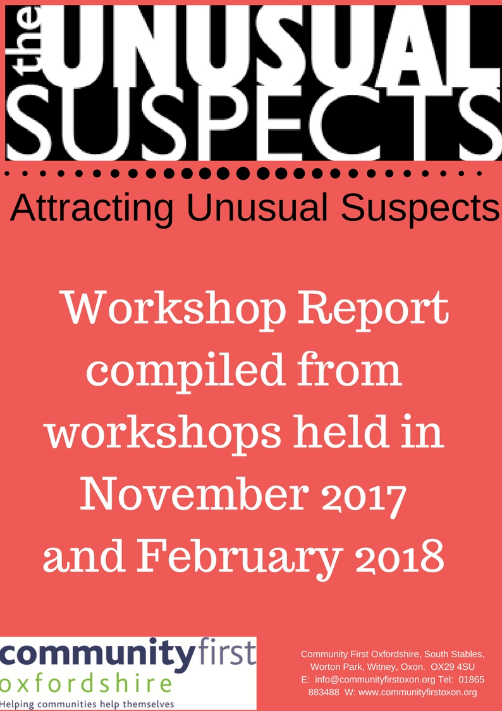

Introduction
The Attracting Unusual suspects workshop were organised by Community First Oxfordshire as a result of listening to village hall committees, parish councils and other community action groups who are concerned about the lack of new people getting involved in their community. Two workshops were held – on in November 2017 and one in February 2018

Objectives of the workshop

- To identify issues facing community action groups in getting people involved in positions of responsibility
- To discuss strategies for encouraging people to get involved.
Over 90 people attended the workshops from a variety of organisations which were facilitated by Grant Hayward from Collaborent.
The workshop was designed to be participative and experiential and this report will highlight some of the outputs.

Workshop

As people arrived they were invited to think about the following questions.
- What motivates you about being involved in your community?
The responses were wide and varied but could fit into the following categories.
- The desire to preserve and maintain village life
- Wanting to give something back – having the time to do so
- To make a difference and a positive change
- To bring the community together
- To meet new people
- Wanting to improve the community
- To use personal skills and gifts
- It is the ‘right thing’ to do

- What frustrates you about being involved in your community?
Again, responses were varied but can be categorised as follows.
- Frustration with the constraints of legal obligations
- Lack of involvement by others
- Apparent resistance to change and to new ideas
- The length of time it takes to ‘do things’
- Lack of skills, knowledge or experience
- Communication barriers and issues
- Deep rooted divisions within the community
- Lack of money
At the first workshop Richard Preston from Steeple Aston and Charles Chadwick from the Diocese of Oxford gave short speeches about volunteering today and their experiences of trying to attract unusual suspects .
At the second workshop, Cllr Kellie Hinton ,Mayor of Henley gave a talk along with Charles Chadwick.
Speakers biographies and the notes from these speeches are at the end of the report.
The participants were asked to discuss and answer the following questions .
Each table had the opportunity to discuss and answer all the questions and the top six were identified .
- What types of people get involved in your community?
- Those with particular skills – practical and professional
- Those with particular interest at a given point in their lives
- Those with a sense of civic duty
- Proactive – activist, appreciative, usual suspects
- Busy with a passion
- Relevant skills – believe they have , confidence, transferable skills, good communicators
- Former beneficiaries
- Older , middle class, well educated people
- Confident people
- People with a personal need, lonely people
- People with an ‘agenda’ – ‘do -gooders ‘

- What skills do you need to be an active citizen?
- Pragmatism
- Willingness to participate and engage ( with commitment )
- Communication skills – welcoming and inclusive nature
- Being open to change, allowing new ideas – listen
- People skills team work co-operation
- Enthusiasm – making things happen
- Confidence
- Leadership – networking – negotiation
- Flexibility
- Making people feel valued

- What might prevent people from getting involved?
- Time – work commitments -work / life balance
- Apathy
- Too much red tape / liability
- Lack of time – fear of over commitment
- Lack of confidence to come forward in roles not necessarily needing specific skills
- Lack of motivation
- Not knowing how to get involved
- The word ‘committee’ , meetings and committee behaviours – the structures
- The process and demands are inaccessible
- They have not been asked
- The people already involved and their attitudes

- Engaging with young people
One of the major concerns of communities is engaging with younger people . In order to address these issues CFO commissioned two young people to speak about:
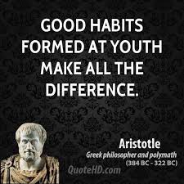
‘Developing a culture and environment that nurtures young people’s interest in being a lifelong active citizen’
Harry Gable talked to the workshop via a film
Daisy Campion’s experiences about being involved with a neighbourhood planning group were read out.

Having heard from speakers and identified issues that might prevent people from getting involved, people were asked:
How could we do things differently ?

- How could we do things differently?

The following table highlights the most popular ideas

Idea
Discreet task and finish approach
Direct and personal approach to people for specific tasks
Create easy to access taster sessions of roles so people can see what they can get out of it
Use social media and organise tutorials
Embrace technology and use it
Be specific and clear about what you are asking for with roles
Offer opportunities to enhance CV and skills and develop leadership skills
Mentor volunteers
Welcome pack for new communities and new developments
Thank volunteers – write letters -let them know they are appreciated
Use different communication channels for different audiences

Start to engage with young people at an early age and make ourselves approachable

Have events with food

Offer taster events

See things from others’ perspectives – what’s in it for them?

Review current processes to see if they are fit for purpose

Limit the time people can be on committees

Get people doing what they want to do

Appreciate that there is not a hierarchy of involvement – all roles are needed

- What one thing would help ?
People were asked to identify what would help in the short term. The possible solutions are as a result of CFO research after the workshop.

One thing we need | Possible solutions, ideas and places to go for further information
More Trustees | OCVA offer support with this  https://ocva.org.uk/
More volunteers | OCVA  NCVO volunteering toolkits  https://www.ncvo.org.uk/ncvo-volunteering  OCVA and Abingdon and Witney College training for volunteers  http://www.abingdon-witney.ac.uk/coursesearch/?area=Volunteering&type=PT  Don’t assume people aren’t doing anything already- maybe community of interest /identity rather than geography .
Breaking down jargon | Avoid using jargon and acronyms – challenge ‘professionals’ who use jargon
Advice pointers for other people
How to bring in young people | District Youth engagement officers  Duke of Edinburgh award : oxfordshiredofe.org.uk  NCIS : oxfordshire.gov.uk/cms/content/national-citizen-service-oxfordshire  Local organisations e.g scouts
Counter some reasons for people not getting involved. E.g. DBS. Legal obligations | OALC – parish council advice and support  http://www.oalc.org.uk  OCVA – DBS info  CFO - village halls and shops advice
Improved communications | Develop social media and marketing courses
Resources to support residents contacts ,set up RA’s | Housing Associations
How do we help people commit in a commitment light age | ‘The Elephant in the box’- new research  lankellychase.org.uk/elephants-in-the-box/ - principles for engagement  Break down roles and tasks into smaller chunks.  Its ok for people to dip in and dip out – Personal circumstances change .
What do other people do? | CFO to undertake research from elsewhere and share via website
Other agencies we could engage to get people involved | Know your local community -who is already working in the area?  Local authority – team building volunteering days .  West Oxfordshire - http://www.vlu.org.uk  Cherwell DC - http://volunteerconnectbanbury.com  County Wide - http://oxonvolunteers.org
Ideas of how we can empower others | Be welcoming , avoid cliques  Open to new ideas.  Mentoring  Training  Building confidence -OCVA and Abingdon Witney College training  Ensure there are no barriers perceived or real preventing people from getting involved  Offer to pay expenses – caring costs
Share own passions | Share at community events
Succession planning | Sharing roles – mentoring
New community hall – need ideas to bring others onto the committee | Tessa Hall -CFO Halls advice
How to reach out and involve and get views from unusual suspects | Marketing  Youth engaging  District Council communication teams  Go where people are -don’t expect them to come to you
How to involved newly retired and those new to the area | Personal contact  Businesses via HR department  Retirement planning and support  SODC volunteer officer
How to keep people’s interest | New ideas – open to change – do things differently
How to get the message through that people are needed . | Marketing  Personal contacts
Tools and ideas for attracting different people | CFO toolkit to be developed
How to get people to understand importance of fundraising | http://www.gnof.org/wp-content/uploads/2014/06/10-most-important-things-FD.pdf  www.institute-of-fundraising.org.uk
Attracting people who can run projects | Skills audits  Advertise specifically  futurelearn.com – free project management training courses

At the end of the workshop people were asked to take a moment of reflections and to identify
- One thing I will do differently :
This was a personal activity but some people were willing to share their thoughts
.Here are some of the responses.
- Approach people directly with regard to volunteering /assisting
- Be proactive in gaining other people’s ideas and aspirations
- Monthly news letter with contributions from as many groups as possible.
- Less discussion, more action
- Personal communication
- Get volunteers to see ‘what’s in it for them’
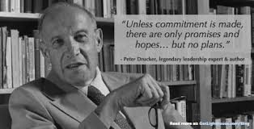

Next steps

Community First Oxfordshire will go back to participants after 6 months to see if they have managed to do things differently following on from the workshop and to offer further support.
Following these workshops CFO will bring people ( who have indicated they would like to be further involved ) together to develop a toolkit or some other form of support.
We hope that attendees found the workshop useful and are able to apply the learning to attract many new Unusual Suspects from all sections of their community.

Further information

To discuss any of the above or to get further details or support, please contact:
hilary.lombard@communityfirstoxon.org

Biographies

Charles Chadwick -Since 2014 Charles Chadwick has worked for the Diocese of Oxford as a Parish Development Adviser. This role involves him in visiting churches and clergy across rural Oxfordshire and advising them on how they may develop their work. Prior to this he was a parish priest for over 25 years. He has served in a voluntary capacity in organisations including the YMCA and the Sea Cadets. He is interested in how volunteering can be made attractive and accessible to people today.
Richard Preston - Richard is 70 years old and has lived in Steeple Aston all his life. He worked in and around the village for over 40 years. His first engagement with village organisations, apart from playing some sports and attending village activities, was to join the village hall management committee in the 1980's. He became a parish councillor in 1991 to try and motivate the council into providing amenities for young people. Over his 25 years with the council Richard was part of a team that acquired over 500k for sports and play improvements in the village. Richard currently chairs four village organisations and has a keen interest in promoting children's play and gardening. Not necessarily at the same time! At present he also organises (for lack of a better description) a seniors group of 100 members so his interests are spread over a wide age range.
Harry Gable - Harry is 21, from Abingdon and has Cerebral Palsy. He recently completed his Undergraduate Degree at Oxford Brookes, where he obtained First Class Honours in Politics with History. He was also the recipient of the 2017 Politics and International Relations Dissertation Prize, after writing about national identity and the EU Referendum. The challenges of youth engagement in the political process were central to this research. Harry is passionate about politics, and keen to make a difference. Having recently started a job with the South Oxfordshire District Council, he hopes to pursue a career in public policy in the future.
Daisy Campion – Daisy has lived in Cyprus, Scotland and England and travelled to dozens of countries, but has now settled down in a quaint village and it’s the only place she ever expected to live in for a long time so she’s chosen to be involved in the future of the community. She is studying economics A-Level so her studies involve politics, and she finds understanding the government from the perspective of a lower tier offers a unique insight in her course. Daisy agreed to making her speech because she thinks it’s really important that council groups are inclusive and accepting, and to do this they need the perspective of every section of society, especially young people.
Kellie Hinton - Mayor of Henley on Thames -Kellie has lived in Henley for most of her life, living for a short while in Tokyo, Reading and Spain. Prior to starting a family her background was in sales and finance. When moving back to Henley as a young adult she found it extremely difficult to find affordable housing and moved into Henley YMCA. After becoming a tenants representative and fundraising for the YMCA, she found a natural interest in getting involved with the local community.
After becoming a mother and settling down with her small family, she became part of Henley Residents Group to have more of a say in the town she was raising her child in. Through her involvement with HRG, she was elected on to Henley Town Council in May 2011 and immediately got involved with the Henley Skate Park Initiative

Speaker’s notes

Charles Chadwick Parish Development Adviser
CMD Team Member , Dorchester Archdeaconry , Diocese of Oxford

VOLUNTEERING TODAY
In the 21st century people volunteer for a number of reasons, which include:
- Doing something valuable and worthwhile
- Being part of a team
- Belief in the cause.
- To not be responsible/have stress.
- To enhance their skills base/CV.
- To give structure to their lives and to build confidence.
- To feel part of a community.
- To feel useful.
- To meet people and make new friends and to enjoy themselves.
- To make themselves “work-ready”
- Family and friends do/did it.
- Having time on their hands.
WHAT HELPS AN ORGANISATION ATTRACT, RECRUIT AND RETAIN VOLUNTEERS?
- Having a suitably strong positive local profile and a good reputation.
- Word of mouth.
- Be clear what the task is, what is involved, and how long it will take.
- Thinking about wording – not everyone appreciates the word ‘volunteer’.
- Offering occasions for people to do a taster and giving them a chance to look around and try a range of tasks and asking them what their interest is.
- Having a ‘Volunteer Co-ordinator’ who focuses on this.
- Don’t expect people to work on their own. This can be tackled in a number of ways: (A) Asking for a project team – people are more likely to join other people than offer to do it on their own, and where there is a definite time limit. (B) Producing a list of those who have already volunteered. This is a better approach than a blank sheet, as who wants to be first?! (C) Putting people in pairs or giving them the chance to be ‘a shadow’. (d) Having mentors
- Provide flexibility, choice, and the chance for people to walk away.
- A number of people are motivated by results, so it can be beneficial to say how their voluntary role contributes towards the ‘success’ of the whole organisation.
- Opportunities for acknowledgement and thanks, perhaps with food. Few people are seeking this but it is much appreciated.

Richard Preston -Steeple Aston
About me
Lived in same village all my life
Strong interest in gardening – flower shows
Nearly 30 years ago, when children were young. No play-space. Realised I needed to change way of thinking with PC. Outcome – play-space like Islip.
As parish councillor in 2002 approached to help with fairly minor project to improve changing facilities for football club. Outcome – 350k project with help of a committee of five!
Present day. Retired from PC after 25 years. Chair four clubs / village charities. Active member of village hall.
Why me?
Passionate about village community. Find the only way to make things happen is to be involved. Always had a problem saying “NO” Discovered the best result for any project is targeting the best possible outcome. I.E. request for small changing space resulted in superb outdoor sports pitches and state of the art changing rooms. Self-satisfaction!
How to attract unusual suspects? Need to ‘sell’ the idea. Make the opportunity to serve on a committee or help with any organisation attractive by demonstrating the benefits, not only to the club or society but to the volunteer. By helping others, you will also help yourself. I run a seniors group which, when I took over the reins consisted of 30 members, playing bingo and waiting to move into a care home or worse. We now have 100 members who are looking to the future by visiting places of interest and being entertained by high quality speakers and entertainers. Most importantly, they all help to make the club a success.
New volunteers usually come from a direct approach, not articles in the village magazine. I referred to article on Steeple Aston’s website asking for help or ideas in readiness for your meeting and unfortunately, no response although over 50 people had viewed it.
Kellie Hinton - Mayor of Henley on Thames
Kellie offered interesting insights about what people think about councillors and the role. Her slides are available here
Daisy Campion
Hi there everyone. I’m called Daisy Campion and I’m 17.
I am, in my village’s neighbourhood plan steering group because I personally felt it was really important that my generation were represented in the planning of our village’s future, especially considering it would be them who inherits their parent’s houses and will suffer or benefit based on our decisions.
I have been involved from the start. So far, I have designed and sent the young person’s survey that targets real issues for people of my age or younger, like road safety and cycle paths.
I must admit that although all the team were very welcoming ,I do sometimes feel excluded from conversations because I either don’t know the whole village inside out ( as a resident who has only lived here a year ) or because I don’t have the time to real through all the information packs that are sent out. I think to overcome this, current members of the council groups could arrange a meeting solely to brief the newcomer. This would take pressure off them from reading and comprehending everything themselves, or at the very least let us know what is necessary to read because it will be discussed and what is information especially for specific people
My role in our groups ,as I said before, is largely based around young people ,so I sometime feel as though my other inputs aren’t considered appropriately ; for example, I am an economics student so when we had to cover economic strength in the SWOT analysis I gave a few ideas but they were all disregarded . I got the distinct impression that it was because the only input I could have where I would be listened to is if it was associated with young people . Perhaps to tackle this, we could all try to be more inclusive, me included.
Emailing is always inclusive because you can’t be intimidated by anyone’s actual presence and provided they speak English they can be involved. It’s simple but I have notices a real lack in advertising to attract new members and the only way people can be actively involved is through word of mouth which sometimes doesn’t have the widest reach .
So ,in conclusion I strongly recommend just trying to get the work out that everyone’s input will be appreciated and then genuinely showing interest in what they have to day.
I recommend to just listen and acknowledge everyone’s input even if they aren’t officially in the group because making villages feel heard is the first steps to attract them as ‘fresh new faces .’

