

Wantage - Community Profile: July 2017

1. **Map and Overview**

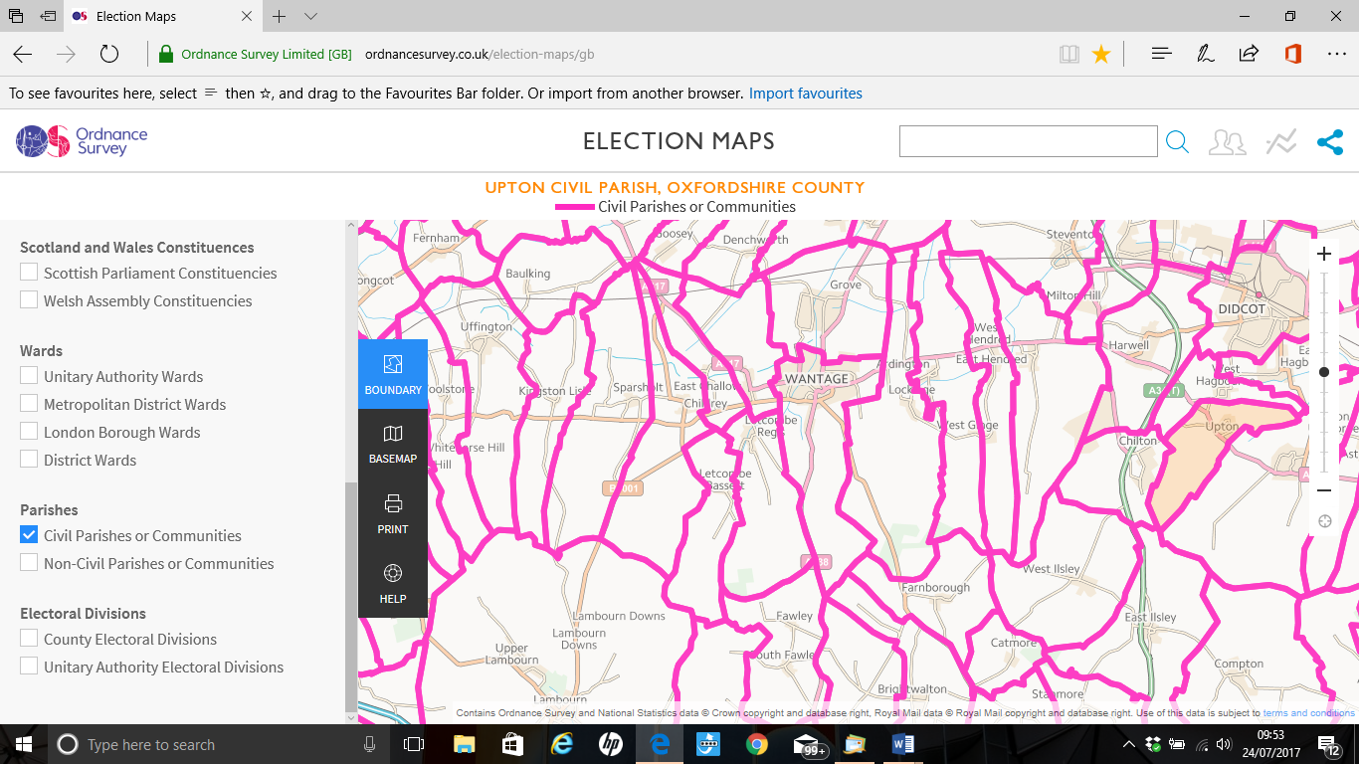

Wantage Parish (Source: Ordnance Survey Election Maps)

Overview

Wantage is a market town and civil parish in the Vale of the White Horse, Oxfordshire, England. The town is on Letcombe Brook, about 8 miles south-west of Abingdon, 10 miles west of Didcot, 15 miles south-west of Oxford and 14 miles north north-west of Newbury. It has a good range of shops and services, including plenty of pubs and restaurants, places to visit and accommodation. Links with the past are strong. It is the town in which King Alfred the Great was born. It also has literary connections in Sir John Betjeman and Thomas Hardy. The Ridgeway and many Oxfordshire villages are nearby for countryside walking.

The population of the Wantage Parish at the time of the 2011 Census was 11,353. Both the proportion and absolute number of those aged over 65 is expected to decrease over the coming decades.1

Ward forecasts for the Parish supplied by Oxfordshire County Council predict the population of this age group will increase by 54% in the 15 years from 2011 to 2026. The forecast of the total Wantage Parish population in 2026 is 15,332.1

1 [http://insight.oxfordshire.gov.uk/cms/oxfordshire-county-council-population-forecasts-january-2014-excel-format](http://whitehorseharriers.uk/contact-us)

Schools

**Charlton Primary School** in Wantage is a 4-11 Primary School and also converted to an academy on 1st October 2013. It currently has 365 pupils but is expanding to two form entry across the school. The school is currently graded as Good by Ofsted. (June 2015). 01235 762861 [office@charlton.vale-academy.org](http://www.better.org.uk) Headteacher, Steven Rose. Charlton Primary School, Wantage, Oxon. OX12 7HG

**Charlton Acorns Preschool.** Charlton Acorns is an independent preschool situated in the grounds of Charlton Primary School. They take children from the age of 2 years until they are of school age. Charlton Village Road, Wantage OX12 7HG 01235 [770317 gemmamoore78@btinternet.com](http://www.better.org.uk) [http://www.charltonacorns.co.uk](http://www.wantageband.org/contact)

**Wantage CE Primary School** is a 3-11 Voluntary Controlled Church of England Primary School and Nursery with 421 pupils. It converted to an academy on 1st October 2013. The school is currently graded as Good by Ofsted. (June 2015) Newbury Street, Wantage, Oxon OX12 8DJ 01235 762396 [office@wantagece.vale-academy.org](mailto:office@wantagece.vale-academy.org)

**King Alfred's Academy.** King Alfred’s is an outstanding college (Ofsted 2011). It caters for years 7 – 13. It has recently become an Academy which ensures that the governors, staff and parents have more control over their destiny and future success. [Portway, Wantage OX12 9BY](http://wantagetennisclub.co.uk?lid=YN1029x100209863&id=YN1029x100209863&q=King+Alfred's+Academy&name=King+Alfred's+Academy&cp=51.5865135192871~-1.42882096767426&ppois=51.5865135192871_-1.42882096767426_King+Alfred's+Academy) OX12 9BY 01235 225700 [enquiries@kaacademy.org](mailto:770317%20gemmamoore78@btinternet.com) [http://www.kingalfreds.oxon.sch.uk](mailto:wantageclerk@btconnect.com)

Services

**Buses** run regularly from Oxford, Didcot, Abingdon and Faringdon, with Saturday services from Swindon and Newbury.

The X90 runs to Oxford and on to London.

The Connector X32 and Connector 32 run to Didcot via Harwell and onto Swindon.

The 31 runs to Abingdon.

The 67 runs to Faringdon and connects to the Stagecoach Gold to Swindon.

Doctors/Hospital

**Wantage Community Hospital**. Provides maternity and musculoskeletal and Obstetric Physiotherapy. Garston Lane, Wantage OX12 7AS 01235 205801.

**Wantage Health Centre.** There are two practises in the Health Centre.

**Church Street practice** covers Wantage and Grove and the surrounding villages. The team consists of 8 doctors, 5 Nurses, 17 support staff and 11 attached community staff. A comprehensive range of medical and preventative services is offered for 12,400 patients. Wantage OX12 9BN 01235 770245 [churchstreetpractice@nhs.net](http://www.whitehorsecroquet.org.uk) <http://www.wantagechurchstreet.co.uk>

**The Newbury Street Practice** covers Wantage and Grove and extends to include the villages in a radius of approximately 8 miles from the Health Centre. Wantage OX12 9BN 01235 763451 [http://www.newburystreetpractice.co.uk](https://www.bing.com/local)

There are also a number of private and alternative sources of health care. [http://wantage.com/directory/categories/health-care-private-and-alternative](mailto:enquiries@kaacademy.org)

Town Council

The Wantage Town Council holds its meetings on a Monday at 19.30 at The Beacon, Civic Centre, Portway, Wantage. OX12 9BX. Office hours are 09.30 to 12.30 each weekday.01235 763459 [wantageclerk@btconnect.com](http://www.facebook.com/groups/257674977739114)

Post Office/shops

Post Offices

* 18 Wallingford Street, Wantage, Oxfordshire. OX12 8AX. Open Mon – Fri 09.00 – 17.30 Sat. 09.00 – 12.30. Sun. Closed.
* 12 Barnards Way, Wantage, Oxfordshire. OX12 7EB. Open Mon & Tue. 09:00-17:30

Wed 09:00-13:00 Thu & Fri 09:00-17:30 Sat 09:00-12:30 Sun. Closed.

Wantage has many independent and main High Street shops. There are both Sainsbury and Waitrose supermarkets in the main town centre.

|  |  |
| --- | --- |
| **Halls for Hire** | **Contact details** |
| **The Beacon** Portway, Wantage,  Oxfordshire OX12 9BX | [beacon.wantage@whitehorsedc.gov.uk](mailto:theteam@wantagecc.co.uk)  01235 763456 Technical Enquiries  George Jackson (Technical Officer)  [george.jackson@southandvale.gov.uk](mailto:george.jackson@southandvale.gov.uk) |
| **Lains Barn** Grove Park Drive, Nr Ardington  Wantage, Oxfordshire OX12 7QG | 01235 832745 [events@lainsbarn.co.uk](http://www.kingalfreds.oxon.sch.uk) |
| **Wantage Methodist Church Hall & Chapel**  Newbury Street, Wantage, OX12 8DA | Bookings Secretary — Gordon Skidmore  [wntgmethodistbookings@gmail.com](mailto:churchstreetpractice@nhs.net)  [http://www.wantagemethodist.org.uk/our-church/hall-and-room-hire.html](http://www.pitchero.com/clubs/wantagetownfc/information)  07710 214601 |
| **Wantage Town Football Club**  Alfredian Park, Manor Road, Wantage, OX12 8DW | Ian Glover 07449555451  01235 764781  [http://www.pitchero.com/clubs/wantagetownfc/a/clubhouse-hire-6141.html](http://www.newburystreetpractice.co.uk) |
| **King Alfred District Scouts HQ.** Springfield Road, Wantage OX12 8ES | <http://s165926809.websitehome.co.uk/web/dhq/make-a-hall-booking> |

**2. Areas of Deprivation**

Part of Wantage Charlton ward LSOA E01028757

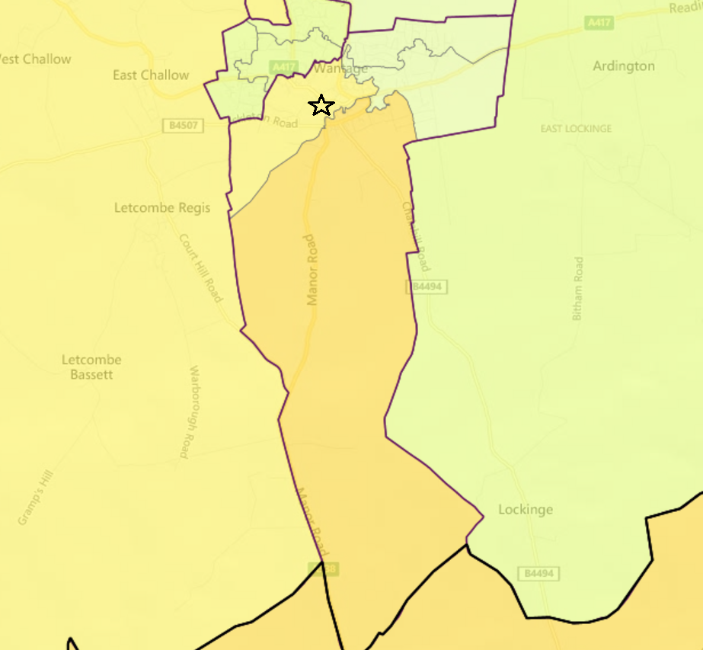

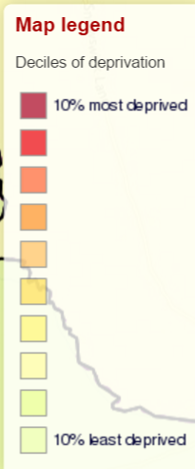

**3 .Service Overview**

|  |  |  |
| --- | --- | --- |
| **Day Care** | **Transport** | **Service Care** |
| **Wantage Day Service**  Offers support in a wide range of activities, both on and off site. Providing daytime support for adults with learning disabilities, daytime support for adults with learning disabilities in the Wantage area.  There is a sensory room, cafe and gardens. Assist people to learn skills in the cafe project, using their personal budget.  Activities on offer include a community arts project, sensory support including the SPICE sensory sessions.  They also support people to access employment and volunteering opportunities.  There are full personal care facilities and support for people with their physical care and physiotherapy needs.  Charlton Village Road, Wantage  OX12 7HG 01235 769261  Manager: Anne Sargent  [anne.sargent@oxfordshire.gov.uk](mailto:events@lainsbarn.co.uk)  07500 784415 | **Buses** run regularly from Oxford, Didcot, Abingdon and Faringdon, with Saturday services from Swindon and Newbury.  The X90 runs to Oxford and on to London.  The Connector X32 and Connector 32 run to Didcot via Harwell and onto Swindon.  The 31 runs to Abingdon.  The 67 runs to Faringdon and connects to the Stagecoach Gold to Swindon. | **The October Club. Alzheimer’s Day Care Centre.** Caring for people suffering from Alzheimer’s and Dementia.  The Club provides a safe and comfortable Day Centre where clients are cared for with understanding and dignity, and give brief respite and support for carers and relatives.  There are a range of appropriate activities, including card and board games, bingo, musical activities, indoor bowls and skittles, art and craft, quizzes and outings to places of interest and entertainment. A hot and nourishing meal is provided at lunchtime and beverages are available at any time.  1-3 The Cloisters, Wantage, OX12 8AQ.  Contact during Opening Hours (9am to 3pm Wednesday, Thursday and Friday)  01235 760428  [enquiries@octoberclub.org.uk](http://www.charltonacorns.co.uk)  <http://www.octoberclub.org.uk> |
| **Wantage Health and Wellbeing Centre.** Community computer classes are available as well as a daily lunch club. Providing a social atmosphere, promoting independence and providing vital care services to the elderly on a Monday to Friday basis.  Monday to Friday 08.30 – 17.00  Stirlings Close, Garston Lane  OX12 7AQ Wantage  Manager: Jane Doyle  01235 765934  [admin.wantageHWC@oxfordshire.gov.uk](http://www.pitchero.com/clubs/wantagetownfc/a/clubhouse-hire-6141.html) |  | **Wantage Dementia Cafe**  The Mably Health Centre Wantage OX12 9BN  01235 531989  07889 604599  Contact Katie Appleton.  The cafe provides people with dementia and their carers a platform to talk openly about living with dementia and other services locally, within a relaxed and informal environment. They also hear from a variety of guest speakers including health and social care professionals and representatives from the local community. First Friday of every month between 2.00pm to 3.30pm. |
|  |  | **Wantage & Grove Foodbank**  A practical, community based project, organised by local churches, which provides food parcels to those in the immediate area who find themselves temporarily in difficult circumstances. Dependent upon donations of food the foodbank is staffed by church volunteers. Food donations can be dropped off at: The independent Advice Centre, The Kings Book Shop (Wantage) & Cornerstone Coffee Shop (Grove) or a local church. Wantage OX12 9BQ  01235 766849 |
|  |  | **The Butler Centre** provides affordable childcare for the local community.  Centre manager: Annie Harris  077 87 79 44 78  [butler.centre.clubs@gmail.com](http://wantage.com/directory/categories/health-care-private-and-alternative) |
|  |  | **Wantage Counselling Service.** Founded in 1984 to provide counselling for individuals, couples and young people over the age of 15 years. Portway Wantage OX12 9BU  01235 769744  [wantagecounselling@tiscali.co.uk](mailto:anne.sargent@oxfordshire.gov.uk)  [http://www.wantagecounselling.org.uk](mailto:wntgmethodistbookings@gmail.com) |
|  |  | **Wantage Independent Advice Centre**  16 Market Place, Wantage, OX12 8AE  (behind Barclays Bank)  Tel: 01235 765348 Fax: 01235 763862  [help@wantageadvice.org.uk](mailto:help@wantageadvice.org.uk)  Monday to Friday from 10.00am to 3.30pm.  Drop in service or pre-booked appointments available.  Telephone line 01235 765348 open Monday to Friday from 9.30am to 4.00pm and answerphone out of hours.  **The Fourteen Club** is an independent social club for people with learning disabilities in Wantage and surrounding areas. The minimum age is 14. The club meets on Monday evenings during school term for a variety of fun social activities, such as craft, discos, cooking, games etc. The club is run entirely by volunteers The Fourteen Club  Fitzwaryn School  Denchworth Road, Wantage. OX12 9ET  01235 764504  [info@14Club.org.uk](mailto:admin.wantageHWC@oxfordshire.gov.uk) |

**4. Distance to Services**

|  |  |  |  |  |  |  |
| --- | --- | --- | --- | --- | --- | --- |
| Community | Barriers to Housing and Services | Geographical Barriers | Distance (km) to: | |  |  |
| LSOA | PO | Food | GP | Primary school |
| Wantage |  |  |  |  |  |  |
| E01028757 | 5 | 4 | 0.86 | 0.91 | **2.33** | **1.10** |



**5. Community Assets**

Allotments

There are five allotment sites in Wantage, they are: Grove Road, Lark Hill, Letcombe Field, Naldertown, and Stockham Park. Wantage Town Council are responsible for their maintenance.

Halls

* The Beacon. Has a choice of rooms for hire, including a large auditorium, a dance studio and two other function rooms.
* Lains Barn. Can accommodate up to 180 seated guests.
* Wantage Methodist Church Hall & Chapel. The Hall is a well - equipped and versatile community facility. The large main hall (max dimensions 10.2m x 11m), with a modular self-assembly stage consisting of 10 square modules, 3ft x 3ft, with 2 triangular half blocks and 2 sets of steps; (choice of 9in or 18in high), audio facilities, a reflective wall for digital projection (as used by Wantage Camera Club), folding tables (10 large: 6 of 1830mm x 685mm/ 6ft x 2ft 6in, 4 of 1830 x 610/ 6ft by 2ft 3in; 6 small: 915mm x 685mm/ 3ft by 2ft 6in), 12 stacking coffee tables, stackable seating for 100. There is a separate committee room (Parlour) suitable for meetings of up to 25 people. A small committee room (Godfrey Room) is available for meetings of up to 12 persons. The main hall and Parlour are served by hatches from the kitchen; included in the hire of the main hall, or available for hire separately). A small car park is adjacent to the building for the disabled or those with restricted mobility (6 cars), with a large public car park nearby. Alcoholic beverages are not permitted on the premises. The adjoining traditional mid - 19th century chapel, with rear balcony, is also available for hire. It is equipped with audio-visual facilities; light, movable seating; a larger stage; upgraded lighting; an insulated floor; energy-efficient heating; a large street-entrance lobby with central rear entry to the Chapel.
* Wantage Town Football Club. Club House is ideal for weddings, family parties, discos, live music and events. Dance Floor, Licensed Bar, Adaptable Seating & Dining Planning, Stage, Kitchen Facilities, Large car park.
* King Alfred District Scouts HQ.

Library

Wantage Library. Stirlings Road, Wantage OX12 7BB

01235 762291 [wantage.library@oxfordshire.gov.uk](http://www.wantagemethodist.org.uk/our-church/hall-and-room-hire.html)

Sports/Play Facilities

* The Chestnuts Play Area. Small well maintained play area in Charlton village. Tirrold Way, Wantage. OX12 7DL.
* Hamfield Play Area
* A small enclosed grass play area and playground at the end of Mary Whipple Court in Wantage, equipped with good standard play equipment but reportedly not maintained as well as it could be. Mary Whipple Court, Wantage. OX12 9RD
* Humber Close Playground. At the end of Humber close nestled between the houses is a small green area with sprinkling of standard play equipment. Humber Close, Wantage. OX12 7DT.
* Memorial Park and Play area. Occupies approximately 17 acres of open space with views overlooking Wantage town. The park has a large grassed area for informal play, and a well - equipped playground area with an interactive splash park, which is active daily between 10.30am and 7pm until mid – September. Manor Road, Wantage. OX12 8DP.

**6. Community activity: overview**

|  |  |  |  |
| --- | --- | --- | --- |
| **Theme** | **Group and Details** | **Contact** | **Notes** |
| Adults | [**The**](mailto:beacon.wantage@whitehorsedc.gov.uk) **Core Benefit/The Pilates Studio.**  KA Fitness 8-10, Grove Street, Wantage, Oxfordshire OX12 7AA | <http://corebenefit.co.uk>  07806 270207  [hello@corebenefit.uk](mailto:wantagecounselling@tiscali.co.uk) | They offer a range of services such as Pilates sessions. There are barre and movement therapy classes, relaxation and Core Restore and Pelvic Health Packages.  The Core Benefit is a MuTu® inspired exercise package and lifestyle of core restoring exercises [diastasis recti and pelvic floor], healthy balanced eating, short easy to do sessions, and an  encouragement to live a healthy outlook. |
|  | **Townswomen’s Guild**  **Wantage & Grove** | Mrs C Middlebrook  01235 762536 |  |
|  | **Wantage WI.**  Monthly meetings take place at the Masonic Hall, Wantage, OX12 8AN, on the second Wednesday of each month (except August) at 10.30am. | [rita10@ntlworld.com](mailto:enquiries@octoberclub.org.uk)  01235 224984 |  |
|  | **Wantage and Grove Lions Club.**  2nd Tuesday of every month at 8pm  Where:  Hanney Royal British Legion | Alan 01865 820366  Leonie and Stuart 01235 414045 |  |
|  | **Wantage Poetry Club** | [mikebjones@live.com](mailto:wantage.library@oxfordshire.gov.uk)  Mike Jones  01235 751656 |  |
|  | **Wantage Mummers.** | Steve Dagnall  The Wantage Mummers  Old Berrycroft Cottages  Ashbury  Oxfordshire, UK  SN6 8LX  01793 71040  07762 372106  [enquiries@wantagemummers.org.uk](mailto:info@14Club.org.uk) |  |
|  | **Wantage Male Voice Choir**  Rehearsals on Tuesday evenings from 7.30 to 9.30 in the Hanney War Memorial Hall, East Hanney, OX12 0JL. | Keith Mansell (secretary)  01235 766964.  [secretary@wantagemalevoicechoir.org.uk](mailto:secretary@wantagemalevoicechoir.org.uk) | The Main Choir comprises approximately 30 choristers, available to sing in the evenings or at weekends.  A smaller group, of a dozen or so, is able to represent the Choir on weekdays, during the day |
| Children | **Girl Guiding** | DC Pam Palmer  01235 770029  [www.oxfordshiregirlguiding.org.uk](mailto:hello@corebenefit.uk) |  |
|  | **Wantage Air Cadets**  **No. 1861 (Wantage) Squadron, Air Training Corps.**  Cadet Forces Centre Icknield Lane, Wantage OX12 8ES | 01235 762079 | As a cadet in the Royal Air Force Air Cadets you can fly in civilian or military aircraft, take part in aerobatics, and learn to fly a glider or go on a UK or overseas camp. Activities include shooting, parachuting, caving, climbing, hill walking and trekking, aeromodelling, sports, canoeing, rock climbing, amateur radio, parades, the Duke of Edinburgh’s Award and the chance to train as a musician and join a cadet band.  To join you have to be in year 8 or up. |
|  | **Sweatbox Youth Club**  King Alfred's Academy East Site, Springfield Rd, Wantage  OX12 8ET  Hours 16:30 - 18:00 | [http://sweatboxwantage.co.uk](http://www.wantagecounselling.org.uk) | The Sweatbox is a purpose designed Youth Centre attached to King Alfred’s Academy East Site main hall. It consists of a spacious coffee bar area equipped with pool table, air hockey, table football and big screen TV. The centre piece of the facility is an impressive mirrored stage room featuring a sophisticated lighting and sound system and a wide range of musical instruments, backline equipment and DJ technology. |
| General | **Rotary Club of Wantage** | David Godding  01488 72197  [www.rotary-ribi.org/clubs/homepage.php?ClubID=576](mailto:butler.centre.clubs@gmail.com?ClubID=576) |  |
|  | **Vale and Downland Beekeepers Association** | [http://www.valeanddownlandbees.org.uk/contact-page](mailto:office@charlton.vale-academy.org) | Represents the interests of beekeepers and beekeeping in the Vale of the White Horse and surrounding areas. |
|  | **Wantage Camera Club.**  Wantage Methodist Church Hall  Newbury Street  Wantage  OX12 8DA  Tuesdays 7:30pm | [http://www.wantagecameraclub.co.uk](mailto:rita10@ntlworld.com)  Dave Richardson  [chair@wantagecameraclub.co.uk](mailto:chair@wantagecameraclub.co.uk) | Run a varied programme of lectures, competitions and instructional evenings, including demonstrations of new digital technology and techniques. |
|  | **Wantage Bridge Club**  Thursday evenings by 7.20 pm for 7.30 pm. | Gaye Kyle  [gayekyle@btinternet.com](http://corebenefit.co.uk)  [http://www.bridgewebs.com/wantage](http://www.rotary-ribi.org/clubs/homepage.php) |  |
|  | **Wantage Chess** | George Spalding  01235 868466 |  |
|  | **Wantage and District League Cribbage** | Mr Rolfe  Tel: 01235 868341 |  |
|  | **Wantage Orchestra**  Rehearsals on Tuesday evenings 7:30pm to 9:30 pm during term time, at King Alfred's Sports and Community College West Site - OX12 9DU | @wantageorch  [http://www.wantageorchestra.org.uk](http://www.oxfordshiregirlguiding.org.uk) |  |
|  | **Wantage Silver Band.**  Reading Rd, Wantage OX12 8FR | [http://www.wantageband.org/contact](http://sweatboxwantage.co.uk) | The Wantage Silver Band is an amateur brass band organisation, based in the small market town of Wantage, Oxfordshire. The organisation comprises 6 bands, possibly making it the largest brass band in the country. |
|  | **Wantage Choral Society**  Tuesday 7.30 | Geoff Williams  01235 798349 |  |
|  | **Wantage Wildlife Archaeology and History Group**  Second Friday in the month7.30 at the Beacon, Portway Wantage OX12 9BX | Gillian Taylor  01235 751646  <http://www.wantagewahg.co.uk> | Programmes of monthly talks by experts in their field but will be interesting to everyone.   Many are of local interest but not confined merely to these. |
|  | **Cornucopia  Appalachian Step Clogging and British Clog Dancing** | [http://cornucopia-dance.org.uk/contact-us](mailto:enquiries@wantagemummers.org.uk) 01235 760010  [www.cornucopia-dance.org.uk](http://www.wantagecameraclub.co.uk) | Cornucopia perform Appalachian Step Clogging and British Clog Dancing to a variety of American, Irish and British acoustic folk music (jigs, reels and hornpipes. |
|  | **Wantage Folk Dance** | Malcolm Bright  01235 818585 |  |
|  | **Karen Brind School of Dance.**  The Beacon, Portway | 01235 769109 |  |
|  | **Darts** | Wantage & District League  [www.facebook.com/groups/257674977739114](mailto:chairman@wantagebowlingclub.co.uk) |  |
|  | **Flower Club**  The Beacon, Portway, Wantage, OX12 9BX.  7.30pm  1st Thur in month. |  |  |
|  | **Sustainable Wantage** | Mim 01235 766689 |  |
|  | **Wantage Gardeners Association** | Chairman  Brian Jones  [Brianmralph@gmail.com](mailto:gayekyle@btinternet.com)  01235 767232  <http://www.wantagegardeners.org.uk> | Open every Saturday morning, including Holiday weekends, 9am to 12 mid-day during the season from the first Saturday in February and ending the last Saturday in September. During September hours are reduced to 10am to 12 noon. Also open on Wednesday evenings (6 - 7:30) from when the clocks change to the end of May  The "Shop" is located in the Scout Romany hut in Icknield Lane, next to the Wantage Air Cadets HQ,. |
| Sports | **Cycling UK Wantage** | [info@cyclingukwantage.org.uk](http://www.wantageorchestra.org.uk) | Cycling UK Wantage is a local member group of Cycling UK, the UK's national cyclists' organisation, covering Wantage and surrounding towns and villages.  The group offers rides for all types of recreational rider predominantly on the roads and occasionally along the local by-ways and bridleways. They cater for beginners, families and more experienced riders. |
|  | **Wantage Badminton Club.**  Wednesday night between 8:30 - 10:30pm in Wantage Leisure Centre | Den Crumpen  01235 767561  07721 420530  [Den@wantagebadmintonclub.co.uk](http://www.cornucopia-dance.org.uk) | The Club has Mixed, Men's Doubles and 3D discipline teams, all playing in their respective division 3 in the Oxford & District Badminton League. |
|  | **Wantage Bowling Club Bowls.** | Marian Stradling  Wantage 765157  [chairman@wantagebowlingclub.co.uk](mailto:mikebjones@live.com) | For all ages and abilities.  **Coaching** is available, free of charge.  **Casual Games**  Can be played at any time after noon (10 am weekends), providing a rink is available.  **The Monday Bowls Drive**  Commence at 2 pm throughout the season and enable members to play against each other on a fairly casual basis yet still with a competitive element.  **Friendly Matches**  The club play friendly matches against other clubs, both at home and away. Matches can be for men only, women only or mixed. The men-only and mixed matches are usually played on Saturday and Sunday afternoons and on Wednesday evenings. The women-only matches have no set day or time. |
|  | **Wantage and Grove Cricket Club.**  **Training**  During the season training takes place every Thursday from 6pm at the club, doing a range of batting, bowling and fielding practices. | [theteam@wantagecc.co.uk](http://cornucopia-dance.org.uk/contact-us).  <http://www.wantagecc.co.uk> | **Saturday Cricket.** The team plays in the OCA division 2. The team is looking to grow and continue their climb up the leagues.  **Wednesday Cricket** team plays in the Charles Hoile Downs division 1. A T20 style format is used and enjoyed by all.  **Sunday Cricket** Play friendlies against a number of local and touring sides, with social cricket the order of the day. |
|  | **Wantage Health Walks.** Every Thursday | Meet in the Vale and Download Museum, Church Street.  Bob Mclatchie 01235 763581 / 07887715493 [bob.mclatchie@ntlworld.com](mailto:info@cyclingukwantage.org.uk) | Covering about 2 miles around the town and returning to the Vale and Downland Museum. Whenever necessary, the walk leaders will organise a more limited walk for those who cannot manage the full route starting out with the whole group and re-joining the group in the Museum at the end. |
|  | **Wantage Town Girls Football Club.** Alfredian Park, Manor Road, Wantage.  Training sessions are weekly and take place on Wednesday Evenings from 6.45pm | [www.clubwebsite.co.uk/wantagegirlsfootballclub](mailto:Brianmralph@gmail.com) | The girls play on pitches adjacent to the Wantage Town FC pitch.  Wantage Town Ladies includes anyone over 16.  Other teams are: U9, U10, U11, U12, U13, U14, U15, U16 and U18. |
|  | **Wantage Town FC.**  Alfredian Park  Manor Road  Wantage  Oxon  OX12 8DW | Ian Glover Chair  01235 764781  [http://www.pitchero.com/clubs/wantagetownfc/information](http://insight.oxfordshire.gov.uk/cms/oxfordshire-county-council-population-forecasts-january-2014-excel-format) | **Senior**  1st Team  Reserves  Ladies  **Youth**  Under 17s  **Junior**  Girls Under 9s  Girls Under 10s  Girls Under 12s  Girls Under 13s  Girls Under 15s  Boys Under 7s  Boys Under 8s  Boys Under 9s  Boys Under 10s  Boys Under 11s  Boys Under 13s  Boys Under 14s |
|  | **Wantage Concords FC.**  Wantage Town site Charlton Ct, Reading Rd: Sat-Nav: OX12 8DW.  Tugwell Site: Sat-Nav: OX12 8HT | Jeremy Moor  07730 929550  [wantagetownjuniors@gmail.com](http://www.valeanddownlandbees.org.uk/contact-page)  [http://www.wantagetownjuniors.org.uk](mailto:Den@wantagebadmintonclub.co.uk) | Wantage Town Juniors runs junior football teams for boys and girls aged from under 7 to under 15. The Club is affiliated to the Berks and Bucks FA and most teams play in the Oxford Mail Boys League. |
|  | **White Horse Croquet Club.** Based at Wantage Cricket Ground in Charlton Village Road, Wantage. | 01235 768453  [info@whitehorsecroquet.org.uk](mailto:info@whitehorsecroquet.org.uk)  [http://www.whitehorsecroquet.org.uk](http://www.clubwebsite.co.uk/wantagegirlsfootballclub) | Play on two lawns set out in the outfield of the cricket ground. |
|  | **White Horse Harriers.** | [http://whitehorseharriers.uk/contact-us](http://www.bridgewebs.com/wantage) | White Horse Harriers AC. athletics club based in Wantage & Grove, Oxfordshire. Around 150 members of all abilities and ages spanning from ‘Year 6’ well into retirement. Coaching of youngsters, encouraging beginners to get jogging, explore trails through Oxfordshire’s beautiful countryside as well as competing in Sportshall, Track & Field, Road Running, Cross Country and Ultras. |
|  | **Squash**  Wantage Leisure Centre, Portway | 01235 766201  [www.better.org.uk](mailto:bob.mclatchie@ntlworld.com) |  |
|  | **Swimming**  Wantage Leisure Centre, Portway | 01235 766201  [www.better.org.uk](http://www.wantagetownjuniors.org.uk) |  |
|  | **Over 55’s Table Tennis.** Wantage Leisure Centre | Mr & Mrs English  01235 763012 |  |
|  | **Wantage Lawn Tennis Club**  Manor Road Memorial Park  Wantage  Oxon OX12 8DW | Chairman  Mark Rowe  07584130662  [rowe.mark@btinternet.com](mailto:rowe.mark@btinternet.com)  [http://wantagetennisclub.co.uk](mailto:wantagetownjuniors@gmail.com) | Four floodlit courts, as well as two courts, available for non-members to book which are managed by the club.  There is a full coaching programme for juniors from 2- 17 and adult sessions including Cardio and Tennis Express for beginners.  There are club sessions for juniors, beginners, social and team players.  The club engages competitively with other local tennis clubs including fielding 10 weekend teams in the Oxfordshire Summer leagues and two midweek ladies teams. During the winter there are seven weekend teams. |

**7. Summary of key local issues**

Later in the year there will be NHS consultations proceeding concerning the future provision of local health services and what services will be provided locally. The Town Council’s Health Sub-committee has proceeded with its own survey of public opinion in order to inform it on how to respond to the consultation.

Wantage has a Youth Town council.

There is a food bank and the local churches offer debt counselling.

There is a draft Neighbourhood Plan that is currently being revised after having failed at inspection.