

Wallingford - Community Profile: July 2017

1. **Map and Overview**

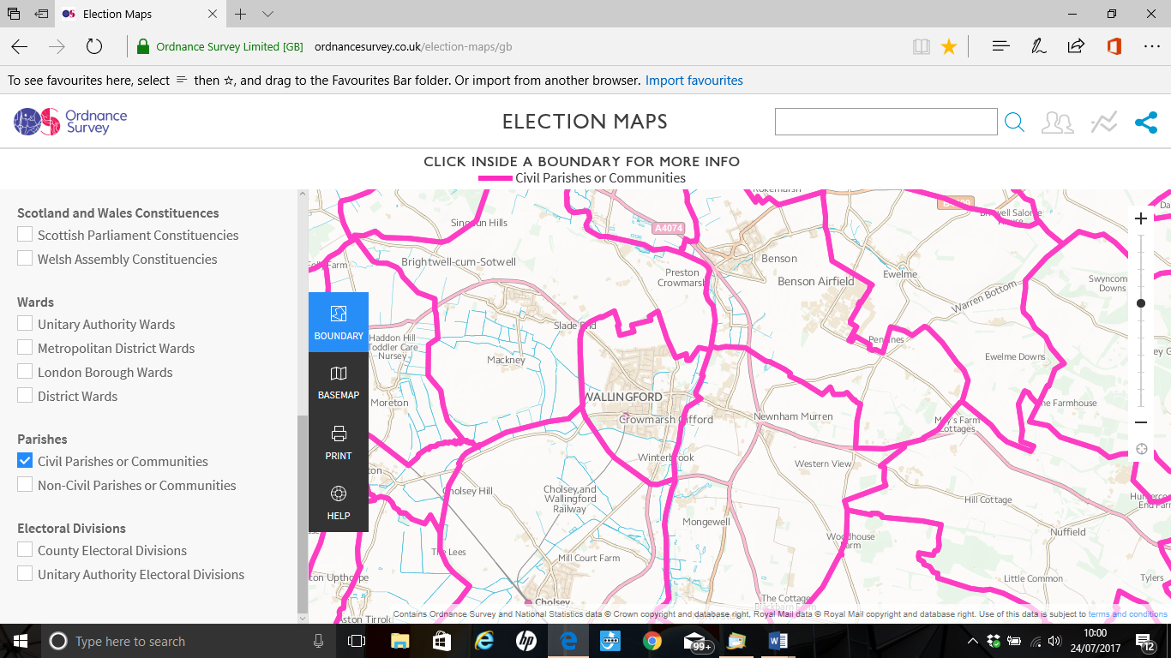

Wallingford Parish (Source: Ordnance Survey Election Maps)

Overview

* Wallingford is an ancient market town and civil parish in the upper Thames Valley in England. Historically in Berkshire, it was transferred to Oxfordshire for the purposes of administration in 1974. Wallingford is situated 12 miles north of Reading, 13 miles south of Oxford and 11 miles north - west of Henley-on-Thames. The town's royal but mostly ruined Wallingford Castle held high status in the early medieval period as a regular royal residence until the Black Death hit the town badly in 1349. Empress Matilda retreated here for the final time from Oxford Castle in 1141. The castle declined subsequently, much stone being removed to renovate Windsor Castle. Nonetheless the town's Priory produced two of the greatest minds of the age, the mathematician Richard of Wallingford and the chronicler John of Wallingford.1
* The Wallingford parish population at the time of the 2011 Census was 6,051. Both the proportion and absolute number of those aged over 65 is expected to continue to increase over the coming decades.2
* Ward forecasts for the town supplied by Oxfordshire County Council predict the population of this age group will increase by 43% in the 15 years from 2011 to 2026.[1] The forecast of the total Wallingford population in 2026 is 6,907.[2]

Schools

* St John’s Primary School. Headteacher: Miss Nicola Hughes. St John’s Road, Wallingford, OX10 9AG. 01491 837305 [office.2567@st-johns.oxon.sch.uk](mailto:office.2567@st-johns.oxon.sch.uk). Age range: 4 – 11. Student count: 204
* Fir Tree Junior School. Fir Tree is a Community school. Headteacher: Ms. Khan. Radnor Road, Wallingford OX10 0NY. 01491 836341 [www.firtreejuniors.org](http://www.firtreejuniors.org) Age range: 7 – 11. Student count: 217.
* St. Nicholas' Church of England Infants' School and Nursery Class. Headteacher: Miss Amy King. St Nicholas Road, Wallingford OX10 8HX. 01491 836408 [www.st-nicholas.oxon.sch.uk](http://www.st-nicholas.oxon.sch.uk) Age range: 3 – 7. Student count: 172.

Wallingford School. Headteacher: Mr. N Willis [head.4140@wallingfordschool.com](mailto:head.4140@wallingfordschool.com) [office.4140@wallingfordschool.com](mailto:office.4140@wallingfordschool.com) Facebook:www.facebook.com/wallingford4140 Twitter: twitter.com/wallingford4140

[St Georges Road, Wallingford OX10 8HH](https://www.bing.com/local?lid=YN1029x100246317&id=YN1029x100246317&q=Wallingford+School&name=Wallingford+School&cp=51.6055755615234%7e-1.12725102901459&ppois=51.6055755615234_-1.12725102901459_Wallingford+School&FORM=SNAPST). 01491 837115. Age range: 11 – 18 Student count: 1199.

Services

* Please see Thames Travel website new River Rapids route due to opening of Westgate Centre, Oxford.

A number of buses travel to Wallingford and beyond.

**97** Wallingford - Dorchester - Berinsfield - Clifton Hampden - Long Wittenham – Didcot

**114** Wallingford - Dorchester - Berinsfield - Culham – Abingdon

**126** Wallingford - Benson - Chalgrove - Stadhampton – Wallingford

**134** Wallingford - Crowmarsh - The Stokes – Goring

**136C** Wallingford - Cholsey – Wallingford

**139** Wallingford - Benson - Nettlebed – Henley

**X39** Oxford - Nuneham Courtenay - Shillingford - Wallingford - Reading

**X40** Oxford - Nuneham Courtenay - Shillingford - Wallingford - Woodcote – Reading

* Medical

Wallingford Medical Practice. Reading Road, Wallingford, Oxfordshire, OX10 9DU. 01491 835577.

Wallingford Community Hospital [www.nhs.uk](http://www.nhs.uk) NHS Trust Hospital Reading Road, Wallingford OX10 9DU. 01865 904488. Services offered: Dental services (community), Mental Health - Adults of all ages, Physiotherapy and Podiatry.

* Police

now closed

Town Council

Wallingford Town Council is the parish authority for Wallingford.  The Town Council is dedicated to representing the people of Wallingford, providing statutory and non-statutory services, civic functions and community events.3

Halls for hire

|  |  |
| --- | --- |
| **Hall for hire** | **Contact details** |
| Wallingford Town Hall  Market Place  OX10 0EG Wallingford | Bookings and enquiries via the Town Council Offices. Mondays – Thursdays: 09.00 – 17.00 Fridays: 09.00 – 16.30. 01491 835373 [admin@wallingfordtowncouncil.gov.uk](mailto:admin@wallingfordtowncouncil.gov.uk) |
| Regal Centre  St Martin's Street, Wallingford, Oxfordshire, OX10 0AL  **Now closed until further notice** | [admin@wallingfordtowncouncil.gov.uk](mailto:admin@wallingfordtowncouncil.gov.uk) |
| Wallingford Sports Park  Hithercroft Road  Wallingford  Oxfordshire  OX10 9RB | Manager: Dave Greedy  01491 835044  07746646632  [wspmanager@tiscali.co.uk](mailto:wspmanager@tiscali.co.uk) |

1[en.wikipedia.org](http://en.wikipedia.org/wiki/Wallingford,_Oxfordshire)

2 <http://insight.oxfordshire.gov.uk/cms/oxfordshire-county-council-population-forecasts-january-2014-excel-format>

3 <https://www.wallingford.co.uk/town-council>

1. **Areas of Deprivation**

Parts of Wallingford North ward LSOAs E01028675, E01028676 (possibly E01028677) with a focus on education skills and training and children and young people

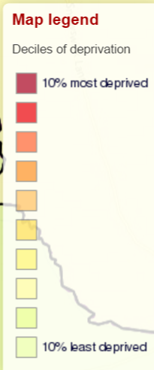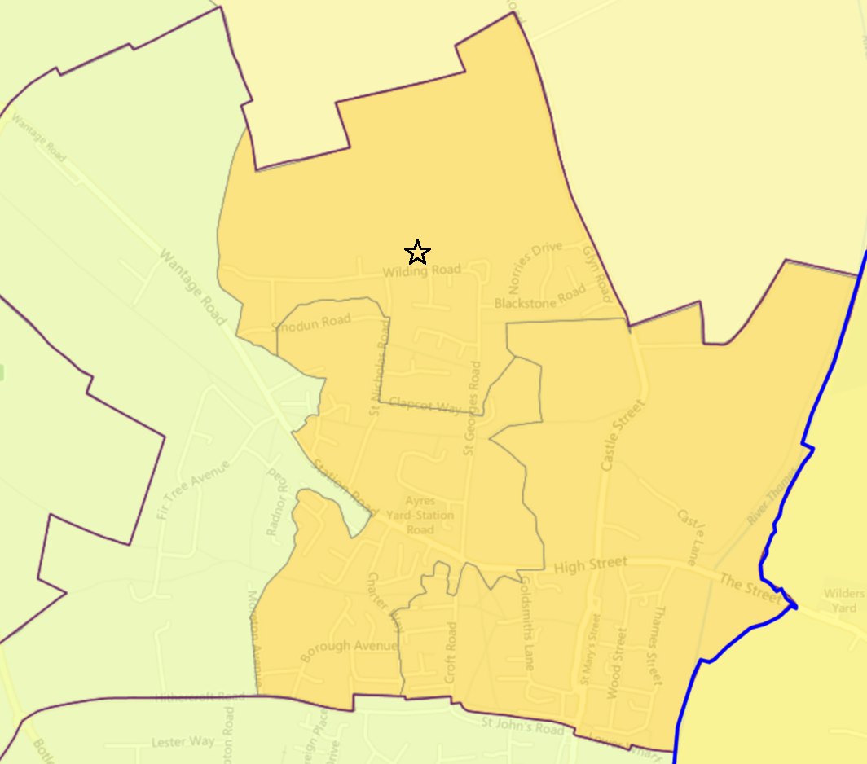

1. **Service Overview**

|  |  |  |
| --- | --- | --- |
| **Day Care** | **Transport** | **Social Care** |
| High Street  Wallingford  OX10 0DB  United Kingdom  Group: Oxfordshire County Council  Opening Times:  9.30 -12.30  12.30 -3.30  Male / Female Accepted: Male & Female  Care Offered: Elderly Care, Mental Health Condition, and Physical Disability.  Tel: 01865 897106  Email: [wallingfordcss@oxfordshire.gov.uk](mailto:wallingfordCSS@oxfordshire.gov.uk) | **97 Thames Travel** Wallingford - Dorchester - Berinsfield - Clifton Hampden - Long Wittenham - Didcot Mon-Sat 3 journeys.  **114 Thames Travel** Wallingford - Dorchester - Berinsfield - Culham - Abingdon Mon-Fri 1/2 journeys.  **125 Oxfordshire CC** Chalgrove - Watlington - Ewelme - Benson - Wallingford Wed/Fri 1 journey.  **126 Oxfordshire CC** Wallingford - Benson - Chalgrove - Stadhampton - Wallingford Wed/Fri 1 journey.  **131 Oxfordshire CC** East Hagbourne - Blewbury - The Moretons - Wallingford Wed/Fri 1 journey.  **135 Oxfordshire CC** Goring - Streatley - Moulsford - Wallingford Tue/Thu 2/3 journeys.  **135 Oxfordshire CC** Goring - Streatley - Moulsford - Wallingford Tue/Thu 2/3 journeys.  **139 Thames Travel** Wallingford - Benson - Nettlebed - Henley Mon-Sat 60 min.  **X2 Thames Travel** Oxford - Abingdon - Drayton - Steventon - Milton Park - Didcot - Wallingford Daily 60 mins.  **X39 Thames Travel** Oxford - Nuneham Courtenay - Shillingford - Wallingford - Reading Mon-Sat 60 mins.  **X40 Thames Travel** Oxford - Nuneham Courtenay - Shillingford - Wallingford - Woodcote - Reading Daily 60 mins. | **Soha Housing** has secured a European Social Fund grant to increase support to help people into employment and training. This support is to anyone living in Oxfordshire. They do not have to be a Soha tenant.  They can offer 1:1 employment support – Each applicant will receive an individual assessment of their needs to identify the right support to help them into employment. Any other needs and support required such as mental health, drugs or alcohol will be referred to specialist partner agencies. They work alongside these agencies to support applicants.  They can also help with Digital Inclusion - Guidance to ‘get online’ to help applicants search and apply for jobs and prepare for attending interviews, and Training - Individual training needs will be identified by our Employment Advisor, Digital Inclusion Officer and the referring agencies. All training commissioned will reflect the needs of clients to support them towards employment. Training is held at Soha’s head office, in the community and online. Anyone who may benefit from the service can ring or email for a referral form. [ri@soha.co.uk](mailto:ri@soha.co.uk).  01235 515900 or 0800 014 15 45 |
| **Tuesday Lunches. Wallingford Methodist Church**  **St. Leonard's Square,**  **Wallingford,**  **Oxon,**  **OX10 0AR**  Volunteers serve lunches in the Church Hall every Tuesday lunchtime on a first come first served basis.  Diners can choose a main course, sweet, or both, as well as options with baked potatoes.  A menu is displayed inside.   Lunch is served at 12:30 |  | **Style Acre**  Evenlode House, Howbery Park, Wallingford OX10 8BA  01235 519675  <http://www.styleacre.org.uk>  [info@styleacre.org.uk](mailto:info@styleacre.org.uk)  Style Acre provides day opportunities in Didcot, Wallingford and Banbury: supported living, work development and community involvement for adults with learning disabilities.  This includes Wantage Market Garden Project, Tea Rooms at Savages, and a charity shop in Wallingford.  No formal qualifications are required.  Training: Develop skills for home and for the workplace, self-confidence and independence. Develop different interests e.g. sports, arts and crafts, social activities etc. |

1. **Distance to Services**

|  |  |  |  |  |  |  |
| --- | --- | --- | --- | --- | --- | --- |
| Community | Barriers to Housing and Services | Geographical Barriers | Distance (km) to: |  |  |  |
| LSOA |  |  | PO | Food | GP | Primary school |
| Wallingford |  |  |  |  |  |  |
| E01028675 | 7 | 4 | **1.33** | 0.51 | **1.83** | 0.65 |
| E01028676 | 7 | 4 | **1.11** | 0.72 | **1.44** | 0.76 |
| E01028677 | 9 | 7 | 0.36 | 0.26 | 0.87 | 0.60 |

**SOURCE - Road distance to key services (km) in 2014 - IMD 2015 Barriers to Housing and Services Domain**

1. **Community Assets**

Library

Wallingford Library. 51 High Street, Wallingford Oxfordshire OX10 0DB. 01491 837395. Monday and Tuesday 9.30am - 5.30pm. Wednesday - Closed. Thursday 9.30am - 7.00pm. Friday9.30am - 5.30pm. Saturday 9.30am - 1pm. Sunday – Closed.

Post Office

Reynolds, 52 St Martins Street, Wallingford.

Markets

* Charter Market Every Friday, all day in the Market Place Wallingford’s oldest market, in operation since 12th Century. Includes everything from fish, meats, fruit and vegetables to jewellery, pet products and clothes.
* Country Market Every Friday, 8.30am – 12 noon in the in St Mary’s Church Selling a range of baked goods, preserves, eggs and honey, garden plants and produce, crafts and cards. All goods are homemade.
* Farmers Market. Every third Tuesday and fifth Saturday of the month 8.30am-1pm in the Market Place. From February the Market will also operate on every first Saturday. A range of local produce including meat, vegetables, baked goods, crafts and plants.
* Local Producers’ Market Every Saturday 10am-1pm in the now in St Marys Church. All products are grown, farmed, produced and crafted within a 30 mile radius of Wallingford. The produce includes meat, fruit and vegetables, bread, cheeses, wines, beers, sweets and desserts, ready prepared food, jams, preserves, plants and crafts including wood, knitting, jewellery, cosmetics, pottery, photography and painting. [www.wlpm.org.uk](http://www.wlpm.org.uk)

Wallingford Street Pastors

Back in 2011 19 volunteers from 6 churches in the area were commissioned and 15 of them set out for the first time with support from the assembled churches, police, town and district councils and our local MP. Since then new Street Pastors have been trained and some have transferred from other areas but they still welcome more volunteers. People have generally been pleased to see them, to stop for a chat and accept flip-flops and lollipops. For the first hour or two they do what Street Pastors do – they walk slowly around the town, picking up bottles and broken glass and just ‘be there’ for people. It gets a bit livelier after midnight when the late pubs close.  They’ve helped people who’ve been enjoying themselves too much and sometimes had to call an ambulance for people who needed medical attention. They’re currently out and about every Friday night from 22:00 to 02:00. <https://streetpastors.org/locations/wallingford>

**6. Community activity: overview**

|  |  |  |  |
| --- | --- | --- | --- |
| **Theme** | **Group and details** | **Contact** | **Notes** |
| Adults | **Oasis @ WBC.**  Thames Street  Wallingford OX10 0BH | Esther Mason 01491 824891 or Alan Rhodes 01491 839015  <http://wallingford.org.uk/Groups/265851/Oasis_WBC.aspx> | Oasis” is a group meeting most Thursday afternoons.  Starting many years ago as a group of “seniors”, there are now some younger people and Oasis is open to all men and women who would enjoy meeting together to worship and learn about God, be encouraged and stimulated by listening to interesting speakers and occasionally have the opportunity to share their own gifts and talents.  There is a “Holiday at Home” event over a week in early summer which normally includes outings, activities at the church and a meal together.  Lifts are offered to and from the meetings, trips and outings for those who cannot get there under their own steam and there is always a time of refreshment together. |
|  | **Wallingford Methodist Church**  St. Leonard's Square,  Wallingford  Oxon,  OX10 0AR | Rev Katherine Pickering  01235 813242  [Katherine.pickering@methodistchurch.org.uk](mailto:Katherine.pickering@methodistchurch.org.uk) | **Coffee Morning**  Every Thursday 10.30 am to 12 noon. Shoppers, visitors, members, all are welcome.  A problem trained Acorn Listeners will be in attendance if you have a problem you want to discuss.  **Loving Hands (Krafty Knitters).** The small group knitting for charity meets on Wednesday at 2.30 – 4.00pm (or any time in between). We have plenty of wool, needles and patterns, so why not bring a friend and come along for a relaxing and useful afternoon? More details contact Barbara Gosden 01235 834344 **Friendship Club.** This is open to anyone who is free in the afternoon and would like to meet with other people. It meets fortnightly at church, on Tuesday afternoons (2.30 - 4.0 p.m.). There is a mixed programme including talks on a variety of topics, holiday videos and informal discussions, followed by refreshments. Occasional outings are also arranged.  **House Groups.** There are a number of groups meeting, in both Wallingford and Shillingford, usually meeting on Wednesdays in peoples’ homes.  Wednesday morning the Bloc Brazilian Group meets in the church lounge. All these groups have Discussion, bible study, prayer and fellowship. Contact The Minister**.**  **Gap,** meets alternate Wednesdays. Aimed at 30 - 55 year olds it explores how to express our Christian faith in a contemporary culture.  **Wesley Guild.** The Guild meets fortnightly from October until May, at church, on Tuesday evenings (7.30 p.m.). After a time of opening worship, the meetings take a variety of different forms. Speakers are invited to talk on a range of subjects; there are also informal evenings run by the members. |
|  | **St. Mary-Le-More**  22 Castle St, Wallingford OX10 8DW | <http://marylemore.co.uk>  The Revd. David Rice  22 Castle Street  Wallingford, Oxfordshire  OX10 8DW  Tel 01491 202188  [rector@marylemore.co.uk](mailto:rector@marylemore.co.uk)  Women’s Fellowship – Milli Eaton – 01491 835689  Kathy Dunn – 01491 835846 | **Church Women’s Fellowship.**  4th Monday of month 14.30 – 16.30. At St Mary’s or home of host.  **Coffee**  In St Mary’s. 10.00 – Noon. Mon, Fri and Saturday. |
|  | **“Wallingford Dads with Bikes”** 7.30am in Wallingford Market square on a Saturday. | Michael Higgin 0773 813 5593 | If you are an intermediate road cyclist, you are invited to join a weekly ride every Saturday from the Market Place. The ride starts at 7.30am and aims to finish at around 9.30am, covering about 50km. |
| Children | **Youth @ WBC**  Baptist Church  Thames Street  Wallingford OX10 0BH | <http://wallingford.org.uk/Groups>  [info@wallingfordbaptist.co.uk](mailto:info@wallingfordbaptist.co.uk)    01491 839904 | **ROC Youth Club**  ROC youth club is on every Friday night (term time) for those in Years 7-9 at Wallingford Baptist Church.  There are lots of games and activities in the main area, and table-football and table tennis are available in the school room.  There are also trips out on occasions such as bowling or swimming.  **Youth Life Group**  Youth Life Group (YLG) is the small group (life group) for young people in years 9 to 13. Meet mainly in the leaders' homes and sometimes at church. Meet every Sunday night (during term time) and it's a mixture of Bible study, discussion and socialising. Also watch films and discuss them over pizza. The aim is to explore the Christian Faith and our place in the world, whilst supporting each other in our Christian journeys.  Zoe or Sam Whitmarsh [youth@wallingfordbaptist.co.uk](mailto:youth@wallingfordbaptist.co.uk)  **Toddlers @ WBC**  Toddlers runs from 10am-11.30am every Tuesday during school term time. There are 2 rooms full of toys suitable from babies up to pre-school age children. Sometimes have craft activities and at around 10:50am each week we have a story-time and singing lead by Pastor Simon and members of the Toddlers Committee.  From time to time Parenting Courses are run and groups which explore what Christians believe. |
|  | **Wallingford Methodist Church**  St. Leonard's Square,  Wallingford  Oxon,  OX10 0AR | Shirley. 07712524150 or [webmaster@wallingfordmethodistchurch.org.uk](mailto:webmaster@wallingfordmethodistchurch.org.uk) | **Tots’ Time**  Every Wednesday in term time. . An opportunity for mums, dads, and carers of children 0 - 4 yrs. To meet. Contact Shirley Tel. No. 07712524150  Wednesday 9.30 -11am.   This is held in the Hall. |
|  | **St. Mary-Le-More**  22 Castle St, Wallingford OX10 8DW | Jennie Bispham – 01491 826223 | **Baby Singing Group**  Wednesday in term time. 09.30 – 11.00  **Toddler’s Group.**  Wednesday in term time 10.00 – 11.30 |
|  | **Oxfordshire GG** | [www.oxfordshiregirlguiding.org.uk](http://www.oxfordshiregirlguiding.org.uk)  0800 169 5901  [www.oxfordshiregirlguiding.org.uk](http://www.oxfordshiregirlguiding.org.uk)  Ann Goddard Divisional President 836236 |  |
|  | **Scouting**  **2nd Wallingford Scout Group**  25 Allnatt Ave, Wallingford OX10 0 | The 2nd Wallingford Scout Hut is on land called Station Fields at the base of the water tower, off Station Road in Wallingford.  [membership@2ndwallingfordscouts.org.uk](mailto:membership@2ndwallingfordscouts.org.uk).  <http://2ndwallingfordscouts.org.uk> | **Beaver Scouts** - boys and girls aged 6 to 8 years. Beaver Colony meets on Tuesdays from 4.15pm to 5.15pm.  The Group has **two Cub Packs** for boys and girls aged 8 to 10½ years.  **RAMA** – which meets on Tuesday evenings from 5.45pm to 7.30pm  **SEEONEE** – which meets on Wednesday evenings from 6.00pm to 7.30pm.  The Group also has two **Scout Troops** for boys and girls aged 10½ to 14 years.  **SILVATICA** – which meets on Monday evenings 7.00pm to 9.00pm  **INFERNO** – which meets on Thursday evenings 7.00pm to 9.00pm.  **Explorer Scouts** aged 14 to 18 years meet on Tuesday evenings from 8.00pm to 9.30pm. |
|  | **966 Wallingford Sqn ATC**  Thames St  Wallingford  Oxfordshire  OX10 0BH  Parade Nights: Tue & Thur 1900-2130 | 01491 201968  <http://966atc.org.uk> | The minimum joining age is 12 years (+school year 8) |
|  | **Wallingford Army Cadets.**  **Wallingford Detachment**  Old TA Centre, Old TA Centre, Thames Street, Wallingford, Oxfordshire , OX10 9HD | <https://armycadets.com/county/oxfordshire-acf/our-locations>  SMI M Quigley 07780360455 or 682148 | Wednesday: 1930-2130 |
| General | **Riverside Park and Pools Wallingford**Mon - Sun  09:00 - 20:00 | Crowmarsh Gifford  Wallingford  OXON  OX10 8EB  02038598208 or 07780974413 | Riverside Campsite and Heated Outdoor Pool is located adjacent to the River Thames between Crowmarsh Gifford and Wallingford. The Riverside Jubilee Splash Park makes water fun for children of all ages. The Feature encourages learning as well as the excitement of splashing water. |
|  | **St. Mary-Le-More.**  22 Castle St, Wallingford OX10 8DW | **Bellringing**  Tower captain Chris Tuckett 01491 659091 [christopher.tuckett@gmail.com](mailto:christopher.tuckett@gmail.com)  Tower secretary is Jo Gamester [wallingford@onb.org.uk](mailto:wallingford@onb.org.uk)  **Choir**  [www.wallingfordchoirs.org.uk](http://www.wallingfordchoirs.org.uk) | **Bellringing**  The present band comprises a very wide range of both age and ability and they ring variously from rounds & call changes to surprise depending on who is present. There is a weekly practice every Thursday from 7.45-9.30pm. Sunday ringing is from 9.30-10am, and from 6-6.30pm.  **Choir**  Wallingford Parish Church has a fun band and a thriving choir with over 50 members, including 20+ juniors. They rehearse on Friday evenings and sing weekly services at St Mary’s and St Leonard’s Churches as well as at weddings, civic services, etc. Wallingford is one of a limited number of parishes that maintain a tradition of sung weekly Evensong services. These services are normally held at 6.30pm on Sunday at St Leonard’s church, and feature sung responses, canticles, an anthem, and hymns from Ancient and Modern, Revised. At a monthly choral evensong the choir also sings the canticles to a special setting. |
|  | **Wallingford Allotments & Gardens Society.**  The Trading Store is in the courtyard of Centre 70, off the Kine Croft, Wallingford  It is open most Saturday mornings most months. | <http://www.wags-wallingford.com> | Wallingford Town Council allocates allotments in Wallingford.  WAGS Membership entitles you to:  Purchase items from the Trading Store at prices a little above cost.  Order Dobies Seeds at huge discounts  Order tools and equipment at discounted prices  Obtain discounts at some local garden related businesses  Receive a quarterly Newsletter by e-mail, or in printed form if required  Take part in all classes in the Autumn Show  Take part in organised coach trips to gardens of interest when available |
|  | **Didcot & Wallingford Ramblers** | <http://www.ramblers.org.uk/go-walking/group-finder/areas/oxfordshire/groups/didcot-and-wallingford.aspx> | The Didcot & Wallingford group contributes over 50 walks a year to the area programme, as well as arranging an annual weekend away in various locations in England and Wales. New walkers and potential members are always welcome. |
| Sports | **Wallingford Rugby Club**  The Hithercroft Sports Park,  Hithercroft Road  WallingfordOX10 9RB | <https://www.wallingfordrugbyclub.com>  [rugbywallingford@gmail.com](mailto:rugbywallingford@gmail.com) | **Start Rugby**  From age 4  **Mini Rugby**  U6 to U12  **Junior Rugby**  U13 to U16  **Maidens: Girls Rugby**  **Teams** at U13, U15 & U18  **Senior Development Squad**  U17 to U21  **2nd XV**  League: Berks/Bucks & Oxon 3  **1st XV**  League: Southern Counties North  **Touch**  Registered ‘O2 Touch’ Club |
|  | **Wallingford Hockey Club**  Wallingford Sports Park. Hithercroft Road. Wallingford OxfordshireOX10 9RB | 01491 835044  [info@wallingfordhc.org.uk](mailto:info@wallingfordhc.org.uk)  Ladies Club Captain: Philippa Morris  [ladiesclubcaptain@wallingfordhc.org.uk](mailto:ladiesclubcaptain@wallingfordhc.org.uk)  Men’s Club Captain: Jonny Chitty  [mensclubcaptain@wallingfordhc.org.uk](mailto:mensclubcaptain@wallingfordhc.org.uk) | There are 5 men's teams, 4 ladies' teams many boys' and girls' teams. Playing ranges from regional hockey to a very much slower pace of the game.  The Wildcats coaching takes in boys and girls from age 5. There are also players in their 70’s. |
|  | **ABM Skittles**  Wallingford Sports Park. Hithercroft Road. WallingfordOxfordshireOX10 9RB | 01491 835044  <http://www.abmskittles.com> |  |
|  | **Hithercroft Squash Club**  Wallingford Sports Park. Hithercroft Road. WallingfordOxfordshireOX10 9RB | <https://www.hithercroftsquash.com>  General Enquiries  [hithercroftsquash@gmail.com](mailto:hithercroftsquash@gmail.com)  Membership enquiries  Jerry Marshall - [jmarshall@tagaviation.co.uk](mailto:jmarshall@tagaviation.co.uk)  Coaching  Neil Thompson - [hithercroftsquash@yahoo.co.uk](mailto:hithercroftsquash@yahoo.co.uk)  Team squash  Anyone wanting to play team squash in the Oxfordshire  league please contact:  Club Captain: Graham Taylor    [graham.taylor@aksward.com](mailto:graham.taylor@aksward.com) | Non-members are encouraged to go to club night on Monday evenings.  It is a members only club and caters for all levels of experience and involvement; from casual off peak membership to ladies and men’s team squash in the Oxfordshire leagues and the Berkshire veterans league.  There are 3 courts, one of which is glass-backed. They mainly play squash, but also encourage people to play Racket Ball and have Table Tennis equipment.  Team matches in the Oxfordshire leagues regularly take place on Tuesday, Wednesday or Thursday evenings from 7:30pm depending on the fixture schedule.  There are three men’s' teams and one ladies' team playing throughout the year.  It is one of a few squash clubs in Oxfordshire that has a Coach. Neil Thompson is the general fitness trainer and club squash coach and can be booked by members and non-members alike. Young people, triathletes, hockey players as well as squash training - Neil will help you attain the fitness level you desire. |
|  | **Portcullis Tennis Club.**  Wallingford Sports Park. Hithercroft Road. Wallingford  OxfordshireOX10 9RB | <https://clubspark.lta.org.uk/portcullistennisclub>  Coaching enquiries - 0800 888 6030 [portcullis@ctatennis.org](mailto:portcullis@ctatennis.org)  Club Coach (Richard Myall) - 07515 353948 [richard.myall@ctatennis.org](mailto:richard.myall@ctatennis.org)  Membership enquiries (Nicola) - 07739 407259  General enquiries contact (Kay) - 07801 233660  Adult Rusty Rackets & Beginner Coaching (Monday 9 - 10am, Liz) -  [Liz_btc@yahoo.co.uk](mailto:Liz_btc@yahoo.co.uk) | This is a Tennismark accredited club with over 200 members. There are 5 all-weather hard courts and floodlight facilities The club competes in various county competitions at all ages and abilities.  Portcullis has a resident coach, provided by Community Tennis Association, and a thriving junior section. |
|  | **Wallingford Castle Archers**  Wallingford Sports Park. Hithercroft Road. WallingfordOxfordshireOX10 9RB |  | **Outdoor shooting**  Sessions run from 1.30pm to 6pm every Sunday, and from 6pm on Wednesdays and Fridays. Outdoor sessions run from April to September.  13:30-15:00 Sundays – Junior session. Only junior members will be allowed to shoot, along - side any parents, space permitting.  15:00-18:00 Sundays – Open session. All members welcome, but under 18s must be supervised by an adult.  18:00-dusk Wednesdays – open session. Juniors welcome but parents or guardians must be present.  18:00-dusk Wednesdays – squad session. Squad training takes place alongside the open session on a separate range. If you are interested in being considered for squad membership, please speak to Marc or Charlie at a session.  18:00-dusk Fridays – open session. Juniors are not required to be supervised.  **Indoor shooting.** October to March. The indoor range is based at Wallingford School, in the Castle Sports Hall.  Sessions run from 10am to 4pm every Sunday, and from 6pm to 9pm every Friday  10:00-11:30 Sundays – Beginners course or alternative coaching session  11:30-13:00 Sundays – Junior session. Only junior members will be allowed to shoot, along - side any parents, space permitting.  13:00-16:00 Sundays – Open session. All members welcome, but under 18s must be supervised by an adult.  18:00-19:30 Fridays – Open session. Juniors are not required to be supervised.  19:30-21:00 Fridays – Squad session. Only squad members are allowed to shoot. If you are interested in being considered for squad membership, please speak to Marc or Charlie at a session. |
|  | **Wallingford Town FC.**  Wallingford Sports Park. Hithercroft Road. WallingfordOxfordshireOX10 9RB | <https://www.clubwebsite.co.uk/wallingfordtown> | An open age football club with three teams competing for honours in the North Berks Football League.    The first team play in Division 1 and the reserve team will be playing in Division 3 next season.  The A Team plays in Division 5 acts as a development squad and creates a platform for young players new to Adult Football to develop the craft and confidence to progress into the higher leagues  Facilities include three excellent pitches, a floodlit stadium and training area.  All our squads train together on Tuesday evenings. |

**7. Summary of key local issues – to be discussed with Town Council**

The Children’s centre received transition funding and funding from town council to remain open for next three years

**Potential mitigation projects**

|  |
| --- |
| * Supporting groups after recent closure of the Regal Centre by the Town Council. The centre provided space for leisure, community and market-trading activities * Town Council are currently undertaking a Neighbourhood plan |

1.
2.