

Upper & Lower Heyford - Community Profile: July 2017

1. **Map and Overview**

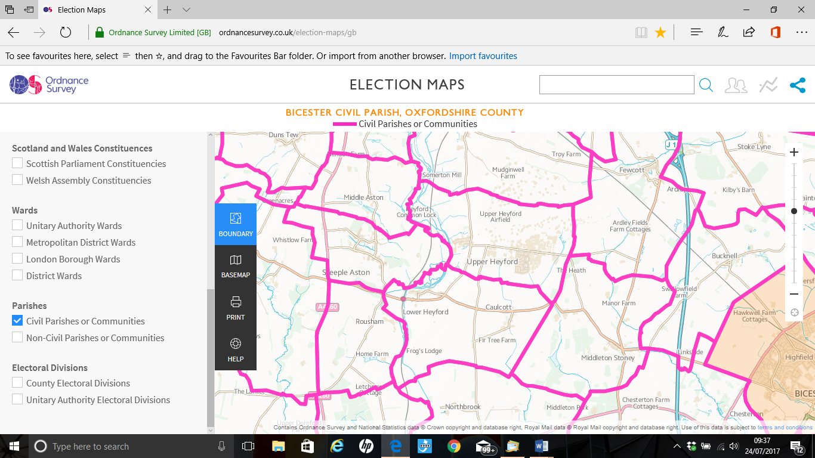

Upper & Lower Heyford Parish (Source: Ordnance Survey Election Maps)

Overview

* Upper Heyford is a small village about 6 miles northwest of Bicester in Oxfordshire. It is located on the east bank of the River Cherwell. ‘Upper’ distinguishes it from Lower Heyford which is about 1 mile ‘lower’ downstream along the Cherwell valley.
* The village has access to the Oxford canal from Allens Lane (at Allens Lock) which runs parallel to the River Cherwell. The canal flows from Banbury and Somerton to the north towards Lower Heyford and Oxford to the south. The village is surrounded by working farmland, some arable and some livestock.
* The village comprises just over 100 homes: a mixture of original 1700s and 1800s Cotswold stone cottages, converted barns, stone-brick houses, 1950s and ’60s brick bungalows and rendered houses. The most recent houses have Cotswold stone exteriors, more in keeping with the village’s character.
* The village green is overlooked by the old school, now a private house. The village has allotments, sports ground (home of Heyford United football team), village hall, children’s playground, and The Barley Mow public house.1
* Lower Heyford and Caulcott are 15 minutes from Bicester Village.
* The Astons and Heyfords parish population at the time of the 2011 Census was 4,942. Both the proportion and absolute number of those aged over 65 is expected to continue to increase over the coming decades. 2
* Ward forecasts for the Parish supplied by Oxfordshire County Council predict the population of this age group will increase by 110% in the 15 years from 2011 to 2026. The forecast of the total Astons and Heyfords population in 2026 is 6,224.
* About 1 mile (1.6 km) to the east of the village is the former RAF Upper Heyford airbase. Much of the projected increase in population is due to the development on this former airbase where over 700 homes are programmed to be built. The plan proposed the protection of most of the historic elements of the airbase.
* The base was used by the RAF from the 1920s as a bomber base, then in the 1950s assigned to the USAF. Since its closure in 1994, the base has become an industrial and commercial estate of some importance. The runway (once the second longest in Europe) is used to store new cars awaiting delivery to dealers. Several relics from the cold war remain such as the disused bunkers, water towers, huts and fences. There is a large number of ex-service houses immediately south of the base/industrial area which are rented.
* Cherwell DC local plan requires that Heyford Park takes its share of the new housing. Heyford Park is being developed by Dorchester Group as the main buider along with other smaller developers – there will be an additional 1600 houses between now and 2031. This is in addition to the 1100 new houses already approved, some of which are under construction, and the 300 or so existing house.

Thus by 2031 Heyford Park will have 3000 houses. The population will be roughly 9000 – making it a large village.

1 [http://upperheyford.com/](mailto:upnoverdtc@gmail.com)

2 [http://insight.oxfordshire.gov.uk/cms/oxfordshire-county-council-population-forecasts-january-2014-excel-format](mailto:Sharon.keenuk@gmail.com)

School

Heyford Park Free School opened in 2013 as part of Dorchester Group developement and includes a newly refurbished indoor sports centre and outdoor pitches available for community use as well as the school. It is a small and inclusive all-through Free School that takes students from the age of 4 through to 19.

Services

* Buses. Thames Travel have taken over running the local bus routes from Heyfordian.

Buses 25 and 25A carry passengers from Upper Heyford to Bicester and Oxford.

* Trains. Heyford. Trains from here are operated by First Great Western. This station is unmanned, and an infrequent service runs between Banbury and London Paddington, usually requiring changes at Oxford, Didcot Parkway or Reading.
* Volunteer Connect, which is supported by Cherwell District Council, runs a volunteer transport scheme that helps people with problems accessing public transport and who cannot get to important appointments.
* Oxfordshire Comet. This is a bookable transport service from Oxfordshire County Council, available for people in Upper Heyford Parish who do not have access to suitable public transport.

Doctors

Residents of Upper and Lower Heyford fall within the catchment area of Deddington Health Centre.

Parish Council

* **Upper Heyford Parish Council** meetings are held on Thursday evenings, in Upper Heyford Reading Room or the Conference Room at Heyford Park Community Centre at 7:15 pm. Meetings are open to the public. The Parish Council welcomes community participation. Clerk Jack Goodman Jr: 07791-399823 Email: [uhparishclerk@gmail.com](mailto:anneandwill@btinternet.com)
* The **Lower Heyford and Caulcott Parish Council** meetings are usually held on the 3rd Thursday of each month at 7.00pm in the Church. All villagers are very welcome to attend.

Minutes and agendas are available by e-mail [parishclerk.lowerheyford@gmail.com](https://sites.google.com/site/upnoverdtc/home)

Halls for Hire

|  |  |
| --- | --- |
| **Hall for Hire** | **Contact details** |
| **Church of England (Heyford Park Chapel)** | The Chapel can be booked for functions as can a smaller room for up to 12 people. You can also book the cafe (seating about 25 people) along with its kitchen.  Barbara MacGarry 01869 233687 (mornings) |
| **Heyford Park Community Centre.**  Brice Road, Bicester, Oxfordshire OX25 5TE | Ian Ridley at the Centre (mornings) or message him on the Heyford Park Village Facebook page. |
| **Sports Centre & Playing Fields.**  [74 Camp Road, Upper Heyford OX25 5HD](http://upperheyford.com/?lid=YN1029x10979686959516018327&id=YN1029x10979686959516018327&q=Heyford+Park+Free+School&name=Heyford+Park+Free+School&cp=51.9294013977051~-1.2521630525589&ppois=51.9294013977051_-1.2521630525589_Heyford+Park+Free+School&FORM=SNAPST) | Sports Centre and Gym on 01869 232203  [lettings@heyfordparkfreeschool.org](http://insight.oxfordshire.gov.uk/cms/oxfordshire-county-council-population-forecasts-january-2014-excel-format) [gym@heyfordparkfreeschool.org](http://www.buckstkdacademy.co.uk/) |
| **Upper Heyford Village Hall**. Somerton Road, Upper Heyford, Bicester, Oxfordshire OX25 5LB. | Marlene Bibani: [vhhire@upperheyford.com](https://www.facebook.com/groups/483806938394576/)  01869 232668 |
| **Upper Heyford Reading Room.** The Green, Upper Heyford, Bicester, Oxfordshire OX25 5LG | Barry Parsons: [rrhire@upperheyford.com](mailto:info@heyfordparkscouts.org.uk)  07557 941534. |

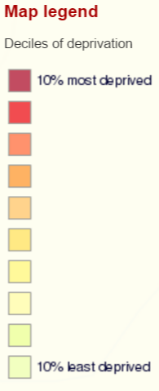

1. 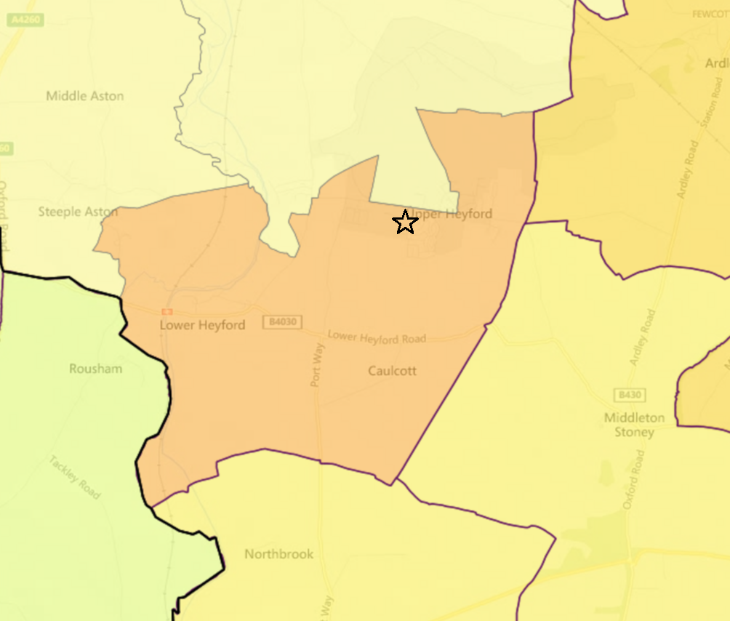**Areas of Deprivation**



**SOURCE- Index of Multiple Deprivation 2015 Deciles (where 1 is most deprived 10% of small areas - LSOAs)**

1. **Service Overview**

|  |  |
| --- | --- |
| **Transport** | **Service Care** |
| **Free Hospital Transport**  Free transport to the Horton, John Radcliffe and Churchill Hospitals is available for some patients who don’t have access to their own transport, and where there is no available public transport.  The scheme is administered by the Patient Contact Centre for the Oxford Radcliffe Hospitals Trust. Booking must be made 48 hours in advance.  Contact: 0845 330 8888  [orh.appointments@orh.nhs.uk](mailto:tealrain@hotmail.co.uk).  **Oxfordshire Comet**  The new bookable transport service from Oxfordshire County Council, available for people in Upper Heyford Parish who do not have access to suitable public transport.   * Wherever you need to be in Oxfordshire, the Comet can get you there. * The Comet can do one-off journeys, regular and group trips. Regular routes for local communities, similar to a bus route can be offered.   The service is available 10.15am – 2.30pm Monday to Friday  *Costs will vary based on your journey and travel type*  To book a journey call: 01865 323201  For full terms and conditions visit: [www.oxfordshire.gov.uk/cms/content/oxfordshire-comet](http://www.heyfordparkresidents.org.uk)  **Thames Travel** have taken over running the local bus routes from Heyfordian.  Buses 25 and 25A carry passengers from Upper Heyford to Bicester and Oxford.  The bus stops are located just beyond the crossroads on Camp Road.  **Heyford Station**  Trains from here are operated by First Great Western. This station is unmanned, and an infrequent service runs between Banbury and London Paddington, usually requiring changes at Oxford, Didcot Parkway or Reading. Visit the websites below for times, fares and real time information (to find the station, search for Heyford, not Lower Heyford).  **Contact** Website: [www.firstgreatwestern.co.uk](mailto:sarahmediabird@icloud.com)  National Rail: Website: [www.nationalrail.co.uk](mailto:orh.appointments@orh.nhs.uk) Tel: 08457 484950  **Cherwell Rail Users’ Group** (CRUG) represents the views of people travelling on this line. For more information, email [crug1@btinternet.com](mailto:allenjoke@aol.com), or phone the chairman Chris Bates on 01295 758325.  **Volunteer Connect**  This is supported by Cherwell District Council, runs a volunteer transport scheme that helps people with problems accessing public transport and who cannot get to important appointments.  If help is needed getting to the doctor, hospitals, dentist, other medical appointments, etc. A local, vetted volunteer driver will be provided.  The price is 45p per mile to cover the cost of petrol. Call 0300 3030 125 for help with a journey, or to register. | **Clean Slate**  Clean Slate is a charity aiming to provide support to men and women with the suffering from the effects of childhood and domestic abuse, and assists in dealing with the issues around mental ill health. There are 4 different services catering to different age and gender groups.  What is offered in each of the services:   * One to one support * Counselling * Social events and outings * Exercise and healthy living support * Advocacy and practical support * Outreach Services * Crisis Management * Free Courses   **Contact** The Chapel, Brice Road Heyford Park Bicester Oxon OX25 5TE  Tel: 01869 232461 Mobile: 07825 630203 Email: [office@cleanslate.org.uk](mailto:suewatson20@btinternet.com) Website: [www.cleanslate.org.uk](mailto:historicalsociety@upperheyford.com)  **Lower Heyford Relief in Need Charity (LHRNC)** is a long established charity in the Parish. It derives its income from the rent of property and agricultural land in the Parish. This income is used to assist persons in times of genuine need or financial hardship as well as supporting projects which benefit people living in Lower Heyford and Caulcott.  An example is the Educational Grants for Young Persons. These are aimed at young people aged between 16 and 25 from Lower Heyford or Caulcott who are planning to continue their education through College or University or through other forms of Training or an Apprenticeship.  The Charity’s principal aim remains providing financial help to residents of the villages who can demonstrate a real and unavoidable need. If anyone is suffering from financial hardship and has to meet an unexpected expense then the Trustees of LHRNC may be able to make a contribution towards the cost.  All enquiries and assistance will have complete confidentiality and be considered on individual merit. To see if eligible  contact any of the Trustees they all live in Lower Heyford:  Ms Sarah Edwards (Trustee) – [sarahmediabird@icloud.com](mailto:gym@heyfordparkfreeschool.org)  Dr Liz Goodwin (Clerk) – 01869 349950 – [liz_goodwin@ymail.com](mailto:vhhire@upperheyford.com)  Mr Leigh Thompson (Trustee) – 01869 347042 – [leighthompson1@btinternet.com](mailto:rrhire@upperheyford.com)  Dr Susan Watson (Chair) – 01869 347251 – [suewatson20@btinternet.com](mailto:emma@aspiredance.co.uk) |

1. **Distance to Services**

|  |  |  |  |  |  |  |
| --- | --- | --- | --- | --- | --- | --- |
| Community | Barriers to Housing and Services | Geographical Barriers | Distance (km) to: |  |  |  |
| LSOA |  |  | PO | Food | GP | Primary school |
| Upper and Lower Heyford |  |  |  |  |  |  |
| E01028505 | **1** | **1** | **2.27** | **1.39** | **9.38** | **4.06** |

## 

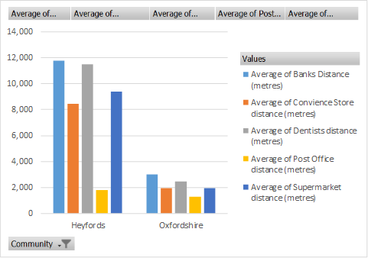

Source – Road distance to key services (km) in 2014. IMD 2015 Barriers to Housing and Services domain

**5. Community Assets**

Potential Hall. – The Lower Heyford Village Hall Fund holds the proceeds of disposal of the former village hall in trust for the benefit of the whole community, subject to the Trust Deed provisions. Whilst the original intention was to provide a replacement hall on the playing field the Parish Plan in 2011 indicated that this was not what the majority of residents wanted, but instead they wished to concentrate on improved facilities in the church and the sports and social club. This fund has now existed for some years the Committee is keen to establish where appropriate investments are to be made and hopes to do this within the next year or two.

Upper Heyford Village Hall. - Having recently been restored the Village Hall offers a capacity for 100 standing, 90 seated theatre style & 80 seated at tables and these capacities can be increased if a marquee is erected at the side of the building. The Hall is located on Somerton Road and opens onto the recreation area, which has an enclosed child’s play area. The building is regularly hired for private events. Exercise, martial arts, yoga & art classes meet here, a number of social clubs use the space and is the chosen venue for the annual fund raising events including Flower Show, Quiz Night, Race Night, Friendship Evening and Bonfire Night.

Upper Heyford Reading Room. - Having recently been restored the Reading Room offers a capacity for 60 standing, 50 seated theatre style or 36 seated at tables, plus up to five servers. Parking facilities are limited and due to its residential location hirers are asked to keep noise at a reasonable level, particularly after 8pm.The building is located next to the village green & benefits from having a small play area next to it, designed for toddlers & young children.

Heyford Park. - **Shop & Café**. In the Community Centre, Brice Road. **Shop Opening Hours** Monday to Friday 06.45 to 17.00; Saturday 08.00 to 13.00; Sunday 10.00 to 12.00.01869 233976 **Cafe Opening Hours.** Monday, Tuesday, Thursday and Friday 07.00 to 14.15; Wednesday 09.15 to 14.15; Saturday 08.00 to 11.00; Sunday – closed.

Lower Heyford - Has a small shop selling basics at the boatyard in Lower Heyford. Open from 9 till 4 including weekends, but times may vary. Phone 01869 340348.

As part of the new development there will be a new community centre, shops, restaurants and other amenities.

**6. Community activity: overview**

|  |  |  |  |
| --- | --- | --- | --- |
| **Theme** | **Group and details** | **Contact** | **Notes** |
| **Adult** | **Adult Street Dance.**  Every Wednesday 7.30 to 8.30 p.m. in the Sports Centre, Izzard Road. £5 per session | [dave@jinglesstreetdance.co.uk](http://upperheyford.com/public-services/www.nationalrail.co.uk)  [www.jinglesstreetdance.co.uk](mailto:ianloughscott@btinternet.com?u=http://www.jinglesstreetdance.co.uk/&h=9AQE2Qlit)  07814 142658 |  |
|  | **Boxercise for Women.**  20.15 to 21.15 on Tuesdays at the Free School. | 07979 524923  [felicity@felicitywood.co.uk](https://www.bing.com/local)  [felicitywood.co.uk](mailto:lettings@heyfordparkfreeschool.org) |  |
|  | **Dru Yoga**  **Fitness and wellbeing. E**very Tuesday from 10.30am to 12.00pm at the Community Centre in Heyford Park. | [www.facebook.com/raisinyoga](mailto:healthyheyford@aol.com)  [www.raisinyoga.co.uk](mailto:liz_goodwin@ymail.com) [raisinloaf@yahoo.co.uk](mailto:crug1@btinternet.com)  07832 382229 |  |
|  | **Hatha Yoga & Pregnancy Yoga**  Tuesdays 7-8 in the Sports Centre, Izzard Road | 07980 304590 |  |
|  | **Latin & Ballroom Dancing.**  Step by Step Dance School  Friday evenings in the Community Centre. | [cameron@danceschool-stepbystep.com](mailto:office@cleanslate.org.uk)  Cameron Wishart – 07809 213882 |  |
|  | **Parenting Group** | [https://www.facebook.com/groups/411233602359047/](http://upperheyford.com/public-services/www.cleanslate.org.uk) |  |
|  | **The Heyfords W.I**  meet on the third Wednesday of the month in The Reading Room, School Lane, Upper Heyford at 7.30pm | Denise Ball – 01869 343364 | The Heyfords WI is a group of local women who meet socially each month. |
|  | **Upper Heyford Village Group** | Simon 01869 233664. | This group exists to consider and react to the development and proposals at Heyford Park. |
|  | **Watercolour Painting Classes** | Jo on 01869 232291 or 07734 562028. | Beginners Watercolour Painting Class with a local landscape artist David Meeks in Upper Heyford. |
|  | **Weekly Art and Craft Sessions.**  Thursdays 10-12 at the Upper Heyford Reading Room. |  |  |
|  | **Weekly Morning Walks around the Cherwell Valley.**  Every Monday, 10.00am-12noon –usually meeting at Upper Heyford Village Hall car park at 10.00am | Jo [healthyheyford@aol.com](mailto:uhparishclerk@gmail.com), 01869 232291 or 07734 562028. | The walks are between 3 and 5 miles, at a leisurely pace over fields, and take about 2 hrs. |
| **Children** | **Epic**  For 9 – 13 year olds meets in the Chapel at 6.45 – 8.30 p.m. on Fridays. | Sally Anne Mildenhall – 07778 431165 |  |
|  | **Heyford Ark**  Parent & Baby group in the Chapel  10 – 11.30 on Wednesdays during term time**.** |  |  |
|  | **Kids’ Church**  For 5 – 9 year olds meets in the Chapel at 4.30 – 6.15 p.m. on Fridays. | Sally Anne Mildenhall – 07778 431165 |  |
|  | **Scouting**  **Beavers** (5-7 years) meet on Monday 17:00 – 18:00.  **Cubs** (7-10 years) meet Monday 18:15 – 19:45.  **Scouts** (11-14 years) meet on a Monday evening 19:00 – 21:00. | **Beaver and Cubs contact:**  e-mail: [elainejanerobinson@hotmail.co.uk](mailto:felicity@felicitywood.co.uk)  Elaine Robinson 01869 232886  **Scouts contact:**  e-mail [info@heyfordparkscouts.org.uk](mailto:Adrian-tkd@hotmail.com.uk)  Nigel Heinrich – 01869 233383 |  |
|  | **Youth Club**  Meets Wednesdays at 6 p.m. in the Chapel for 13-18 year olds. | Sally Anne Mildenhall – 07778 431165 |  |
| **General** | **Art Classes**  Tuesdays from 1 till 3 p.m. in the Chapel, Heyford Park. | Nuala Francis |  |
|  | **Book Group**  **Upper Heyford Book Group.** Meets in or around Wellington Road on the second Monday of each month. | [**uhbookgroup@gmail.com**](http://upperheyford.com/public-services/www.firstgreatwestern.co.uk) |  |
|  | **Community Garden**  Brice Road, opposite the Chapel | Sharon Keen 01869 232880  [http://hpcommgarden.wix.com/garden](mailto:dave@jinglesstreetdance.co.uk)  [https://www.facebook.com/heyfordparkcommunitygarden?fref=ts](mailto:parishclerk.lowerheyford@gmail.com?fref=ts)  [hpcommgarden@gmail.com](mailto:cameron@danceschool-stepbystep.com) | A place to rest, to meet with friends, have picnics, take the family. The garden has a large barbecue which is available for use by anyone by arrangement. |
|  | **Heyford Loose Ends**  Chatty Crafty Group 10 am-1 pm every Monday in the Chapel. |  |  |
|  | **Heyford Park Residents**  Has monthly committee meetings.  Building 549, Brice Road, Bicester, Oxfordshire OX25 5TE | http://www.heyfordparkresidents.org.uk  [hprcda@gmail.com](https://www.facebook.com/raisinyoga)  01869 23261 | The Heyford Park Residents & Community Development Association has been in existence for almost 10 years now. The main objective is to look after the collective interests of all residents who live at (and groups which operate from) Heyford Park. |
|  | **Lower Heyford Bowls Club**. B4030. Upper Heyford. | FB Lower Heyford Bowls Club  Secretary, Sharon Keen at [**Sharon.keenuk@gmail.com**](http://www.raisinyoga.co.uk/) | All ages and abilities are welcome, pro, semi-pro, able-bodied, not so able, men, women, and children. |
|  | **Up and Over Dog Training** | [https://sites.google.com/site/upnoverdtc/home](mailto:leighthompson1@btinternet.com)  [upnoverdtc@gmail.com](mailto:uhbookgroup@gmail.com)  01280 703121 9am-7pm Mon-Fri | Wide range of classes at various times on the airbase at Gate 7. |
|  | **Upper Heyford Poetry Group.**  Meets in member’s homes. 20.00 to 22.00. Meetings are held once a fortnight during school term times. | Heather and Roger Burt Tel: 01869 232770  Alan Hedges Tel: 01869 233660 | A very informal group – no fees or formalities. The aim is to read and enjoy poetry. Each meeting takes a poet, or a set of poems, or a theme. The topics are suggested by members of the group, agreed by all and circulated beforehand. Typically a member of the group does a bit of background reading and introduces each session |
|  | **Upper Heyford Historical Society.**  Meets in member’s homes. | [historicalsociety@upperheyford.com](http://aspiredance.co.uk/) | There is no fee to join. The society’s main priority is to archive material already gathered.  Currently focusing on the previous two centuries. |
|  | **Upper Heyford Poors Allotments.** | **Trustees:** Anne May (Chair) 01869 233736  [anneandwill@btinternet.com](http://l.facebook.com/l.php)  Sue Prattley (Secretary)01869 232492[tealrain@hotmail.co.uk](mailto:elainejanerobinson@hotmail.co.uk)  Kevin Allen (Treasurer) 01869 232291 [allenjoke@aol.com](https://www.oxfordshire.gov.uk/cms/content/oxfordshire-comet) | Allotments are available to anyone who lives in Upper Heyford Parish.  For more information contact one of the Trustees. |
| **Sports** | **Bollywood Bhangra Dance Workout.**  Sports Centre, Izzard Road, Thursdays at 7.00 p.m**.** £6 | To book use TEXT ONLY to 07456 020350 |  |
|  | **Dance:**  Meets in Sports Centre Saturdays (various times for various ages) | Aspire Dance Academy – Emma Elliot – 07834 195180  [emma@aspiredance.co.uk](mailto:hprcda@gmail.com)  [aspiredance.co.uk/](http://hpcommgarden.wix.com/garden) | Tap, Ballet, Modern & Musical Theatre. |
|  | **Heyford Athletic FC**. King George Playing Field Lower Heyford Oxfordshire OX25 5NS | 01869 340108 | Heyford United Football Club was established on 17th September 1896 as an Upper Heyford & Lower Heyford Football team; in 1950 Lower Heyford formed its own team, Heyford Athletic FC. |
|  | **Heyford United Football Club.**  Upper Heyford Recreation Field, Somerton Road, Upper Heyford, OX25 5LB | **Chairman**  Chris Scarrott Tel: 01869 232435  **Treasurer & Secretary**  Ian Lough Scott Mobile: 07759776570 01869 232788 [ianloughscott@btinternet.com](mailto:raisinloaf@yahoo.co.uk) | Heyford United Football Club  Heyford United Football Club was established on 17th September 1896 as an Upper Heyford & Lower Heyford Football team.  Heyford United Football Club is affiliated to the Oxfordshire Football Association and the Banbury District & Lord Jersey Football Association. Heyford United FC is in Division 2 of the Banbury District & Lord Jersey Football Association |
|  | **Karate**  In the Community Centre on Tuesday and Thursday evenings. |  |  |
|  | **Running**  There is a running group at Heyford Park. | [https://www.facebook.com/groups/483806938394576/](mailto:hpcommgarden@gmail.com) |  |
|  | **Street Dance**  Mondays in the Sports Centre, Izzard Road 4.15 – 4.45 and 4.45 to 5.15. |  |  |
|  | **Strength & Conditioning**  Sports Centre, Izzard Road, Mondays at 6.15 p.m. £5 |  |  |
|  | **Suspension Training**  **Sports Centre,** Izzard Road, Wednesdays at 6.15 p.m. £5 |  |  |
|  | **Taekwando** 4-7 year olds  Saturdays at the Free School from 09.00 – 45 minute session. | 07979 524923  [Adrian-tkd@hotmail.com.uk](https://www.facebook.com/groups/411233602359047/)  [www.buckstkdacademy.co.uk](https://www.facebook.com/heyfordparkcommunitygarden) |  |

**7. Summary of key local issues**

Dorchester Living are the primary developer of Heyford Park they are building over 700 new homes at the Heyford Park development. Their approach to the development is to include the local community and businesses in the scoping and design of the overall scheme and local services, and this ensures the community is enriched through the development.

**Potential mitigation projects – to be discussed with parish council**

|  |
| --- |
|  |