

Cropredy - Community Profile: July 2017

1. **Map and Overview**

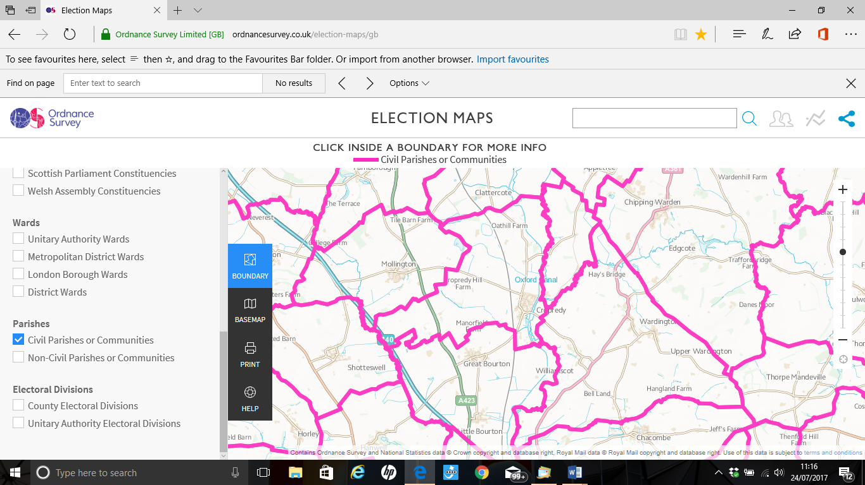

Cropredy Parish (Source: Ordnance Survey Election Maps)

Overview

* The Cropredy parish population at the time of the 2011 Census was 2718. Both the proportion and absolute number of those aged over 65 is expected to continue to increase over the coming decades.
* Ward forecasts for the town supplied by Oxfordshire County Council predict the population of this age group will increase by 46% in the 15 years from 2011 to 2026.[1] The forecast of the total Cropredy population in 2026 is 2743.[2]
* The village of Cropredy has its roots in Anglo-Saxon times and its name is thought to be derived from the Old English word "croppe" - meaning *hill* and "ridig" - *small stream.* The village and its manor were mentioned in the Domesday Book (1086) and before the Reformation it was part of the estate held by the Bishop of Lincoln.
* The picturesque Oxford Canal and the River Cherwell run in parallel on the south east border of the village. The Canal opened in 1790 and there is evidence of a former coal wharf, corn granary and brickworks, all of which used barges to transport their goods. The Toll Office still stands by the narrow section of the canal where an oak beam was lowered until the tonnage had been established and the tolls paid.
* The Church of St. Mary the Virgin dates from the 13th Century with additions in the 14th and 15th centuries. There is evidence of an earlier Church on the same site. The South Chapel is dedicated to St. Fremund who, according to legend, was the son of Offa of Mercia.3

Social Life

* Annually there is Fairport’s Cropredy Convention. Many local organisations benefit from this event. It is an annual festival of folk and rock music held on the edge of the village. It has taken place in August since 1976.
* There are two public houses. The Red Lion and The Brasenose Arms.

School

Cropredy has a Church of England Primary School based on Christian principles and values.

Services

* There are two bus services that serve Cropredy. However they are infrequent.
* The Doctors surgery is located on the Claydon Road.

Parish Council

Parish council meetings take place at the Methodist Chapel in Cropredy every second Monday of the month at 7pm. Clerk to the Council Ken Porter Conifers, Main Street, Great Bourton OX17 1QU 01295 758352. [info@cropredyvillage.info](mailto:info@cropredyvillage.info)3

1. **Areas of Deprivation**

Cropredy is not a deprived area other than barriers to housing due to high house prices and access to services.

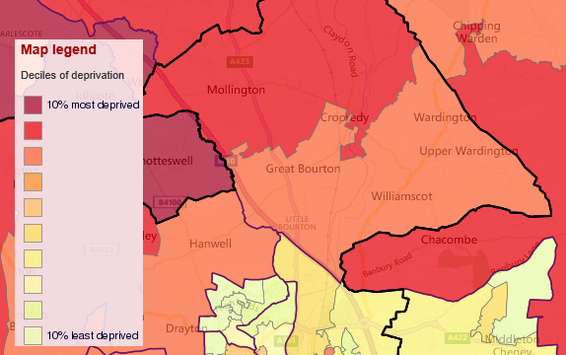The map below shows results for the living environment deprivation domain and the table shows a range of different domains.

**SOURCE- Index of Multiple Deprivation 2015 Deciles (where 1 is most deprived 10% of small areas - LSOAs)**

1. **Service Overview**

|  |  |  |
| --- | --- | --- |
| **Day Care** | **Transport** | **Social Care** |
| **Cluster Care Group**  The Cluster Care Group is an independent Day Centre, and  also a Registered Charity, No. 1100948, and has been  running for 15 years.  · It serves the group of villages of Cropredy, Claydon, Great  Bourton, Little Bourton, Hanwell, Horley, Hanwell Fields,  Mollington and Wardington, hence the name Cluster Group.  · The Day Centre is located in Cropredy, in the Sports  Pavilion, and is open on Tuesdays from 10.00 – 15.00.There is disabled access.  · It is a small independent Day Centre, with two qualified staff trained to the standards required to run the Centre, with the help of volunteers; each day consists of two staff members for the twelve clients, plus two volunteers.  Co-ordinator  Moya Reed  'Tea Leaves'  13, Cup and Saucer  Cropredy  Oxfordshire  OX17 1NN  Telephone/Fax 01295 758531  Mobile 07974 105947 | **Stagecoach Midlands** route 502 runs between Leamington/Harbury - Temple Herdewyke/Banbury via Cropredy on Saturdays and Good Friday.3  **Catteralls Coaches** route 503 runs between Long Itchington and Southam to Banbury via Cropredy on Thursdays only.3 | **Cropredy Welfare Trust**  Cropredy Welfare Trust is a group of Cropredy Charities dating back to the Sixteenth Century. The objective of the Trust is to grant financial support to Cropredy residents who are in conditions of extreme need, hardship or distress.  Applications are invited from Cropredy residents who believe they may satisfy the above criteria and their needs are not covered by other grants or benefits.  The Trust meets annually to review administration needs and is bound by strict Charitable Trust Status rules.  Applications to:  Gill Moss, 8 Creampot Close, Cropredy OX17 1NX |

1. **Distance to Services**

|  |  |  |  |  |
| --- | --- | --- | --- | --- |
| LSOA code (2011) | Road distance to a post office indicator (km) | Road distance to a primary school indicator (km) | Road distance to general store or supermarket indicator (km) | Road distance to a GP surgery indicator (km) |
|  |  |  |  |  |
| E01028479 | 2.48 | 3.35 | 2.29 | 2.31 |
| E01028480 | 2.73 | 2.34 | 2.17 | 2.82 |
|  |  |  |  |

Source – Road distance to key services (km) in 2014. IMD 2015 Barriers to Housing and Services domain

1. **Community Assets3**

The Post Office

The Post Office is open on Mondays and Wednesdays from 09.30 to 13.30 in the Church Rooms, Church Lane, Cropredy.

The Village Hall

The village hall is used throughout the week by a number of clubs and societies, and is available for hire by others (when available). For booking enquiries contact: Mrs Margaret Boscott, 20, Cup and Saucer, Cropredy, OX17 1NN. 01295 750440

1. **Community activity: overview**

|  |  |  |  |
| --- | --- | --- | --- |
| **Theme** | **Group and details** | **Contact** | **Notes** |
| **Adults** | **Women's Institute** | Beryl Lascelles (President)     01295 758244  Frances Whitaker (Secretary) 01295 758448 | Cropredy Women's Institute meet on the second Tuesday of every month (with the exception of August when there is no meeting) in Cropredy Village Hall at 7.20pm. |
| **Children** | **Cropredy Church of England Primary School**.  Station Rd Cropredy Banbury OX17 1PU. | Head teacher:  Mrs H Stevens  [office.3000@cropredy.oxon.sch.uk](mailto:office.3000@cropredy.oxon.sch.uk)  01295 750210 | The school is based on Christian principles and values. The school is a happy and thriving place, where children and adults work and flourish together in a rewarding atmosphere. A supportive, secure, and stimulating environment is provided where high standards of learning are expected. |
| **General** | Bell ringers | Stephen Day  01295 758782 |  |
|  | Community Farm | Mike Wakeford  [mwak8240@cropredy.sch.uk](mailto:mwak8240@cropredy.sch.uk) | The school is playing a part in an independent new venture - a community agriculture project in Cropredy. They are part of a group made up of the school community, local people, businesses and landowners that see the vision of fresh, local and chemical free food available on their doorstep as too good an opportunity to miss!  They are in the process of creating a Community Interest Company (CIC) to run the project and manage any available funding. This is run by all stakeholders - all local people are welcome to join the committee and help this group function successfully. They meet most months, ask in school for details. 'Cropredy Old Diary Farm' is on Facebook to see current discussions and get up-to-date information. |
|  | Exercise Group | Debbie Young  07796 427703  [info@cropredyvillage.info](mailto:info@cropredyvillage.info) |  |
|  | Film Society | To join, fill in the application form and forward (plus subscription fee) to the Society’s Secretary, Frances Whitaker, The Barn, Kyetts Corner, Cropredy OX17 1JW  Cheques should be made payable to Cropredy Film Society.  Contact details: [f.61whitaker@btinternet.com](mailto:f.61whitaker@btinternet.com) 01295 758448 | The Cropredy Film Society was inaugurated in Spring 2007 and currently has a membership at around 200.   New members are always welcome and you do not need to live in the village to join.  Membership is required so that the society can operate under the appropriate licensing agreements.  Life membership costs £10, with a concessionary fee for Over-60s of £8  Screenings are held in Cropredy Village Hall.  Evening screenings include supper, and tickets for members cost £8 per person.  Members may bring a maximum of 2 guests, paying £10 per guest ticket.  There are two film seasons per year, Spring and Autumn, and occasional other screenings. |
|  | Gardening Club | Carol Bateman  01295 750603 | Cropredy Gardening Club is a thriving society with members from Cropredy and the surrounding area.  Members range from those with a passionate interest in gardening and allotment growing, to those who enjoy visiting gardens listening to varied speakers.  Monthly meetings, usually on the second Wednesday of the month, though this sometimes varies and occasionally there are organised visits at weekends. |
|  | Hand Bell Ringers | Peter Bottomley  01295 758913 |  |
|  | Historical Society | Martyn & Sue Lester  01295 750397 | The Society holds regular meetings with visiting speakers. In the summer outdoor visits are arranged.  Membership costs just £10 a year and gives free access to all indoor meetings. Non-members are very welcome to join us for individual talks at a charge of £3 per indoor meeting. |
|  | Short Mat Bowls | Ben Watkiss  01295 750323 |  |
|  | Sports and Social Club | David Cherry  01295 750610 |  |
|  | The Cropredy Harlequins | Follow on Facebook  Harlequins Cropredy | Group Details  Type: straight drama, comedy, variety & pantomime  Age Range: adult (+ children over 5 for panto)  Rehearsals: variable – according to cast availability |
| **Older People** | Firs (Over 60's Club) | Margaret Boscott  01295 750440 |  |
|  | Luncheon Club | Gill Parrett 01295 750427  Angie Ferguson 01295 750964  Sue Bendle 01295 750334 |  |
| **Sports** | **Banbury & District Canoe Club** | Cropredy Wharf  Cropredy  OX17 1PJ  Email: [info@banburycanoeclub.com](mailto:info@banburycanoeclub.com) | Banbury & District Canoe Club (BDCC) is based on the Oxford Canal at Cropredy.  BDCC is run by the members as a Community Amateur Sports Club (CASC) with one part-time funded British Canoeing Club Competition Coach.   All the club coaches are British Canoeing qualified, and the club holds the BC Top Performance Club and Top Community awards for the quality of its coaching, as well as the Sport England Clubmark. |
|  | **Cropredy Cricket Club.**  Williamscote Road  Cropredy, Banbury  Oxfordshire  OX171PG | [peter.cooling@btopenworld.com](mailto:peter.cooling@btopenworld.com)  01295 750213  <http://cropredycc.play-cricket.com//> | New players of all abilities are always welcome. There are opportunities to play both on weekends, and mid-week, and train every week. The club has a good social scene, with regular events, and a warm and enjoyable atmosphere. |
|  | **Cropredy Football Club.**  Williamscot Arena  Williamscot Road  Cropredy  Oxfordshire  OX17 1PG | 07584 564480  Secretary  Michael Burrell | There are Cropredy FC and Cropredy FC Reserves. |
|  | **Cropredy Tennis Club**  Two hard courts are situated at Cropredy Sports Field, Williamscot Road. | Chairman: Simon Bright  [bright@lascelles.org](mailto:bright@lascelles.org) | Club nights for all adult members are held on Monday evenings throughout the season from 6.00 pm onwards. Non-members are welcome to come to their first club night as a free “taster”, if they want to try out the facilities and meet other members before they decide to join the club.   Ladies-only club nights are held on Wednesday evenings from 6.00pm, and from 5.00pm towards the end of the season, as the evenings shorten. |

3 <http://www.cropredyvillage.info/aboutus.htm>

**7. Key local issues – to be discussed with parish council**

Keep the Horton General pressure group

Some concerns with closure of bus routes, and lack of Highway maintenance

**Potential mitigation projects**

|  |
| --- |
|  |

1. <http://insight.oxfordshire.gov.uk/cms/oxfordshire-county-council-population-forecasts-january-2014-excel-format>
2. <http://insight.oxfordshire.gov.uk/cms/oxfordshire-county-council-population-forecasts-january-2014-excel-format>

   3 <http://www.cropredyvillage.info/aboutus.htm>