

Carterton - Community Profile: July 2017

1. **Map and Overview**

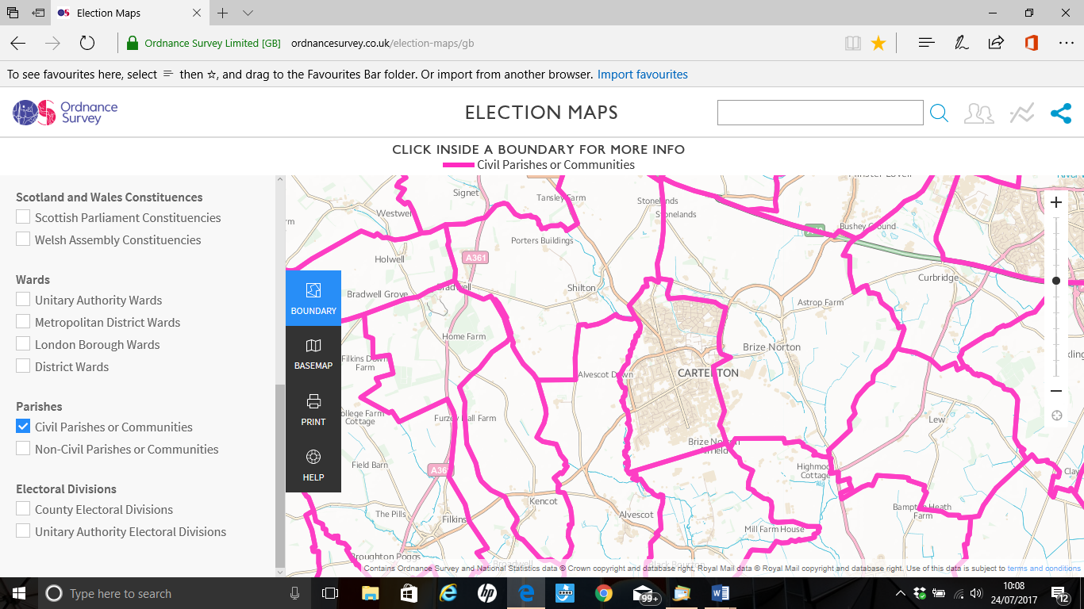

Carterton Parish (Source: Ordnance Survey Election Maps)

Overview

* Carterton is one of Oxfordshire’s newest towns and the second largest in West Oxfordshire. In 1894 the enterprising William Carter bought part of the Duke of Marlborough's estate and parceled it up in to 6 acre plots, which he then sold off to settlers. At first it was known for its market garden produce, tomatoes in particular, but in 1935 the Royal Air Force arrived: RAF Brize Norton is now Britain's largest air base.1
* The town lies on the edge of the Thames Valley and is close to the Cotswold area of outstanding natural beauty.
* The Carterton parish population at the time of the 2011 Census was 16,234. Both the proportion and absolute number of those aged over 65 is expected to continue to increase over the coming decades.2
* Ward forecasts for the town supplied by Oxfordshire County Council predict the population of this age group will increase by 74% in the 15 years from 2011 to 2026.[1] The forecast of the total Carterton population in 2026 is 19,719.[2]
* Much of this high development rate has been due to the presence of the adjoining RAF Brize Norton Air Base. Carterton is proud of its relationship with the Royal Air Force, which is the largest employer in the area.
* Other local employment is found on the Carterton South Industrial Estate where there is a wide range of companies of all sizes, on the West Oxfordshire Business Park, and on Ventura Business Park which covers some 23 acres to the east of the town.
* The Leisure Centre on Broadshires Way has a 25m swimming pool, a children's pool and a fitness suite. The Centre was provided by West Oxfordshire District Council who also provided playing pitches and a sports pavilion on Monahan Way to the north-east of the town.
* It is hoped that the current planned growth of the town will be matched by improvements to the town centre and local facilities. The Town Council is doing all it can to attract new shops and businesses to the town and also to provide much needed sport and leisure facilities. In recent years Aldi and Morrisons have come to the town centre, giving shoppers increased choice. The most recent change is that the Co-op Superstore was taken over by Asda in the autumn of 2015, with an Asda petrol station now on the site of the former Co-op petrol station.3

Schools

Carterton has 5 Primary schools, 3 of which have Nursery provision. A Secondary school which also provides advanced education.

* Primary Schools:

Edith Moorhouse Primary School, Lawton Avenue. Tel 842372.

St John the Evangalist Primary School. Shilton Park, Bluebell Way. Tel 843124.

Gateway Primary School, Netheravon Close. Tel 842189.

St. Joseph's RC Primary School, Lawton Avenue. Tel 841240.

Carterton Primary School, Burford Road. Tel 842502.

* Secondary School:

Carterton Community College, Upavon Way, Carterton. 01993 841611

[office.4041@ocnmail.net](mailto:office.4041@ocnmail.net)

<http://www.cartertoncc.oxon.sch.uk>

* Nursery Units:

Carterton Nursery Unit (LEA), Burford Road.

Edith Moorhouse Nursery Unit (LEA), Lawton Avenue.

St John's Nursery Unit, Bluebell Way, OX18 1JF - Tel: 01993 843124

* Advanced Education

Community Education Centre, Carterton Community College, Upavon Way, Carterton.

Services

* There are a number of bus services that run in and out of Carterton, these include:  
  **19** - Carterton - Bampton - Standlake - Witney  
  **233** - Carterton - Woodstock - Witney - Burford  
  **S1/S2** - Carterton - Witney - Oxford  
  **T9** - A free bus service from Carterton to Tesco Abingdon.
* **MEDICAL :**
* Carterton Health Centre, Alvescot Road.
* Broadshires Health Centre, Broadshires Way.
* **POLICE**  
  Carterton Police Station, Burford Road, Carterton.  
  Telephone 101 for non-emergency calls.  
  The Police Station is open from 10.00am to 2.00pm on Tuesdays, Wednesdays and Thursdays.

**Town Council**

This offers a range of services within the town of Carterton. West Oxfordshire District Council and Oxfordshire County Council also provide services in Carterton.3

Halls for Hire

|  |  |
| --- | --- |
| **Hall for hire** | **Contact details** |
| **Brownes Hall** (Social Centre)  Brownes Lane, Alvescot Road, Carterton OX18 3JH | Club: 01993 846788  Bookings Secretary: 07538 921454  E: browneshall16@gmail.com  <http://cartertonsocialclub.net/index.html> |
| **Carterton Community Centre**  Trefoil Way, Carterton OX18 1AX | Tel 01993 842807  [www.cartertoncommunitycentre.com](http://www.cartertoncommunitycentre.com) |
| **Carterton Football Club**  Kilkenny Lane, Carterton OX18 1DY | Tel 01993 842410  [www.cartertonfc.co.uk](http://www.cartertonfc.co.uk) |
| **Elderbank Hall**  Station Road, Brize Norton, OX18 3PL | Tel: Diane Davies on 01993 843430 |
| **Gateway School**  Netheravon Close, Carterton OX18 3SF | Tel 01993 842189  [www.gateway-oxon.co.uk](http://www.gateway-oxon.co.uk) |
| **Methodist Church**  Burford Road, Carterton OX18 3AA | Tel 01993 841786 |
| **Millennium Amenities Centre**  Stanmore Crescent, Carterton OX18 3UF | Tel 01993 897785 (ask for Alex Turner)  Email: [BZN-MAC-bookingcoord@mod.gov.uk](mailto:BZN-MAC-bookingcoord@mod.gov.uk) |
| **St John the Evangelist Church**  Burford Road, Carterton OX18 3AA | Tel 01993 846996  [www.stjohnschurchcarterton.org.uk](http://www.stjohnschurchcarterton.org.uk) |
| **St John the Evangelist School**  Bluebell Way, Shilton Park, Carterton, OX18 1JF | Tel: 0816575678  Email: [info@2jevents.com](mailto:info@2jevents.com)  <http://2jevents.com/schools/st-john-the-evangelist/> |
| **St Joseph's RC Church**  Arkell Avenue, Carterton, OX18 3BS | Tel: 01993 842463  Email: [andrewjamesfoster1956@ntlworld.com](mailto:andrewjamesfoster1956@ntlworld.com)  [www.stjosephscarterton.uk](http://www.stjosephscarterton.uk) |
| **Town Hall**  Alvescot Road, Carterton OX18 3JL | Tel 01993 842156  [www.carterton.net](http://www.carterton.net) |
| **WI Hall**  Brize Norton Road, Carterton OX18 3HN | Tel 01993 841674 |

1 <http://www.oxfordshirecotswolds.org/plan-your-visit/towns-and-villages/carterton-p230231>

2 <http://insight.oxfordshire.gov.uk/cms/oxfordshire-county-council-population-forecasts-january-2014-excel-format>

3 <http://www.carterton-tc.gov.uk/Carterton-Town-Council/Discover_Carterton_10846.aspx>

1. **Areas of Deprivation**

## Deprivation

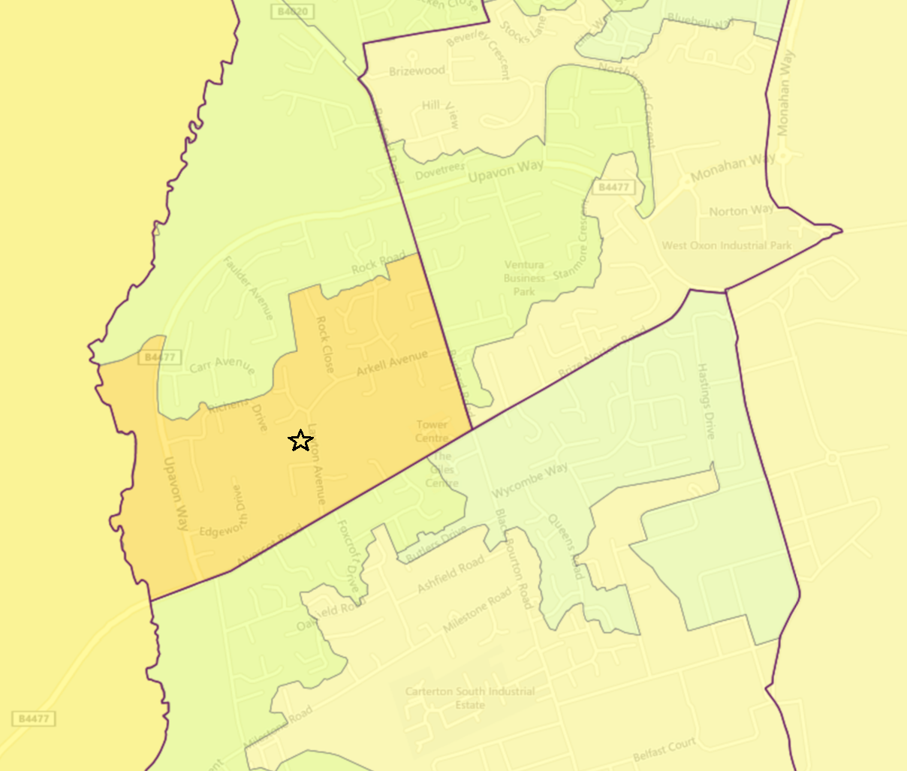Part of Carterton North West ward LSOA E01028771

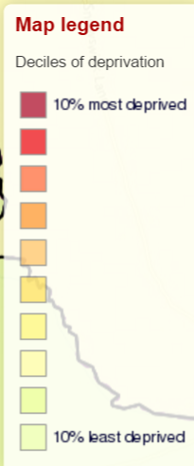



Source- Index of multiple deprivation 2015 deciles ( where 1 is most deprived 10% of small areas LSOAs)

1. **Service Overview**

|  |  |  |
| --- | --- | --- |
| **Day Care** | **Transport** | **Social Care** |
| [**Carterton Day Centre for the Elderly**](http://cartertondaycentre.org/) **(formally Age Concern)**  Registered Charity No. 1116592   Company No. 05673815  The Day Centre is situated off Lawton Avenue and is open to elderly clients from Carterton and the surrounding villages. They have their own transport.  Open Monday, Tuesday and Wednesday from 9am - 2pm, providing a hot 2 course lunch  Manager Lyn on 01993 840162  [cartertondaycentre@outlook.com](mailto:cartertondaycentre@outlook.com) | **19** - Carterton - Bampton - Standlake - Witney **233** - Carterton - Woodstock - Witney - Burford **S1/S2** - Carterton - Witney - Oxford For more information on these services visit the [Stagecoach](http://www.stagecoachbus.com/) website. **T9** - A free bus service from Carterton to Tesco Abingdon. | **Carterton Community Food Bank.** The Carterton Community Food Bank runs from the Pavilion on the Alvescot Road Recreation Ground in Carterton.  It was set up to help individuals and families in need.They are on call 24/7. Contact Lynn Little on 07790 451567, email [lynn.little@tiscali.co.uk](mailto:lynn.little@tiscali.co.uk) or Greville Trevelyan on 01993 213025. All donations of food can be left at the Town Hall.  **Lights Up.** This club helps to unlock memories through the arts. Carterton ‘Lights Up’ encourages anyone living with dementia, including friends, families and carers, to come together and build friendships and learn new skills. Set up by West Oxfordshire District Council, ‘Lights Up’ meets twice a month and includes a host of activities to stimulate the mind, such as sharing experiences, making music, art and storytelling. West Oxfordshire District Council is working with a host of organisations to run the ‘Lights Up’ arts and memory club in Carterton including Cottsway Housing. Funding applications are also being considered by Oxfordshire County Council and Carterton Town Council. Volunteers help to run the Club and sessions are led by professionals and artists with experience of working with older people. Anyone wishing to volunteer should contact Val McKay on 01451 810637.The club runs on the second and fourth Thursdays of the month, from 10.30am to 12.30pm; meeting at Blenheim Court, Sycamore Drive, Carterton OX18 3BX. People can turn up on the day and do not need to book in advance. For more information contact Val McKay on 01451 810637 or [enquiries@memoryclubs.co.uk](mailto:enquiries@memoryclubs.co.uk). |

1. **Distance to Services**

|  |  |  |  |  |  |  |
| --- | --- | --- | --- | --- | --- | --- |
| Community | Barriers to Housing and Services | Geographical Barriers | Distance (km) to: | |  |  |
| LSOA | PO | Food | GP | Primary school |
| Carterton |  |  |  |  |  |  |
| E01028771 | 8 | 5 | 0.98 | 0.79 | **2.06** | 0.43 |



Source – Road distance to key services (km) in 2014. IMD 2015 Barriers to Housing and Services domain

**5. Community Assets**

Post Office

Inside Asda Store, Black Bourton Road, Carterton - Tel: 01993 835708

Community Centre

Link to Community Centre Website **http://www.cartertoncommunitycentre.com/** The Community Centre was opened in late 2008. It is both a Charity and a Company limited by Guarantee. Although the building is owned by the Town Council it is operated by an independent management committee, representing the Town Council, user groups and members of the community. The centre provides a service to local individuals, community groups and businesses as well as providing a venue for wedding receptions and events with a wider audience such as the town’s annual art exhibition The centre now provides a forum for the local Community College students to display artwork, both group and individual. It has also provided a venue for The Oxfordshire Travelling Theatre Company which has staged two shows here and the West Oxfordshire Music School who perform annually.

It has the ability to host conferences and can provide screens, projectors sound and light systems. A fully equipped kitchen is also available.

Regular user groups & events:

MIND

Various Martial Arts Groups

University of The Third Age

Various Exercise Classes

Community Church

Housing Association Workshops

National Blood Transfusion Service

Counselling

Craft & Gift Fairs

Music & Dance Groups

Baby Groups

Annual Wedding Fayre

Annual Art Exhibition

Table Top & Car Boot Sales

Carterton Educational Trust

After formation in 1994, the Trust gained Charity Status in 1995 - Charity No 1043540. Carterton was a relatively new town and did not possess any charitable trusts. The venture was the first of its kind (and remains so in 2016). Since December 1996, the Trust has granted more than 200 grants to local people totalling more than £22,000. Typically, these consist of grants to children from less affluent families to help them to participate in school trips or even towards the cost of their school uniform; to students to help defray the cost of books and materials for their University courses; and grants to local playgroups and school activity clubs for play materials and equipment. In addition grants have been given to a number of students to allow them to undertake educational gap year projects such as teaching in Africa and China, and helped to fund a number of talented children to continue with music lessons they would otherwise be unable to afford. 4

4 <http://cartertoneducationaltrust.weebly.com/>

**6. Community activity: overview**

|  |  |  |  |
| --- | --- | --- | --- |
| **Theme** | **Group and details** | **Contact** | **Notes** |
| **Adults** | **Cotswold Flower Club**  1st Wed. of each month, W.I. Hall, 7.30pm-9.30pm. | Secretary: Betty Holmes 01993 841140, Chairwoman: Gill Crapper 01993 843236 |  |
|  | **Lions Club**  Meetings held at Carterton Manor, Corbett Road, 1st Tues in month, 7.30pm. | President: Alan Lewin. 01993 841815  Secretary: Maddy Radburn. 01993 772241. |  |
|  | **Over 60s & Early Retired Club**  Meets every Friday 2-4pm at Social Centre, Brownes Lane. | Mrs Heather O'Neill - 01993 842043. |  |
|  | **Royal Air Force Association, Carterton and Brize Norton**  Meetings 8pm 2nd Monday of each month at Bowls Club, Arkell Avenue, Carterton. | Bob Wise, 3 Humphries Close - 01993 212595 Secretary Phil Caswell - 01993 212429. |  |
|  | **Royal Naval Association**  2nd & 4th Monday of each month. 8pm, Social Centre, Brownes Lane. | Chairman: S.W. Scarsbrook, 12 Westfield Road, Witney.  Secretary: A.J. Wixey. 01993 844699. |  |
|  | **Royal Antediluvian Order of Buffaloes – Flaming Torch Lodge 7494.**  Every Thurs evening at the Social Centre, Brownes Lane | Mr. M.C. Drew, 46 Ampney Orchard, Bampton. 01993 210129. |  |
|  | **Royal British Legion**  Meetings of the Carterton Branch of the Royal British Legion are held at The Sports Pavilion, Monahan Way, Carterton, OX18 3AN, on the third Monday of each month at 8.00 p.m. | Branch officers are:  Mr Peter Madden (Chairman) - 01993 843163  Mrs Dee Bulley (Secretary) - 01993 842427  Mr John Staddon (Membership Secretary) - 01993 841861 |  |
|  | **Save the Children** | Sue James (Chairman) on 01993 212911 or Pauline Evans (Secretary) on 01993 842983. | Save the Children - This international Charity was founded in 1919 by Eglantyne Jebb who studied at Oxford University. The charity supports vulnerable children both here in the UK and Overseas. The Charity responds to Emergencies worldwide but also undertakes long term development work covering the Rights of the Child, food/education/clean water/safety & health. |
|  | **Shillvalley Stitchers**  Meets 1st Monday in the month. Town Hall, Carterton. 7.30pm-9.30pm. | Julie Foster 01993 840276  Susan Portergill 01367 860217 | A small group of needlewomen formed several years ago. Originally with lacemaking as the main interest, they do other crafts - now more of **a** self-help craft group |
|  | **SSAFA Forces Help, Carterton & Witney Division**  Meets every 6 weeks at the Sports Pavilion, Monahan Way, Carterton. | Contact Lynn Little, Divisional Secretary 01993 842269 |  |
|  | **Carterton U3A**  Monthly meetings are held in the main hall at the Carterton Community Centre on the 4th Tuesday of the month at 2:00pm | Terri Jory - 01993 709497  Ian Wright - 01993 842686 | U3A stands for the University of the Third Age, which is a self-help organisation for people no longer in full time employment providing educational, creative and leisure opportunities in a friendly environment.  Carterton U3A was conceived in 2008 when a small Steering Committee was formed under the Acting Chairmanship of Maxine Crossland, who was Town Mayor at the time. |
|  | **Carterton WI**  Carterton WI meets on the second Tuesday of each month from 7.30pm  Meetings are held in the hall in Brize Norton Road, behind the bus stop opposite The Golden Eagle pub | President: Jenny Maxwell 01993 212395. Secretary: Mrs Bamford 01993 843650. | There are a wide variety of speakers and activities to which all are welcome. Prospective members can attend as a visitor for two meetings and then join officially. There are speakers on a wide variety of subjects and/or craft demonstrations. |
| **Children** | **Air Training Corps – 2267 (Brize Norton) Sqn. ATC**  Tues & Thurs 7-9.30pm. Boys & Girls 13½-18 years. Building 901 (behind Gateway House). | Bob Wise - 01993 212595 |  |
|  | **Allandale Youth Centre**  The Allandale, Burford Road, Carterton. | Hayley Phillips, Station Youth Worker - 07887 498730  [**hayley.phillips@4children.org.uk**](mailto:hayley.phillips@4children.org.uk) | **Monday Night** Juniors  Day:  Mondays  Time:  6.00-8.00 pm  Age:  8-10 yrs of age  Cost:  50p per session  **Inters Club**  **Day:**  Wednesdays  Time:  6.30-8.30 pm  Age:  School Years 7-9  Cost:  50p per session  **Senior Club** -  **Held at Flat 10, Ely Close**  Day:  Thursdays  Time:  7.30-9.30 pm  Age:  School Year 10 upwards  Cost:  50p per session |
|  | **Army Cadet Force.**  Tuesdays 7.30-9.30 pm. Scout Building, Swinbrook Road. Ages 13-18 years. | Simon Hall – 01608 810118 |  |
|  | **Drama Club - We Are Theatre!**  The Pavilion, Monahan Way, Carterton.  8's to 11's from 16:15 to 17:45. 12's to 16's from 18:00 to 20:00 £5 per child per session or £60 if booking in advance for a full 13 week term. | Contact Tania - 07595 915981 [info@thedecktheatrecompany.co.uk](mailto:info@thedecktheatrecompany.co.uk)  <http://www.thedecktheatrecompany.co.uk/> | Term-time sessions in creative and devising theatre for young people in Carterton. |
|  | **Guiding**  Rainbows 5-7 years. Brownies 7-10 years. Guides 10-14+ years. Young Leaders 14-18 years. Senior Section 14-26 years. | Pam Howard - 01993 844631  Carol Hadgraft - 01993 842562  <http://carterton-girlguides.org.uk/>  **MILLENNIUM ACTIVITIES CENTRE**  Rainbows 1st RAF Brize Norton Rainbows - Wednesdays 2nd Carterton Rainbows - Thursdays  Brownies 2nd RAF Brize Norton Brownies - Thursdays 4th RAF Brize Norton Brownies - Wednesdays  Guides 3rd RAF Brize Norton Guides - Mondays  **ST JOHNS CHURCH**  Rainbows 3rd Carterton Rainbows - Thursdays  Brownies 1st Carterton Brownies - Mondays 3rd Carterton Brownies - Wednesdays  Guides 1st Carterton Guides - Joint with 2nd Carterton Guides - Wednesdays Senior Section Fridays (every 2 weeks)  **METHODIST CHURCH**  Rainbows 1st Carterton Rainbows - Fridays  **WI HALL**  Brownies 2nd Carterton Brownies - Mondays | Guides are individuals and not conformed to a standard mould. Each girl has her own talent, skills and interests - unique to her. Guiding challenges her to use and extend these abilities in a positive way. Guiding is about doing one's best, not meeting set targets in a strict time limit. Guiding is fun.  Guiders are volunteer leaders trained to help girls and young women achieve their full potential. Any women between her 18th and 65th birthdays can become a Guider, as long as she is willing and able to make the Guide Promise and undertake the necessary training.  Brize Norton District covers RAF Brize Norton, Carterton and Minster Lovell areas |
|  | **Music & More**  Tuesday 10.00 Ages 12 months – 4 years  11.00 Birth – 12 months  Carterton Community Centre | Liz Thorpe – 077 333 20 113 [**info@musicandmoretots.co.uk**](mailto:info@musicandmoretots.co.uk) [**www.musicandmoretots.co.uk**](http://www.musicandmoretots.co.uk/) | Sharing songs, rhymes and musical activities with young children in a supportive environment. Supports development  and learning too. |
|  | **Scouting**  Beavers 6-8 yrs Cubs 8-10½ yrs Scouts 10½-14½ yrs Explorers 14½-18 yrs | **2nd Brize Norton (RAF) Air Scout Group** meet as follows:  Chipmunk Beavers Tuesdays 6-7.15pm at Brownes Hall  Lightning Beavers Thursdays 6-7.15pm at Cadet Hut  Hawk Cubs Wednesdays 6.30-8pm at Cadet Hut  Jaguar Cubs Mondays 5.45-7.15pm at Brownes Hall  Scouts Thursdays 5.45-7.15pm at Brownes Hall  Explorers Thursdays 8-9.30pm at Cadet Hut    Group Scout Leader: Suzi Coul 01993 837015, brizegsl@gmail.com |  |
| **General** | **A.C.T**  **Acting Community Thingumybogs** | Contact via website:  [www.actingcommunitythingumybogs.btck.co.uk/](http://www.actingcommunitythingumybogs.btck.co.uk/Contact%20us) | The Acting Community Thingumybogs are not an ordinary amateur dramatics group. A non-profit group of volunteers who raise money for Save The Children Fund. Performing a pantomime each year and a spring production, as well as summer workshops.  Based in Carterton, Oxfordshire using the drama studio at the local community college for rehearsals and performances. |
|  | **Allotments Association.**  Swinbrook Road, Carterton. | Secretary Mr. M. Alcock - 01993 841704. |  |
|  | **Carterton Carers Support Group**  Monthly - Third Week of Month (Thursdays) 2pm - 4pm  Town Hall, 19 Alvescot Road, Carterton, OX18 3JL | Organiser: Carers Oxfordshire  Contact Anney Harris before attending first session to check details.  [anneyharris@ageuk.oxfordshire.org.uk](mailto:anneyharris@ageuk.oxfordshire.org.uk)  07557 430874 |  |
|  | **Carterton Social Centre Club**  Town Hall 19 Alvescot Rd, Carterton OX18 3JH | Robert Cleary, Club Secretary - 01993 846788  07890 81114 | Carterton Social Centre Club is a members Club for all the family. Membership forms can be obtained from the door or from the bar.  There are a number of activities undertaken: Quiz nights, Mini Fun Quizzes, Bingo, Music in the Bar, Darts, Club, Dominos, Cricket, Aunt Sally and also trips to the seaside and shopping trips at Christmas.  The Club is open every day and evening (except Christmas Day).  The Large Bar is open Thursday, Friday, Saturday and Sunday lunchtimes and each evening at 7.00 pm. The Small Lounge is open Monday, Tuesday and Wednesday lunchtimes and every evening from 8.00 pm. |
|  | **The Holosophic Society UK** | Patricia – 07855 771465  [phb6534@gmail.com](mailto:phb6534@gmail.com) |  |
|  | **St. John Ambulance Brigade** | Cadets Contact: Claire Hammond, 212687. Adults Contact: Dave Wesson, 779842. |  |
| **Sports** | **Carterton Bowls Club**  Arkell Avenue | Club Secretary Gill 01993 213000. Club 01993 843366. | A six rink outdoor green and a two rink indoor facility providing year round bowling opportunities. Caters for bowlers of all abilities and ages, from those keen to compete at national and county level, those who enjoy friendly competition against other local clubs, to those who simply want to enjoy a game with friends. The club bar and lounge facilities are open for members and their guests in the evening and during the day on match days.  The club has a strong link with the community and is used by a number of other local organisations for their meetings or one off events. The club is also ideal for small private functions and can be hired for a very reasonable fee.  Bowling membership is open to all, with coaching available for new bowlers. There are also a limited number of social memberships available |
|  | **Carterton Football Club**  Community Stadium  Kilkenny Lane  Carterton  Oxon  OX18 1DY | 07810 652741  <http://www.cartertonfc.com/information> | Senior  CFC Vets  Carterton FC 1st Team  Youth  FA Allied Counties U18's  Junior Premier League U18's  U16's  U13's  U8's - Girls & Boys team |
|  | **Carterton Squash & Squash 57 Club**  Located at the end of Baldwin Mews, Off Swinbrook Road, OX18 1DS | [cartertonsquash@sky.com](mailto:cartertonsquash@sky.com)  Club Telephone Number  01993 842996 | Run by volunteer members for the benefit of the community.  The club offers membership for all levels of ability and all ages.  Whether playing in Friday club nights, taking part in the internal Club Leagues, playing for the Club Teams in the Oxfordshire Squash League, or just playing your friends, you are guaranteed to find the right level for your game.  Licensed bar (weekday evenings), individual member key cards providing 24 hour access to 2 heated courts. As a member-run club it is not affiliated to a public sports centre Everything you need to play great squash or racketball.  This includes:  Two courts, with viewing balcony.  Secure key-card entry allowing 24/7 access to the club - play anytime, day or night.  On-line court booking system.  No time limits to how far ahead courts can be booked.  Occasional Friday club nights, pay £2.50 and play all night.  Sunday evening club night, social squash between 17:00 and 19:30 for £2.50, bar available post session.  On-court heating for those winter months.  A licensed bar open Tuesday & Thursday 18:30-21:30 and Team Matches 19:00-23:00.  Internal Club ladder, Adult and Junior leagues or just play socially.  Qualified coaches are available to fine tune or teach the basic game.  Children's lessons are available, ages 5 - 16 (subject to demand).  Annual membership fees, £5 (Junior), £40 (Single) and £70 (Family).  Highly competitive court fees; the court lights are switched on by tokens.  Tokens cost £2.50 each and one token gives 20 minutes of court light.  Tokens can be purchased from the bar, the treasurer or a committee member.  Team training sessions. |
|  | **Kilkenny (Carterton) Cricket Club**  The Sports Pavilion  Monahan Way  Carterton  May-Sept: Saturdays, OCA league; Sundays & Wednesdays, non-league fixtures. | [hafeezkashif@hotmail.com](mailto:hafeezkashif@hotmail.com) | Fairly large outfield, N-S wicket, wicket can be quick in dry months. Outfield drains quickly. Artificial nets and wicket now installed.  Changing Facilities on-site  Covers  Pavilion  Rollers  2 Artificial Nets  1 Artificial Match Play wickets  Square 1 -6 |

**7. Summary of key local issues**

The withdrawal of the 64 bus has resulted in people becoming more isolated and unable to easily attend medical appointments .The town council has organised public meetings and are working in partnership to find solutions.

There is a perceived need for more care /residential homes

The Town Hall has reduced its fees for local groups in order to encourage more social activity and there is a new lunch club .

The family centre has closed but there is 3 years funding and services are being offered in 4 venues as there is no centre available.

There has been a recent increase in vandalism as reported by TVP

The town council are asking for volunteers to assist with environmental projects .

**Potential mitigation projects to be discussed with town council**

|  |
| --- |
| Potential support for local transport scheme |

1.
2.