IMPROVING ACCESS TO OXFORDSHIRE’S COUNTRYSIDE AND GREEN SPACES

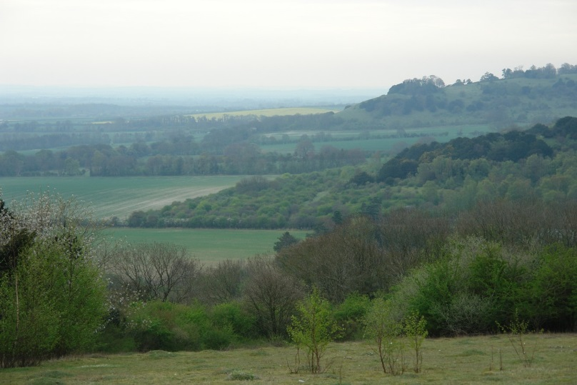

Oxfordshire has an excellent network of local rights of way and accessible green spaces in its countryside, rural communities and in urban areas. The county is also criss-crossed by longer trails such as the Thames Path and the Ridgeway and by regional routes such as the Oxfordshire Way.

Footpaths and bridleways provide opportunities for people to access green spaces for relaxation, exercise and enjoyment. Walking or cycling has many health benefits and brings people closer to the natural world, while better links along rights of way within and between communities offer scope for reducing car use. Local voluntary groups are often involved with looking after local paths and bridleways; now the summer is on its way, what better time to get outside and get involved with local access projects, or just enjoy exploring our beautiful county?

But could we make better use of rights of way in Oxfordshire? Some routes have challenging surfaces, stiles or gates and many lack information and signage about points of interest and circular routes. The County Council is responsible for managing the rights of way network, doing so by working with farmers and local communities. But OCC has limited funding and time to carry out improvements; this is where TOE2 and volunteers can help.

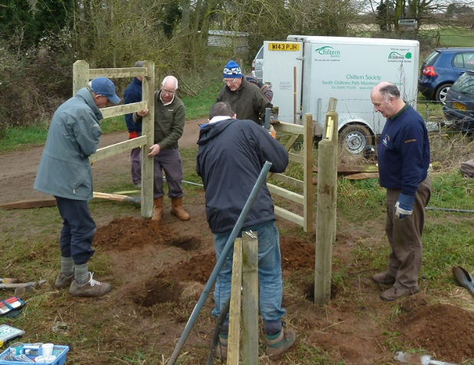

TOE2 works in partnership with OCC, supporting communities to ensure better rights of way networks that are more accessible and easier to use, providing valuable links between and within settlements. TOE2 is keen to support more local voluntary groups to help maintain and improve Oxfordshire’s Rights of Way Network, building on the excellent work of existing groups such as the South Chilterns Path Maintenance Volunteers, the Cotswold Voluntary Wardens, and the Ramblers Path Works Volunteers. Working alongside Parish Councils and OCC such groups help ensure that local people can enjoy better connected paths and bridleways to access local green spaces.

What is TOE2 and what are we doing for rights of way in Oxfordshire?
TOE2 is Oxfordshire’s independent environmental funder, supporting projects that make real and lasting improvements to the environment and to the lives of local people. TOE2, a charity and a not-for-profit company, has worked in partnership with OCC for several years to improve access to rights of way and green spaces across the county, supporting the aims of the Oxfordshire Rights of Way Improvement Plan (www.oxfordshire.gov.uk/rowip).

TOE2 can provide grant funding to support local access projects so that local groups can get materials and possibly training. Since 2011 TOE2 has allocated about £200,000 to access projects across Oxfordshire, primarily with funding provided by Grundon Waste Management through the Landfill Communities Fund. Here are a few examples of projects we have funded:
- South Chilterns Path Maintenance Volunteers – several significant projects across the southern Chilterns to improve access through replacing stiles with gates. Projects often link to pubs and other village facilities and usually improve a number of stretches of rights of way or even whole routes (https://chilternsociety.org.uk/path-maintenance/)
- A grant of £5,000 supported path surface improvements between Benson and Wallingford, a very well used section of the Thames Path National Trail (http://www.nationaltrail.co.uk/sites/default/files/tp_newsletter_autumn_2016.pdf)
- The Oxford Preservation Trust has recently carried out a range of access improvements over a stretch of open countryside on Boars Hill providing valuable access to green space on the edge of the city (http://www.oxfordpreservation.org.uk/sites/www.oxfordpreservation.org.uk/files/Dreaming%20Spires%20walk.pdf)
- Bloxham Parish Council - The project created circular walks of 4.5 miles and 1 mile, including replacing stiles with gates. The route is now being enjoyed by the local community and is used by the health walks organised through the local surgery (http://www.bloxhamparishcouncil.co.uk/?page_id=1977)
- Aston Rowant Parish Council used TOE2 funding to create a more accessible promoted ‘Discovery trail’ route that gave access to the Aston Rowant NNR Talking Trail (http://www.astonrowant.org.uk/Aston-Rowant-Discovery-Trail.pdf)
- A partnership with Brakspear is involving local volunteers in providing information to create circular routes from 30 Brakspear pubs (http://www.pub-trails.co.uk/). In return Brakspear is providing funding to support additional grants for access improvements. TOE2 would welcome the opportunity to work with other corporate partners in this way.

TOE2 welcomes funding applications from non-profit making organisations and groups including:
- Parish Councils
- Local charities
- Environmental charities and groups
- Other local voluntary groups

What sorts of projects would we like to fund?
- More support for strategic routes and for links to these routes, eg; National Trail links, the Oxfordshire Way, longer riding routes
- Better links with the health agenda, eg; Centre for Sustainable Healthcare, trim trails and path exercise circuits, access for people with disabilities, Green Health Routes
- More funding to support families wishing to access green spaces on foot or by bicycle
- Improving year round access for wheelchairs and pushchairs
- Projects that link biodiversity, education and access
- Supporting the establishment, training and work of groups of access volunteers

Are you interested in supporting access to green spaces in Oxfordshire?
We would love to hear from any local organisations or companies interested in supporting better access to green spaces in Oxfordshire; TOE2 provides an effective mechanism for delivering funding to good local projects.

For further information about TOE2:

Fiona Danks, Director, Trust for Oxfordshire’s Environment (TOE2)
Earth Trust Centre, Little Wittenham, Abingdon, OX14 4QZ
www.trustforoxfordshire.org.uk 01865 407003 fiona.danks@trustforoxfordshire.org.uk @toe2_oxon

