

Witney - Community Profile: October 2017 update

1. **Map and Overview**

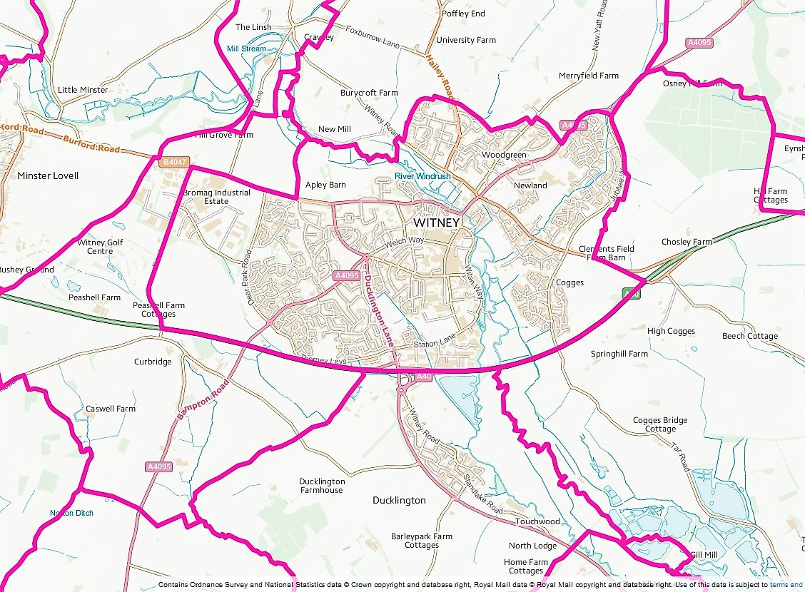

The town of Witney (Source: Ordnance Survey Election Maps[1])

**Overview**

The 2011 Census population of Witney was 27,522. Witney is the largest market town and employment centre in West Oxfordshire.

**Social life**

* Cogges Manor Farm Museum is a unique working museum depicting Oxfordshire rural life in Victorian times set in an historic manor house and Cotswold stone farm buildings.
* The Witney and District Museum tells the story of Witney's history with an emphasis on the Blanket Industry, school life and ecclesiastical diversity.

**Schools**

Secondary schools:

* [Henry Box School](https://en.wikipedia.org/wiki/Henry_Box_School),
* [Wood Green School](https://en.wikipedia.org/wiki/Wood_Green_School)
* Springfield School

Primary schools:

* The Batt School (Church of England)
* The Blake School (Church of England)
* Our Lady Of [Lourdes](https://en.wikipedia.org/wiki/Lourdes) Catholic Primary School
* Madley Park Community Primary School
* Queen's Dyke Primary School
* Tower Hill Community Primary School
* West Witney Primary School
* Witney Community Primary School

[Abingdon and Witney College](https://en.wikipedia.org/wiki/Abingdon_and_Witney_College):

* The Witney campus has a construction skills centre.

**Services**

* Bus services – Witney has regular services to Oxford, Abingdon, Chipping Norton. Burford and Carterton.
* Witney Community Hospital - Provides rehabilitation and palliative care for people who no longer require the services of an acute hospital but require greater support than currently provided in their home environment. In addition to its inpatient beds, the hospital has a Minor Injuries Unit (MIU), an Emergency Multidisciplinary Unit (EMU), X-ray facilities and a range of outpatient clinics.
* Doctors - Witney has three GP surgeries. A fourth surgery (Deer Park) closed on 31st March 2017.
* Community transport – West Oxfordshire Community Transport operates a town centre bus service using volunteer drivers.
* Volunteer car driver scheme – Volunteer Link Up manages a scheme that covers the whole of West Oxfordshire, including Witney.
* Witney Library – Open Monday to Saturday with PCs, Internet access and free Wi-fi
* Daycare – From October 2017 the county council will deliver all its day care services from a single location in Witney, the Witney Resource Centre.
* Childrens’ centres – Services are now being delivered from a single location in Witney, the Witney Children and Family Centre.
* Windrush Leisure Centre - Gym, 25 metre swimming pool, separate learner pool, exercise studio, Livestrong cycling studio, 4 court sports hall suitable for badminton, football, basketball

**Town council**

Witney Town Council, Town Hall, Market Square, Witney, Oxon, OX28 6AG, 01993 704379 Town Clerk – Mrs Sharon Groth townclerk@witney-tc.gov.uk

1. **Areas of Deprivation**

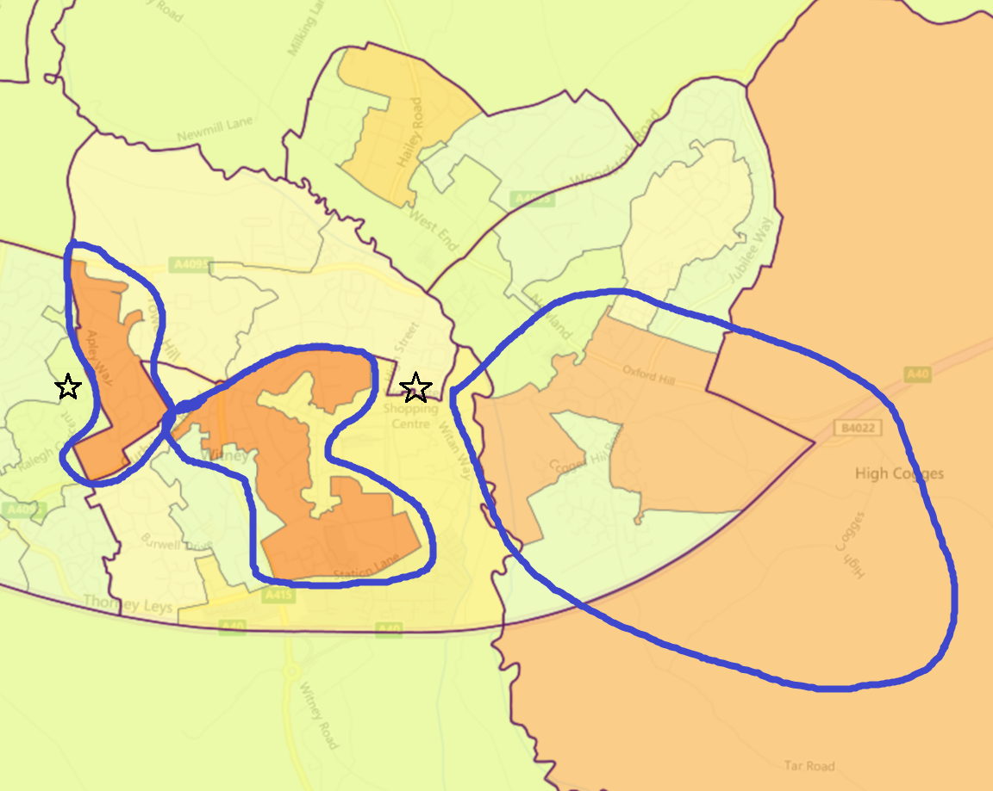Witney South E01028819 and Witney Central E01028809 have higher levels of deprivation, There is also a possible need to focus on education/skills/children and young people in Witney East E01028811 and Witney North E01028813. This could include the eastern edge of Eynsham and Cassington ward adjacent to Witney East.

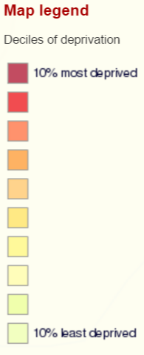



1. **Service Overview**

|  |  |  |
| --- | --- | --- |
| **Children’s Centre** | **Day Centre** | **Transport** |
| As part of the 2016/17 budget Oxfordshire County Council decided that eight children and family centres  will be created across Oxfordshire, providing a base for a service for 0-19 year olds and their families.  One of these centres is in Witney and it is co-located with the existing Witney Early Intervention Hub for young people. The other Witney children's centres will be financially supported by the county council until April 2017. After this date they will have to be financially self supporting but can apply for a grant from the county council’s £1m transition fund. | As part of the 2017/18 budget Oxfordshire County Council has decided that the health and wellbeing centre service will be replaced by a community support service delivered from 8 building bases around the county, including Witney.  The buildings will provide multi-functional spaces, and deliver individual and group support, using facilities available at the base, as well as in local communities. Existing funding for voluntary sector day time support will come to an end but new county council funding will be available (£900,000 in 17/18, £600,00 in 18/19 and £350,000 in 19/20) to assist transition and continue some voluntary sector services. | The 19 bus service from Carterton to Witney is still operating following the withdrawal of bus subsidies.  The Witney Town Service Routes 214 and 215 is now operated by West Oxfordshire Community Transport |

1. **Distance to Services**

|  |  |  |  |  |  |  |
| --- | --- | --- | --- | --- | --- | --- |
| Community | Barriers to Housing and Services | Geographical Barriers | Distance (km) to: | |  |  |
| LSOA | PO | Food | GP | Primary school |
| Didcot |  |  |  |  |  |  |
| E01028621 | **3** | **2** | **1.78** | **1.50** | **1.81** | **1.54** |
| E01028632 | 9 | 8 | 0.70 | 0.80 | **1.09** | 0.80 |
| E01028633 | **3** | **2** | **1.37** | **1.08** | **1.67** | **1.51** |
| E01028635 | 10 | 9 | 0.62 | 0.62 | **1.25** | 0.57 |
| E01028636 | 8 | 7 | 0.56 | 0.59 | 0.55 | 0.82 |

1. **Community Assets**

|  |  |
| --- | --- |
| **Name** | **Details** |
| Burwell Hall, Thorney Leys, Witney OX28 5NP | * Main hall and meeting room |
| Corn Exchange, Market Square, Witney OX28 6AB | * Main hall (167.9 sqm) and gallery room (74.2 sqm) |
| Madley Park Hall, Northfield Farm Lane, Witney, Oxfordshire, OX28 1UE | * The hall (135 sqm) comprises three spacious areas that can be opened up and used as one open space, or separated by large wooden doors. A separate conference room can accommodate up to 40 people |
| Ley Recreation Ground | * 7 acres - cricket and football pitches, tennis courts |
| Queen Elizabeth II Field – Burwell | * Football pitches |
| King George V Playing Field – Newland | * Football pitch |
| West Witney | * Football and cricket pitches |

1. **Community activity: overview**

| **Theme** | **Group and details** | **Contact** | **Notes** |
| --- | --- | --- | --- |
| **Young people** | Yellow Submarine | Witney hub and café - 1st Floor, Windrush Leisure Centre, OX28 4YA  <http://www.yellowsubmarine.org.uk/contact-us/find-us-in-witney/> | Helps young people with learning disabilities gain confidence, independence and a sense of self-worth |
|  | Base 33 | 4 Welch Way, Witney. OXON. OX28 6JF  CEO - Wendy Dawson, [wendy@base33.org](mailto:wendy@base33.org) 07590556968 | Supports young people with a wide range of issues; focusing on drug use, homelessness and unemployment with mentoring, training and emotional support |
|  | Witney Children and Family Centre | Centre Manager: Anthony Sayles, Tel: 01865 328730, Email: [witneyfst@oxfordshire.gov.uk](mailto:witneyfst@oxfordshire.gov.uk) | Support and advice to children and families – with a special emphasis on supporting the whole family |
| **Older people** | Witney Dementia Support Group | The Elms Wellbeing Centre, 2-4 Moorland Road, Witney, OX28 6LF  [oxford@alzheimers.org.uk](mailto:oxford@alzheimers.org.uk) |  |
|  | Witney Resource Centre | 6 Moorland Road, Witney, Oxfordshire, OX28 6LF | Oxfordshire County Council community support service/day care hub |
|  | Leonard Cheshire Disability | The Elms Wellbeing Centre, 2-4 Moorland Road, Witney, OX28 6LF  William Blake 01993 706 824 | Members have to be 65 or above and accept people with all sorts of disabilities which include Dementia, Strokes and old age |
|  | Late Spring Witney | Wesley Room, Methodist Church, High Street, Witney, OX28 6HG  [helensollis@ageukoxfordshire.org.uk](mailto:helensollis@ageukoxfordshire.org.uk) | Support group for those aged 60+ who have been bereaved |
|  | Witney & District Carers Club | Amos Room, Methodist Church, High Street, Witney, OX28 6ZJ  Anney Harris 07557 430 874 |  |
|  | Stroke Club | Isis Room Windrush Health Centre Welch Way, Witney, OX28 6JS  Margaret Groom 01993 771261 |  |
|  | Mobility Aids Short Term Loan | Methodist Church, High Street, Witney, OX28 6HG  0844 412 2750 | British Red Cross service |
| **Transport** | Volunteer Link Up | Methodist Church Centre, 10 Wesley Walk Witney. OX28 6ZJ, 01993 776277 [office@vlu.org.uk](mailto:office@vlu.org.uk) | Co-ordinates a West Oxfordshire volunteer driver scheme providing transport mainly for hospital appointments  Also provides volunteer befrienders who help with shopping and practical tasks such as gardening or DIY. |
| **Other** | Citizens Advice Bureau | The Old Print House, Marlborough Ln, Witney OX28 6DY  [0344 411 1444](javascript:void(0))  [info@citizensadvicewestoxon.org.uk](mailto:info@citizensadvicewestoxon.org.uk) |  |
|  | Multiple Sclerosis Society West Oxfordshire Branch | Burwell Hall, Witney, OX28 5NP  [westoxfordshire@mssociety.org.uk](mailto:westoxfordshire@mssociety.org.uk) |  |
|  | West Oxfordshire Rethink Carers Support Group | Witney Methodist Church, High Street, Witney, OX28 6HG  Kelly Grimes 01865 904656 |  |
|  | Witney & West Oxfordshire Foodbank | Cottsway House Heynes Place, Avenue Two WITNEY OX28 4YG  [01993 890000](tel:01993%20890000)  [info@witney.foodbank.org.uk](mailto:info@witney.foodbank.org.uk) |  |

1. **Summary of key local issues**

The county council’s reduction in funding for day care and children centres could result in a reduction in the quality and/or range of services provided by the statutory and voluntary sectors. The possibility that services will be provided in fewer locations across Witney could also result in lack of access to the services that are available.

**Potential mitigation projects**

|  |
| --- |
| **Using community transport to reduce social isolation**  The Witney Town Service is a circular route which links two large housing estates to Witney Town Centre, where there is a concentration of services. The service has previously been operated by Stagecoach and Go Ride but was due to come to an end on 28 January 2017. Residents and passengers were particularly concerned about the loss of service and the impact it would have on older residents.  A group of residents formed West Oxfordshire Community Transport and took over the service from 30 January 2017. CFO provided advice and £2,000 start-up grant on behalf of Oxfordshire County Council |

1. [https://www.ordnancesurvey.co.uk/election-maps/gb/#](https://www.ordnancesurvey.co.uk/election-maps/gb/)