

The Bartons – Community Profile: March 2017

1. **Map and Overview of area**

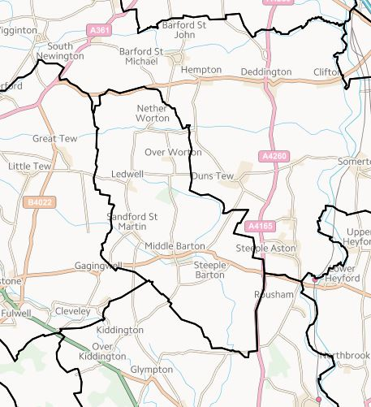

**Bartons Ward- West Oxfordshire (Boundary Commission)**

The Bartons consist of three villages: Westcot Barton, Steeple Barton and Middle Barton. There are two parish councils (Steeple Barton and Sandford St. Martin) and one parish meeting in the Bartons (Westcote Barton Parish Meeting).

Overview

* The parish of Steeple Barton is in the ward of The Bartons, within the District of West Oxfordshire. According to the 2011 census, Steeple Barton parish has a total population of 1523, comprising 647 households. Steeple Barton is about 10 miles from Chipping Norton and about 11 miles from Banbury.
* The parish of Sandford St. Martin is in the ward of The Bartons, within the District of West Oxfordshire. According to the 2011 census, Sandford St. Martin parish has a total population of 80, comprising 91 households.

Social life

* A newsletter is delivered within Steeple Barton and beyond, *The Barton Bulletin*.
* There is an Anglican church in Steeple Barton, St Mary’s, and also a Methodist Chapel.
* There is a village hall and sports and social club in Middle Barton, supporting various social and leisure groups.
* Groups, clubs, societies, and organisations in (or including) the Bartons include: cricket club, football club, history group, bowls club, yoga group, bell-ringers society, brownies, cubs, scouts, guides, allotment society, drama group, Jubilee Club (senior citizens), Bartons Benefice Choir, and British Legion

Schools

* There is a pre-school and primary school in Middle Barton.
* The catchment school for secondary-age young people is Chipping Norton School.
* There is a bus service to take young people from the Bartons to Chipping Norton School.

Services

* There are two pubs in Middle Barton, *The Carpenter’s Arms* and *The Fox Inn*.
* There is a village store and Post Office in Middle Barton.
* There is no doctor’s surgery in the Bartons, the nearest one being in Deddington
* The Bartons have no public transport links

Parish Council/ Meeting

* **Sandford St Martin Parish Council**
  + Mr T Ringrose (acting clerk): 01608 683763. [sandfordclerk@hotmail.co.uk](mailto:sandfordclerk@hotmail.co.uk)
* **Steeple Barton PC**
  + Abigail Beale (clerk): 01869 347329. [clerk@steeplebartonpc.org.uk](mailto:clerk@steeplebartonpc.org.uk)
* **Westcote Barton Parish Meeting**
  + Mr Rupert Massey (clerk): OX7 7AB. 01869 340434/ 07817 027252. [westcotebartonpm@gmail.com](mailto:westcotebartonpm@gmail.com)

Websites

<http://www.steeplebartonpc.org.uk/>

1. **Areas of Deprivation**

The Bartons are relatively affluent, with housing costs and barriers to services being the main issues.

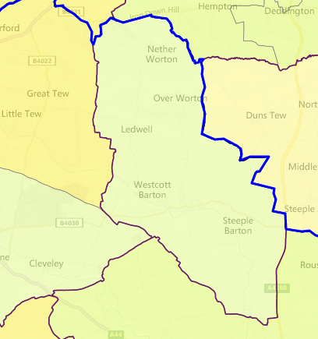

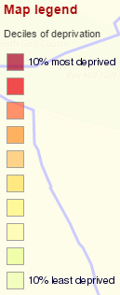





**SOURCE - Index of Multiple Deprivation 2015 Deciles (where 1 is most deprived 10% of small areas – LSOAs)**

1. **Service Overview**

|  |  |  |
| --- | --- | --- |
| **Children’s Centre** | **Day Centre** | **Transport** |
| There is no CC in the Bartons. The nearest integrated children and family service Hub is in Bicester, 10 miles away.  The nearest non-Hub CC which has received transition funding is in Bloxham, 10 miles away. | There is no day centre in the community, the nearest ones being in Stonesfield- Lunch Club (8 miles) and Chipping Norton- Highlands Day Centre (8 miles)  OCC has ‘[proposed](http://mycouncil.oxfordshire.gov.uk/documents/s36119/CA_JAN2417R26%20-%20Daytime%20Support.pdf) to replace our current annual funding for 47 community daytime support services [**including the Stonesfield and Highlands services**] of £992,000 a year, with grant pots totalling £250,000 a year, which services could bid for under two categories. The Sustainability Fund would provide grants to enable the ongoing delivery of daytime support services in areas of high need. The Innovation Fund would provide one-off grant funding to establish self-sustaining projects to fill gaps in services.’ | Subsidised bus service was terminated in 2016, leaving the community without public transport links |

1. **Distance to Services**





**SOURCE: Road distance to key services (km) in 2014 - IMD 2015 Barriers to Housing and Services Domain**

1. **Community Assets**

|  |  |
| --- | --- |
| **Name** | **Details** |
| Alice Marshall Hall | * North North Street Middle Barton OX7 7BU * Tricia Lusted: 01869 340157. [kentricia.lusted@btinternet.com](mailto:kentricia.lusted@btinternet.com) * Seated capacity: 70 * Disabled access |
| Bartons Victory Memorial Hall and Playing Fields | * The Bartons Victory Memorial Playing Fields, Worton Road, Middle Barton, OX7 7EE |
| Sandford St. Martin Village Hall | * Ledwell Road, Sandford St Martin, Chipping Norton, Oxfordshire OX7 7AH * Helen Northwood: 07944476007 and 01608683401.   [helen_northwood@hotmail.com](mailto:helen_northwood@hotmail.com)   * <http://sandfordstmartinvillagehall.wordpress.com/> * Seated capacity 60 * Disabled access |
| United Benefice of Steeple Barton, Westcote Barton, Sandford St Martin and Duns Tew | * The Rectory, 29 Enstone Road, 01869 340 510 |
| Methodist Chapel | * The Methodist Chapel, South Street, Middle Barton, OX7 7BU: 01608 661843 |
| Middle Barton Primary School | * **See below** |
| **For more information see** <http://www.steeplebartonpc.org.uk> | |

1. **Community activity: overview**

| **Theme** | **Group and details** | **Contact** | **Notes** |
| --- | --- | --- | --- |
| **Children** | Busy Bees  Mother and Toddler Group for 0-5 year olds |  | Meet Tues and Thursday 9.30 to 11.00 am in the Alice Marshall Hall |
|  | Middle Barton Pre-School | 29 Church Lane, Middle Barton, Chipping Norton, Oxfordshire, OX7 7BX  <http://www.middlebartonpreschool.co.uk/> |  |
|  | Middle Barton Primary School | 27 Church Lane, Middle Barton, Oxfordshire  OX7 7BX    01869 340522  Email: [office.2151@middle-barton.oxon.sch.uk](mailto:office.2151@middle-barton.oxon.sch.uk)  <http://www.middlebartonschool.co.uk/> |  |
|  | Mothers Union |  |  |
| **Older people** | Jubilee Club |  |  |
|  | Dance to Music | Organised by Age UK Oxfordshire. Generation Games - 01235 849403  [generationgames@ageukoxfordshire.org.uk](mailto:generationgames@ageukoxfordshire.org.uk) | Alice Marshall Hall every Monday, 10-11 |
|  | Royal British Legion |  | Meetings are held on the 2nd Monday of each month, 7.30pm at the Sports & Social Club |
| **Transport** | Our Bus Bartons | 01869 699 699  Email: [support@ourbus.co](mailto:support@ourbus.co) |  |
| **For more information see** <http://www.steeplebartonpc.org.uk> | | | |

1. **Recent projects to mitigate service reductions**

|  |
| --- |
| **Our Bus Bartons- new community minibus**  The Bartons struggle with a lack of transport and this was exacerbated by the loss of their public bus service. The Parish Council and community had looked at several potential transport options from 2015/16.  Community First provided advice and support to help set up a community minibus scheme to cover the Bartons and outside parishes. Our Bus Bartons was awarded £3,000 from the Oxfordshire County Council Community Transport fund (administered by CFO) to help set up the new scheme  Update from the chair of Our Bus Bartons, December 2016: ‘*We took 1,362 passengers on our timetabled services in our very first quarter of operations, this does not include excursion or hire passengers. We have a volunteer team of about 20 – Directors, Drivers, Charity Officers, Operational Staff and Executive Committee Members. We have completed 8 private and 1 community hire, 2 shopping excursions and 3 flu-jab runs in partnership with Chipping Norton Health Centre. We have applied for funds for a new bus from the community minibus fund and from the national lottery. Our service benefits scholars, workers and people who don't drive. Our drivers are often complimented on what a great job they do and what a great service we provide*.’  **For more information see**: <http://ourbus.co/bartons/> |

|  |
| --- |
| **Potential Bartons Good Neighbours Scheme**  Following the successful launch of Our Bus Bartons, there may be interest if developing the scheme into a GNS. CFO has made initial contact with relevant groups and stakeholders in the Bartons with a view to arranging a meeting – to be led by Volunteer Link Up- to discuss GNS and how to go about setting up a scheme locally. |