

Launton cluster (Piddington, Arncott and surrounding area) – Community Profile: March 2017

*Initial focus of this audit is Piddington, with other areas to follow*

1. **Map and Overview**

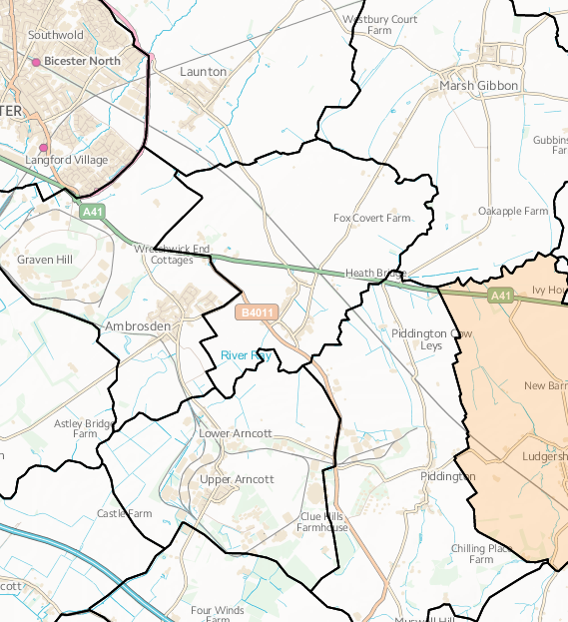

Source: Ordnance survey[1]

Overview

**Initially, this audit focuses on Piddington as this part of Launton ward shows up as relatively more deprived through lack of access to services, children and young people, and education and skills.**

* This cluster of villages to the east of Bicester includes Launton and smaller villages including Piddington and Arncott and other nearby villages which are experiencing significant reductions in services. Each village has particular issues.
* Piddington is 4.5 miles southeast of Bicester, close to the border with Buckinghamshire.
* It is likely that the issues will span across other villages nearby such as Arncott and Blackthorn and is likely to also involve cross border work with Buckinghamshire.
* The population of Piddington parish at the time of the 2011 census was 370, 22% of the population was over 6, 32.6% of residents over 16 were qualified to Level 4 or above, 7.6% of households (23) did not have a car or van.
* The evidence for the situation in the area is from local questionnaires (Piddington report due Jan 2017), Parish Council minutes and contact with local people.

Social life

* Piddington is an active community but with very few community spaces.
* A lot of activity centres around the parish council and the village hall committee.

Parish Council

* Anne Davies – parish clerk: [piddington.parish.clerk@googlemail.com](mailto:piddington.parish.clerk@googlemail.com)

Website

* [www.facebook.com/piddingtonoxfordshire](https://www.facebook.com/piddingtonoxfordshire)
* Twitter- [@Piddingtonoxon](https://twitter.com/Piddingtonoxon)
* <http://www.piddingtonvillageoxfordshire.org.uk/parish-council.html>

1. **Deprivation**

There is one area of Launton ward which shows up as somewhat deprived relative to the rest of Oxfordshire. This area includes Arncott and Piddington villages (LSOA E01028500).

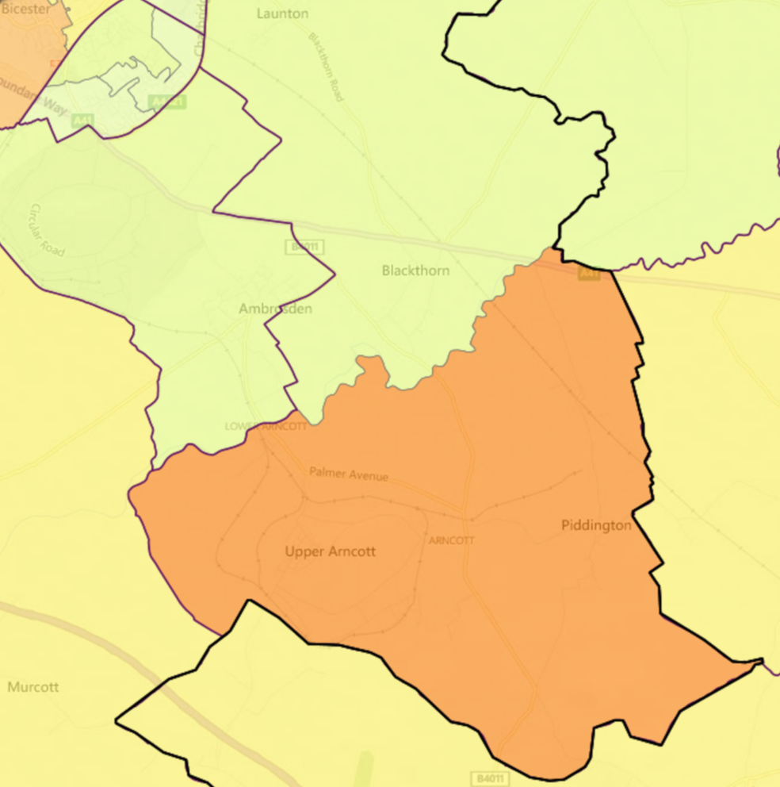

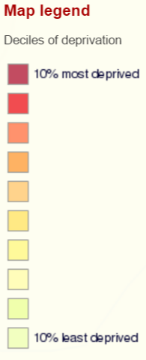





**Index of Multiple Deprivation 2015 Deciles (where 1 is most deprived 10% of small areas - LSOAs)**

1. **Service overview**

|  |  |  |
| --- | --- | --- |
| **Children’s Centre** | **Day Centre** | **Transport** |
| Nearest service Bicester | Nearest service Bicester Health and Well-Being Centre | Service cut: T94 to Bicester and Oxford  Alternatives being sought (see Section 7, below) |

1. **Distance to services**





**SOURCE- Road distance to key services (km) in 2014 - IMD 2015 Barriers to Housing and Services Domain**

1. **Community assets**

|  |  |
| --- | --- |
| **Name** | **Details** |
| Piddington Village Hall | Well-used for many activities including the pop up pub and the weekly Pantry (café and community shop) and provides meeting space for several clubs and groups. The village hall requires extension |
| St Nicholas' Church | A focus of community activity |

1. **Community activity: overview**

| **Group** | **Contact** | **Notes** |
| --- | --- | --- |
| The Pantry | Francesca Darby | Piddington market and coffee shop opens every week on Saturday.  Twitter: [@pidding_pantry](https://twitter.com/pidding_pantry) |
| Regular fitness sessions |  | Piddington village hall - short mat bowls, exercise, pilates |
| Annual community apple pressing day |  | Since 2015, this was initiated as a result of community engagement in the Community Led Plan |
| 200 Club |  |  |

1. **Recent projects to mitigate service reduction**

**Analysis of gaps in services**

Transport is the key local issue. The T94 bus route provided a daily route to Bicester. The loss of this service has affected some people in the village significantly (a group used it weekly, particularly on Bicester market day) and alternative solutions have been sought. Community First has been in discussions with parish councillors to advise.

Piddington has decided not to use OCC’s COMET bus service but is working with Buckinghamshire CC to make the community operated “Bernwood Bus” available to Piddington residents. The council has been trying to engage with three options:

* Stagecoach - extending the X5 and service that goes to Bullingdon Prison to Piddington. This would add 4 minutes both ways for their bus which is a 25-minute walk down an unlit country lane
* Charlton Services - extending the route of the 94 to include Piddington
* The Bernwood Community Bus - a Bucks initiative which will service nearby villages. BCC is keen to promote cross boundary initiatives

Village Hall improvements are needed – Community First Oxfordshire advising. Funding for this has not yet been identified.

A play area for the older youngsters of the village is something the Parish Council have been endeavoring to establish for many years: investigations into a possible site are progressing.

Widnell Park and Playing Fields: PC is trying to regenerate the area both environmentally and for the community. Couple of successful grant applications which will start the clearance process and has enabled purchase of park furniture. Their next challenge is to raise approximately £5000 for green gym equipment (hoping to install by spring 2017).

**Potential Projects**

Potential projects (from initial discussions with the parish council) are:

* Community transport
* School transport
* Village hall improvements
* Play area

|  |
| --- |
| **Potential Piddington area community transport initiative**  Finding a potential solution has involved liaison with other villages including one across the county border. CFO has met with local parish councillors and initiated a process to identify specific areas where links to various agencies might be of use. |

1. [https://www.ordnancesurvey.co.uk/election-maps/gb/#](https://www.ordnancesurvey.co.uk/election-maps/gb/)