

Great Milton (including Little Milton and the Haseleys) - Community Profile: March 2017

1. **Map and Overview**

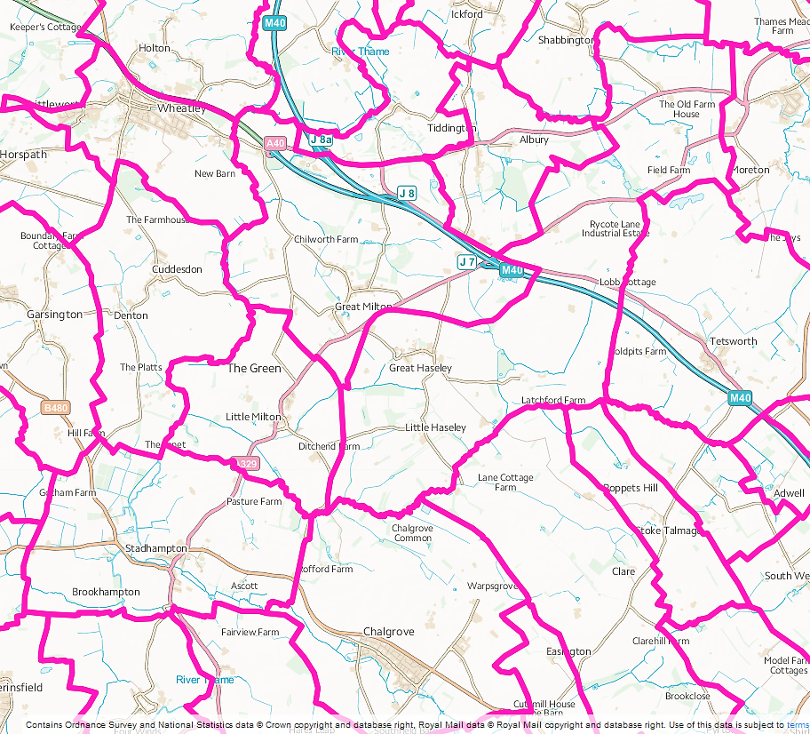

Great Milton, Little Milton and Great Haseley (the Haseleys) parishes (Source: Ordnance Survey Election Maps[1])

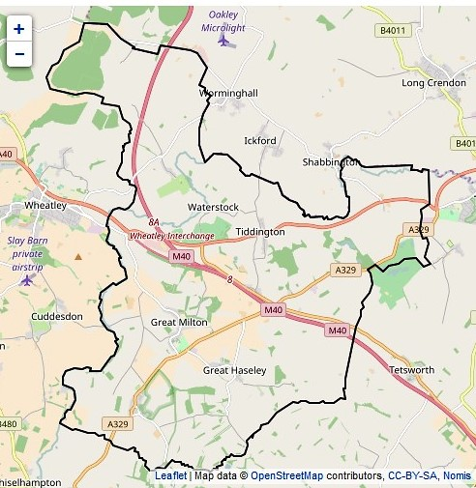

Great Milton ward (E05006585) at the time of the 2011 Census[2] (South Oxfordshire ward boundaries changed in with effect from the South Oxfordshire District Council elections in May 2015 and the Great Milton ward became part of the new and larger Haseley Brook ward).

Overview

* The population of Great Milton parish at the time of the 2011 census was 790, 26.1% of the population was over 60, 34.8% of residents over 16 were qualified to Level 4 or above, 7.4% of households (23) did not have a car or van.
* The population of Little Milton parish at the time of the 2011 census was 486, 21.4% of the population was over 60, 43.3% of residents over 16 were qualified to Level 4 or above, 4.6% of households (9) did not have a car or van.
* The population of Great Haseley parish at the time of the 2011 census was 511, 24.5% of the population was over 60, 47.9% of residents over 16 were qualified to Level 4 or above, 6.5% of households (14) did not have a car or van.
* The Great Milton ward population at the time of the 2011 Census was 2,734 and in 2014 was forecast to change to 2,742 in 2026.[3]

Social life

*Great Milton*

* The Bull pub was built in 1684 and, in 2013, became a community-owned pub. There is also the Manoir aux Quat’ Saisons Hotel and restaurant
* The Neighbours Hall is centrally-heated community hall with a fully-equipped kitchen and parking, licensed to hold 100 people
* The Pavilion and Recreation Ground are available for private hire. The Pavilion is used for parish council meetings, as well as cricket and football.
* Old Field is a peaceful, rural area of 4 acres for the enjoyment of local people whilst allowing an increasing diversity of wildlife to flourish
* St Mary’s Church
* Great Milton Methodist Church

*Little Milton*

* The Pine Lodge village hall has a capacity of up to 300 standing and 120 seated banquet style
* The Lamb is the village pub
* The recreation ground has a children’s play area, floodlit multi-use games area, tennis courts, and an open space
* St James’ Church

*Haseleys*

* The Plough Pub was bought by the village community in 2012 and is now run as a free house for the benefit of the community
* Great Haseley village hall is an old converted barn with kitchen facilities and can be booked for events for up to 150 people
* The Playing Fields have a cricket pitch, two tennis courts and a basketball post. There is also a pavilion with kitchen facilities.
* The Cross Field has open space areas for the playing of ball and other games, and for picnics. Play equipment includes a balance trail, climbing nets, swings and a slide. There is also a Millennium Wood.
* St Peter’s Church

Schools

* Great Milton Church of England Primary School is a voluntary controlled school
* Little Milton Primary School is a Church of England Aided School
* Great Milton, Little Milton and the Haseleys are in the Wheatley Park School catchment area

Services

* The 103 bus service from Little Milton via Great Milton, the Haseleys and Wheatley, to Oxford ended on 2nd December 2016
* A volunteer driver scheme operates for Great Milton, Little Milton and the Haseleys to provide transport to the doctor's surgery at Wheatley, Thame Hospital and the Oxford hospitals (Three Villages Car Scheme).
* The Great Milton General Store (which includes the Great Milton Post Office) is open seven days a week
* The Community Shop in Little Milton was established in September 2008 and is open Monday to Saturday. the Little Milton Post Office is also in the shop.
* The Little Milton Orchard Pre-school offers pre-school education for 2 to 5 year olds based on the Early Years Foundation Stage areas of learning and personal development
* The nearest libraries are in Wheatley and Thame

Parish Councils

* Great Milton Parish Council 21 Fullers Field, Great Milton, OX44 7PJ: Helen Cherry [contact@clerkgreatmilton.co.uk](mailto:contact@clerkgreatmilton.co.uk) 07554 516989
* Little Milton Parish Council, 27 Chiltern View Little Milton, OX44 7QP: Raymond Fergusson, [lmparishcouncil@btinternet.com](mailto:lmparishcouncil@btinternet.com) , 01844 279150
* Great Haseley Parish Council, Christmas Cottage, Latchford Lane, Great Haseley, OX44 7LE: Mrs J E Simcox, [clerk@thehaseleys.co.uk](mailto:clerk@thehaseleys.co.uk) 01844 279631

Websites

* Great Milton: <http://www.great-milton.co.uk/>
* Little Milton [https://www.hugofox.com/community/little-milton-village-community-7833/about-us#](https://www.hugofox.com/community/little-milton-village-community-7833/about-us)
* The Haseleys: <http://www.thehaseleys.co.uk/>

1. **Areas of Deprivation**

LSOA E01028646 Great Milton, Little Milton, Great Haseley is not deprived but there are issues with barriers to housing and access to services.

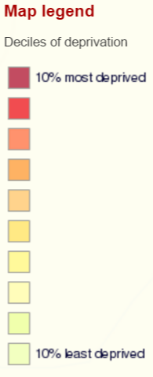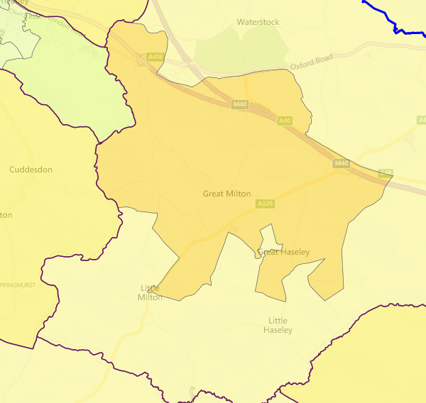





**SOURCE- Index of Multiple Deprivation 2015 Deciles (where 1 is most deprived 10% of small areas - LSOAs)**

1. **Service Overview**

|  |  |  |
| --- | --- | --- |
| **Children’s Centre** | **Day Centre** | **Transport** |
| County council funding for the Maple Tree Children's Centre in Wheatley is scheduled to be withdrawn in April 2017.  In February 2016, the council agreed to set aside £1m for creating a ‘one off’ fund to provide pump priming to support Children’s Centres. In Feb. 2017 OCC cabinet was recommended to approve transition funding to the Friends of Maple Tree CC.  The services currently delivered from Maple Tree CC will therefore be transferring to a community provision led by Friends of Maple Tree. Start date has yet to be confirmed. | Thame and District Day Centre is the nearest centre. It is open 3 days a week and offers a hot meal and plenty of stimulating activities and trips out at certain times of the year.  Thame’s day centre relies on a grant from Oxfordshire Social Services to finance its core services, but also relies on charitable donations from the public for activities, entertainment, outings and a Christmas lunch for the elderly members who may be frail or otherwise isolated.  OCC has ‘[proposed](http://mycouncil.oxfordshire.gov.uk/documents/s36119/CA_JAN2417R26%20-%20Daytime%20Support.pdf) to replace our current annual funding for 47 community daytime support services [**including the Thame and District Day Centre**] of £992,000 a year, with grant pots totalling £250,000 a year, which services could bid for under two categories. The Sustainability Fund would provide grants to enable the ongoing delivery of daytime support services in areas of high need. The Innovation Fund would provide one-off grant funding to establish self-sustaining projects to fill gaps in services.’ | The 103 bus service from Little Milton via Great Milton, the Haseleys and Wheatley, to Oxford ended on 2nd December 2016.  Parishes affected by the service withdrawal met on 26th October to discuss alternative options but no decision was made.[4]  The weekly 124 bus service to Thame ended on 20th July 2016 |

1. **Distance to Services**





**SOURCE - Road distance to key services (km) in 2014. IMD 2015 Barriers to Housing and Services Domain**

1. **Community Assets**

|  |  |
| --- | --- |
| **Name** | **Details** |
| Great Milton Neighbours Hall | * Licensed to hold 100 people |
| Little Milton Pine Lodge village hall | * Capacity of up to 300 standing |
| Great Haseley village hall | * Events for up to 150 people |
| Great Milton Sports Pavilion | * Available for private hire |

1. **Community activity: overview**

| **Theme** | **Group and details** | **Contact** | **Notes** |
| --- | --- | --- | --- |
| **Children** | Great Milton Toddler & Baby Group | 01844 279967 | Weekly during term time at Neighbours’ Hall |
|  | Great Milton Junior Sports | 01844 278116 | Sport and exercise for ages of 5 to 11 at the recreation ground, Saturday morning during term time |
| **Older people** | Great Milton Party Fund Committee | Secretary: Chris Simmons | Organises an annual party for all senior citizens, widows and widowers in the Parish of Great Milton. The party is held on the Saturday after Easter in the Neighbours Hall when guests are treated to a roast turkey meal followed by an evening of entertainment. |
|  | Great Milton Neighbours’ Club | 01844 279432 | Open to everyone over 55 years, twice a month at the Neighbours Hall, talks and other activities. |
|  | Little Milton & District Women’s Institute | 01844 279438 |  |
| **Transport** | Great Milton, Little Milton and the Haseleys Car Service | 01844 279416 | ‘Three Villages Car Scheme’ |
| **For more details see community websites listed in the parish overview sections** | | | |

1. **Recent projects to mitigate service reductions**

**Analysis of gaps in services**

The withdrawal of a scheduled bus service from Great Milton, Little Milton and the Haseleys has highlighted the issue of social isolation for residents who do not drive or who cannot walk very far. The existing Three Villages Car Scheme could be extended to include shopping and social trips as well as medical appointments, but this may require the recruitment of more volunteer drivers. A good neighbour scheme would also help to tackle the issue of social isolation.

The three parishes could also share resources to start a community transport scheme, similar to Our Bus Bartons in West Oxfordshire; the start-up of which was supported by Community First Oxfordshire.

Great Milton appears to organise more activities for older people and there is potential to extend these activities and share resources between the three parishes. Providing a youth service in the village, either as a youth club or using nearby services was a high priority in the Great Milton Parish Plan 2012 but a youth club does not seem to have been sustainable. Again, the sharing of resources between the parishes may result in a feasible young peoples' project.

**Projects**

|  |
| --- |
| **Potential community transport and ‘placemaking’ initiatives**  CFO has offered advice regarding a CT solution, potentially following the Our Bus Bartons model. CFO is also working with Little Milton on issues of concern, including: the impact on traffic of local development; the character of the village and its open spaces. CFO has met with the parish council as part of their neighbourhood plan process, and has ongoing involvement in discussions about how best to manage the pressures following budget cuts and faced with strategic development nearby. |

1. https://www.ordnancesurvey.co.uk/election-maps/gb/#
2. <https://www.nomisweb.co.uk/query/construct/components/stdListComponent.asp?menuopt=12&subcomp=100>
3. <http://insight.oxfordshire.gov.uk/cms/oxfordshire-county-council-population-forecasts-january-2014-excel-format>
4. <https://www.hugofox.com/shared/attachments.asp?f=1f69cb16%2Dbb27%2D4510%2D96cf%2D01176a9e4502%2Epdf>