

Didcot - Community Profile: March 2017

1. **Map and Overview**

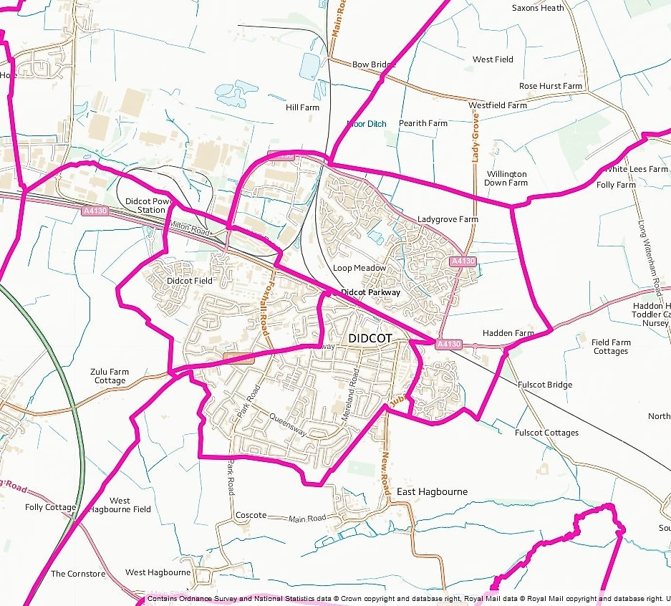

The town of Didcot (Source: Ordnance Survey Election Maps[1])

Overview

The population of the town of Didcot at the time of the 2011 Census was 24,416

In December 2015, Government announced that Didcot will become a Garden Town, delivering 15,050 new homes and 20,000 high-tech jobs in the greater Didcot area over the next 15 years. The majority of sites for the 15,050 homes are allocated. Most of these are within Vale of White Horse District (outside the town of Didcot), and many already have planning consent. Didcot’s population is expected to grow from its current level of 24,530 to 65,200 by 2031.

With a larger population comes a greater demand on services, from healthcare and transport, to leisure

and retail. Therefore, there is a need to make sure that the town is prepared to deal with growth and that growth is delivered in a sustainable way. Key to the Greater Didcot Garden Town transformation is the opportunity to address the current deficiencies in landscaping, environment and open space within the town. The creation of local allotments, enhanced public parks and sporting and leisure facilities will contribute to the health and wellbeing of the community.[2]

Social life

* Cornerstone Arts Centre - purpose-built, professional arts, culture and entertainment venue. Cornerstone comprises a 220 seat auditorium, café bar, gallery and four studios.
* Didcot Railway Centre - home to the Great Western Society's unique collection of steam engines, coaches, wagons, buildings and small relics; and a recreation of Brunel's broad gauge railway.

Schools

Didcot is served by six primary schools: All Saints' C of E, Ladygrove Park, Manor, Northbourne C of E, Stephen Freeman and Willowcroft.

There are three state-funded secondary schools in Didcot: St Birinus School and Didcot Girls' School

are single-sex schools that join together at sixth form. UTC Oxfordshire is a university technical college that opened in 2015 for students aged 14 to 19 years.

Services

* Didcot Parkway railway station - The station is served by local services operated by Great Western Railway from Reading to Didcot and Oxford, and by main line services from London Paddington to Swindon, Bristol and South Wales, but some of the main line services do not call at the station.
* Bus services – Didcot has regular services to Oxford, Abingdon, Wallingford, Wantage and Grove and major employment sites at Culham Science Centre, Harwell Campus and Milton Park.
* Didcot Community Hospital - The hospital provides rehabilitation and palliative care for people who no longer require the services of an acute hospital but require greater support than currently provided in their home environment.
* Didcot has three GP surgeries.
* Volunteer car driver scheme - Didcot Volunteer Centre organises a scheme for medical appointments, shopping and social events. The scheme covers Didcot and surrounding villages i.e. The Astons, Milton, Blewbury, The Moretons, Chilton, Steventon, The Hagbournes, Upton, Harwell, The Wittenhams.
* Didcot Health and Wellbeing Centre - The day centre supports adults with physical disabilities, mental health problems and dementia.
* Didcot Early Intervention Hub - The Didcot Hub offers services and a venue for groups and activities, for children, young people, parents and families in the Didcot, Henley, Sonning Common, Thame, Wallingford and Woodcote area.
* Children's Centres – Stephen Freeman, South Didcot and Didcot Ladygrove Children’s Centres are for children under five and their families and offers a variety of services that families may need to thrive and make the most of life’s opportunities, whatever their background or circumstances.
* Didcot Library - The library is open from Monday to Saturday and has free wi-fi and computers with internet access.
* Retail - A new shopping centre opened in Didcot in 2004/5 and a second phase is planned.
* Leisure centres - Didcot Leisure Centre offers a sports hall, squash courts, bar & function room. Didcot Wave has wave machine, indoor flume ride and beach area. It also has a gym. Willowbrook Leisure Centre has a gym, sportsd hall and cycling studio.
* Parks - Edmonds Park is 8.5 hectares and has 2 play areas, a pavilion, senior and junior football pitches and sports courts. Ladygrove Park is 11.38 hectares and has a play area, multi-use area, football pitches and three tennis courts. All these parks are owned by the town council.
* Boundary Park - Boundary Park is a brand new multi-sports facility situated within Great Western Park in Didcot. It contains 17½ acres of amenity grass land encompassing two cricket pitches, two rugby pitches, one full size football pitch and five junior pitches of assorted sizes. The pitches are serviced by a two storey pavilion which houses six 20-person changing rooms and a social space which includes a bar, kitchen and function room.

Town council

* Didcot Town Council, Council Offices, Britwell Road, Didcot, OX11 7HN, 01235 812637.
* Town clerk, Kathy Fiander [kfiander@didcot.gov.uk](mailto:kfiander@didcot.gov.uk)
* <http://www.didcot.gov.uk/default.aspx>

1. **Areas of Deprivation**

Didcot All Saints and Northbourne and Didcot Park LSOAs E01028621, E01028632, E01028633, E01028635, E01028636

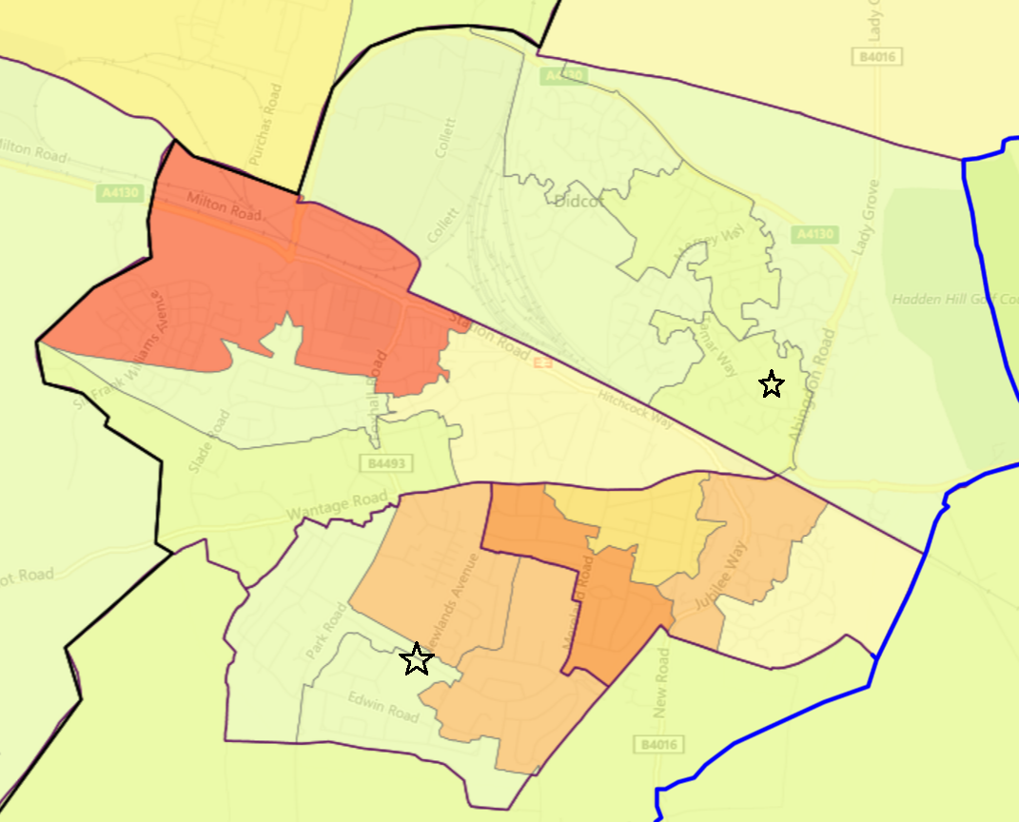

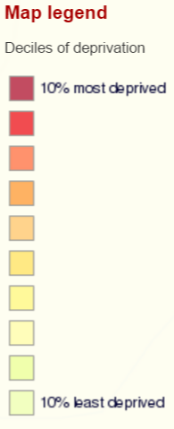



1. **Service Overview**

|  |  |  |
| --- | --- | --- |
| **Children’s Centre** | **Day Centre** | **Transport** |
| As part of the 2016/17 budget Oxfordshire County Council decided that eight Children and Family Centres  will be created across Oxfordshire, providing a base for a service for 0-19 year olds and their families.  One of these centres will be in Didcot and it is proposed that it will be co-located with the existing Didcot Early Intervention Hub for young people. The existing Didcot Children's Centres will be financially supported by the county council until April 2017. After this date they will have to be financially self-supporting but can apply for a grant from the county council’s £1m transition fund. | As part of the 2017/18 budget Oxfordshire County Council has decided that the health and wellbeing centre service will be replaced by a community support service delivered from 8 building bases around the county, including Didcot.  The buildings will provide multi-functional spaces, and deliver individual and group support, using facilities available at the base, as well as in local communities. Existing funding for voluntary sector day time support will come to an end but new county council funding will be available (£900,000 in 17/18, £600,00 in 18/19 and £350,000 in 19/20 | Bus services to and from neighbouring villages (Blewbury, the Hagbournes, the Moretons) have stopped following the withdrawal of bus subsidies. |

1. **Distance to Services**

|  |  |  |  |  |  |  |
| --- | --- | --- | --- | --- | --- | --- |
| Community | Barriers to Housing and Services | Geographical Barriers | Distance (km) to: | |  |  |
| LSOA | PO | Food | GP | Primary school |
| Didcot |  |  |  |  |  |  |
| E01028621 | **3** | **2** | **1.78** | **1.50** | **1.81** | **1.54** |
| E01028632 | 9 | 8 | 0.70 | 0.80 | **1.09** | 0.80 |
| E01028633 | **3** | **2** | **1.37** | **1.08** | **1.67** | **1.51** |
| E01028635 | 10 | 9 | 0.62 | 0.62 | **1.25** | 0.57 |
| E01028636 | 8 | 7 | 0.56 | 0.59 | 0.55 | 0.82 |

1. **Community Assets**

|  |  |
| --- | --- |
| **Name** | **Details** |
| Didcot Civic Hall, Britwell Road, Didcot, OX11 7HN | * Main hall seats 350 theatre style, Ladygrove Room seats 100 theatre style |
| Fleet Meadow Community Hall, Sandringham Rd, Didcot OX11 8TP |  |
| All Saints' Youth and Community Hall, Roman Place, Didcot, OX11 7ER | * Main hall seats 76 |
| King Alfred Drive Community Centre, 2 King Alfred Drive, Didcot OX11 7NU |  |
| GWP Northern Neighbourhood Centre, Greenfinch Rd, Didcot OX11 6AS | * Capacity for 60 people |
| Ladygrove Community Centre, Tamar Way, Didcot OX11 7QH |  |

1. **Community and services: overview**

| **Theme** | **Group and details** | **Contact** | **Notes** |
| --- | --- | --- | --- |
| **Young people** | Didcot TRAIN Youth Project | 01235 519315  118 Broadway, Didcot OX11 8AB  <http://www.didcottrain.org.uk/> | TRAIN helps the young people in Didcot make informed choices, avoid risky behaviours, find ways out of difficult situations, find their own voices, and be who they want to be. |
|  | Didcot Early Intervention Hub | Park Road Didcot, OX11 8QX  <http://oxme.info/cms/life/didcot-early-intervention-hub> | The Early Intervention Service offers high quality early intervention and specialist services to children, young people and families with additional and complex needs, both through service staff and across partner agencies. |
| **Older people** | Didcot Carers Support Group | Cath Evans 07557 430877 | For carers to come and have a chat, pick up information and seek advice |
|  | Didcot Dementia Support Group | [oxford@alzheimers.org.uk](mailto:oxford@alzheimers.org.uk) | The peer support group gives people the opportunity to meet with others who understand some of what they are going through. |
|  | Didcot Good Neighbour Scheme | [info@dgns.org.uk](mailto:info@dgns.org.uk) |  |
| **Transport** | Didcot Volunteer Centre | [didcotvolunteercentre@talktalk.net](mailto:didcotvolunteercentre@talktalk.net)  01235 816709 | 40+ volunteers who provide a transport service for people in Didcot and the surrounding villages so that they can attend their medical & other appointments. |
| **Employment** | Sophea | 01235 510774 (office)  [info@sofea.uk.com](mailto:info@sofea.uk.com)  <http://www.sofea.uk.com/> | SOFEA trains people struggling to find jobs in logistics-related work, using food donated by supermarkets which is then given to local charities |
| **Other** | Citizens Advice Bureau | Dales, 9-15 High Street, Didcot, OX11 8EQ |  |
|  | Didcot Rethink Support Group | Lisa McKue 01865 455 876 | Rethink Mental Illness |
|  | Didcot Foodbank | 01235 813187 |  |
|  | Didcot First | <http://www.didcotfirst.org.uk/>  [mail@didcotfirst.org.uk](mailto:mail@didcotfirst.org.uk) | Help to promote that Didcot is a positive place to live, work and invest. |

1. **Recent projects to mitigate service reductions**

**Analysis of gaps in services**

Didcot is a rapidly growing town. However, there is little resource being directed at helping new residents become part of the existing community.

People make a place far more than buildings and if Didcot's new housing developments are going to become part of a sustainable and attractive community it is important that as well as good quality housing, good green space, community facilities and appropriate infrastructure there are good social networking opportunities.

**Projects**

|  |
| --- |
| **Building a thriving community on the Great Western Park development**  In late 2015, Community First Oxfordshire (CFO) had discussions with the Community Infrastructure Projects Officer at South and Vale District Council to discuss a recent study undertaken by CFO for Cherwell District Council, which set out best practice recommendations for building vibrant, sustainable communities on major new housing developments. CFO was subsequently commissioned to undertake a study for South and Vale District Council and Sovereign Housing Association.  As well as making a number of best-practice recommendations to support placemaking and community development on strategic housing sites district-wide, the study recommended that – at Great Western Park- South and Vale District Council should create a GWP Development Trust and hold a GWP ‘summit’ of community representatives, developer and stakeholders  A key concern expressed by interviewees that the ad hoc community development approach on GWP has meant that needs of vulnerable residents and those in greater social need appear to be being somewhat overlooked. |

1. https://www.ordnancesurvey.co.uk/election-maps/gb/#
2. <http://www.southoxon.gov.uk/business/support-business/supporting-our-town-centres/didcot/didcot-garden-town>