

Chipping Norton - Community Profile: October 2017 update

1. **Map and Overview**

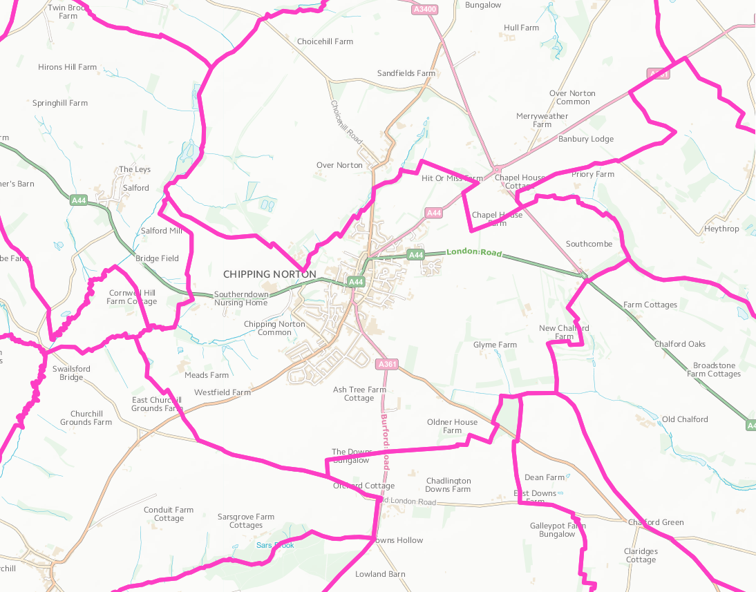

Chipping Norton Parish (Source: Ordnance Survey Election Maps)

Overview

* The Chipping Norton parish population at the time of the 2011 Census was 6,337. Both the proportion and absolute number of those aged over 65 is expected to continue to increase over the coming decades.
* Ward forecasts for the town supplied by Oxfordshire County Council predict the population of this age group will increase by 36% in the 15 years from 2011 to 2026.[1] The forecast of the total Chipping Norton population in 2026 is 7,681.[2]
* At the time of the 2011 Census 71% of those aged 16 to 74 were in employment with the rate of employment growth outpacing the rate of population growth over the previous 10 years.
* The town has a greater than average proportion of residents employed in skilled trades and Personal services.
* 8.3% of working residents work at or mainly from home. 35.9% of commutes originating within

Chipping Norton are completed within the town itself, 64.1% commute out from the town to elsewhere.

* 66.3% of residents’ convenience shopping is bought within the town.[3]

Social life

* The town hosts a number of annual arts festivals: Chipping Norton Literary Festival ('ChipLitFest'), Chipping Norton Music Festival, and Chippy Jazz and Music ('CJAM').
* The Theatre Chipping Norton opened in 1975 in a converted Salvation Army citadel, and is a theatre, cinema, gallery and music venue. It hosts original productions and touring companies.

Schools

* The town has three schools. Holy Trinity Roman Catholic School and St Mary's Church of England School are primary schools. Chipping Norton School is the town's secondary school and has a sixth form.

Services

* Chipping Norton War Memorial Community Hospital Out-Patient and Maternity Unit
* Chipping Norton Health Centre (West Street Surgery and White House Surgery moved to purpose built premises and merged to become Chipping Norton Health Centre in April 2015) The health centre has 14,972 registered patients[4]
* Chipping Norton Leisure Centre is a modern dual use site shared with Chipping Norton School. Facilities which include a 25 metre main swimming pool with learner pool, main activity hall, dance studio, squash courts and a gym.[5]

**Main bus services**: S3, Oxford - Chipping Norton; 488/489, Chipping Norton – Banbury; X8, Chipping Norton - Kingham Station; X9, Chipping Norton – WitneyV3 Villager Community Bus, Chipping Norton Rotary Good Neighbour Shuttle Service (Hospital to Health Centre via town centre, Aldi and housing areas)

Town Council

* Chipping Norton Town Council are responsible for the Town Hall, the War Memorial, the Closed Churchyard at St. Marys Church, Church Street, the Worcester Road Cemetery, four recreation grounds in the town at the moment, Pool Meadow, Greystones recreation grounds, litter bins and grit bins in the town.[6]
* Vanessa Oliveri, Town Clerk: 01608 642 341 - [cntownclerk@btconnect.com](mailto:cntownclerk@btconnect.com)
* <http://www.chippingnortontowncouncil.co.uk/>

Websites

* <http://www.chippingnortontowncouncil.co.uk/>
* <http://experiencechippingnorton.com/>

1. **Areas of Deprivation**

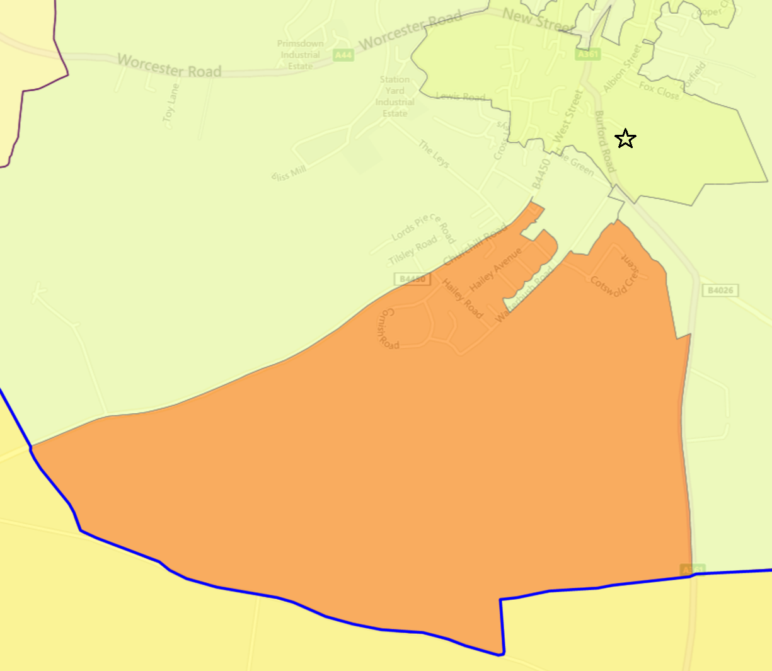Chipping Norton E01028781

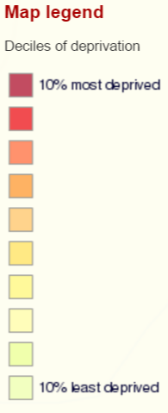

Chipping Norton has one area of relative deprivation, particularly in the areas of education skills and training, children and young people and adult skills.





**SOURCE- Index of Multiple Deprivation 2015 Deciles (where 1 is most deprived 10% of small areas - LSOAs)**

1. **Service Overview**

|  |  |  |
| --- | --- | --- |
| **Children’s Centre** | **Day Centre** | **Transport** |
| **Ace Children’s Centre**[7][8]  Burford Road.  Currently provides child care which is being supported to become self-financing from April 2017 and will provide outreach activities to children and families from the centre. The intention is that the centre remains open offering a range of services, some of which will be run by the county council.[9]  In February 2016, the council agreed to set aside £1m for creating a ‘one off’ fund to provide pump priming to support Children’s Centres. In Feb. 2017 OCC cabinet was recommended to approve transition funding to the Ace Centre.  Therefore, the services currently delivered from the Ace CC will be transferring to a community provision led by The Ace Charity. Start date has yet to be confirmed. | **Highlands Day Centre,**  Burford Road (see *Community Assets*, below)  A day centre for older people providing a home cooked lunch and refreshments, a variety of activities, trips and guest speakers.  OCC has ‘[proposed](http://mycouncil.oxfordshire.gov.uk/documents/s36119/CA_JAN2417R26%20-%20Daytime%20Support.pdf) to replace our current annual funding for 47 community daytime support services [**including the Highlands Day Centre**] of £992,000 a year, with grant pots totalling £250,000 a year, which services could bid for under two categories. The Sustainability Fund would provide grants to enable the ongoing delivery of daytime support services in areas of high need. The Innovation Fund would provide one-off grant funding to establish self-sustaining projects to fill gaps in services.’ | Regular bus services currently running without subsidy.  Chipping Norton Rotary Good Neighbour Shuttle Service carrying 120 passengers a month |

1. **Distance to Services**





**SOURCE- Road distance to key services (km) in 2014 - IMD 2015 Barriers to Housing and Services Domain**

1. **Community Assets**

|  |  |
| --- | --- |
| **Name** | **Details** |
| Chipping Norton Leisure Centre, Burford Road, Chipping Norton, OX7 5DY | * Leisure centre with dual use between the community and the secondary school. 25 metre main swimming pool, learner pool, activity hall, dance studio, squash courts, gym. Owned by West Oxfordshire DC, run by Better |
| The Lido, Fox Close, Chipping Norton, OX7 5BZ | * Heated 25m pool and toddler pool, slide and café. The pool has been run by local people as a charity since 2004 |
| Chipping Norton War Memorial Community Hospital, Russell Way, London Rd, Chipping Norton OX7 5FA | * Out-patient, maternity, intermediate care. Hospital Action Group claims intermediate care services have been reduced since management was transferred to Orders of St John Trust |
| Chipping Norton Town Hall, Chipping Norton, OX7 5NJ | * Main hall, lower hall and council chamber available for hire |
| Chipping Norton Fire Station, Burford Rd, Chipping Norton OX7 5DZ | * Becoming a one pump station due to difficulty in recruiting fire fighters |
| The Theatre, Chipping Norton, 2 Spring Street, Chipping Norton, OX7 5NL | * 213 person auditorium * Running cost £200,000.00 per year, 76% of the Theatre’s income comes from ticket sales. The rest of the income comes from Chipping Norton Town Council and West Oxfordshire District Council. Subject to feasibility looking to purchasing the old hospital site and develop into an Arts Centre with two cinema screens. |
| Glyme Hall Community Centre, 98 Burford Road Chipping Norton, OX7 5DY | * General purpose community centre; activities hall, kitchen, classroom with IT facilities and a social room and meeting room |
| The Albion Centre, 1 Market Place, Chipping Norton, OX7 5DD | * Learning disabilities day centre (run by Southern Health NHS Trust) |
| Chipping Norton Library, Goddards Lane, Chipping Norton, OX7 5NP | * Various literary talks and community activities |
| Citizens Advice Bureau | * Chipping Norton Health Centre, Russell Way, Chipping Norton, OX7 5AD |
| Highlands Day Centre | * 73 Burford Road, Chipping Norton, OX7 5EE * Jane Simms - 01608 643320; [ppmlake@aol.com](mailto:ppmlake@aol.com) * 4 days per week, 20 per session (Chipping Norton). A day centre for older people providing a home cooked lunch and refreshements, a variety of activities, trips and guest speakers. Also available on-site are a hairdresser, footcare and assisted bathing. * Highlands Community Club also offers support in the community under the banner ‘Highlands in the Community’. By actively working with other local groups they have also ensured that their building is used almost constantly throughout the week by the community as a whole, creating a natural hub in the community |

1. **Community activity: overview**

| **Theme** | **Group and details** | **Contact** | **Notes** |
| --- | --- | --- | --- |
| **Children** | REMIX Youth Club, | * Glyme Hall * [youth@stmaryscnorton.com](mailto:youth@stmaryscnorton.com) | * For school years 7 to 11, every Friday during term-time, 3.15pm – 4.45pm |
| **Older people** | Gadget drop-in sessions, | * Age UK/Chipping Norton Library | * Bring in your tablet, laptop or smartphone for help getting started or improving your knowledge/skills from one of our friendly volunteers |
|  | Highlands Day Centre | * **See details in *Community Assets*, above** |  |
|  | Chatterbox | * Lower Town Hall * Pat Lake: 01608 643320 | * Run by Age UK * Fortnightly coffee morning |
|  | Lights Up | * Highlands Day Centre, 73 Burford Road * 01993 893573 | * Run by Lights Up * Fortnightly * Living well with dementia through the Arts |
|  | Chipping Norton Carers Coffee Club, | * Bitter & Twisted 1 Middle Row Town Centre * Anney Harris 07557 430874 | * Run by Carers Oxfordshire * Monthly |
|  | Late Spring | * Highlands Day Centre, 73 Burford Road * Joan Douglas 07827 235 453 | * Run by Age UK * Network of support groups for anyone aged 60+ who has been bereaved; fortnightly |
|  | Chair based exercise | * Chipping Norton Town Hall * Generation Games 01235 849403 | * Run by Age UK * Fortnightly |
|  | Mobility Aids Short Term Loan | * Mobile vehicle, Chipping Norton School * 0844 412 2750 | * Weekly * Run by British Red Cross |
|  | Singing for Better Breathing | * Glyme Hall * [kath@songspace.co.uk](mailto:kath@songspace.co.uk) | * Run by British Lung Foundation |
|  | Chipping Norton Good Neighbour Scheme | * 01608 644107 [ar-b@talktalk.net](mailto:ar-b@talktalk.net) |  |
|  | Dementia Carer Support Group | * Highlands Day Centre, Burford Road * Brenda Green: 07827 235449 | * Monthly * Run by Dementia Carer Support Group |
| **Transport** | Chipping Norton Rotary Good Neighbour Shuttle Service | * Keith Gowing: [kcgowing@btinternet.com](mailto:kcgowing@btinternet.com) | * Run by Villager Community Bus services   **See case study below** |

1. **Summary of key local issues**

*DRAFT SECTION - IN PROGRESS*

**Mitigation projects**

|  |
| --- |
| **Chipping Norton Rotary Good Neighbour Shuttle Service**  The community identified the need for a regular bus service within Chipping Norton to enable people without cars to access health care at the new, out of town, hospital and doctors’ surgery as well as to shops and social amenities. CFO Advised on grant funding to start shuttle service and awarded a grant of £1,060 from the Oxfordshire County Council Community Transport Fund. The Shuttle service started in May 2016 and is now carrying around 120 passengers per week, with 12 volunteers. |

1. <http://insight.oxfordshire.gov.uk/cms/oxfordshire-county-council-population-forecasts-january-2014-excel-format>
2. <http://insight.oxfordshire.gov.uk/cms/oxfordshire-county-council-population-forecasts-january-2014-excel-format>
3. West Oxon Retail Needs Assessment Update, 2012
4. <http://www.nhs.uk/Services/GP/Overview/DefaultView.aspx?id=36684>
5. <http://www.better.org.uk/leisure-centre/west-oxfordshire/chipping-norton-leisure-centre>
6. <http://www.chippingnortontowncouncil.co.uk/>
7. <http://www.ace-chipping-norton.co.uk/>
8. Children’s Centres are for children under five and their families, places where they can find a variety of activities, play, information and support from professionals working in a wide range of fields, whatever their background or circumstances.
9. <http://mycouncil.oxfordshire.gov.uk/documents/s33298/CA_MAY2416R09%20Childrens%20Services.pdf>