

Bloxham - Community Profile: October 2017 update

1. **Map and Overview**

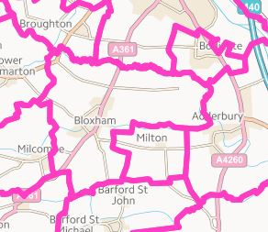

**Bloxham parish- Cherwell (Ordnance Survey)**

Overview

* The parish of Bloxham is in the ward of Bloxham and Bodicote in the district of Cherwell
* According to the 2011 census, Bloxham has a total population of 3374, comprising 1347 households. Bloxham is about 3.5 miles from Banbury.

Social life

* A newsletter is delivered within the parish, *The Bloxham Broadsheet*.
* There is an Anglican church in Bloxham, St Mary’s, and also a Baptist Church
* There are a number of halls and community spaces (see *community assets* section below), supporting various social and leisure groups
* Groups, clubs, societies, and organisations in Bloxham include: history club; reading club; job club; various mother and toddler groups, Boys Brigade, football, gardening, bell-ringing, senior citizens, health walking group

Schools

* There is a primary school in the parish: Bloxham Church of England Primary School

Services

* There are three pubs in the parish, *The Joiners Arms, the Elephant and Castle, and the Red Lion*
* There is a Post Office and several shops/ stores in Bloxham, including a butchers. There is also a farm shop and regular country market
* There is a doctor’s surgery and dentist in the parish
* Stagecoach service 488/489 serves Bloxham

Parish Council

* **Bloxham Parish Council**
* Theresa Goss (clerk). 01295 710 965. [bloxhampc@aol.co.uk](mailto:bloxhampc@aol.co.uk)

Website

<http://bloxham.info/>

1. **Areas of Deprivation**

Bloxham is relatively affluent, with barriers to services being the main issue.

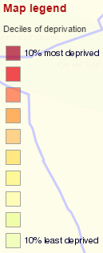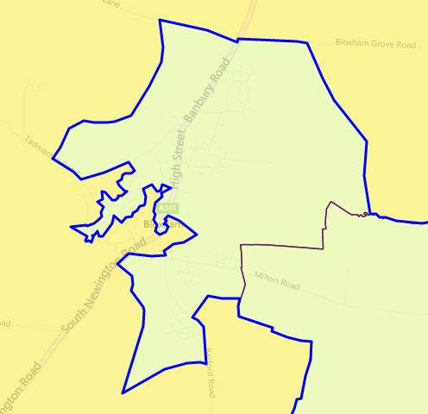





**SOURCE- Index of Multiple Deprivation 2015 Deciles (where 1 is most deprived 10% of small areas - LSOAs)**

1. **Service Overview**

|  |  |  |
| --- | --- | --- |
| **Children’s Centre** | **Day Centre** | **Transport** |
| In February 2016, Oxfordshire County Council council agreed to set aside £1m for creating a ‘one off’ fund to provide pump priming to support Children’s Centres.  The November 2016 bid from **Butterfly Meadows Children’s Centre, Bloxham** for transition funding was successful.  **See details below** | **Thursday Club-** St Mary’s Parish Rooms (see Community Activity below)  OCC has ‘[proposed](http://mycouncil.oxfordshire.gov.uk/documents/s36119/CA_JAN2417R26%20-%20Daytime%20Support.pdf) to replace our current annual funding for 47 community daytime support services [**including the Thursday Club**] of £992,000 a year, with grant pots totalling £250,000 a year, which services could bid for under two categories. The Sustainability Fund would provide grants to enable the ongoing delivery of daytime support services in areas of high need. The Innovation Fund would provide one-off grant funding to establish self-sustaining projects to fill gaps in services.’ | Stagecoach Service 488/ 489 serves Bloxham up to 12 times daily |

1. **Distance to Services**





**SOURCE: Road distance to key services (km) in 2014 - IMD 2015 Barriers to Housing and Services Domain**

1. **Community Assets**

|  |  |
| --- | --- |
| **Name** | **Details** |
| Ex Servicemen's Village Hall | * High Street, Bloxham, Banbury, Oxon, OX15 4LT * Mervyn Jones: 07881730698. [mervmouse@hotmail.com](mailto:mervmouse@hotmail.com) * Seats 100 - 264m2 area |
| Jubilee Park Hall | * Barley Close, Bloxham, Oxon, OX15 4NJ * Mandy Fountain: 01295 722717. [mandfoun@aol.com](mailto:mandfoun@aol.com) * Seats 100 - 126m2 area |
| Ellen Hinde Memorial Hall | * Chapel Street, Bloxham, Banbury, Oxon., OX15 4PT * Carmen Guard: 01295 720339- [david.guard@which.net](mailto:david.guard@which.net) * Main hall (seats 100) and second hirable room. Total hirable area 110m2 |
| Bloxham Church of England Primary School | * **See contact details below** |
| The Warriner School | * School secretary: 01295 720777 - [admin.4007@warriner.oxon.sch.uk](mailto:admin.4007@warriner.oxon.sch.uk) * Multiple rooms available for community hire after school and weekends |
| Baptist Church | * Bloxham Baptist Church, Hawke Lane, Bloxham, OX15 4PY * 01295 721525 * Available for community hire |
| Bowls Club | * The Ridgeway, Banbury, Oxfordshire, OX15 4LW |
| St Mary’s Parish Rooms | * Church Street, Bloxham, Banbury, Oxon. - 01295 720186 |
| **For more information see** <http://www.steeplebartonpc.org.uk> | |

1. **Community activity: overview**

| **Theme** | **Group and details** | **Contact** | **Notes** |
| --- | --- | --- | --- |
| **Children** | **Bloxham Church of England Primary School** | School secretary: 01295 720224 - [office.3064@bloxham-pri.oxon.sch.uk](mailto:office.3064@bloxham-pri.oxon.sch.uk)  Tadmarton Road, Bloxham, Banbury, Oxon., OX15 4HP |  |
|  | **Bloxham Mothers Union** |  |  |
|  | **Pandas** | Baptist Church- see details above | * Term time, Tuesdays, 9.30-10.45 * ‘Support group for expectant parents and parents of infants up to one-year old.’ |
|  | **Tiddlywinks**  *Toddler Group* | Baptist Church- see details above | Thursdays, 9.45 – 11.45 |
|  | **Bitesize**  *Baby lunch club* | Baptist Church- see details above | Thursdays, 12-1.15 |
|  | **Bumps and Babies café** | St. Mary’s Parish Rooms- see details above | Mondays, 10.30-12 |
|  | **Butterfly Meadows Children’s Centre** | 01295 722240 (main office: [butterflymeadows@oxfordshire.gov.uk](mailto:butterflymeadows@oxfordshire.gov.uk)  Butterfly Meadows Children’s Centre, Tadmarton Road, Bloxham, OX15 4HP | The services currently delivered from Butterfly Meadows will be transferring to a community provision led by Bloxham Primary School and will be delivered from the centre.  This new service will begin in April, after the Easter holidays, and will be a term time only provision. Health Visitor Clinics will also run on the 2nd and 4th Wednesdays of the month, 1pm - 2.15pm. |
| **Older people** | **Senior Citizens Club** |  | The current club leaders are retiring, placing the future of the club in doubt |
|  | **Day Centre- St Mary’s Thursday Club** | Lynn Johnson: 01295 720792 - [lynnjohnson1988@btinternet.com](mailto:lynnjohnson1988@btinternet.com)  St. Mary’s Parish Rooms- see details above | Thursdays 10-3  ‘We offer a friendly and welcoming place to come for the day. We take part in craft sessions, indoor cinema, bingo, weekly raffle, singing and a variety of games such as indoor quoits, boccia and curling. We have a great team of volunteers who dedicate their time and are always happy to listen and help where necessary. Transport provided by the British Red Cross.’ |
|  | **Bloxham Lunch Club**  Home cooked lunch in a friendly environment. | St. Mary’s Parish Rooms- see details above | All spaces are filled but there is a waiting list |
| **Transport** | **Volunteer Connect Community Transport Scheme**  *Volunteer Connect operates a Community Transport scheme, serving the Cherwell area. It recruits volunteer drivers who use their own cars to take people to essential appointments, when there is no reasonable alternative for them to travel.* | Volunteer Connect, 26 Cornhill House, Cornhill, Banbury, Oxon., OX16 5NG. 0300 3030125. [info@volunteerconnect.org.uk](mailto:info@volunteerconnect.org.uk) |  |
| **Employment** | **Job Club**  *Free expert advice on CV’s and Job Search* | Baptist Church- see details above | Fridays, 11-1 |
| **For more information see** <http://www.steeplebartonpc.org.uk> | | | |

1. **Summary of key local issues**

*DRAFT SECTION - IN PROGRESS*