

Berinsfield - Community Profile: March 2017

1. **Map and Overview**

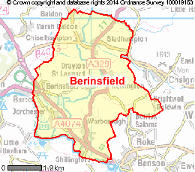

**Source: ONS- Neighbourhood statistics**

Overview

* Berinsfield is a comparatively large village of 2806 inhabitants situated about eight miles south of Oxford City within the District Council of South Oxfordshire (SODC). It has existed in its present form only since about 1960. Previously the site had been used as a WWII airfield (RAF Mount Farm).
* Housing in the village includes a relatively high proportion of rented affordable accommodation.

Social life

* A bimonthly village magazine, 'Your Village Voice'.
* There is a strong sense of community, which is supported by a wide range of clubs and societies (including football, boxing, gymnastics, water sports, WI & Scouts)
* Facilities (see list of community assets) include the library and Abbey Sports Centre.
* Numerous community events all contribute to an informed and cohesive community.

Schools

* Berinsfield Community Primary School
* Abbey Woods Academy

Services

* Berinsfield is a service hub for the surrounding area

Parish Council

* Berinsfield Parish Council, Highsett, Alchester Road, Chesterton, Bicester, Oxon. OX26 1UN
* Telephone: 01869 354135
* Email: [Berinsfieldpc@aol.com](mailto:Berinsfieldpc@aol.com)

1. **Areas of Deprivation**

Berinsfield E01028604 and E01028605

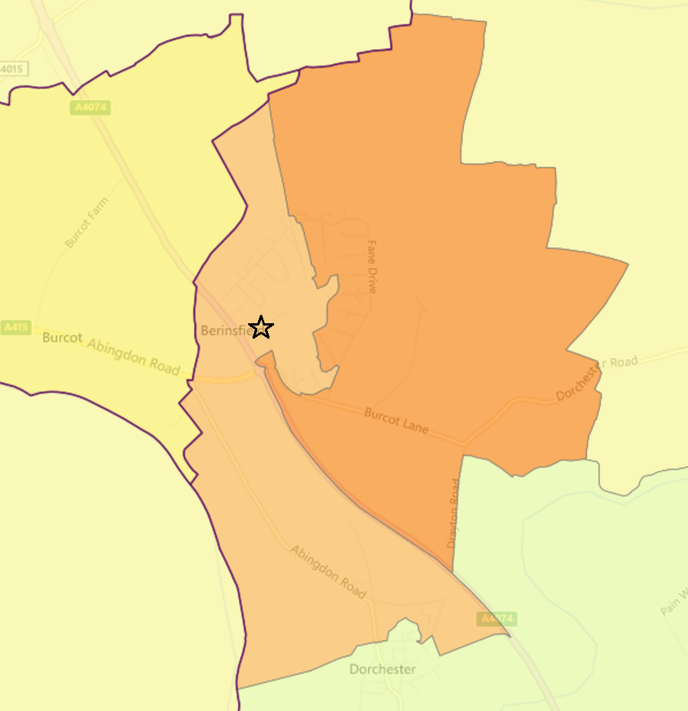

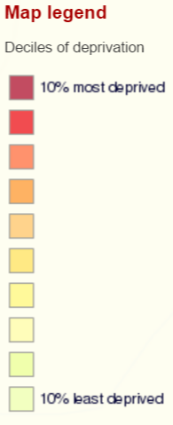

Berinsfield is relatively deprived, particularly in the areas of education skills and training, children and young people and adult skills.





**SOURCE- Index of Multiple Deprivation 2015 Deciles (where 1 is most deprived 10% of small areas - LSOAs)**

1. **Service overview**

|  |  |  |
| --- | --- | --- |
| **Children’s Centre** | **Day Centre** | **Transport** |
| See **Community Assets**, below  In February 2016, the council agreed to set aside £1m for creating a ‘one off’ fund to provide pump priming to support Children’s Centres. In Feb. 2017 OCC cabinet was recommended to approve transition funding to the [Berinsfield] Employment Action Group which will run the Children’s Centre from April 2017 | OCC has ‘[proposed](http://mycouncil.oxfordshire.gov.uk/documents/s36119/CA_JAN2417R26%20-%20Daytime%20Support.pdf) to replace our current annual funding for 47 community daytime support services [**including the Berinsfield Day Centre**] of £992,000 a year, with grant pots totalling £250,000 a year, which services could bid for under two categories.  The Sustainability Fund would provide grants to enable the ongoing delivery of daytime support services in areas of high need. The Innovation Fund would provide one-off grant funding to establish self-sustaining projects to fill gaps in services.’ | Bus services: 97 to Didcot and Wallingford had subsidies cut but is still operated by Thames Travel.  T2 service to Templars Square in Cowley.  Timetable changes to the 114 service, which picks up passengers in Berinsfield, Wallingford and Abingdon.  There are other regular buses to Oxford and Reading, X39, X40 on the A4074 operated by Stagecoach.  Work to construct an A4074 crossing is due to start Easter 2017. |

1. **Distance to services**





**SOURCE - Road distance to key services (km) in 2014 - IMD 2015 Barriers to Housing and Services Domain**

2. **Community assets**

|  |  |
| --- | --- |
| **Name** | **Details** |
| Community Centre | Hall used for community activities (lunch club, family night, karaoke, meat raffle) and available for hire. |
| Pre-school | An independent pre-school in a purpose built building situated between Abbey Woods Academy school and a war memorial. Children 2-4 years old. |
| Berinsfield Community Primary School | 265 pupils, larger than average primary.  There are a few from a variety of minority ethnic backgrounds and some are at the early stage of English language acquisition. The proportion of pupils with learning difficulties and/or disabilities is well above average.  In some classes over a half of the pupils have been identified as having learning difficulties and/or disabilities. The school has a designated unit for up to 30 pupils with moderate learning difficulties. The facility is used by up to 40 per cent of the school as and when additional support is required.  The proportion of pupils eligible for free school meals is above average. In the Early Years Foundation Stage (EYFS) there are 23 children in the Nursery and 27 in the Reception class. |
| The Berin Centre | Building in need of updating. |
| Abbey Woods Academy | Part of CfBT Schools Trust which is a multi-academy trust of 11 primary and five secondary academies and free schools.  Co-educational school for children aged 4+ to 11. The Academy is currently housed in a series of ageing buildings on a cramped site, with limited provision for staff to park their cars.  Abbey Woods Academy is not currently operating at full capacity (there are currently spare places) and some children travel outside the village to go to school. |
| The Pavilion | The Pavilion is available for hire during the day time and some evenings. It is well used by the football clubs based in the village. It has a meeting room, suitable for about 20 people, kitchen and changing rooms. |
| Berinsfield Scout Hut | Fane Drive |
| Oxford City Indoor Arena | Two sports halls which can accommodate a number of sports including futsal, netball, basketball, volleyball and fencing. |
| Community library | Building in need of updating. Books, audio, free wifi, computers and internet. |
| Abbey Sports Centre | Building in need of updating. The facilities include a 35 station gym, swimming pool, wide range of classes, 4 court badminton hall, children’s swimming lessons, archery and 5 aside football. |
| The Health Centre | Has indicated that it can cope with modest increase in population. Will need to be improved for significant population increase. |
| The pub – ‘Village Inn’ |  |
| Dorchester House Business Centre | Supports community groups |
| Berinsfield Information & Volunteer Centre |  |
| St Mary & St Berin church and church hall | A modernisation project for the meeting hall is now underway, subject to funding constraints. The new structure could be of real benefit to the community where, currently, there is no village hall. |
| Adult Learning Centre |  |

1. **Community activity: overview**

Berinsfield has a good range of facilities - primary school, sports centre, library, children’s centre. There is a strong sense of community, which is supported by a wide range of clubs and societies (including football, boxing, gymnastics, water sports, WI & Scouts,) and the social facilities offered by the library and Abbey Sports Centre. There is a skateboard park. A bimonthly village magazine, 'Your Village Voice', and numerous community events all contribute to an informed and cohesive community. Due to the compact nature of the original village, all residents live within easy walking distance of the primary school, the health centre, church, post office, and local retail outlets. Soha Housing has a large number of homes in Berinsfield.

The table lists a summary of some of the activity and services in Berinsfield.

| **Theme** | **Group** | **Contact** | **Notes** |
| --- | --- | --- | --- |
| **Children** | Primary school | Wimblestraw Road Berinsfield OX10 7LZ Tel: 01865 340420 |  |
|  | Pre-school | Wimblestraw Rd, Berinsfield, OX10 7LZ  [01865 340212](javascript:void(0))  [berinsfieldeyps@gmail.com](mailto:berinsfieldeyps@gmail.com) |  |
|  | Playground | Abbey Woods Academy  Wimblestraw Road, OX10 7LZ  [Office@abbeywoodsacademy.oxon.sch.uk](mailto:Office@abbeywoodsacademy.oxon.sch.uk) | currently located with road frontage alongside the Abbey Woods Academy |
|  | Berinsfield Adult Learning | Abbey Woods Academy  Wimblestraw Road, OX10 7LZ  [Office@abbeywoodsacademy.oxon.sch.uk](mailto:Office@abbeywoodsacademy.oxon.sch.uk) | Adult Learning & Voluntary Day Centre Situated in a purpose-built block to the rear of the Academy, offers a variety of courses and classes for adults with learning difficulties. |
|  | Children’s Centre | Wimblestraw Rd, Berinsfield, OX10 7LZ | Building in need of updating. Berinsfield Children’s Centre has had its funding withdrawn. A new service (opening April 2017) will be operated by Employment Action Group and will include family support, a job club and training.  The County Council has approved the maximum 12 months’ rent free period on the building |
| **Family, children** | Berinsfield Community Association | Community Centre, Green Furlong, Berinsfield, OX10 7NR  [01865 340301](javascript:void(0))  Youth Centre: 340201 | Venue for the Campus Youth Centre |
| **Young people** | Youth Group | Campus Youth Centre Community Centre, Green Furlong, Berinsfield, OX10 7NR  [Phone](https://www.google.co.uk/search?espv=2&biw=1600&bih=755&q=campus+youth+centre+at+berinsfield+phone&stick=H4sIAAAAAAAAAOPgE-LWT9c3LMvLy6gwidfSz0620k_Oz8lJTS7JzM_Tz87LL89JTUlPjS9IzEvNKdbPSCyOL8jIz0u1ApMAyNvt6UAAAAA&sa=X&ved=0ahUKEwie98WowPnSAhWJKcAKHZZkDysQ6BMIZTAP): [01865 340301](javascript:void(0)) |  |
|  | Football | Oxford City Indoor Arena, Tower Road, Berinsfield, OX10 7LN  01865 744493 / 07880 198246 | Footballers also use The Pavilion, Lay Avenue |
|  | Berinsfield Amateur Boxing Club | Tower Rd, Berinsfield, Wallingford OX10 7LN  Phone: 07860 156950 | More than 100 members of all ages |
|  | Abingdon Gymnastics Club | Berinsfield, OX10 7LN  01865 340992 |  |
|  | Water sports | Queenford Lakes Watersports  Centre |  |
|  | Wide range of sports: futsal, netball, basketball, volleyball and fencing. | Oxford City Indoor Arena, Tower Road, Berinsfield, OX10 7LN  01865 744493 / 07880 198246 |  |
|  | Scouts | Berinsfield Scout Hut  Tel 340860  Fane Drive, Berinsfield, OX10 7LN |  |
| **Older people** | WI |  |  |
|  | The Health Centre | 24 Fane Drive, Berinsfield, OX10 7NE  01865 340558 | Weekdays 8am-6.30pm |
|  | Church | The Vicarage, Cherwell Rd, Berinsfield, OX10 7PB  Phone: 01865 340460.  Church Contacts Revd. Sue Booys (Rector) 340007 Jean Booth (Church Warden) 340709 Bookings contact Angie Bowden 340389) | The Church Hall is available for hire for meetings, children's parties, social events Small serving kitchen. |
| **Adults** | Community library | Green Furlong, Berinsfield, OX10 7NR  01865 340771 | Books, audio, free wifi, computers and internet. |
|  | Sports and leisure: active women, BoxFit, netball, beginners jogging | Abbey Sports Centre Green Furlong, Berinsfield OX10 7NR  341035 |  |
|  | Events at the pub – ‘Village Inn’ | 19-19A Fane Drive, Berinsfield, OX10 7ND  [01865 343690](javascript:void(0)) |  |
|  | Berinsfield Information & Volunteer Centre | 39 Fane Drive, Berinsfield  OX10 7NE  [www.bivc.org.uk](http://www.bivc.org.uk/)  01865 343044  [help@bivc.org.uk](mailto:help@bivc.org.uk" \o "Email the contact for this service) | Run by volunteers M-F 9:30-12:30. Drop in information service. Offer information and advice in a range of areas; welfare rights, housing, social support, consumer rights and more. Monthly coffee mornings and Crafty Bees craft club.  Berinsfield Good Neighbours Scheme (volunteers transport clients to and from the Health Centre, Berinsfield, Oxford Hospitals and, formerly, Berinsfield Voluntary Day Centre) |
|  | Citizens’ Advice | Berinsfield Information & Volunteer Centre, 39 Fane Drive, Berinsfield  OX10 7NE  [www.bivc.org.uk](http://www.bivc.org.uk/)  01865 343044  [help@bivc.org.uk](mailto:help@bivc.org.uk" \o "Email the contact for this service) | Run by volunteers M-F 9:30-12:30. Drop in information service. Offer information and advice in a range of areas; welfare rights, housing, social support, consumer rights and more. Monthly coffee mornings and Crafty Bees craft club. |
| **Community Transport** | Berinsfield Good Neighbours Scheme | Berinsfield Information & Volunteer Centre, 39 Fane Drive, Berinsfield  OX10 7NE | Volunteers transport clients to and from the Health Centre, Berinsfield, Oxford Hospitals and Berinsfield Voluntary Day Centre |
| **Skills** | Berinsfield Adult Learning | Wimblestraw Rd, Berinsfield, OX10 7LZ  Phone: 01865 340688, 01235 555 585 |  |
|  | Employment Action Group | Dorchester House Business Centre,  Wimblestraw Road, Berinsfield, OX10 7LZ  Phone: 01865 341944  email: [receptioneag@outlook.com](mailto:receptioneag@outlook.com) | A range of services to support individual members of the local community, not-for-profit businesses and community enterprises. Sewing equipment and classes. Table tennis. |

1. **Recent projects to mitigate service reduction**

**Analysis of gaps in services**

Berinsfield has a strong sense of community spirit. However, there are difficulties. A 2012 Environmental Improvements Action Plan (part of the Community Led Plan process) identified a number of problems associated with the physical nature of the village including:

* The lack of a village focal point and many unlit, enclosed alleyways
* Social problems stemming from the bias in the village towards affordable housing including high unemployment and vandalism
* A lack of facilities for key groups – e.g. children & young people

The Neighbourhood Plan (which did not go forward to referendum so did not pass) found that issues that need addressing included:

* Improvement to the Abbey Woods Academy or the construction of a completely new school better suited to requirements
* Shops, local businesses and the employment they provide
* Greater skills training
* More specialised forms of accommodation to meet older peoples’ care needs in the future.
* Better cycle ways and buggy-friendly routes around and through the village. Footpaths should be lit, especially across the Green.
* There is a need for more amenity space, leisure facilities and formal play areas for children.

More recent consultation found that some community services in Berinsfield have concerns about their future – this includes the Children’s Centre, Employment Action Group, and the Berinsfield Information and Volunteer Centre.

A number of these groups are working together to make a plan to keep services going in Berinsfield. There is a lack of shops in the village and the “bottom shops” at the east part of Fane Drive are considered to be in a poor state.

What Berinsfield residents and organisations have said they’d like to see are: long-term support for key community services, including new premises for those which need it; the introduction of new shops or larger shops; regeneration of some existing shopping areas; a new village centre or community hub bringing together different services and activities; a café or meeting place.

Adult learning and employment are also priorities. Residents taking part in a series of community events as part of the Berinsfield Community Investment Scheme responded that schools, a community hub, support for local services and green spaces are a priority for the future of the village and that better parking, improved streets and a new leisure centre are important.