

Abingdon - Community Profile: March 2017

1. **Map and overview**

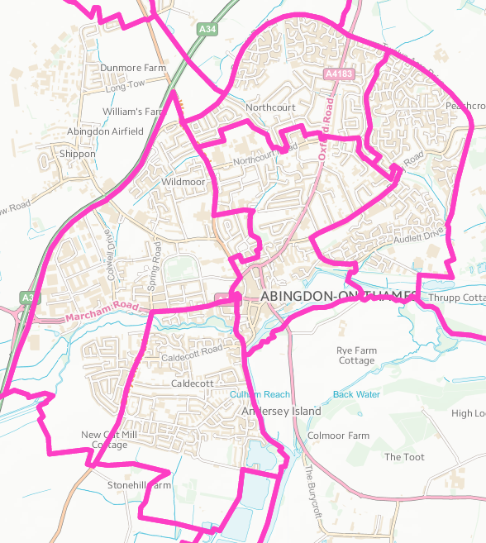

**Source**: [www.ordnancesurvey.co.uk](http://www.ordnancesurvey.co.uk)

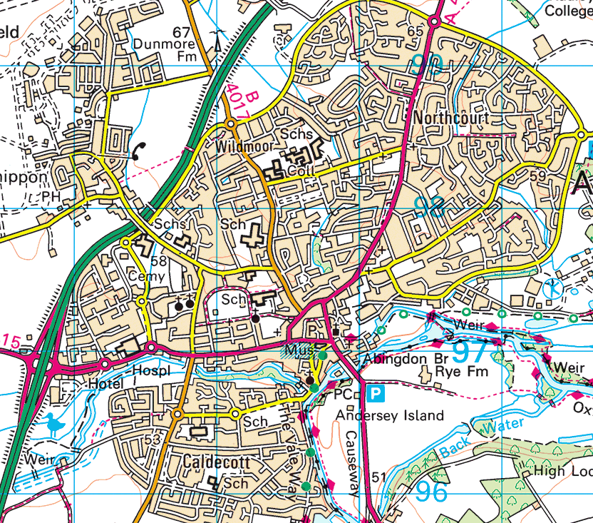

**Source**: googlemaps

Overview

* Abingdon-on-Thames is an historic and still thriving market town in rural Oxfordshire. Abingdon is the largest town in the Vale of White Horse district and is England’s oldest continuously inhabited settlement. Abingdon has experienced substantial growth over the last few decades with the development of modern housing, a business park, a science park, and the regeneration of several areas in the town centre.
* Abingdon benefits from an attractive frontage to the River Thames and an historic town centre. In the emerging Vale of White Horse Local Plan, Abingdon is noted as a highly sustainable location for development, particularly due to its proximity to the city of Oxford and excellent public transport connectivity.
* Abingdon is a town with a rich history. The local history society has compiled a detailed study of all the buildings in the town centre that have historical significance. The town developed around a great Benedictine Abbey, built in the 7th century which, in its time, was larger than Westminster Abbey.
* Its attractive frontage to the River Thames and the fine array of old buildings are major elements of its special character. The remains of the Abbey buildings are owned by the local Civic society.
* The 2011 Census recorded the parish's population as 33,130. This is 2,504 more than in the 2001 Census total of 30,626, and represents just over 8% growth in the population.
* Abingdon is set to grow further through ongoing development including a major strategic site proposed in Vale of White Horse emerging Local Plan and growth at Culham will also impact traffic and services in Abingdon.
* The town has a community hospital, college of further education, library, museum and six secondary schools. The White Horse Leisure and Tennis Centre is a national centre of excellence for tennis, and Tilsley Park has an all-weather athletics track and sports pitches. The River Thames, the open meadows beside it and Abbey Gardens are well used for informal recreation by locals and visitors to the town as well as an open-air swimming pool, paddling pool and new children’s play area.
* Abingdon has a healthy mix of social activity with many active groups and long-held traditions. The Market Place is a focus of town life. The Market Place is central, easily reached, and is the scene of important occasions like Bun-Throwings and music festivals but also of weekly and monthly markets, fairs and community events. Traditions include the famous Bun-Throwing ceremony and the midsummer Election of the Mayor of Ock Street in which the town comes alive with Morris Dancing and mayhem. There are many groups covering a wide range of activity. A few examples are Abingdon Concert Band, the Abingdon Naturalist Society, the Abingdon Astronomical Society, and Abingdon Rowing Club, Morris dancers and Abingdon Carbon Cutters. Two fairs are held in October each year. The Michaelmas fair is the longest street fair in Europe.
* Abingdon has strong links with the city of Oxford and provides housing for people working in Oxford and is a significant employment area in its own right.

Transport and Roads

* Abingdon has excellent access to the strategic road network, including the A34 and A420. Sustrans bicycle route 5 links Abingdon with Oxford and Didcot. Abingdon is at the heart of Science Vale UK, eight miles from Harwell Oxford, five miles from Milton Park and two miles from Culham Science Centre.
* There are buses every hour linking Abingdon with Harwell, Didcot, Wantage, Grove, Milton Park and Culham and buses every 20 minutes to Oxford. It is on the A415 between Witney and Dorchester, adjacent to the A34 trunk road, linking it with the M4 and M40 motorways. The B4017 and A4183 also link the town, both being part of the old A34 and heavily congested at peak times. Abingdon has no rail service. The nearest major stations are Oxford (6 miles/9.7 km) and Didcot Parkway (8 miles/13 km). Radley is a local branch line to Oxford and to Didcot and into London. People can catch fast trains into London from Didcot – seemingly well used
* Abingdon is 6 miles (10 km) south of Oxford in the flat valley of the Thames on its west (right) bank, where the small river Ock flows in from the Vale of White Horse and the River Stert. Abingdon sits at the confluence of the three rivers.

Employment

* Abingdon is near several major scientific employers: the [UKAEA](https://en.wikipedia.org/wiki/UKAEA) at [Culham](https://en.wikipedia.org/wiki/Culham" \o "Culham) (including the [Joint European Torus](https://en.wikipedia.org/wiki/Joint_European_Torus) (JET) fusion research project), [Harwell Laboratory](https://en.wikipedia.org/wiki/Harwell_Laboratory), the [STFC](https://en.wikipedia.org/wiki/Science_and_Technology_Facilities_Council) [Rutherford Appleton Laboratory](https://en.wikipedia.org/wiki/Rutherford_Appleton_Laboratory) and the new [Diamond Light Source](https://en.wikipedia.org/wiki/Diamond_Light_Source) [synchrotron](https://en.wikipedia.org/wiki/Synchrotron), which is the largest UK-funded scientific facility to be built for over 40 years. Many inhabitants work in [Oxford](https://en.wikipedia.org/wiki/Oxford) or commute by rail to London, from nearby [Didcot](https://en.wikipedia.org/wiki/Didcot" \o "Didcot). The [Army](https://en.wikipedia.org/wiki/British_Army) now occupies Dalton Barracks, which, prior to 1993, was the [Royal Air Force](https://en.wikipedia.org/wiki/Royal_Air_Force) station [RAF Abingdon](https://en.wikipedia.org/wiki/RAF_Abingdon).
* Abingdon has a business park which has offices for several national and international companies including [Northern Rock](https://en.wikipedia.org/wiki/Northern_Rock) bank. Until recently, [Vodafone](https://en.wikipedia.org/wiki/Vodafone) had offices in the town, acquired as part of its takeover of [Mannesmann](https://en.wikipedia.org/wiki/Mannesmann) in 2000. The Science Park includes the headquarters of [Sophos](https://en.wikipedia.org/wiki/Sophos), an [anti-virus](https://en.wikipedia.org/wiki/Anti-virus) company. [RM](https://en.wikipedia.org/wiki/RM_plc), an educational computing supplier, commonly refer to themselves as being Abingdon-based, which is technically true – even though their HQ is actually in nearby [Milton Park](https://en.wikipedia.org/wiki/Milton_Park), Milton, they have an Abingdon post code (as does the rest of Milton Park). Penlon Ltd, a medical equipment company, have their premises on the outskirts of Abingdon (their previous site, near the former railway station, has been redeveloped as residential housing). Another major employer is the British head office of the German appliance company [Miele](https://en.wikipedia.org/wiki/Miele).
* Abingdon hosts the headquarters of international corporations such as: Miele GB, Ortho Europe and VTEC Electronics Europe. Internationally renowned companies such as: Sophos, Penlon, GE Healthcare and Tessella started in Abingdon and have their headquarters in the town. Other big employers include: Rapier Employment, Leadbitter, Swets Information Services and Oxford Engineering. There is a strong cluster of science companies concentrated in and around Abingdon, particularly on Abingdon Science Park. The Quadrant offers a wide range of business units for office and science-based businesses. Abingdon hosts many health-related enterprises such as: Ortho Europe, Penlon, GE Healthacare, Opcare, and A and D Instruments. Nearby Milton Park and Culham Science Park are members of Science Vale UK, which is a global hot spot for enterprise and innovation in science, high technology and the application of knowledge. Oxford Instruments is located just a few miles north in Tubney Woods. Car-maker [MG](https://en.wikipedia.org/wiki/MG_(car)) was a major employer from 1929. The factory closed in October 1980 on the demise of the ageing but still popular [MG MGB](https://en.wikipedia.org/wiki/MG_MGB) range.

## 

## **Deprivation**

Abingdon has one area of relative deprivation: part of Abingdon Caldecott ward marked in red in the map below ranks within the second most deprived decile of deprivation in England (the first decile is the most deprived). Particular issues in this small area according to the Index of Multiple Deprivation data are employment, low income, and lack of education skills and training.



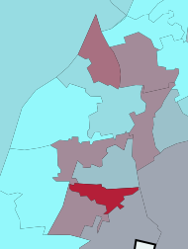

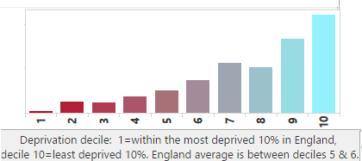

## **Service overview**

|  |  |  |
| --- | --- | --- |
| **Children’s Centre** | **Day Centre** | **Transport** |
| [Abingdon Children and Family Centre](https://www.oxfordshire.gov.uk/cms/content/abingdon-children-and-family-centre) is located in the centre of town.  South Abingdon Children’s Centre is no longer financially supported by the county council. There is strong local support to maintain this service and in March 2017 Abingdon Town Council pledged to provide £30,000 a year for the next three years to keep the centre open. A final decision on what services this centre will provide in the future has yet to be made.  North and North East Abingdon Children’s Centre services will be transferring to community provision led by Wooton & Dry Sandford Community Centre. | From 1 October 2017, health and wellbeing centres and learning disability support services are changing.  They are being replaced by a new, centre-based Community Support Sevice.  The CSS will delivered from 8 dedicated buildings, including [Abingdon Health and Wellbeing Centre](https://www.oxfordshire.gov.uk/cms/content/abingdon-health-and-wellbeing-centre-0) | Bus services that had their subsidies cut in 2016 were 41, 42, 43, 44, 44A, 46, 114, T2, X1, X2, X15, but Abingdon remains well connected by bus to the main centres of employment, retail and leisure. |

## 

1. **Distance to services**

Distance to services is not a particular issue for Abingdon. Abingdon has many services but these are not always within easy reach for specific pockets of people who do not own a car.

## 

1. **Community assets**

Sport and recreation facilities include White Horse Leisure and Tennis Centre, Tilsley Park and the Southern Town Park. Abingdon had four cinemas but all have closed. Recently Abingdon School has started to show National Theatre live screenings.

Shopping in Abingdon fares poorly in comparison to developments in nearby Didcot, Wantage and Witney. The Tesco Extra store west of the town is the largest supermarket in Abingdon and one of the most profitable Tesco stores in the country.

Nearby is the Fairacres Retail Park, recently redeveloped, which includes Homebase, Argos, Subway, Dreams, and Pets at Home stores as well as an AHF furniture store which is part of Anglia Regional Co-operative Society. It originally had two long established Abingdon retailers – Vineys Home Furnishings (now part of the Lee Longlands chain) and Mays Carpets (now part of the Carpetright chain and has re-branded accordingly).

In the town centre, many independent stores, estate agents and charity shops make up the Bury Street shopping precinct. Abingdon has fewer than 5 empty retail units. Abingdon has recently become a Business Improvement District Town and new events are planned to increase the footfall in the town centre.

The town centre of Abingdon was refurbished in 2007 as part of the council's redevelopment plan. The roads around the area have been changed: notably the one-way system around the centre has been partially changed to two-way. While this has slightly reduced traffic within the historic town centre, congestion has greatly increased elsewhere. Local businesses have also complained that the increased traffic has driven shoppers away. The pre-1970s shopping precinct has been redeveloped. The market square was repaved and a new tourist information centre is planned. There is a tourist centre in the Guildhall.

Community Buildings

|  |  |
| --- | --- |
| **Name** | **Details** |
| Caldecott Daycare (Day Nursery) | Pre-school, Local Education Authority |
| Dunmore Pre-School | Pre-school, Local Education Authority |
| Peachcroft Pre-School | Pre-school, Local Education Authority |
| St Nicolas Pre-School | Pre-school, Local Education Authority |
| Abingdon Kindergarten | Private |
| Dalton Pre-School Nursery | Private |
| St Mary’s Nursery | Private |
| Tiny Toes Day Nursery | Private |
| Caldecott County Primary School, | Caldecott Road |
| Carswell Community Primary School, | Bostock Road |
| Dunmore Primary School | Northcourt Road |
| Long Furlong Primary & Nursery School | Boulter Drive |
| Rush Common County Primary Schoo | Hendred Way |
| St. Edmund’s RC Primary School | Radley Road |
| St Nicolas CE Primary School | Boxhill Walk |
| Thameside Primary & Nursery School | Cotman Close |
| Thomas Reade County Primary | Radley Road |
| Fitzharrys School | Northcourt Road, secondary school with 6th form |
| John Mason School | Wootton Road, secondary school with 6th form, hireable hall |
| Larkmead School | Faringdon Road, secondary school with 6th form, hireable hall |
| Kingfisher School | Radley Road, Special School |
| Abingdon School | Park Road, Independent school – Senior & 6th Form |
| Our Lady’s Convent School | Radley Road. Independent school (Co-Educational)- Junior, Senior & 6th Form |
| The Manor Preparatory School | Faringdon Road. Independent school - Junior |
| The School of St Helen and St Katharine | Faringdon Road. Senior & 6th Form |
| Adult Education Centre, Cotman Close |  |
| Abingdon Health and Wellbeing Centre | daily adult day centre on Audlett Drive |
| Abingdon and Witney College | Northcourt Road. Post-16 education |
| Preston Road Community Centre | Midget Close, Preston Rd. 01235 373010 |
| Long Furlong Community Centre | Boulter Drive |
| The Northcourt Centre | Community Centre. Northcourt Rd. 01235 535243 |
| [St Ethelwold House](http://ethelwoldhouse.com/room-hire/) | Community Centre. East St Helen Street OX14 5EB  01235 555486 |
| [North East Abingdon Community Centre](http://www.neaca.org.uk/) | OX14 2RT, 01235 537374 |
| All Saints Methodist Church | 01235 529287 |
| Peachcroft Christian Centre | 01235 537606 |
| Trinity Church | 01235 520282 |
| [Amey Theatre Abingdon School](http://www.abingdon.org.uk/amey_theatre) | In School’s Arts Centre, 446 seat auditorium with fully raked seating and balcony, large stage |
| Community FreeSpace | Bury Street premises for community groups to use.   * Camera Club – exhibition * Carbon Cutters – apple-juicing and exhibition * Oxon and Bucks Woodcarvers – exhibition and demonstrations * Abingdon Flower Club – display and demonstrations * GO Active drop-ins - functional fitness tests for over 60’s * Abingdon Music Centre – workshops * MIND – drop-in sessions * Abingdon Health & Wellbeing Centre – exhibition * Fitzharrys school – Art Exhibition   [freespace@friendsofabingdon.org.uk](mailto:freespace@friendsofabingdon.org.uk) |

## **Community and statutory services: overview of activity**

The table lists a small summary of some of the activity and services on offer in Abingdon.

| **Theme** | **Group** | **Contact** | **Notes** |
| --- | --- | --- | --- |
| **Children** | Abingdon has 8 pre-schools 4 private pre-schools, 4 run by the Local Education Authority, 6 secondary schools (3 with 6th forms), and a special school which caters for ages 3-19. | | |
|  | Abingdon Children & Family Centre | 01865 328400 [AbingdonFST@oxfordshire.gov.uk](mailto:AbingdonFST@oxfordshire.gov.uk)  Stratton Way Abingdon OX14 3RG |  |
|  | Abingdon Kindergarten Ltd - North Court | 122 Oxford Road, Abingdon OX14 2AG |  |
|  | Preston Road Community Centre | Midget Close, Preston Rd. 01235 373010 |  |
|  | Long Furlong Community Centre | Boulter Drive |  |
|  | Northcourt Centre | Northcourt Rd, 01235 535243 | The Northcourt Centre is available for function hire and is host to a wide range of community activities |
|  | The Net Youth Centre | Stratton Way, Abingdon, OX14 3RG,  01865 328400 | Early Intervention Centre that offers support to children, young people and families, |
| **Skills** | Abingdon and Witney College | Northcourt Road | Vocational courses, apprenticeships, 14-16 Horizons (study part time at college whilst still at school), Adult Education, AS/A Levels (Level 3 Extended Diploma courses), Fast Forward (formerly Future Pathways) for school leavers, Gateway for 16-18s not currently in education, employment or training, Higher Education (Honours Degrees, Foundation Degrees and HNCs, as well as Access to Higher Education and professional qualifications), Life and Work Skills Learning Programme (Pathways), MAP (MacIntyre Abingdon Partnership College) for people aged 16 to 25 with complex learning difficulties and autism, Professional Futures, The Propeller Project (collaborative social enterprise project involving young people with a range of learning difficulties and disabilities). |
| **Adults** | Camera Club | [abingdoncameraclub@gmail.com](mailto:abingdoncameraclub@gmail.com) | Active club for more than 30 years. Range of activities includes guest speakers; practical evenings on photographic skills and techniques; trips out; competitions; print exhibitions during Oxfordshire Artweeks and a photo competition during the Abingdon Arts Festival. |
|  | Carbon Cutters | [carbon.cutters@gmail.com](mailto:carbon.cutters@gmail.com)  7.30pm on the third Wednesday of month at St Ethelwold’s House | Responding to climate change, transition to a low carbon lifestyle, expert speakers, practical workshops, expert panel discussions. Particular focus on education, energy, food, transport. |
|  | Abingdon Flower Club | Northcourt Centre,  First Tuesday every month 6.30 for 7.15  Facebook page  07913 129148. | Encouraging interest in the art of flower arranging. |
|  | GO Active | 01235 422219  [www.getoxfordshireactive.org](http://www.getoxfordshireactive.org) | Functional fitness tests for over 60’s |
|  | Abingdon Music Centre | The Old Magistrates Court, Abbey Close  Abingdon OX14 3JD  01235 533633  [admin@abingdonmusic.co.uk](mailto:admin@abingdonmusic.co.uk) | Music activities for all ages pre-school to adult. Singing classes, orchestra, instrumental groups. |
| **Older people** | Abingdon Resource and Wellbeing Centre | Audlett Drive OX14 3GD 01235‐521094 |  |
|  | Age UK | St Edmund House, 39 West Saint Helen Street, Abingdon, OX14 5BT. | Information and advice about what services and support are available locally. Community Information Network team offer a drop in the first Friday of the month, 10.00am - 12.00noon |
| **Transport** | Abingdon and District Volunteer Centre Car Scheme | 01235 522438  35 Ock Street OX14 5AG | Approx 6 mile radius. A voluntary scheme taking people to hospitals, doctors, surgeries, day centres etc. |

## 

1. **Recent projects to mitigate service reduction**

**Analysis of gaps in services**

*DRAFT SECTION - IN PROGRESS*